Technical Design

HypeBest

Table of content

1 INTRODUCTION 3
2 PHYSICAL DATA DESIGN 4
2.1 Data Dictionary 4
2.2 Design of relational data bases (SQL) 4
2.2.1 Table 1 (..n) – XXXXXXXXXXX 4
2.2.1.1 Columns 4
2.2.1.2 Keys 4
2.2.1.3 Event Actions 4
2.2.1.4 Stored procedures 5
2.2.1.5 Sizes and other Physical properties 5
2.2.1.6 Indexes 5
2.2.1.7 SQL Procedures for inserts and updates 5
2.2.2 Relations 5
2.3 File Design 5
2.3.1 File 1 (...n) – XXXXXXXXXXX 5
2.3.1.1 File description 5
2.3.1.2 Fields 6
3 COMPONENT DESIGN 7
3.1 Type of components 7
3.1.1 Details of software component types 7
3.1.2 Rules and build recommendations 7
3.2 Component inventory (structured design) 7
3.2.1 Subsystem SSSSSSSSS (1...n) 7
3.2.1.1 Function AAAAAAA (1...n) 7
3.2.1.2 Subsystem test cases 8
3.2.2 System test cases 8
3.3 Component Inventory (Object oriented design) 8
3.3.1 Subsystem or Layer SSSSSSS (1...n) 8
3.3.1.1 Class CCCCCCCCCC (1...n) 8
3.3.1.2 Object XXXXXXXXXXX (1...n) 8
3.3.1.3 Component XXXXXXXXXXX (1...n) 8
3.3.2 System test cases 8

INTRODUCTION

The Technical Design is based on the functional design. It extends the design specifications depending on the architecture and the real installation environment that are not part of the functional design.

The Technical Design document consists of 2 sections:
- Physical Data Design
- Component Design

Both parts are corresponding extensions of sections of the functional design:
- Logical Data Model
- Logical Process Model

As well as in the functional design it is possible that any section of this template is not used in a special case. This depends on various factors. In this case IT SHOULD BE INFORMED “NOT APPLIED” o “(N/A)” in the body of the section or in the box if it is a table or a form, avoiding the deletion of the section, block or paragraph.

In case that the information was already included in another document, a reference or link to the section of this document should be included, AVOIDING TO REPEAT THE INFORMATION in any case.

PHYSICAL DATA DESIGN

The physical data design links the physical specifications to the real architecture of the SQL tables and other files that are used to store permanently the information that is managed by the system. Not included is the storage of external data.

Data Dictionary

Design of the physical implementation of the data types, defined in the data dictionary that was prepared during the functional design phase, optimized depending on the system architecture and the interfaces. Contain the real data types, which are used in every functional data type.

UTENTE

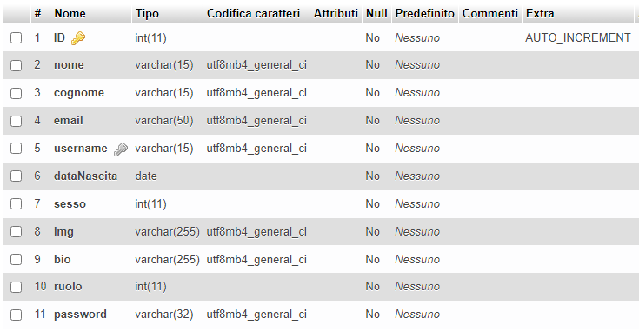

TAG

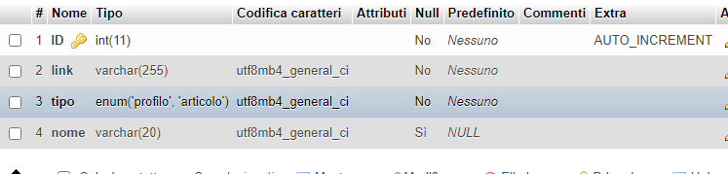

SEGUE

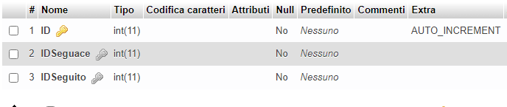

SALVA
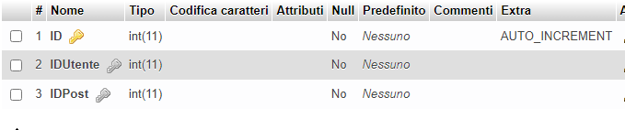

PRESENTA
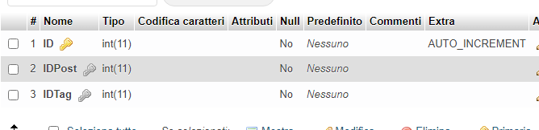

POST
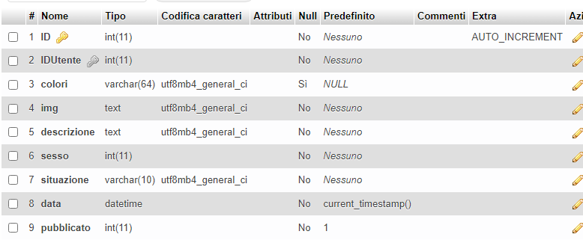
POSSIEDE
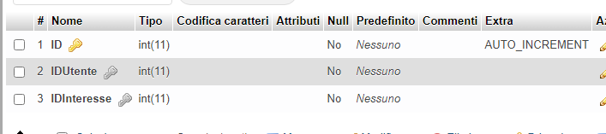
LIKES
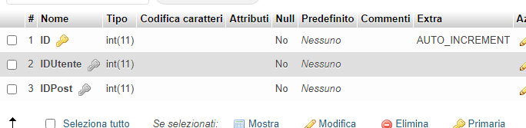

INTERESSE
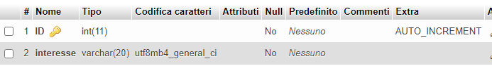

COMMENTI
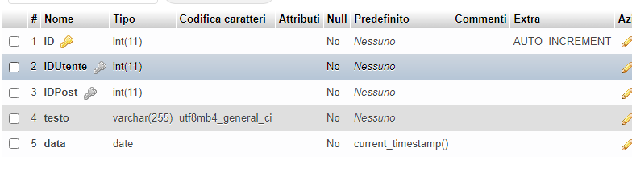

Design of relational data bases (SQL)

Contains information for the build of the tables like its columns (fields), primary keys, secondary keys, foreign keys, indexes, integrity rules, design of the stored procedures and the called events, relations between the tables, start up volume of the lines, yearly growth percentage, copy, restore and reorganisation procedures, etc.

Table 1 (..n) – XXXXXXXXXXX

Columns
SPIEGATO NEL PUNTO 2.1

Keys

KEY | COMPOSITION | LENGTH
Utente
Id | Chiave Primaria
Tag
ID | Chiave Primaria
Segue
Id | Chiave Primaria
IdSeguage | Chiave esterna Utente
IdSeguito | Chiave esterna Utente
Salva
Id | Chiave Primaria
IdUtente | Chiave esterna Utente
IdPost | Chiave esterna Post
Presenta
Id | Chiave Primaria
IdPost | Chiave esterna Post
IdTag | Chiave esterna Tag
Possiede
Id | Chiave Primaria
IdUtente | Chiave esterna Utente
IdInteresse | Chiave esterna Interesse
Likes
Id | Chiave Primaria
IdUtente | Chiave esterna Utente
IdPost | Chiave esterna Post
Interesse
Id | Chiave Primaria
Commenti
Id | Chiave Primaria
IdUtente | Chiave esterna Utente
IdPost | Chiave esterna Post
Post
Id | Chiave Primaria
IdUtente | Chiave esterna Utente

Event Actions

Relation between business or other events related to the table which cause a chain of process actions.

EVENTS | MOMENT | ACTIONS | PROCEDURE
aggiuntaPost | Quando si aggiunge il post | Aggiungere Post
aggiuntaCommento | Quando si vuole commentare il post di un utente | Aggiunta commento
aggiuntaLike | Quando si vuole aggiungere un like ad un post | Aggiunta like
salvaPost | Quando si vuole salvare il post | Aggiunta salva
AggiuntaTag | Quando si vuole aggiungere un tag | Aggiunta tag

Stored procedures
STORED PROCEDURE | TRIGGERING EVENT | DESCRIPTION, ALGORITHM OR DETAILED SPECIFICATION

Sizes and other Physical properties

Physical resources for processing, storage and administration that are required for the table:

DATE | VALUE | COMMENTS

Indexes
INDEX | COMPOSITION | LENGTH | % ACTUALISATION

SQL Procedures for inserts and updates

SQL PROCEDURE | DETAILED SPECIFICATION

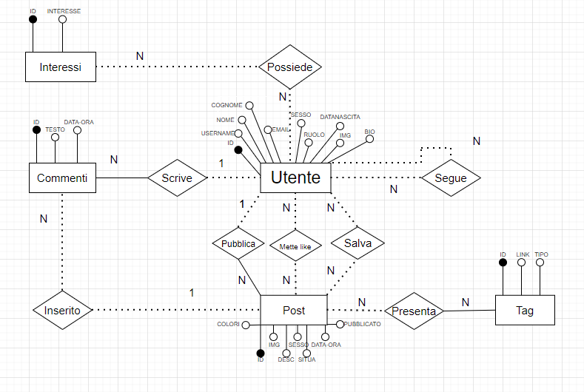
Relations

RELATION ID. FROM FUNCTIONAL DESIGN | PRIMARY TABLE | KEY COLUMN IN PRIMARY TABLE | SECONDARY TABLE | KEY COLUMN IN SECONDARY TABLE | RESTRICTIONS AND INTEGRITY RULES

File Design

Includes the design of all files that are not qualified as SQL tables.

File 1 (...n) – XXXXXXXXXXX

File description

The file XXXXXXXXX contains information related to…

The general properties of this file type are the following:

PROPERTY | ATTRIBUTES | COMMENTS

Fields

FIELD | DATA TYPE  DICTIONARY | POSI-TION | LENGTH | COMMENTS

COMPONENT DESIGN

The component design contains the necessary information to plan and start the building of the system components.

The information is divided between information about the component type and the design of the system components organised as inventory and detail specifications.

Type of components

The information regarding to component types is meant to be a guide for the component construction. For this reason it includes or makes reference to any additional information about the construction, that wasn’t included or referenced in previous phases of requirements or design as guide or programming rules, tool documentation, etc.

Details of software component types

COMPONENT TYPE | DETAILLED DESIGN | CONSTRUCTION TOOL | GENERATION OF EXECUTABLES | TEST WITH  COMPONENTS

Rules and build recommendations

The following tables list the rules and building recommendation in line the clients standards and the other standards that were created by the Project team.

RULE OR  RECOMMENDATION | AFFECTED TYPE OF  COMPONENTS | COMMENTS

Component inventory (structured design)

The components of every subsystem and/or basic function are listed in detail.

Subsystem SSSSSSSSS (1...n)

Function AAAAAAA (1...n)

(Component XXXXXXXXXXX) (i...j)
- Unique name
- Component type
- Short Description
- Design(variable depending on the component type):
  - Diagram
  - Algorithm in pseudo-code
  - Input / Output
  - Verifications / error conditions
  - Calls to other modules
  - Access to tables and types: (Select, Insert, Delete, Update), columns for Where conditions in Selects, etc.
  - Access to files and types: (Sequential, Random), (Read, Write, Extend), etc,
- Component test cases

Function test cases

Subsystem test cases

System test cases

Component Inventory (Object oriented design)

The components of every Subsystem are listed in detail.

Subsystem or Layer SSSSSSS (1...n)

Class CCCCCCCCCC (1...n)
…

Object XXXXXXXXXXX (1...n)
…

Component XXXXXXXXXXX (1...n)
…

System test cases

