David Gibbs

Lab 2

CSC 6710

10-16-13

Problem Statement:

A database needs to be created to store the details of an inventory management website for an online tea company. The website will be used to store product information (name, cost, type, amount in stock, etc.), employee information, employee purchase information, and website login information (username, password). Additional employee information such as phone, manager, address, etc. should not be stored in this database.

The website shall store a history of all modifications so that inventory can be tracked over time. The website shall keep track of the last user who modified a product or inventory. The website shall display the current amount of inventory and the total cost (wholesale and retail). The website shall keep track of all product information and all modifications made to any product information. The website shall have all information needed to purchase a wholesale order from a distributor (distributor information, when to order, shipping time, etc.).

Step 1.

-Business context: Online tea inventory management and employee purchase system

Possible Entities

* Employees
* Orders
* Distributors
* Inventory
* Pricing
* Inventory modification

Step 2.

Possible Relationships

* Employees may place orders (1 or many)
* Orders contain inventory items (1 or many)
* Orders contain prices (1 or many)
* Inventory items have pricing (1)
* Orders cause inventory modifications to be made (1 or many)
* Inventory items have distributors (1 or many)

Step 3.

Entity relationships

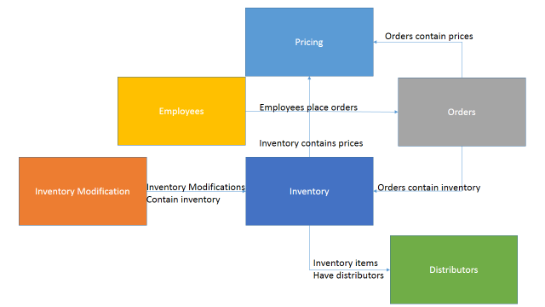

Step 4.

Potential Views

* Orders that employees have purchased, along with the item cost
* Current wholesale and retail value of all products
* Listing items by distributor and price
* Listing inventory adjustments over a time period