**Examples of each of the calculators:**

Ch1_NumbersRecognition

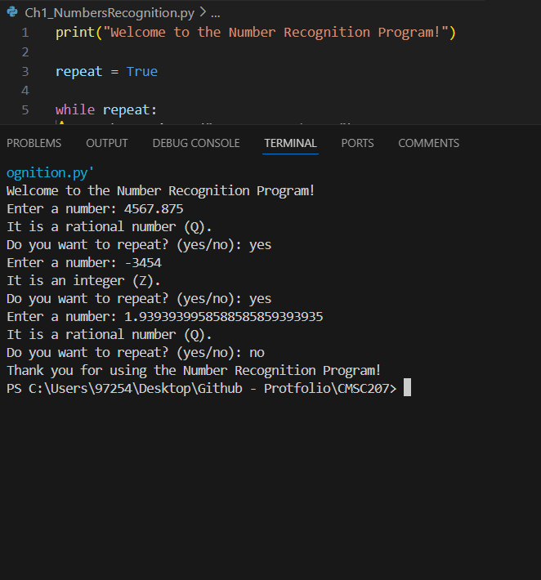

Ch4_GreaterPissibleDivision

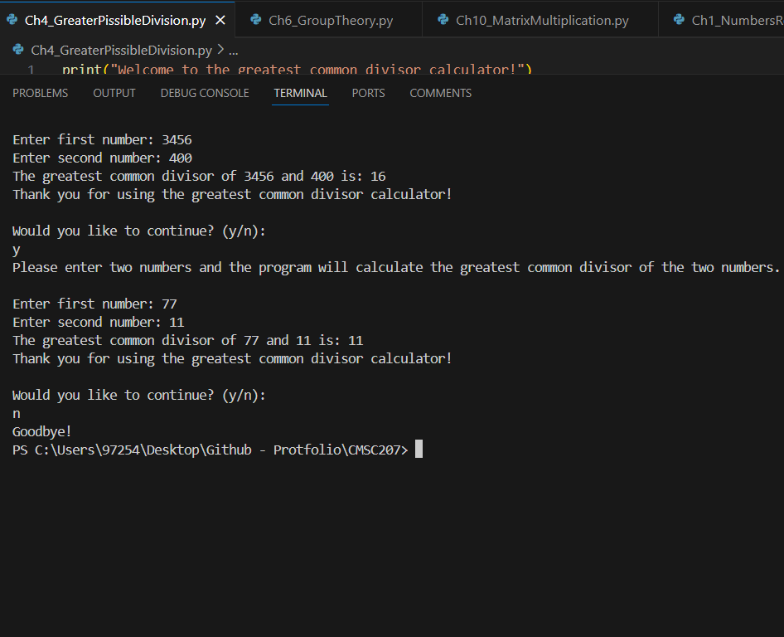

Ch4_UniqeFactorizationTheorem

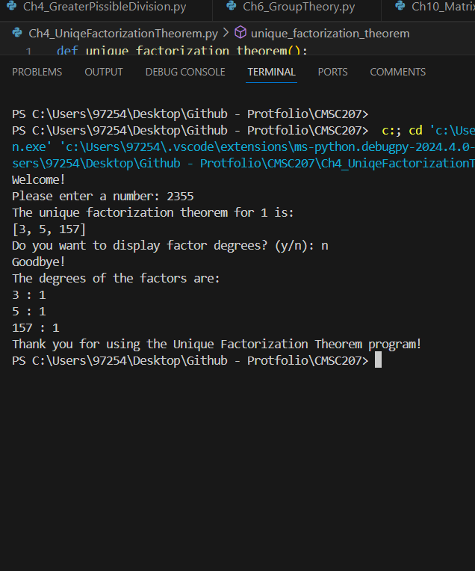

Ch6_GroupTheory

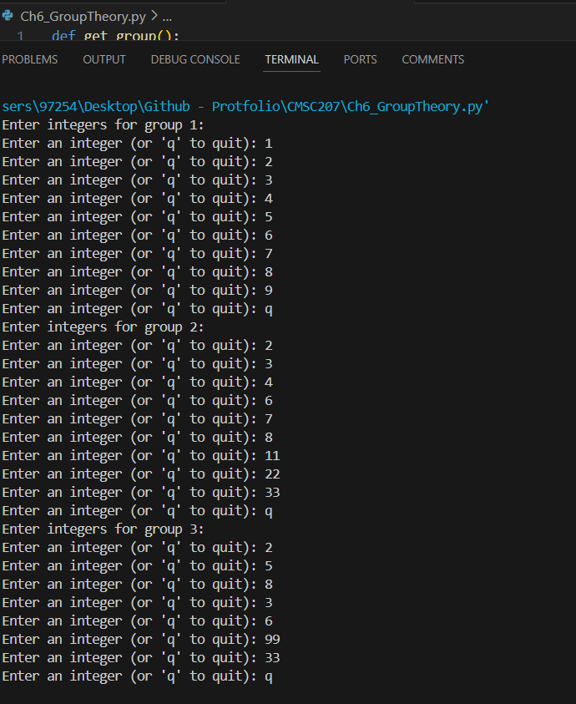

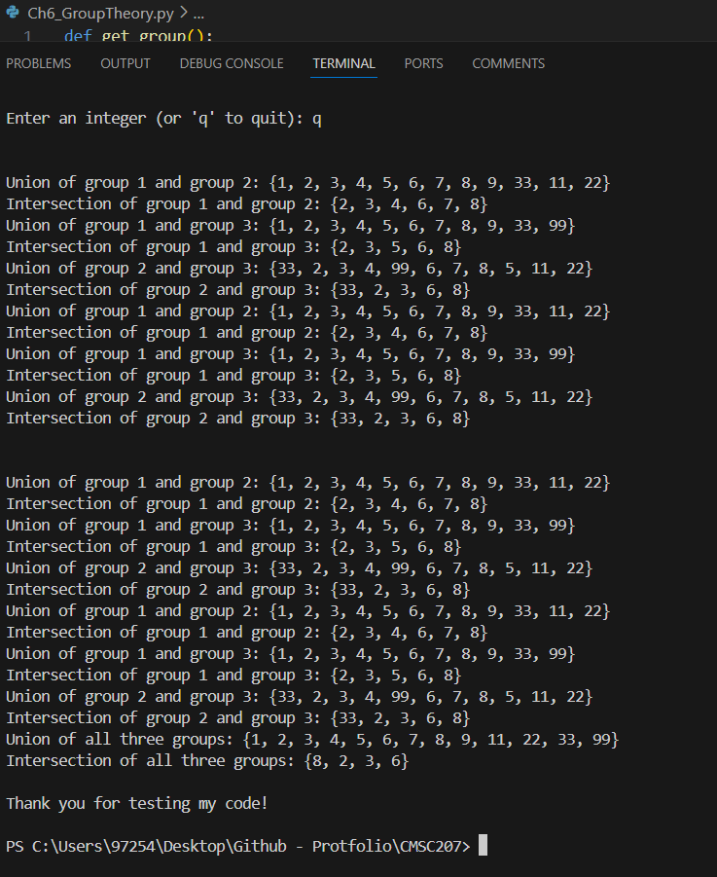

Ch9_Propability

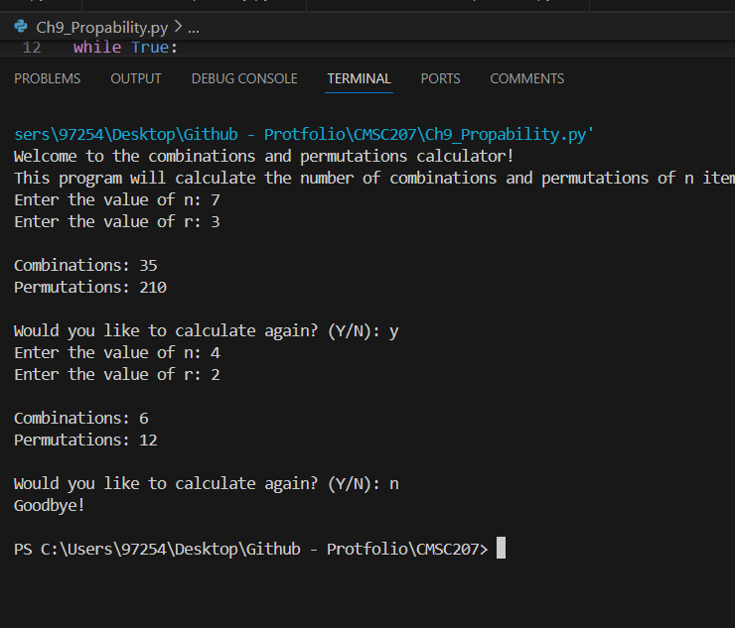

Ch10_MatrixMultiplication

