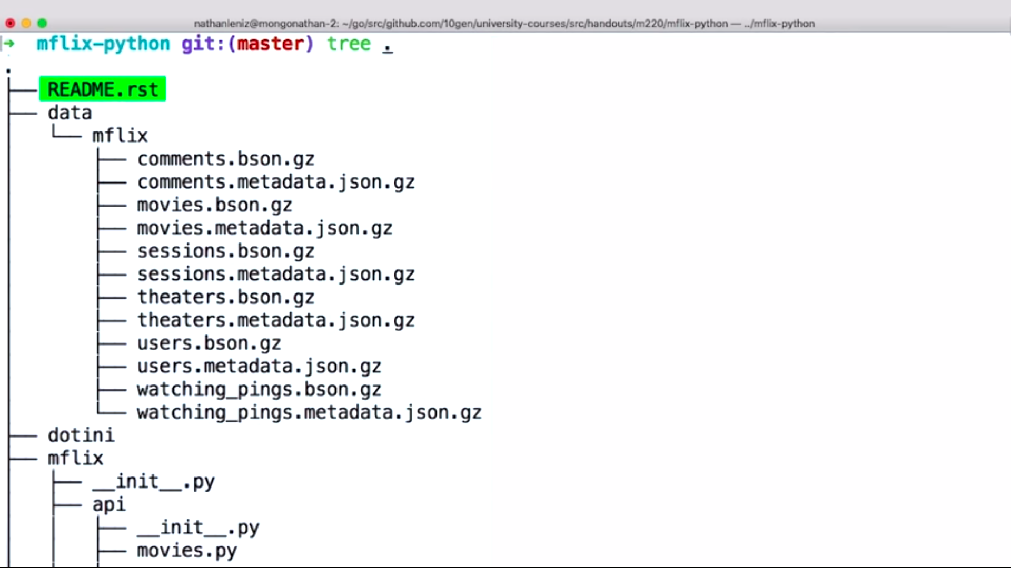

**Readme.rst-** Contains Detailed instructions for setting up environment and info about the layout of the project

**data directory**: contains all the source data we’ll be using for the mflix application

**dotini:** It will be modified and renamed by you in this course and contains info so that application can connect to your atlas cluster and other info the application will use internally

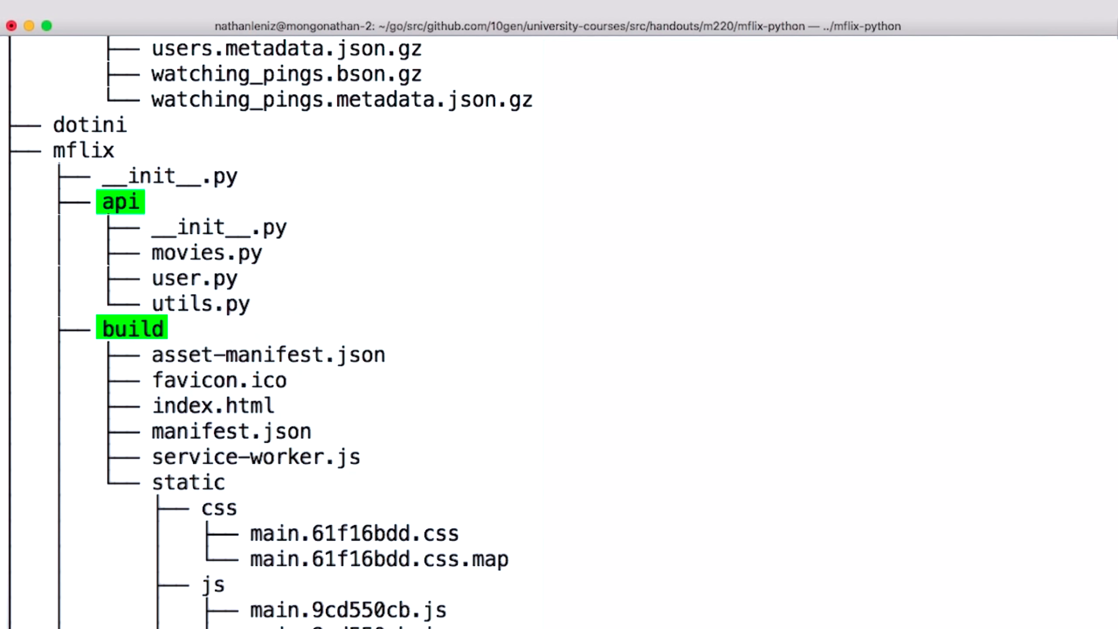

**mflix-> -api  
 -build**

api contains the flask root handlers for the applications,

Build contains the front-end application

Both are completed

Index.html needs to be edited some parts

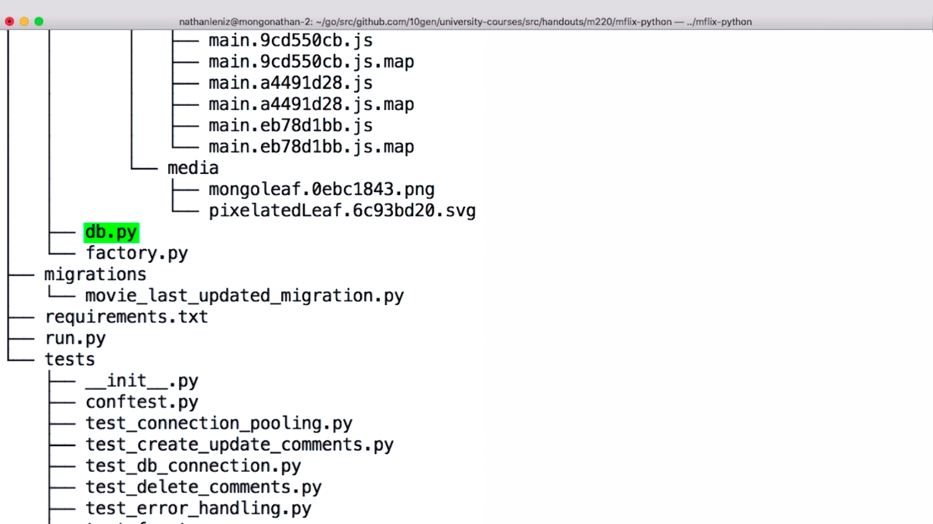

**db.py-** most effort will be focused, contains all methods interacts with the database.

**factory.py-**  contains the functionality that assembles the FOS application for running.,

**dont modify**

