Destiny Bazan
Module 2.3
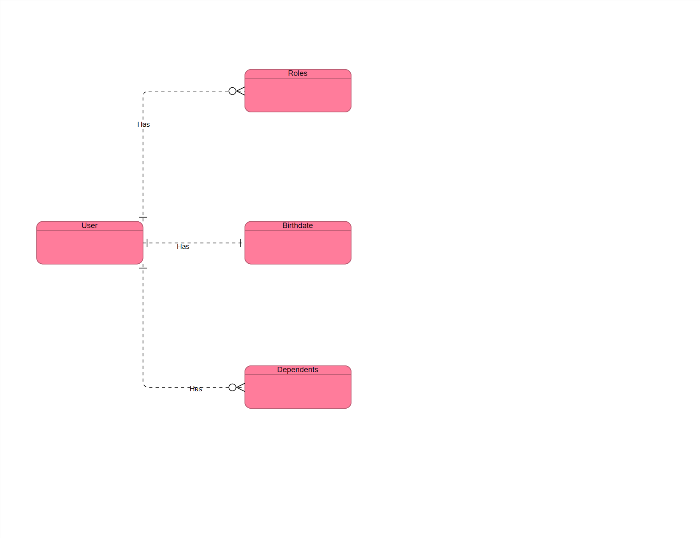

NoSQL
“first_name”: “Destiny”
“last_name": ”Bazan”
“Roles”:[
{
“type”: ”Student”
}
{
“type”: “ Manager“
}
]
“birthdate”: [
{
“month”: “”
“day”: “13”
“year”: “1996”
}
]

