**Tyler Moon**  
*Destiny Bazaan*  
*Cassainy Noel*

03/02/2025

Assignment 11.1

Output Pt.1  
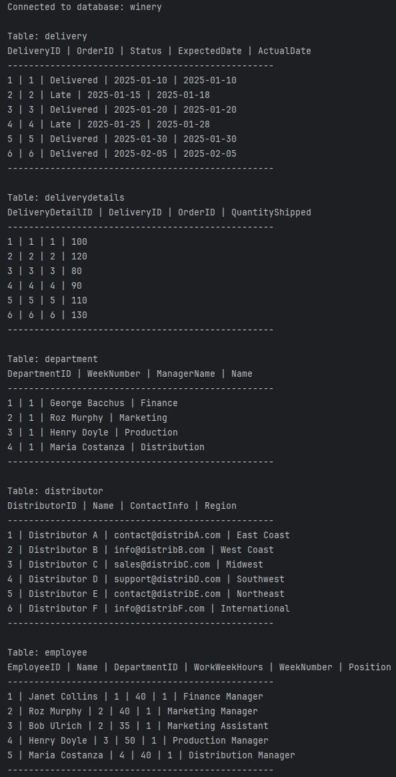

Output Pt.2

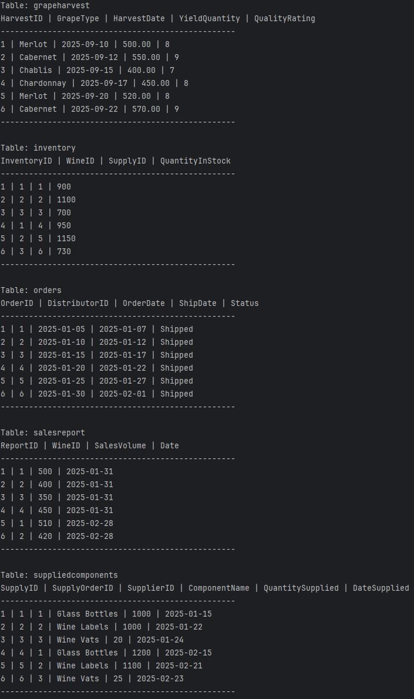

Output Pt.3

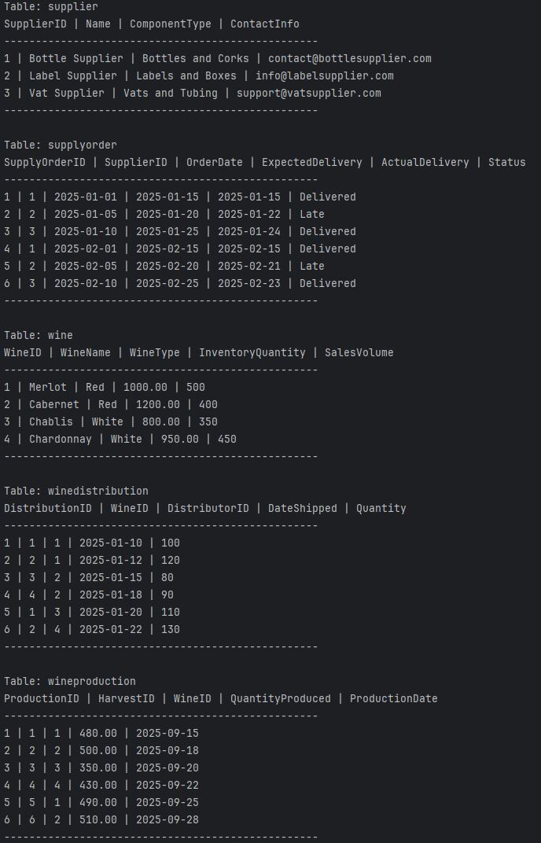

Output Pt.4 (reports)

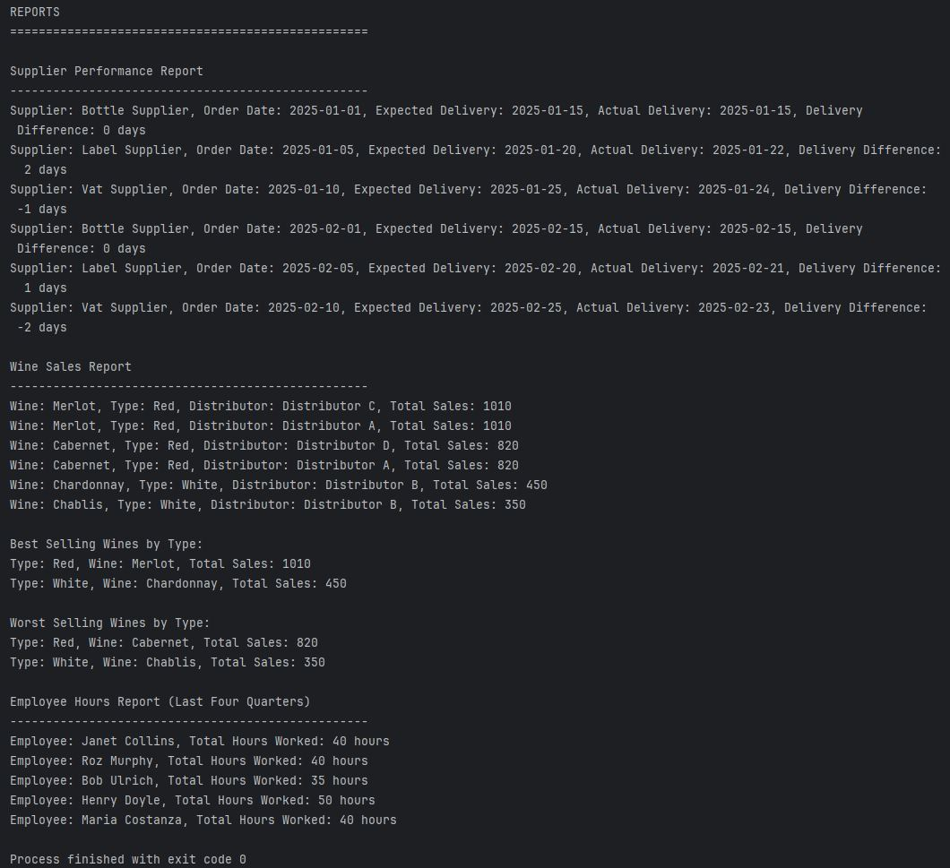

1. Employee Hours Report:  
   This report tracks the hours worked by employees, including the total hours worked during each week. It helps in payroll management, identifying trends in staffing needs, and ensuring that work hours are properly accounted for.
2. Wine Sales Report:  
   This report summarizes the sales data for each type of wine, displaying key metrics such as sales volume, revenue generated, and date of sale. It allows you to monitor the performance of different wine types over time, spot trends in consumer preferences, and adjust inventory levels or marketing strategies accordingly.
3. Supplier Performance Report:  
   This report evaluates the efficiency and reliability of each supplier, focusing on metrics such as delivery timelines (whether the actual delivery matches the expected delivery date), order fulfillment rates, and the quality of supplied components. It helps identify any potential issues with suppliers, track their consistency, and make informed decisions when renewing contracts or seeking alternative suppliers.