# ITWS 4500 – Spring 2017 - LAB 10 (</LABS>)

# **Lab 10 – Lets look at some of the data – Visualizations**

In this lab, we're going to continue the tweet processing from the previous ones (we know how much you like working with tweets) to do the following.

Now that we have a complete Web App – including the install:

* You are now going to add a ‘visualize’ button
* Once clicked – it should take you to a new page
* That page should show three data visualizations
* Your visualizations should show **the results of some analysis**
  + ie how many tweets from some location, or twitter user stats, or how many tweets from a certain device type (like the example below)?
  + Each visualization must represent some unique analysis
  + Be creative and have fun with it
* The user should have the ability to refresh the tweets – or maybe go live streaming? Or go get more periodically in batch? Or maybe subset the current result set with a new query? You may connect to your older functions – or not - Up to you – be creative!
* You may use any library you like from any of (or any other than) the following sources;
  + <http://www.chartjs.org/>
  + <http://selection.datavisualization.ch/>
  + <http://d3js.org/>
* Some inspiration can be found at [http://tweetping.net](http://tweetping.net/)
* An example of reading back the database and showing 1 chart using chart.js is shown here and included on LMS. Note that the example uses tweets from 2013, and you might get errors in the browser console related to ‘404 NOT FOUND’ resources such as profile pictures (users change theirs regularly and the links to those pictures change too) and some other minor errors.
* Site must be responsive
* Continue ‘branding’ your page
* Remember to communicate with your user
* Remember to give me a way back to the main page to start over
* Remember the README.md
* Have fun! This is your last chance to be creative this semester!

**You will be graded on the following:**

**Objective 1 – Analytics : 15**

**Objective 2 – Visualizations : 15**

**Creativity/Interface/Functionality : 15**

**Documentation/Read.me : 5**

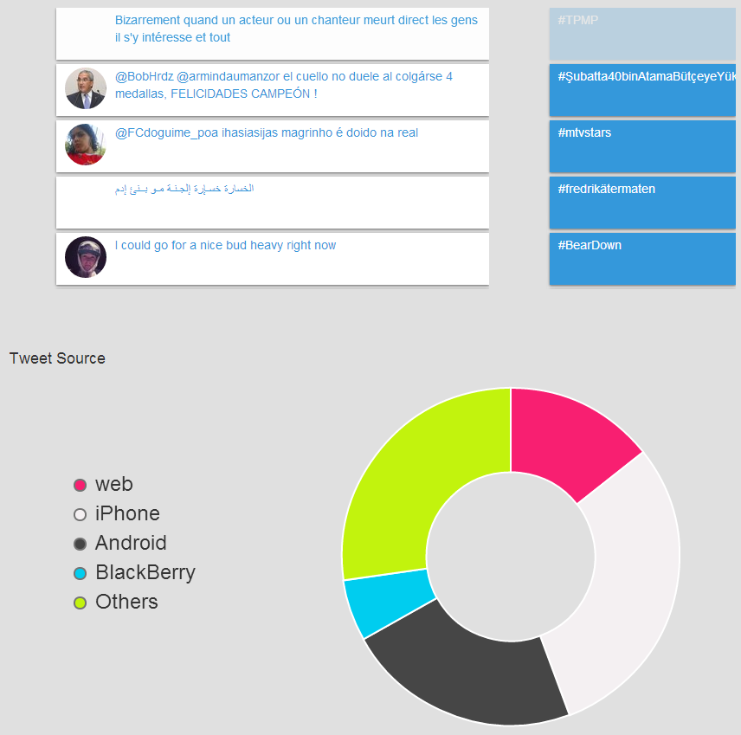

Congratulations on making it through the labs this semester!

</labs>