Create an account and sign up for a free 14-day trial

Click “Create” and from the drop-down menu select “Zaps”

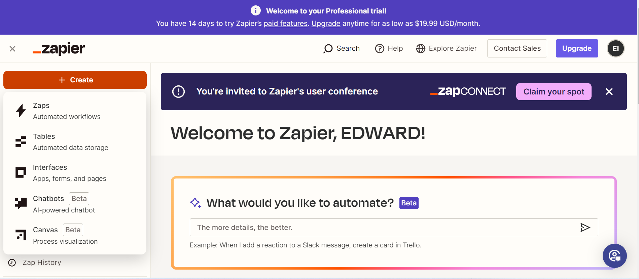

Click the “Trigger” box. This refers to an event that you want to trigger the Zap.

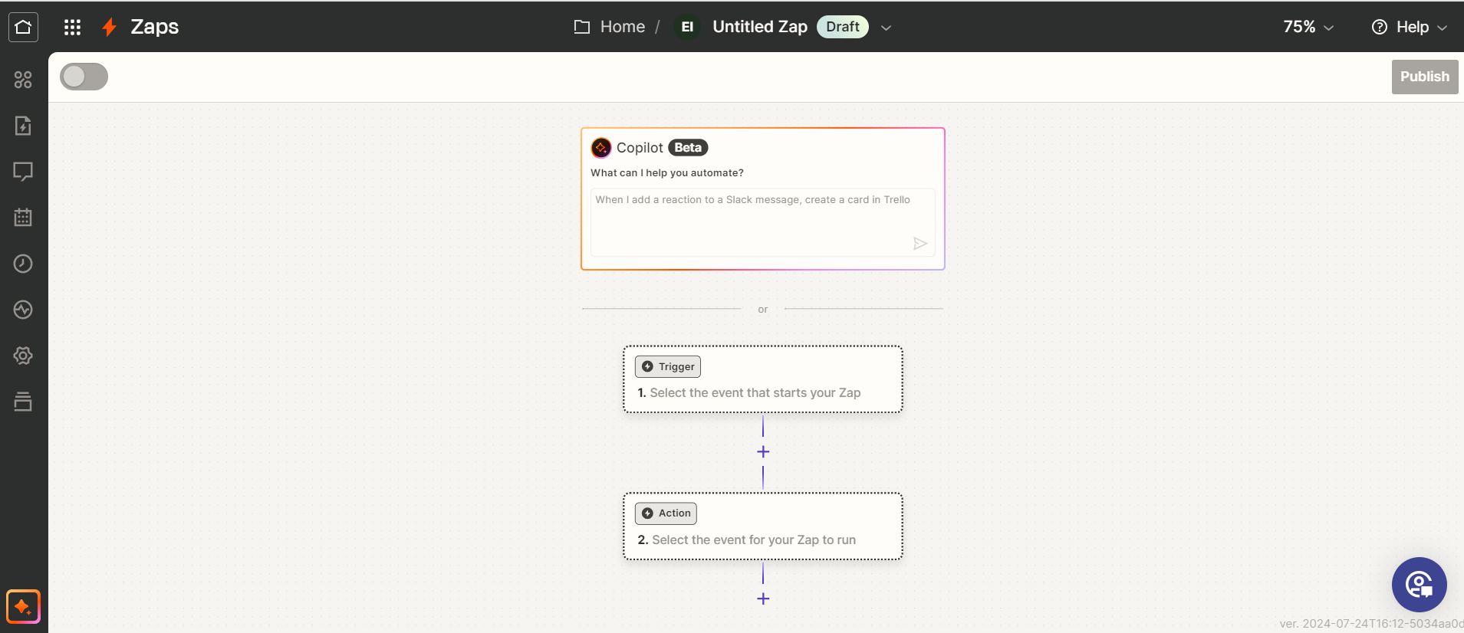

If using a feed from Adafruit to trigger you Zap, select or search for “Adafruit IO”

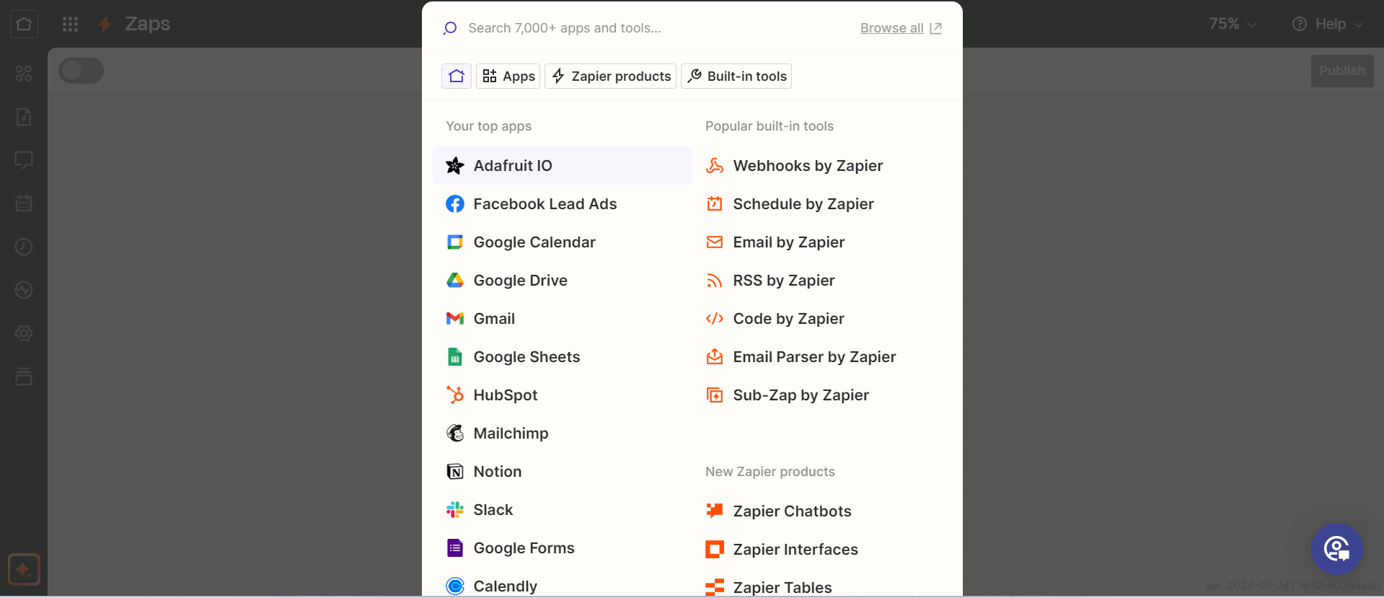

Select “Get Feed Data”

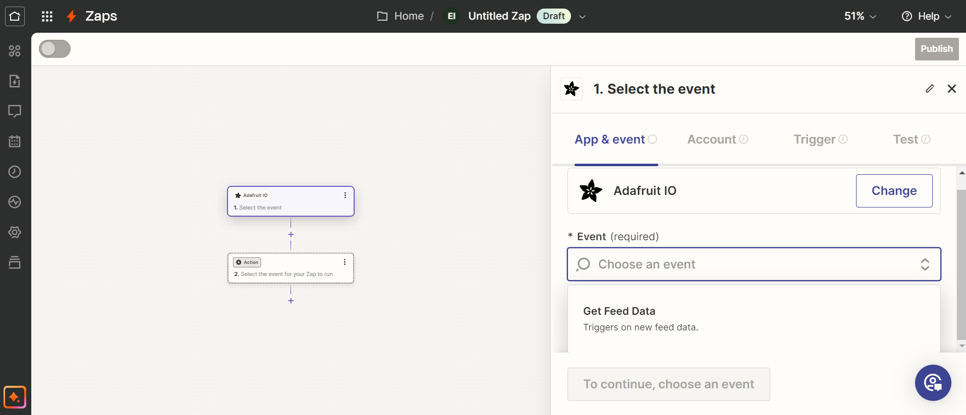

Enter your Adafruit username and key from the Adafruit.io account

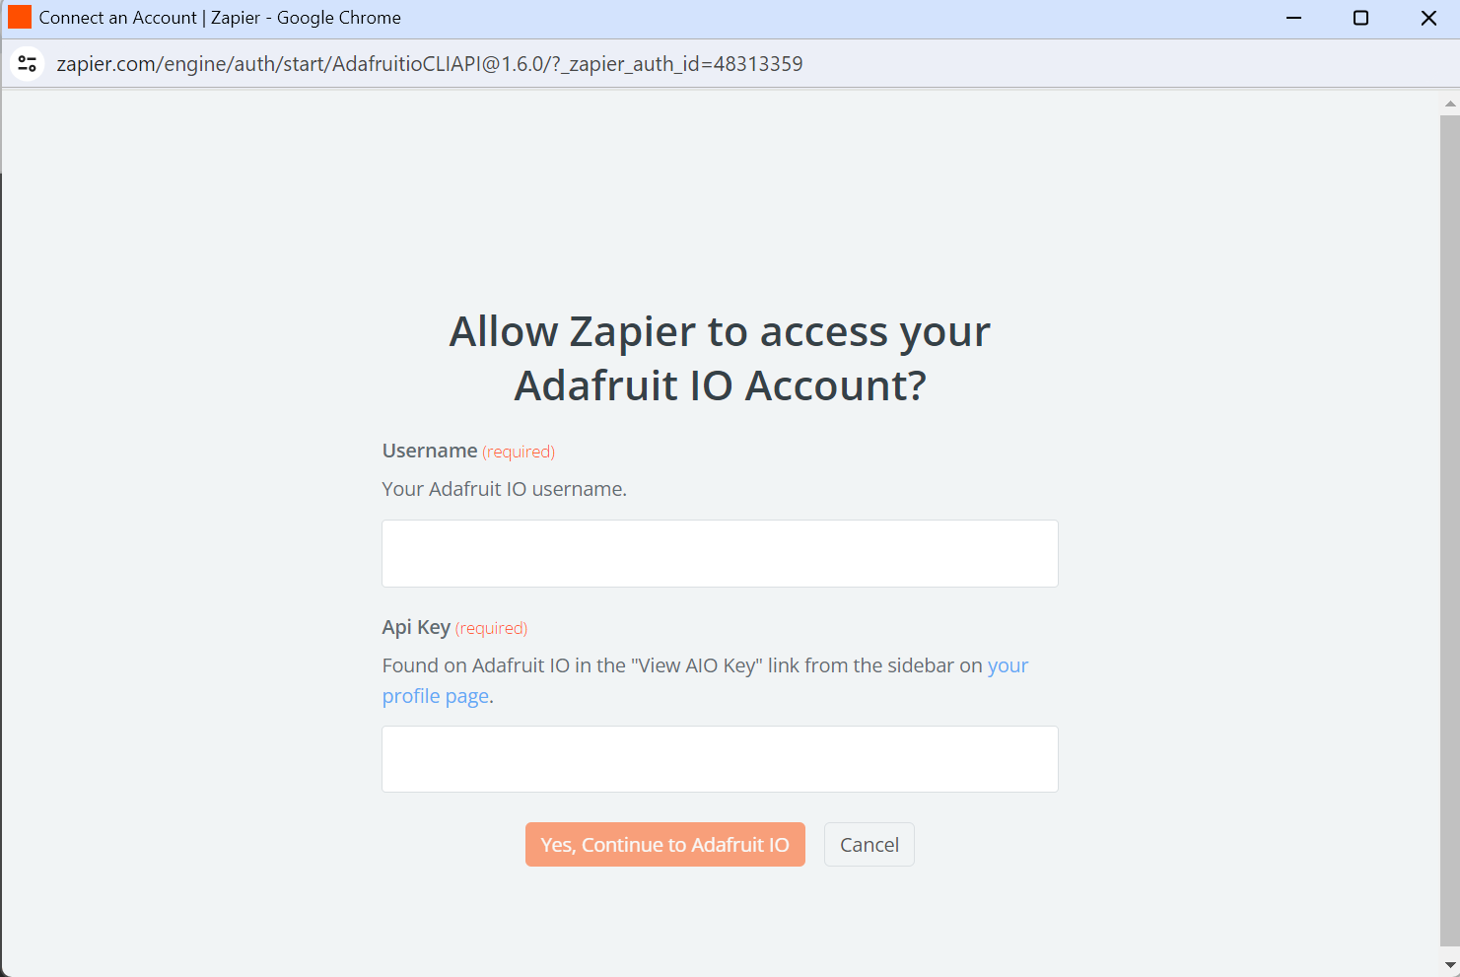

Once logged in, you should see your feeds populate on the right panel. If they don’t show up right away, try logging out and back into Zapier, or clicking the refresh button in the right panel, or entering the feed name manually by clicking “Custom” and typing JUST the feed name or /feed name.

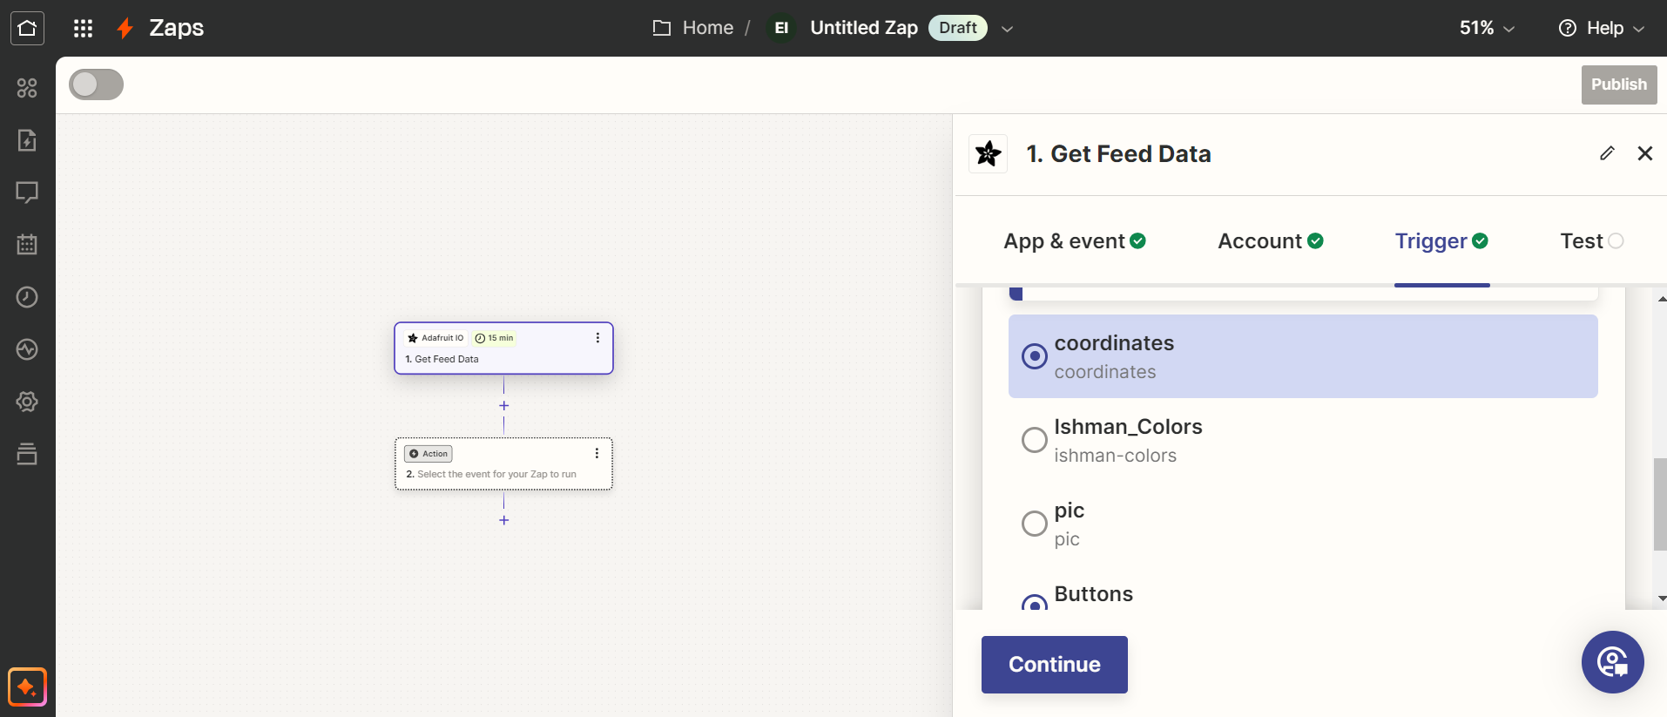

Test your trigger

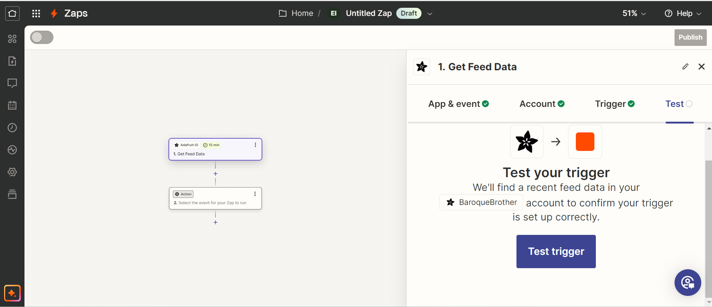

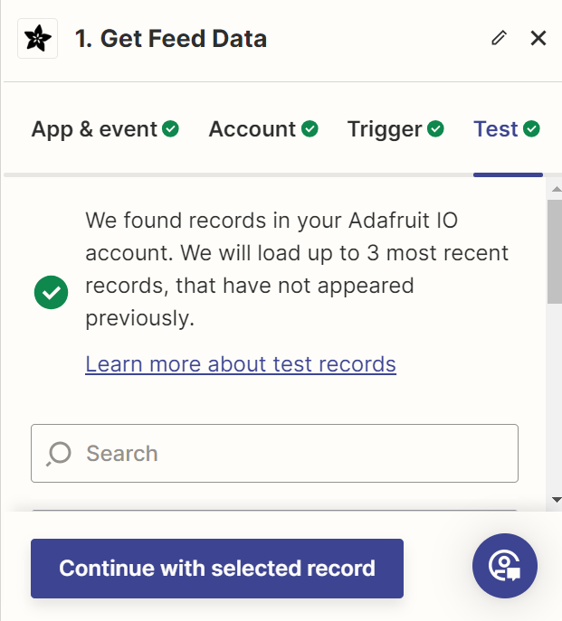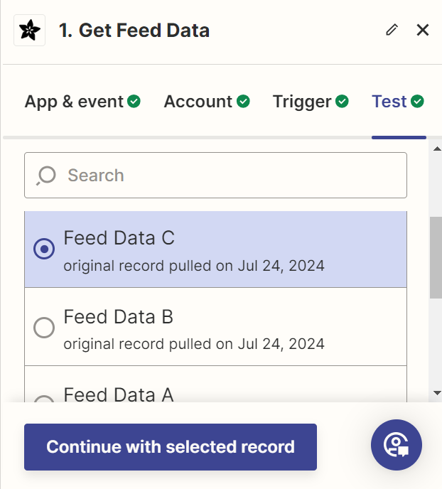

Next, select the “Action” box.

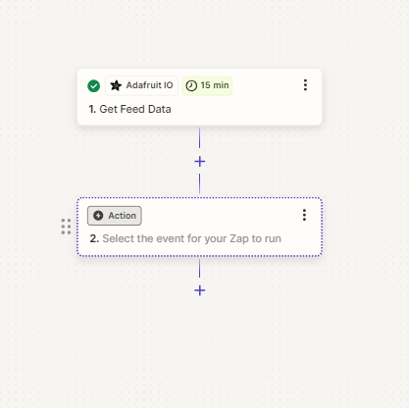

Set a condition for the trigger to activate. In this example, my trigger will activate only if the value from my feed is greater than 0.

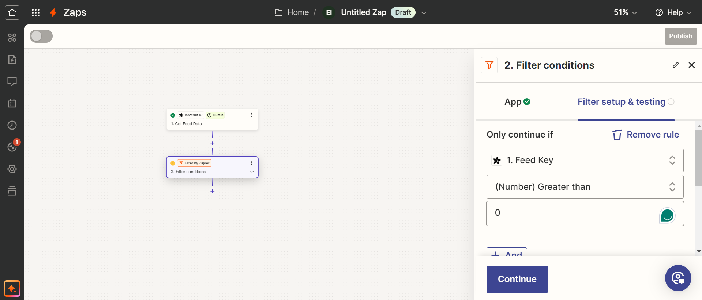

After setting up your condition select the third box. Within the “Built-In Tools” tab look for “Email by Zapier”

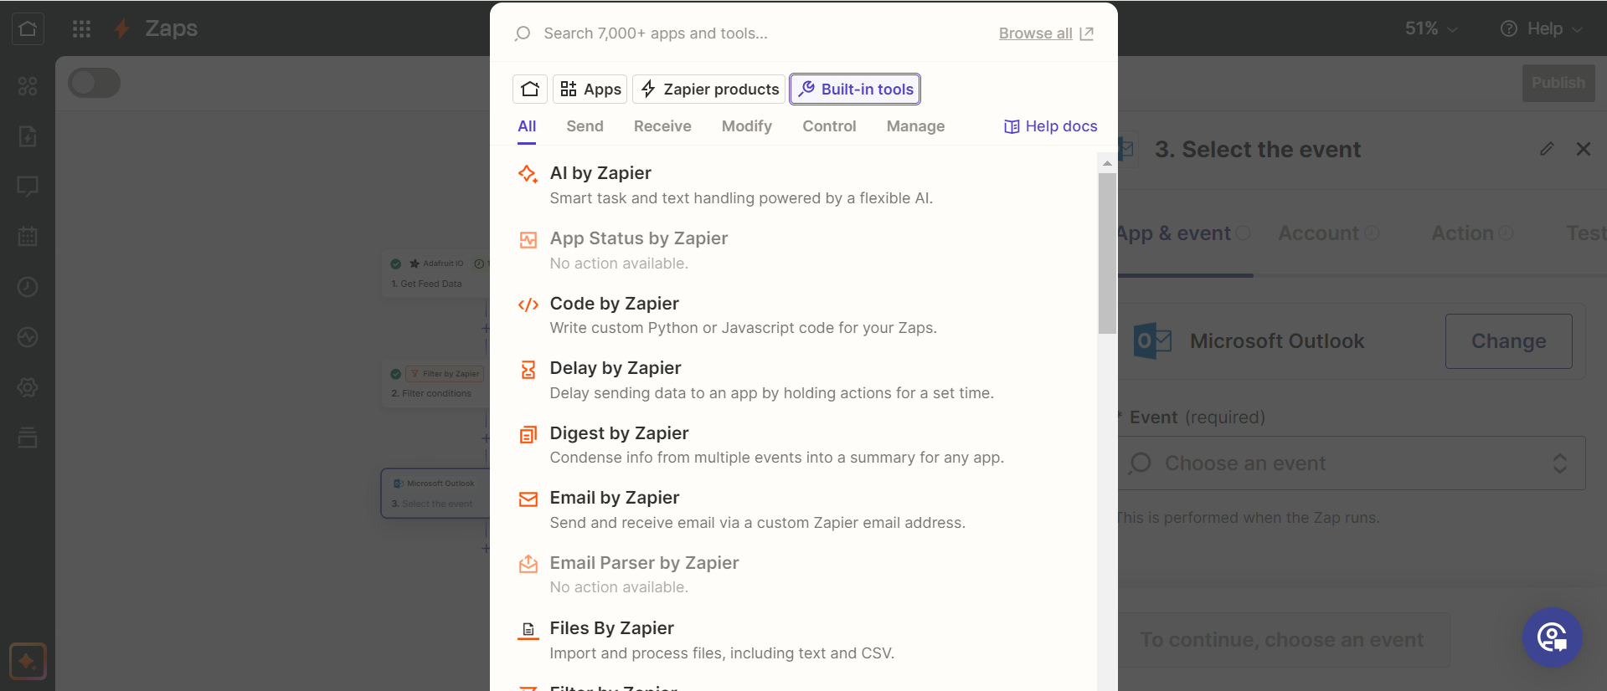

Select “Send Outbound Email”

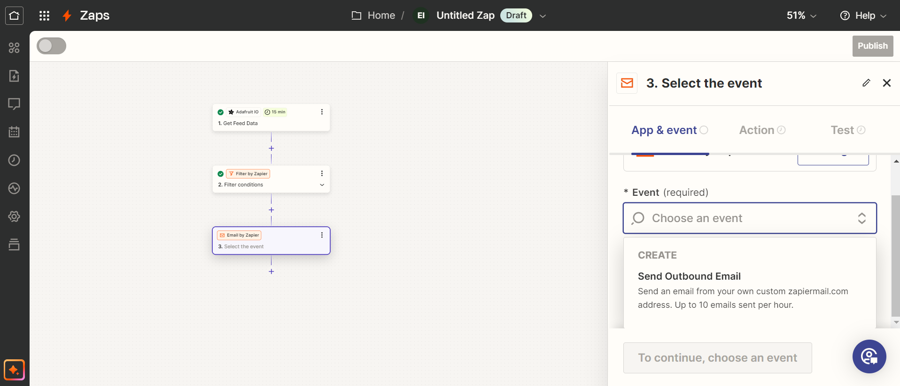

Enter the required (\*) information

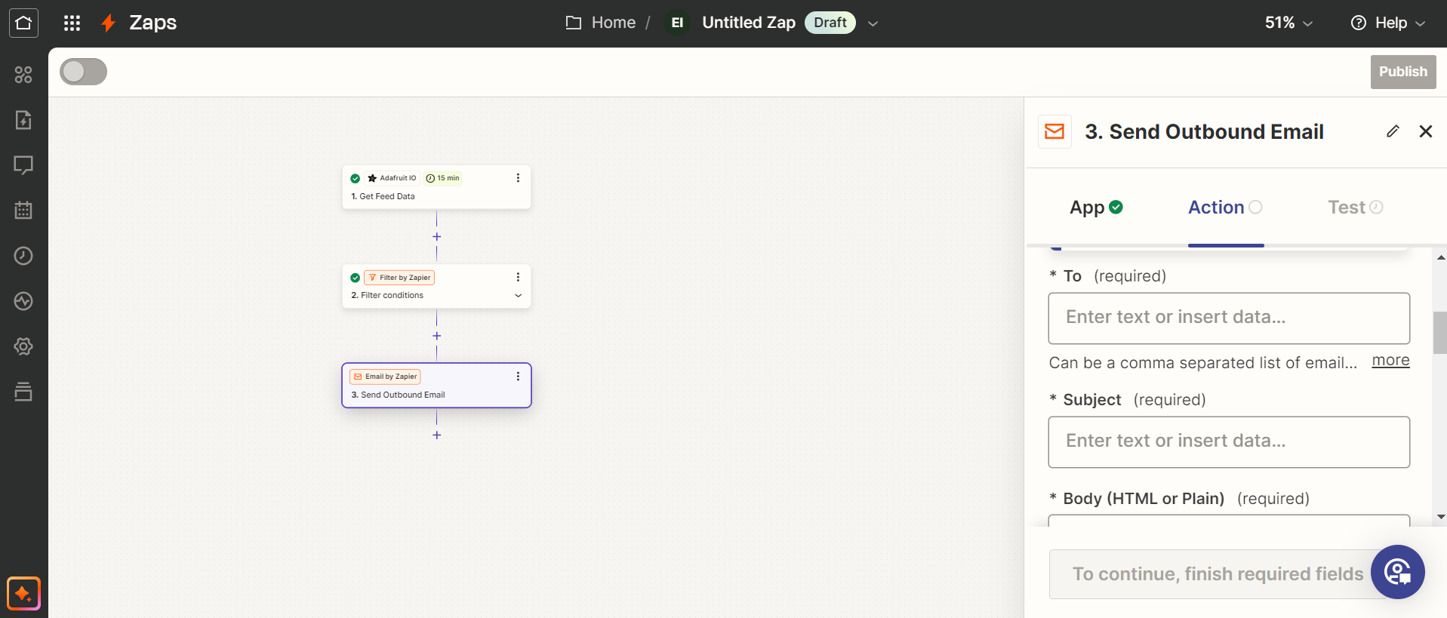

Lastly, test and publish your Zap!

