**How to Change Administrator Name via Advanced Control Panel**

You can also change a user’s account name with Advanced Control Panel, which can be accessed by certain commands. The option appears when you click on *Properties* of the chosen user.

1. **Press the Windows key and R simultaneously on your keyboard.** This will open the Run command tool.
2. **Type *netplwiz* in the Run command tool.**

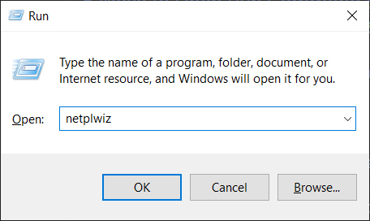

1. **Choose the account you would like to rename.**
2. **Then click Properties.**

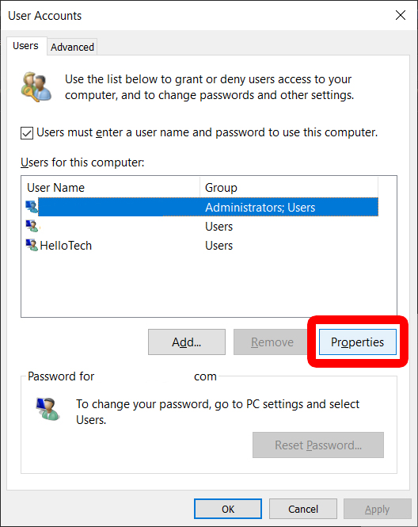

1. **Type a new username in the box under the General tab.**

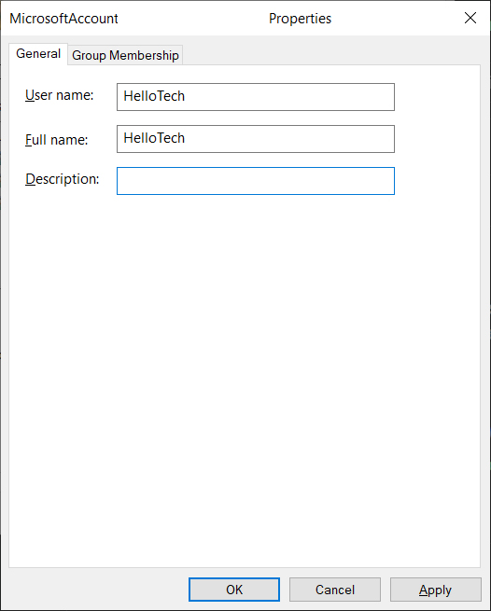

1. **Click OK.**
2. **Click OK again on the User Accounts Panel.**