**Computer and Robot Vision**

**Homework#6**

R01944040 柳成蔭

這次的作業是對原圖進行down sample，然後計算得到Yokoi connectivity number。

我使用VS2012編寫程式

先將binary的Lena圖從512x512 Downsample到64x64: 用8x8的 block作為一個unit, 選左上的pixel作為新64x64圖的pixel值。

|  |
| --- |
| //downsample  Mat imgDownSample(66,66,CV_8UC1,Scalar(0)); //the boundary is zero  for(int i=1; i<=imgDownSample.rows-2; i++)  {  for(int j=1; j<=imgDownSample.cols-2; j++)  { imgDownSample.at<uchar>(i,j)=imgBinary.at<uchar>(8*(i-1),8*(j-1));  }  } |

Down sample result：



1. Formula h

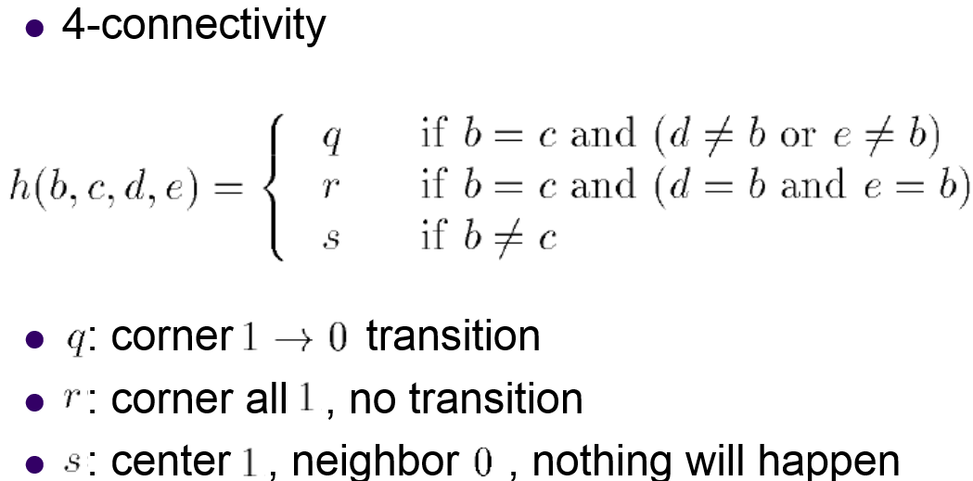

|  |
| --- |
| int h(int b, int c, int d, int e)  {  if( b==c && (d!=b || e!=b) )  return q;  else if( b==c && (d==b && c==b) )  return r;  else if(b!=c)  return s;  else  return -1;  } |

1. Formula f

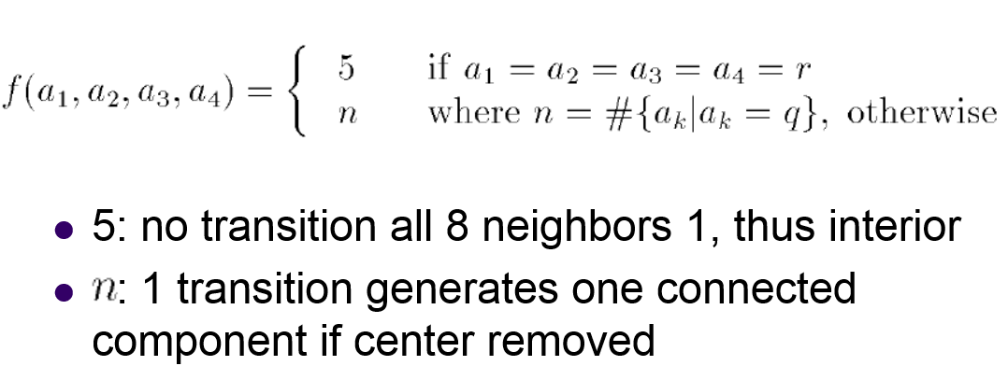

|  |
| --- |
| int f(int a1, int a2, int a3, int a4)  {  if(a1==r && a2==r && a3==r && a4==r)  return 5;  else  {  int n=0;  if(a1==q)  n++;  if(a2==q)  n++;  if(a3==q)  n++;  if(a4==q)  n++;  return n;  }  } |

1. Yokoi number

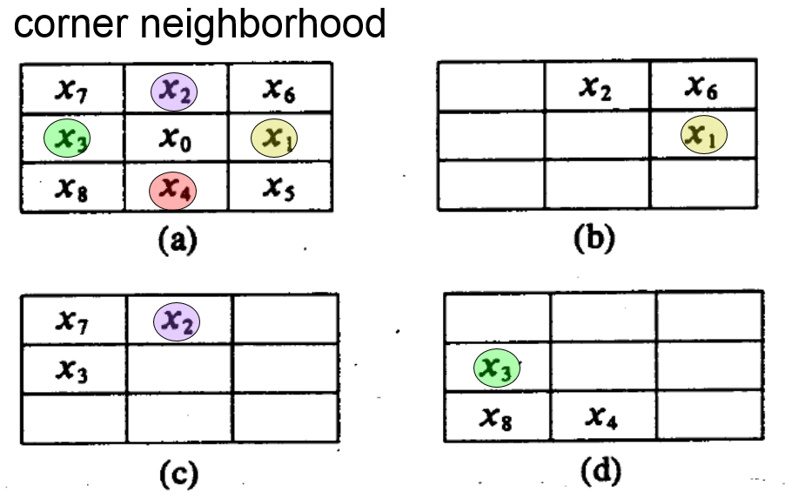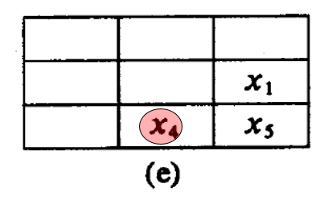

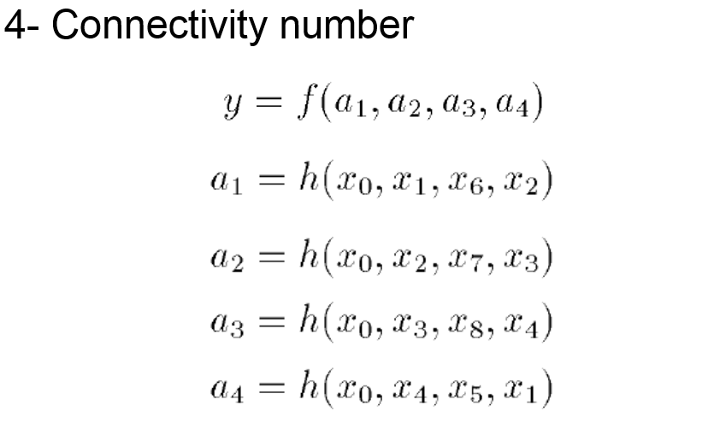

用Formula h來統計四個corner的連通值，用Formula f判斷中間點的Yokoi number。

|  |
| --- |
| int yokoi[64][64]={6};  int rows=64;  int cols=64;  for(int i=0; i<=rows-1; i++)  {  for(int j=0; j<=cols-1; j++)  {  if(imgDownSample.at<uchar>(i+1,j+1)==255)  {  int x[9];  x[0]=imgDownSample.at<uchar>(i+1,j+1);  x[1]=imgDownSample.at<uchar>(i+1,j+2);  x[2]=imgDownSample.at<uchar>(i,j+1);  x[3]=imgDownSample.at<uchar>(i+1,j);  x[4]=imgDownSample.at<uchar>(i+2,j+1);  x[5]=imgDownSample.at<uchar>(i+2,j+2);  x[6]=imgDownSample.at<uchar>(i,j+2);  x[7]=imgDownSample.at<uchar>(i,j);  x[8]=imgDownSample.at<uchar>(i+2,j);  int a1=h(x[0],x[1],x[6],x[2]);  int a2=h(x[0],x[2],x[7],x[3]);  int a3=h(x[0],x[3],x[8],x[4]);  int a4=h(x[0],x[4],x[5],x[1]);  yokoi[i][j]=f(a1,a2,a3,a4);  fout << yokoi[i][j];  }  else  fout << " ";  }  fout << "\n";  } |

最後將得到的Yokoi number記錄下來，結果單獨附在下頁。

