**Computer and Robot Vision**

**Homework#9**

R01944040 柳成蔭

這次的作業是對原圖做Edge Detection。

我使用VS2012編寫程式

1. Robert's Operator

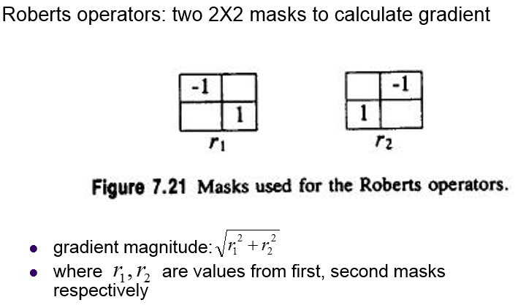

|  |
| --- |
| double RoberGradient( const Mat src, const Kernel Mask1, const Kernel Mask2, int sI, int sJ )  {  float gradient=0;  float r1=0;  float r2=0;  for (int MaskI = 0; MaskI <= Mask1.kRows-1; MaskI++)  {  for (int MaskJ = 0; MaskJ <= Mask1.kCols-1; MaskJ++)  {  int sX=sI+(MaskI-Mask1.anchorX);  int sY=sJ+(MaskJ-Mask1.anchorY);  if (sX>=0 && sX<=src.rows-1 &&  sY>=0 && sY<=src.cols-1)  {  r1=r1+(int)src.at<uchar>(sX,sY) * (float)Mask1.values.at<float>(MaskI, MaskJ);  r2=r2+(int)src.at<uchar>(sX,sY) * (float)Mask2.values.at<float>(MaskI, MaskJ);  }  else  return 0;  }  }  gradient=sqrt(r1*r1+r2*r2);  return gradient;  }  void Robert(const Mat src, Mat res, int threshold)  {  //kernal  float m1[]={-1, 0,  0, 1 };  Mat M1=Mat(2,2,CV_32F,m1).clone();  Kernel Mask1(2, 2, 0, 0, M1);  float m2[]={0,-1,  1,0 };  Mat M2=Mat(2,2,CV_32F,m2).clone();  Kernel Mask2(2, 2, 0, 0, M2);  float gradient;  for (int sI = 0; sI <= src.rows-1; sI++)  {  for (int sJ = 0; sJ <= src.cols-1; sJ++)  {  gradient=RoberGradient(src, Mask1, Mask2, sI, sJ);  if(gradient>=threshold)  res.at<uchar>(sI,sJ)=0;  else  res.at<uchar>(sI,sJ)=255;  }  }  } |

Threshold取12的處理結果：

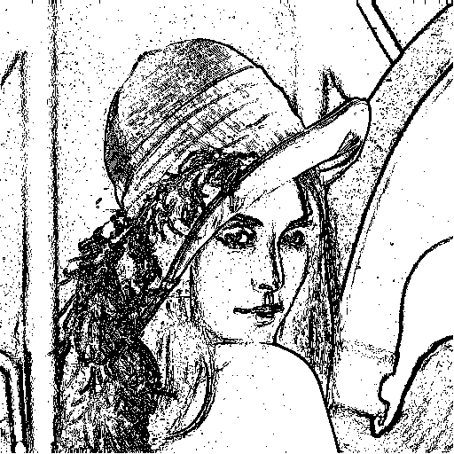

1. Prewitt's Edge Detector

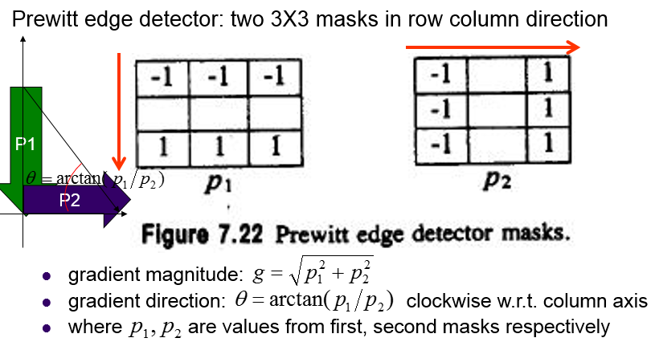

|  |
| --- |
| double PrewittGradient( const Mat src, const Kernel Mask1, const Kernel Mask2, int sI, int sJ )  {  float gradient=0;  float p1=0;  float p2=0;  for (int MaskI = 0; MaskI <= Mask1.kRows-1; MaskI++)  {  for (int MaskJ = 0; MaskJ <= Mask1.kCols-1; MaskJ++)  {  int sX=sI+(MaskI-Mask1.anchorX);  int sY=sJ+(MaskJ-Mask1.anchorY);  if (sX>=0 && sX<=src.rows-1 &&  sY>=0 && sY<=src.cols-1)  {  p1=p1+(int)src.at<uchar>(sX,sY) * (float)Mask1.values.at<float>(MaskI, MaskJ);  p2=p2+(int)src.at<uchar>(sX,sY) * (float)Mask2.values.at<float>(MaskI, MaskJ);  }  else  return 0;  }  }  gradient=sqrt(p1*p1+p2*p2);  return gradient;  }  void Prewitt(const Mat src, Mat res, int threshold)  {  //kernal  float m1[]={-1,-1,-1,  0, 0, 0,  1, 1, 1 };  Mat M1=Mat(3,3,CV_32F,m1).clone();  Kernel Mask1(3, 3, 1, 1, M1);  float m2[]={-1, 0, 1,  -1, 0, 1,  -1, 0, 1 };  Mat M2=Mat(3,3,CV_32F,m2).clone();  Kernel Mask2(3, 3, 1, 1, M2);  float gradient;  for (int sI = 0; sI <= src.rows-1; sI++)  {  for (int sJ = 0; sJ <= src.cols-1; sJ++)  {  gradient=PrewittGradient(src, Mask1, Mask2, sI, sJ);  if(gradient>=threshold)  res.at<uchar>(sI,sJ)=0;  else  res.at<uchar>(sI,sJ)=255;  }  }  } |

Threshold取24的處理結果：

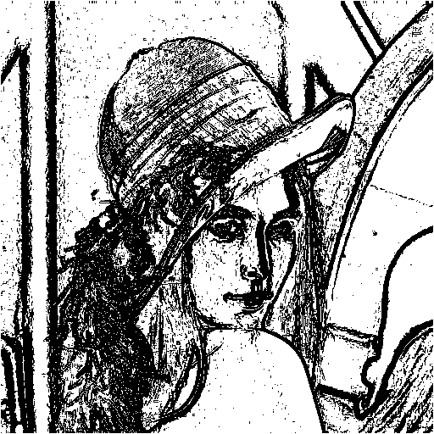

1. Sobel's Edge Detector

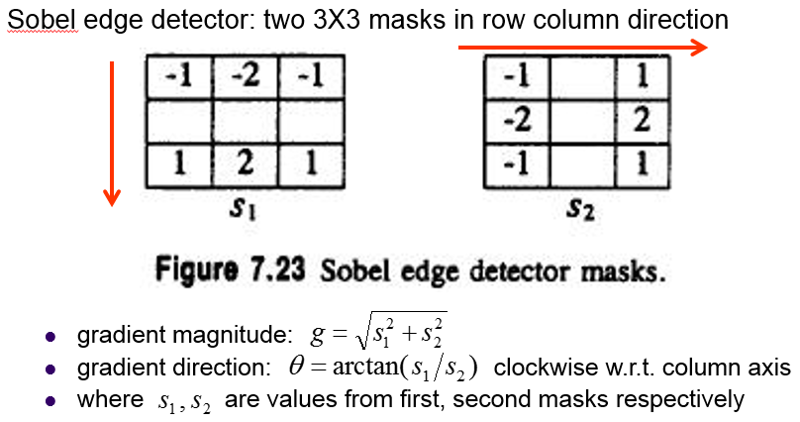

|  |
| --- |
| double SobelGradient( const Mat src, const Kernel Mask1, const Kernel Mask2, int sI, int sJ )  {  float gradient=0;  float s1=0;  float s2=0;  for (int MaskI = 0; MaskI <= Mask1.kRows-1; MaskI++)  {  for (int MaskJ = 0; MaskJ <= Mask1.kCols-1; MaskJ++)  {  int sX=sI+(MaskI-Mask1.anchorX);  int sY=sJ+(MaskJ-Mask1.anchorY);  if (sX>=0 && sX<=src.rows-1 &&  sY>=0 && sY<=src.cols-1)  {  s1=s1+(int)src.at<uchar>(sX,sY) * (float)Mask1.values.at<float>(MaskI, MaskJ);  s2=s2+(int)src.at<uchar>(sX,sY) * (float)Mask2.values.at<float>(MaskI, MaskJ);  }  else  return 0;  }  }  gradient=sqrt(s1*s1+s2*s2);  return gradient;  }  void Sobel(const Mat src, Mat res, int threshold)  {  //kernal  float m1[]={-1,-2,-1,  0, 0, 0,  1, 2, 1 };  Mat M1=Mat(3,3,CV_32F,m1).clone();  Kernel Mask1(3, 3, 1, 1, M1);  float m2[]={-1, 0, 1,  -2, 0, 2,  -1, 0, 1 };  Mat M2=Mat(3,3,CV_32F,m2).clone();  Kernel Mask2(3, 3, 1, 1, M2);  float gradient;  for (int sI = 0; sI <= src.rows-1; sI++)  {  for (int sJ = 0; sJ <= src.cols-1; sJ++)  {  gradient=SobelGradient(src, Mask1, Mask2, sI, sJ);  if(gradient>=threshold)  res.at<uchar>(sI,sJ)=0;  else  res.at<uchar>(sI,sJ)=255;  }  }  } |

Threshold取38的處理結果：

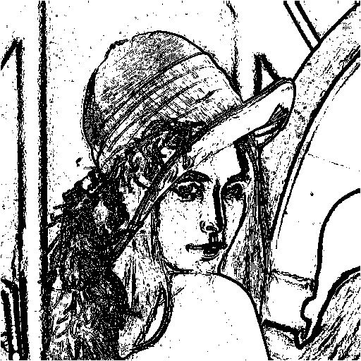

1. Frei and Chen's Gradient Operator

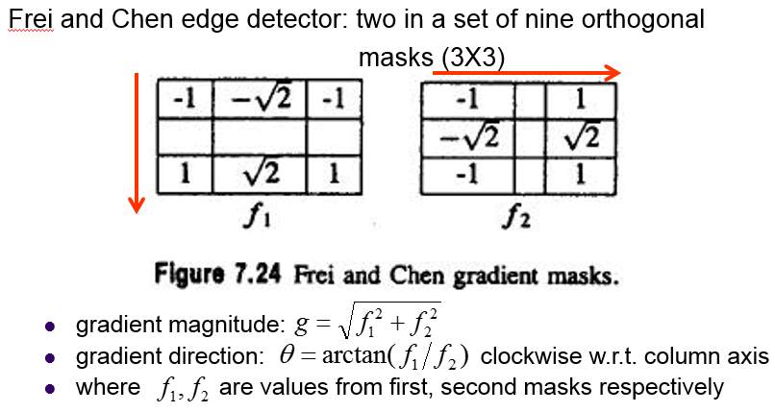

|  |
| --- |
| double FreiChenGradient( const Mat src, const Kernel Mask1, const Kernel Mask2, int sI, int sJ )  {  float gradient=0;  float f1=0;  float f2=0;  for (int MaskI = 0; MaskI <= Mask1.kRows-1; MaskI++)  {  for (int MaskJ = 0; MaskJ <= Mask1.kCols-1; MaskJ++)  {  int sX=sI+(MaskI-Mask1.anchorX);  int sY=sJ+(MaskJ-Mask1.anchorY);  if (sX>=0 && sX<=src.rows-1 &&  sY>=0 && sY<=src.cols-1)  {  f1=f1+(int)src.at<uchar>(sX,sY) * (float)Mask1.values.at<float>(MaskI, MaskJ);  f2=f2+(int)src.at<uchar>(sX,sY) * (float)Mask2.values.at<float>(MaskI, MaskJ);  }  else  return 0;  }  }  gradient=sqrt(f1*f1+f2*f2);  return gradient;  }  void FreiChen(const Mat src, Mat res, int threshold)  {  //kernal  float m1[]={-1,-sqrt(2),-1,  0, 0, 0,  1, sqrt(2), 1 };  Mat M1=Mat(3,3,CV_32F,m1).clone();  Kernel Mask1(3, 3, 1, 1, M1);  float m2[]={ -1, 0, 1,  -sqrt(2), 0, sqrt(2),  -1, 0, 1 };  Mat M2=Mat(3,3,CV_32F,m2).clone();  Kernel Mask2(3, 3, 1, 1, M2);  float gradient;  for (int sI = 0; sI <= src.rows-1; sI++)  {  for (int sJ = 0; sJ <= src.cols-1; sJ++)  {  gradient=FreiChenGradient(src, Mask1, Mask2, sI, sJ);  if(gradient>=threshold)  res.at<uchar>(sI,sJ)=0;  else  res.at<uchar>(sI,sJ)=255;  }  }  } res.at<uchar>(sI,sJ)=0;  else  res.at<uchar>(sI,sJ)=255;  }  }  } |

Threshold取30的處理結果：

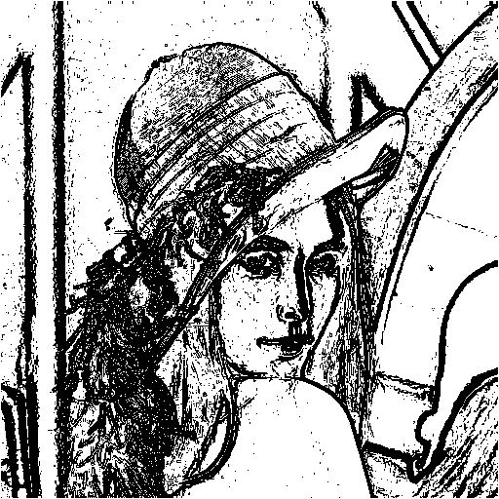

1. Kirsch's Compass Operator

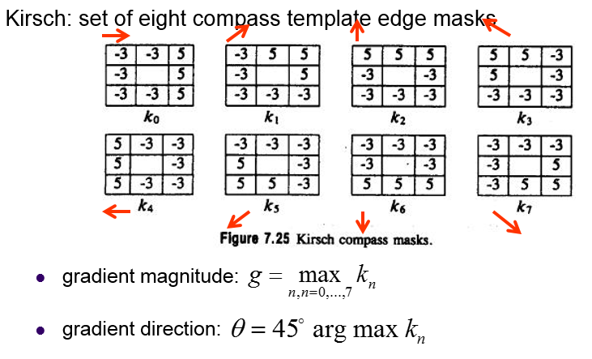

|  |
| --- |
| double KirschGradient( const Mat src, const vector<Mat> M, int sI, int sJ )  {  float gradient=0;  float *k;  k=new float(M.size());  for (int i = 0; i <= M.size()-1; i++)  {  Kernel Mask(M[i].rows, M[i].cols, (M[i].rows+1)/2-1, (M[i].rows+1)/2-1, M[i]);  k[i]=0;  for (int MaskI = 0; MaskI <= Mask.kRows-1; MaskI++)  {  for (int MaskJ = 0; MaskJ <= Mask.kCols-1; MaskJ++)  {  int sX=sI+(MaskI-Mask.anchorX);  int sY=sJ+(MaskJ-Mask.anchorY);  if (sX>=0 && sX<=src.rows-1 &&  sY>=0 && sY<=src.cols-1)  {  k[i]=k[i]+(int)src.at<uchar>(sX,sY) * (float)Mask.values.at<float>(MaskI, MaskJ);  }  else  return 0;  }  }  }    gradient=ArrayMax(k, M.size());  //cout<<gradient<<endl;  //waitKey();  return gradient;  }  void Kirsch(const Mat src, Mat res, int threshold)  {  //kernal  vector<Mat> M;  float m0[]={-3,-3, 5, -3, 0, 5, -3,-3, 5 };  Mat M0(3,3,CV_32F, m0); //Mat M0=Mat(3,3,CV_32F,m0).clone();  M.push_back(M0);  //Kernel Mask0(3, 3, 1, 1, M0);    float m1[]={-3, 5, 5, -3, 0, 5, -3,-3,-3 };  Mat M1=Mat(3,3,CV_32F,m1).clone();  M.push_back(M1);  float m2[]={5,5, 5, -3, 0, -3, -3,-3,-3 };  Mat M2=Mat(3,3,CV_32F,m2).clone();  M.push_back(M2);  float m3[]={5,5, -3, 5, 0, -3, -3,-3, -3 };  Mat M3=Mat(3,3,CV_32F,m3).clone();  M.push_back(M3);  float m4[]={5,-3, -3, 5, 0, -3, 5,-3, -3 };  Mat M4=Mat(3,3,CV_32F,m4).clone();  M.push_back(M4);  float m5[]={-3,-3, -3, 5, 0, -3, 5,5, -3 };  Mat M5=Mat(3,3,CV_32F,m5).clone();  M.push_back(M5);  float m6[]={-3,-3, -3, -3, 0, -3, 5, 5, 5 };  Mat M6=Mat(3,3,CV_32F,m6).clone();  M.push_back(M6);  float m7[]={-3,-3, -3, -3, 0, 5, -3, 5, 5 };  Mat M7=Mat(3,3,CV_32F,m7).clone();  M.push_back(M7);  float gradient;  for (int sI = 0; sI <= src.rows-1; sI++)  {  for (int sJ = 0; sJ <= src.cols-1; sJ++)  {  gradient=KirschGradient(src, M, sI, sJ);  if(gradient>=threshold)  res.at<uchar>(sI,sJ)=0;  else  res.at<uchar>(sI,sJ)=255;  }  }  } |

Threshold取135的處理結果：

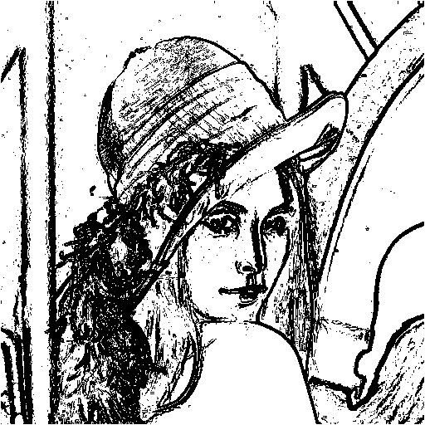

1. Robinson's Compass Operator

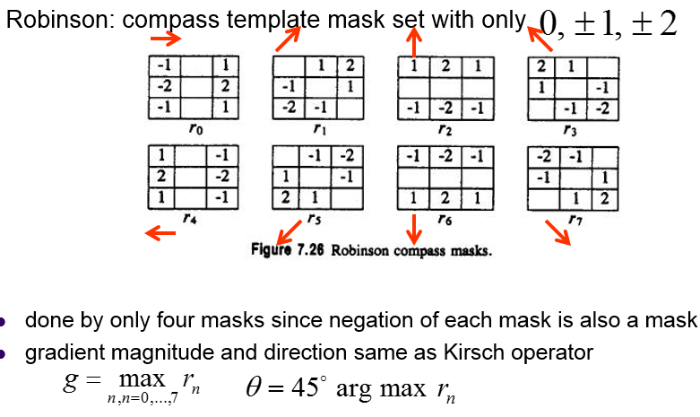

|  |
| --- |
| double RobinsonGradient( const Mat src, const vector<Mat> M, int sI, int sJ )  {  float gradient=0;  float *r;  r=new float(M.size());  for (int i = 0; i <= M.size()-1; i++)  {  Kernel Mask(M[i].rows, M[i].cols, (M[i].rows+1)/2-1, (M[i].rows+1)/2-1, M[i]);  r[i]=0;  for (int MaskI = 0; MaskI <= Mask.kRows-1; MaskI++)  {  for (int MaskJ = 0; MaskJ <= Mask.kCols-1; MaskJ++)  {  int sX=sI+(MaskI-Mask.anchorX);  int sY=sJ+(MaskJ-Mask.anchorY);  if (sX>=0 && sX<=src.rows-1 &&  sY>=0 && sY<=src.cols-1)  {  r[i]=r[i]+(int)src.at<uchar>(sX,sY) * (float)Mask.values.at<float>(MaskI, MaskJ);  }  else  return 0;  }  }  }    gradient=ArrayMax(r, M.size());  //cout<<gradient<<endl;  //waitKey();  return gradient;  }  void Robinson(const Mat src, Mat res, int threshold)  {  //kernal  vector<Mat> M;  float m0[]={-1,0,1,-2,0,2,-1,0,1};  Mat M0(3,3,CV_32F, m0); //Mat M0=Mat(3,3,CV_32F,m0).clone();  M.push_back(M0);  //Kernel Mask0(3, 3, 1, 1, M0);    float m1[]={0,1,2,-1,0,1,-2,-1,0};  Mat M1=Mat(3,3,CV_32F,m1).clone();  M.push_back(M1);  float m2[]={1,2,1,0,0,0,-1,-2,-1};  Mat M2=Mat(3,3,CV_32F,m2).clone();  M.push_back(M2);  float m3[]={2,1,0,1,0,-1,0,-1,-2};  Mat M3=Mat(3,3,CV_32F,m3).clone();  M.push_back(M3);  float m4[]={1,0,-1,2,0,-2,1,0,-1};  Mat M4=Mat(3,3,CV_32F,m4).clone();  M.push_back(M4);  float m5[]={0,-1,-2,1,0,-1,2,1,0};  Mat M5=Mat(3,3,CV_32F,m5).clone();  M.push_back(M5);  float m6[]={-1,-2,-1,0,0,0,1,2,1};  Mat M6=Mat(3,3,CV_32F,m6).clone();  M.push_back(M6);  float m7[]={-2,-1,0,-1,0,1,0,1,2};  Mat M7=Mat(3,3,CV_32F,m7).clone();  M.push_back(M7);  float gradient;  for (int sI = 0; sI <= src.rows-1; sI++)  {  for (int sJ = 0; sJ <= src.cols-1; sJ++)  {  gradient=RobinsonGradient(src, M, sI, sJ);  if(gradient>=threshold)  res.at<uchar>(sI,sJ)=0;  else  res.at<uchar>(sI,sJ)=255;  }  }  } |

Threshold取43的處理結果：

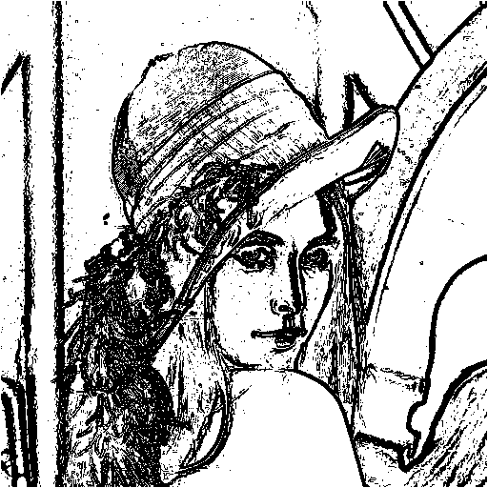

1. Nevatia-Babu 5x5 Operator

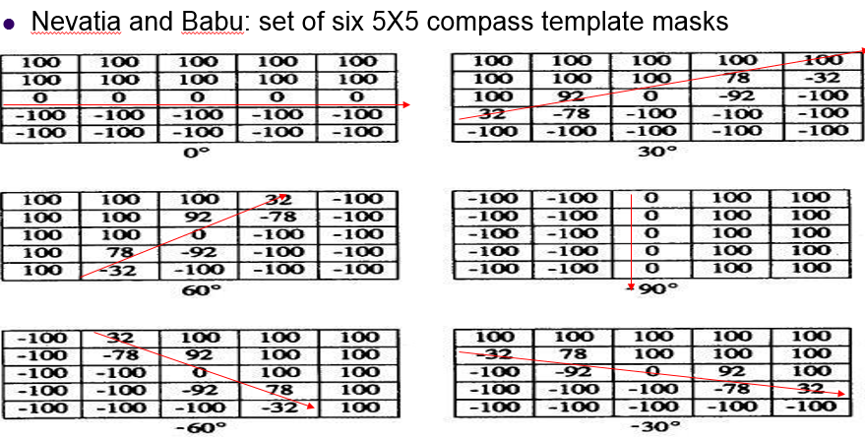

|  |
| --- |
| double NevatiaBabuGradient( const Mat src, const vector<Mat> M, int sI, int sJ )  {  float gradient=0;  float *r;  r=new float(M.size());  for (int i = 0; i <= M.size()-1; i++)  {  Kernel Mask(M[i].rows, M[i].cols, (M[i].rows+1)/2-1, (M[i].rows+1)/2-1, M[i]);  r[i]=0;  for (int MaskI = 0; MaskI <= Mask.kRows-1; MaskI++)  {  for (int MaskJ = 0; MaskJ <= Mask.kCols-1; MaskJ++)  {  int sX=sI+(MaskI-Mask.anchorX);  int sY=sJ+(MaskJ-Mask.anchorY);  if (sX>=0 && sX<=src.rows-1 &&  sY>=0 && sY<=src.cols-1)  {  r[i]=r[i]+(int)src.at<uchar>(sX,sY) * (float)Mask.values.at<float>(MaskI, MaskJ);  }  else  return 0;  }  }  }    gradient=ArrayMax(r, M.size());  //cout<<gradient<<endl;  //waitKey();  return gradient;  }  void NevatiaBabu(const Mat src, Mat res, int threshold)  {  //kernal  vector<Mat> M;  float m0[]={100,100,100,100,100,  100,100,100,100,100,  0,0,0,0,0,  -100,-100,-100,-100,-100,  -100,-100,-100,-100,-100 };  Mat M0(5,5,CV_32F, m0); //Mat M0=Mat(3,3,CV_32F,m0).clone();  M.push_back(M0);    float m1[]={100,100,100,100,100,  100,100,100,78,-32,  100,92,0,-92,-100,  32,-78,-100,-100,-100,  -100,-100,-100,-100,-100 };  Mat M1(5,5,CV_32F, m1);  M.push_back(M1);  float m2[]={100,100,100,32,-100,  100,100,92,-78,-100,  100,100,0,-100,-100,  100,78,-92,-100,-100,  100,-32,-100,-100,-100 };  Mat M2(5,5,CV_32F, m2);  M.push_back(M2);  float m3[]={-100,-100,0,100,100,  -100,-100,0,100,100,  -100,-100,0,100,100,  -100,-100,0,100,100,  -100,-100,0,100,100 };  Mat M3(5,5,CV_32F, m3);  M.push_back(M3);  float m4[]={-100,32,100,100,100,  -100,-78,92,100,100,  -100,-100,0,100,100,  -100,-100,-92,78,100,  -100,-100,-100,-32,100 };  Mat M4(5,5,CV_32F, m4);  M.push_back(M4);  float m5[]={100,100,100,100,100,  -32,78,100,100,100,  -100,-92,0,92,100,  -100,-100,-100,-78,32,  -100,-100,-100,-100,-100 };  Mat M5(5,5,CV_32F, m5);  M.push_back(M5);  float gradient;  for (int sI = 0; sI <= src.rows-1; sI++)  {  for (int sJ = 0; sJ <= src.cols-1; sJ++)  {  gradient=NevatiaBabuGradient(src, M, sI, sJ);  if(gradient>=threshold)  res.at<uchar>(sI,sJ)=0;  else  res.at<uchar>(sI,sJ)=255;  }  }  } |

Threshold取12500的處理結果：

