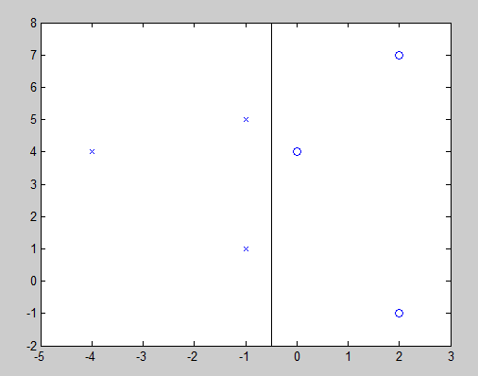

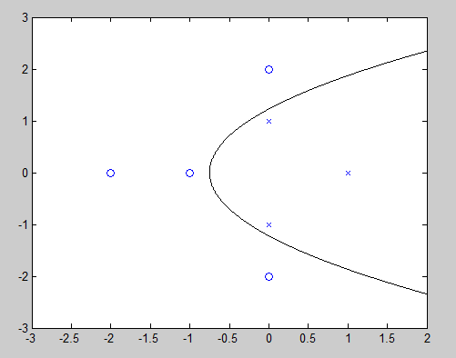

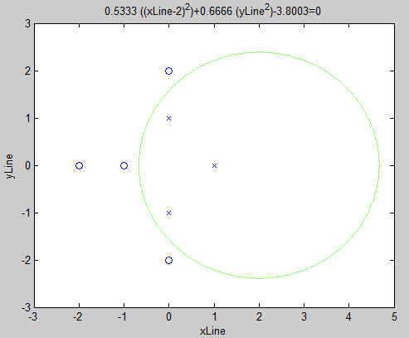

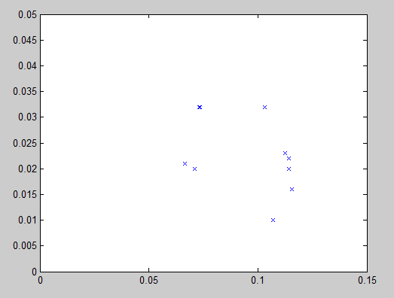

|  |  |  |  |
| --- | --- | --- | --- |
| C $$σ$$ | 0.001 | 1 | 1000 |
| 0.125 | $$E_{in}=41.6\%$$ $$E_{cv}=41.60\%$$ $$\frac{\#SV}{N}=100\%$$ | $$E_{in}=0\%$$ $$E_{cv}=41.6\%$$ $$\frac{\#SV}{N}=100\%$$ | $$E_{in}=0\%$$ $$E_{cv}=41.6\%$$ $$\frac{\#SV}{N}=100\%$$ |
| 0.5 | $$E_{in}=41.6\%$$ $$E_{cv}=41.6\%$$ $$\frac{\#SV}{N}=84.0\%$$ | $$E_{in}=0\%$$ $$E_{cv}=41.6\%$$ $$\frac{\#SV}{N}=100\%$$ | $$E_{in}=0\%$$ $$E_{cv}=41.6\%$$ $$\frac{\#SV}{N}=100\%$$ |
| 2 |  |  |  |

|  |  |  |  |
| --- | --- | --- | --- |
| C $$σ$$ | 0.001 | 1 | 1000 |
| 0.125 | $$E_{in}=41.6\%$$ $$E_{cv}=41.6\%$$ $$\frac{\#SV}{N}=100\%$$ | $$E_{in}=0\%$$ $$E_{cv}=41.6\%$$ $$\frac{\#SV}{N}=100\%$$ | $$E_{in}=0\%$$ $$E_{cv}=41.6\%$$ $$\frac{\#SV}{N}=100\%$$ |
| 0.5 | $$E_{in}=41.6\%$$ $$E_{cv}=41.6\%$$ $$\frac{\#SV}{N}=84.0\%$$ | $$E_{in}=0\%$$ $$E_{cv}=41.6\%$$ $$\frac{\#SV}{N}=100\%$$ | $$E_{in}=0\%$$ $$E_{cv}=41.6\%$$ $$\frac{\#SV}{N}=100\%$$ |
| 2 |  |  |  |

|  |  |  |  |
| --- | --- | --- | --- |
|  | 0.001 | 1 | 1000 |
| 0.125 | $$E_{in}=41.6\%$$ $$E_{cv}=41.6\%$$ $$\frac{\#SV}{N}=100\%$$ | $$E_{in}=0\%$$ $$E_{cv}=41.6\%$$ $$\frac{\#SV}{N}=100\%$$ | $$E_{in}=0\%$$ $$E_{cv}=41.6\%$$ $$\frac{\#SV}{N}=100\%$$ |
| 0.5 | $$E_{in}=41.6\%$$ $$E_{cv}=41.6\%$$ $$\frac{\#SV}{N}=84.0\%$$ | $$E_{in}=0\%$$ $$E_{cv}=41.6\%$$ $$\frac{\#SV}{N}=100\%$$ | $$E_{in}=0\%$$ $$E_{cv}=41.6\%$$ $$\frac{\#SV}{N}=100\%$$ |
| 2 | $$E_{in}=41.6\%$$ $$E_{cv}=41.6\%$$ $$\frac{\#SV}{N}=84.4\%$$ | $$E_{in}=12.6\%$$ $$E_{cv}=39.8\%$$ $$\frac{\#SV}{N}=95.0\%$$ | $$E_{in}=0\%$$ $$E_{cv}=47.20\%$$ $$\frac{\#SV}{N}=93.4\%$$ |