对成像数据进行分析

通过spm_fNIRS 工具箱中的 spm_fnirs_con2d 函数，对所有的数据转换成标准的 NIfTI-1 格式。随后使用 RNifti 包进行读取。

#install.packages("devtools")  
#devtools::install_github("jonclayden/RNifti")  
library(RNifti)  
library(tidyverse)

## Loading tidyverse: ggplot2  
## Loading tidyverse: tibble  
## Loading tidyverse: tidyr  
## Loading tidyverse: readr  
## Loading tidyverse: purrr  
## Loading tidyverse: dplyr

## Conflicts with tidy packages ----------------------------------------------

## filter(): dplyr, stats  
## lag(): dplyr, stats

library(stringr)  
library(R.matlab)

## R.matlab v3.6.1 (2016-10-19) successfully loaded. See ?R.matlab for help.

##   
## Attaching package: 'R.matlab'

## The following objects are masked from 'package:base':  
##   
## getOption, isOpen

extract_fNIRS_beta <- function(filename) {  
 beta_data <- readMat(filename)$S[1,,]$cbeta  
 return(beta_data)  
}  
  
# 计算多个个体nii文件的均值矩阵  
mean_group_nii <- function(nii_list) {  
 dim_single <- dim(nii_list[[1]])  
 file_num <- length(nii_list)  
 dim_array <- c(dim_single, file_num)  
 total_array <- array(dim = dim_array)  
 for(i in 1:length(nii_list)){  
 total_array[,,i] <- matrix(as.numeric(nii_list[[i]]), nrow = dim_single[1], ncol = dim_single[2])  
 }  
  
 mean_matrix <- apply(total_array, MARGIN = 1:2, mean)  
  
 return(mean_matrix)  
}

## 实验1

### 成像数据

读取数据进行分析

test1_nii <- dir("../../../Dropbox/毕业设计/实验数据/仪器数据/SPM处理结果/test1/", include.dirs = T, recursive = T)  
test1_nii <- test1_nii[stringr::str_detect(test1_nii, pattern = "nii")]  
test1_nii <- paste0("../../../Dropbox/毕业设计/实验数据/仪器数据/SPM处理结果/test1/", test1_nii)  
test1_con_01 <- test1_nii[stringr::str_detect(test1_nii, pattern = "con_0001.nii")]  
test1_con_02 <- test1_nii[stringr::str_detect(test1_nii, pattern = "con_0002.nii")]  
test1_con_03 <- test1_nii[stringr::str_detect(test1_nii, pattern = "con_0003.nii")]  
  
test1_con_01_images <- readNifti(test1_con_01)  
test1_con_02_images <- readNifti(test1_con_02)  
test1_con_03_images <- readNifti(test1_con_03)  
  
image(mean_group_nii(test1_con_01_images))

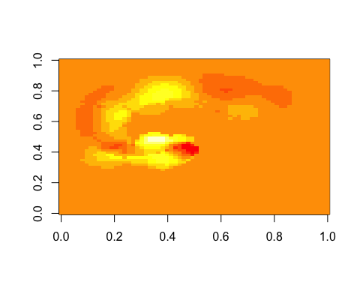

image(mean_group_nii(test1_con_02_images))

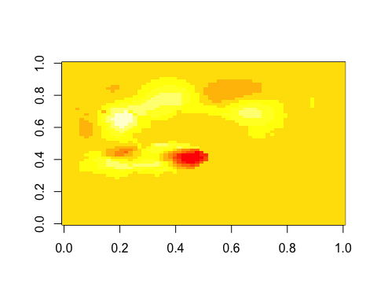

image(mean_group_nii(test1_con_03_images))

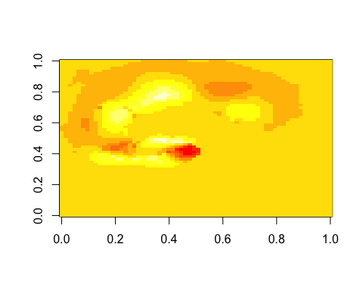

doctor_nii <- dir("../../../Dropbox/毕业设计/实验数据/仪器数据/SPM处理结果/doctor/", include.dirs = T, recursive = T)  
doctor_nii <- doctor_nii[stringr::str_detect(doctor_nii, pattern = "nii")]  
doctor_nii <- paste0("../../../Dropbox/毕业设计/实验数据/仪器数据/SPM处理结果/doctor/", doctor_nii)  
doctor_con_01 <- doctor_nii[stringr::str_detect(doctor_nii, pattern = "con_0001.nii")]  
doctor_con_02 <- doctor_nii[stringr::str_detect(doctor_nii, pattern = "con_0002.nii")]  
doctor_con_03 <- doctor_nii[stringr::str_detect(doctor_nii, pattern = "con_0003.nii")]  
  
doctor_con_01_images <- readNifti(doctor_con_01)  
doctor_con_02_images <- readNifti(doctor_con_02)  
doctor_con_03_images <- readNifti(doctor_con_03)  
  
image(mean_group_nii(doctor_con_01_images))

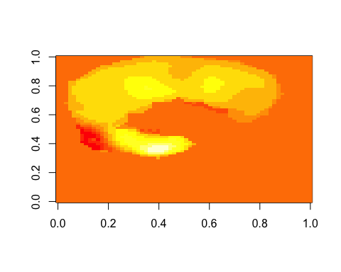

image(mean_group_nii(doctor_con_02_images))

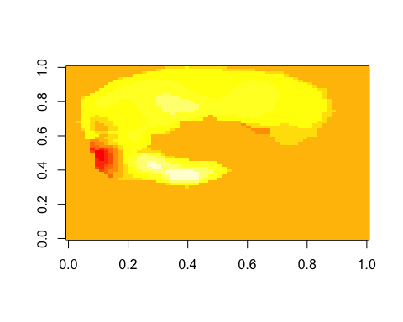

image(mean_group_nii(doctor_con_03_images))

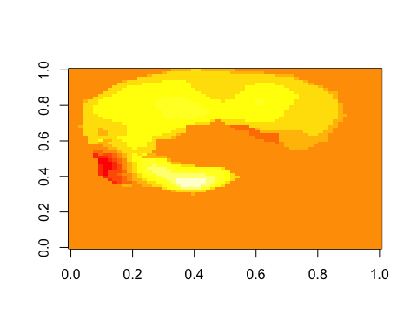

### 组间的假设检验

#普通专业被试的 Block2 的 beta 值  
test1_doctor_files <- dir("/Users/eXrld/Dropbox/毕业设计/实验数据/仪器数据/SPM处理结果/test1", include.dirs = T, recursive = T)  
test1_doctor_con2 <- test1_doctor_files[stringr::str_detect(test1_doctor_files, pattern = "con_0002.mat")]  
test1_doctor_con2 <- paste0("/Users/eXrld/Dropbox/毕业设计/实验数据/仪器数据/SPM处理结果/test1/", test1_doctor_con2)  
  
test1_normal_beta <- matrix(NA, ncol = length(extract_fNIRS_beta(test1_doctor_con2[1])), nrow = length(test1_doctor_con2))  
for(i in 1:length(test1_doctor_con2)){  
 test1_normal_beta[i,] <- extract_fNIRS_beta(test1_doctor_con2[i])  
}  
  
#医学专业被试的 Block2 的 beta 值  
test1_doctor_files <- dir("/Users/eXrld/Dropbox/毕业设计/实验数据/仪器数据/SPM处理结果/doctor", include.dirs = T, recursive = T)  
test1_doctor_con2 <- test1_doctor_files[stringr::str_detect(test1_doctor_files, pattern = "con_0002.mat")]  
test1_doctor_con2 <- paste0("/Users/eXrld/Dropbox/毕业设计/实验数据/仪器数据/SPM处理结果/doctor/", test1_doctor_con2)  
  
test1_doctor_beta <- matrix(NA, ncol = length(extract_fNIRS_beta(test1_doctor_con2[1])), nrow = length(test1_doctor_con2))  
for(i in 1:length(test1_doctor_con2)){  
 test1_doctor_beta[i,] <- extract_fNIRS_beta(test1_doctor_con2[i])  
}  
  
test1_ttest_value <- data.frame(matrix(0, nrow = 45, ncol = 3))  
names(test1_ttest_value) <- c("Ch", "p.value", "sig.")  
for(i in 1:ncol(test1_doctor_beta)){  
 test1_ttest_value[i,1] <- i  
 test1_ttest_value[i,2] <- t.test(test1_normal_beta[,i], test1_doctor_beta[,i])$p.value  
 if(t.test(test1_normal_beta[,i], test1_doctor_beta[,i])$p.value < 0.05){  
 test1_ttest_value[i,3] <- "**"  
 }  
}  
test1_ttest_value

## Ch p.value sig.  
## 1 1 0.08661732 0  
## 2 2 0.05064175 0  
## 3 3 0.09208531 0  
## 4 4 0.03855873 **  
## 5 5 0.08594881 0  
## 6 6 0.08700083 0  
## 7 7 0.27338055 0  
## 8 8 0.04119775 **  
## 9 9 0.11026676 0  
## 10 10 0.11654180 0  
## 11 11 0.09284784 0  
## 12 12 0.12863494 0  
## 13 13 0.02291570 **  
## 14 14 0.04864954 **  
## 15 15 0.09842162 0  
## 16 16 0.10510523 0  
## 17 17 0.10634044 0  
## 18 18 0.07791025 0  
## 19 19 0.12701393 0  
## 20 20 0.00623695 **  
## 21 21 0.08662543 0  
## 22 22 0.22678496 0  
## 23 23 0.13481355 0  
## 24 24 0.04011048 **  
## 25 25 0.90128329 0  
## 26 26 0.09398913 0  
## 27 27 0.60416995 0  
## 28 28 0.65152125 0  
## 29 29 0.37269339 0  
## 30 30 0.09879713 0  
## 31 31 0.65950946 0  
## 32 32 0.89979998 0  
## 33 33 0.46646834 0  
## 34 34 0.90631588 0  
## 35 35 0.02434314 **  
## 36 36 0.11999021 0  
## 37 37 0.11678129 0  
## 38 38 0.12047151 0  
## 39 39 0.36908784 0  
## 40 40 0.18310846 0  
## 41 41 0.18222903 0  
## 42 42 0.83436438 0  
## 43 43 0.31000105 0  
## 44 44 0.35617908 0  
## 45 45 0.44069249 0

## 实验2

### 读取数据

对要分析的数据进行读取

test2_nii <- dir("../../../Dropbox/毕业设计/实验数据/仪器数据/SPM处理结果/test2/", include.dirs = T, recursive = T)  
  
test2_nii <- test2_nii[stringr::str_detect(test2_nii, pattern = "nii")]  
now_path <- getwd()  
#setwd("../../../Dropbox/毕业设计/实验数据/仪器数据/SPM处理结果/test2/")  
  
test2_nii <- paste0("../../../Dropbox/毕业设计/实验数据/仪器数据/SPM处理结果/test2/", test2_nii)  
  
con_01 <- test2_nii[stringr::str_detect(test2_nii, pattern = "con_0001.nii")]  
con_02 <- test2_nii[stringr::str_detect(test2_nii, pattern = "con_0002.nii")]  
con_03 <- test2_nii[stringr::str_detect(test2_nii, pattern = "con_0003.nii")]  
con_04 <- test2_nii[stringr::str_detect(test2_nii, pattern = "con_0004.nii")]  
con_05 <- test2_nii[stringr::str_detect(test2_nii, pattern = "con_0005.nii")]  
  
con_01_images <- readNifti(con_01)  
con_02_images <- readNifti(con_02)  
con_03_images <- readNifti(con_03)  
con_04_images <- readNifti(con_04)  
con_05_images <- readNifti(con_05)  
  
mean_group_nii <- function(nii_list) {  
 dim_single <- dim(nii_list[[1]])  
 file_num <- length(nii_list)  
 dim_array <- c(dim_single, file_num)  
 total_array <- array(dim = dim_array)  
 for(i in 1:length(nii_list)){  
 total_array[,,i] <- matrix(as.numeric(nii_list[[i]]), nrow = dim_single[1], ncol = dim_single[2])  
 }  
   
 mean_matrix <- apply(total_array, MARGIN = 1:2, mean)  
   
 return(mean_matrix)  
}  
  
image(mean_group_nii(con_01_images))

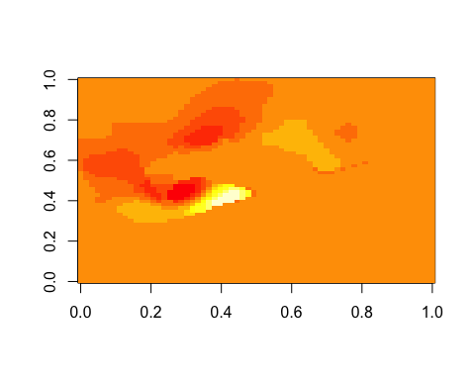

image(mean_group_nii(con_02_images))

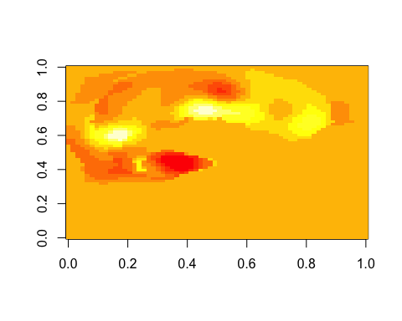

image(mean_group_nii(con_03_images))

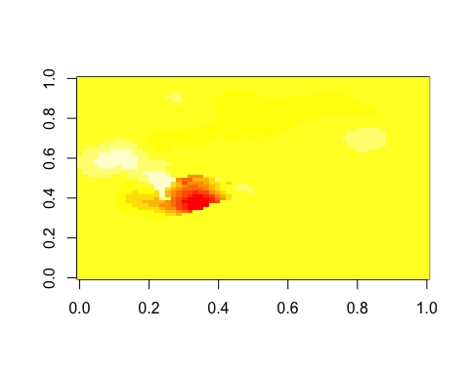

image(mean_group_nii(con_04_images))

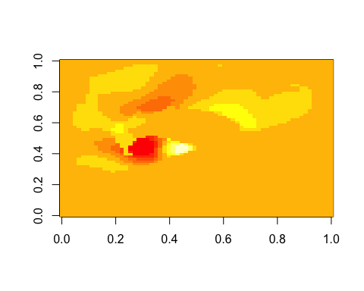

image(mean_group_nii(con_05_images))

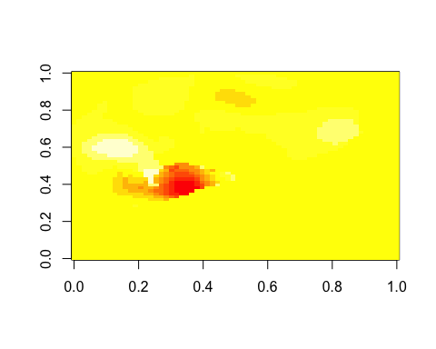

随后对各成像数据进行统计分析，首先取出三种条件下各通道的 beta 值。

test2_beta <- dir("/Users/eXrld/Dropbox/毕业设计/实验数据/仪器数据/SPM处理结果/test2/", include.dirs = T, recursive = T)   
  
test2_con_01 <- paste0("/Users/eXrld/Dropbox/毕业设计/实验数据/仪器数据/SPM处理结果/test2/",test2_beta[stringr::str_detect(test2_beta,pattern = "con_0001.mat")])  
test2_con_02 <- paste0("/Users/eXrld/Dropbox/毕业设计/实验数据/仪器数据/SPM处理结果/test2/",test2_beta[stringr::str_detect(test2_beta,pattern = "con_0002.mat")])  
test2_con_03 <- paste0("/Users/eXrld/Dropbox/毕业设计/实验数据/仪器数据/SPM处理结果/test2/",test2_beta[stringr::str_detect(test2_beta,pattern = "con_0003.mat")])  
  
test2_con_01_beta <- matrix(0, ncol = length(extract_fNIRS_beta(test2_con_01[1])), nrow = length(test2_con_01))  
test2_con_02_beta <- matrix(0, ncol = length(extract_fNIRS_beta(test2_con_01[1])), nrow = length(test2_con_01))  
test2_con_03_beta <- matrix(0, ncol = length(extract_fNIRS_beta(test2_con_01[1])), nrow = length(test2_con_01))  
  
for(i in 1:length(test2_con_01)){  
 test2_con_01_beta[i,] <- extract_fNIRS_beta(test2_con_01[i])  
}  
  
for(i in 1:length(test2_con_01)){  
 test2_con_02_beta[i,] <- extract_fNIRS_beta(test2_con_02[i])  
}  
  
for(i in 1:length(test2_con_01)){  
 test2_con_03_beta[i,] <- extract_fNIRS_beta(test2_con_03[i])  
}

取出各通道 beta 值后，通过方差分析比较其差异

test2_con_01_beta <- cbind(test2_con_01_beta, rep(1, 11))  
test2_con_02_beta <- cbind(test2_con_02_beta, rep(2, 11))  
test2_con_03_beta <- cbind(test2_con_03_beta, rep(3, 11))  
  
test2_beta_table <- data.frame(rbind(test2_con_01_beta, test2_con_02_beta, test2_con_03_beta))  
names(test2_beta_table)[46] <- "Group"  
names(test2_beta_table)[1:45] <- paste0("Ch", 1:45)  
test2_aov_table <- data.frame(matrix(0, ncol = 3, nrow = 45))  
names(test2_aov_table) <- c("Ch", "P.value", "Sig.")  
for(i in 1:45){  
test2_aov_table$Ch[i] <- i  
test2_aov_table$P.value[i] <- summary(aov(test2_beta_table[,i] ~ Group, data = test2_beta_table))[[1]]$`Pr(>F)`  
if(summary(aov(test2_beta_table[,i] ~ Group, data = test2_beta_table))[[1]]$`Pr(>F)` < 0.05){  
 test2_aov_table$Sig.[i] <- "***"  
 }  
}

## Warning in test2_aov_table$P.value[i] <- summary(aov(test2_beta_table[, :  
## number of items to replace is not a multiple of replacement length

## Warning in if (summary(aov(test2_beta_table[, i] ~ Group, data =  
## test2_beta_table))[[1]]$`Pr(>F)` < : the condition has length > 1 and only  
## the first element will be used

## Warning in test2_aov_table$P.value[i] <- summary(aov(test2_beta_table[, :  
## number of items to replace is not a multiple of replacement length

## Warning in if (summary(aov(test2_beta_table[, i] ~ Group, data =  
## test2_beta_table))[[1]]$`Pr(>F)` < : the condition has length > 1 and only  
## the first element will be used

## Warning in test2_aov_table$P.value[i] <- summary(aov(test2_beta_table[, :  
## number of items to replace is not a multiple of replacement length

## Warning in if (summary(aov(test2_beta_table[, i] ~ Group, data =  
## test2_beta_table))[[1]]$`Pr(>F)` < : the condition has length > 1 and only  
## the first element will be used

## Warning in test2_aov_table$P.value[i] <- summary(aov(test2_beta_table[, :  
## number of items to replace is not a multiple of replacement length

## Warning in if (summary(aov(test2_beta_table[, i] ~ Group, data =  
## test2_beta_table))[[1]]$`Pr(>F)` < : the condition has length > 1 and only  
## the first element will be used

## Warning in test2_aov_table$P.value[i] <- summary(aov(test2_beta_table[, :  
## number of items to replace is not a multiple of replacement length

## Warning in if (summary(aov(test2_beta_table[, i] ~ Group, data =  
## test2_beta_table))[[1]]$`Pr(>F)` < : the condition has length > 1 and only  
## the first element will be used

## Warning in test2_aov_table$P.value[i] <- summary(aov(test2_beta_table[, :  
## number of items to replace is not a multiple of replacement length

## Warning in if (summary(aov(test2_beta_table[, i] ~ Group, data =  
## test2_beta_table))[[1]]$`Pr(>F)` < : the condition has length > 1 and only  
## the first element will be used

## Warning in test2_aov_table$P.value[i] <- summary(aov(test2_beta_table[, :  
## number of items to replace is not a multiple of replacement length

## Warning in if (summary(aov(test2_beta_table[, i] ~ Group, data =  
## test2_beta_table))[[1]]$`Pr(>F)` < : the condition has length > 1 and only  
## the first element will be used

## Warning in test2_aov_table$P.value[i] <- summary(aov(test2_beta_table[, :  
## number of items to replace is not a multiple of replacement length

## Warning in if (summary(aov(test2_beta_table[, i] ~ Group, data =  
## test2_beta_table))[[1]]$`Pr(>F)` < : the condition has length > 1 and only  
## the first element will be used

## Warning in test2_aov_table$P.value[i] <- summary(aov(test2_beta_table[, :  
## number of items to replace is not a multiple of replacement length

## Warning in if (summary(aov(test2_beta_table[, i] ~ Group, data =  
## test2_beta_table))[[1]]$`Pr(>F)` < : the condition has length > 1 and only  
## the first element will be used

## Warning in test2_aov_table$P.value[i] <- summary(aov(test2_beta_table[, :  
## number of items to replace is not a multiple of replacement length

## Warning in if (summary(aov(test2_beta_table[, i] ~ Group, data =  
## test2_beta_table))[[1]]$`Pr(>F)` < : the condition has length > 1 and only  
## the first element will be used

## Warning in test2_aov_table$P.value[i] <- summary(aov(test2_beta_table[, :  
## number of items to replace is not a multiple of replacement length

## Warning in if (summary(aov(test2_beta_table[, i] ~ Group, data =  
## test2_beta_table))[[1]]$`Pr(>F)` < : the condition has length > 1 and only  
## the first element will be used

## Warning in test2_aov_table$P.value[i] <- summary(aov(test2_beta_table[, :  
## number of items to replace is not a multiple of replacement length

## Warning in if (summary(aov(test2_beta_table[, i] ~ Group, data =  
## test2_beta_table))[[1]]$`Pr(>F)` < : the condition has length > 1 and only  
## the first element will be used

## Warning in test2_aov_table$P.value[i] <- summary(aov(test2_beta_table[, :  
## number of items to replace is not a multiple of replacement length

## Warning in if (summary(aov(test2_beta_table[, i] ~ Group, data =  
## test2_beta_table))[[1]]$`Pr(>F)` < : the condition has length > 1 and only  
## the first element will be used

## Warning in test2_aov_table$P.value[i] <- summary(aov(test2_beta_table[, :  
## number of items to replace is not a multiple of replacement length

## Warning in if (summary(aov(test2_beta_table[, i] ~ Group, data =  
## test2_beta_table))[[1]]$`Pr(>F)` < : the condition has length > 1 and only  
## the first element will be used

## Warning in test2_aov_table$P.value[i] <- summary(aov(test2_beta_table[, :  
## number of items to replace is not a multiple of replacement length

## Warning in if (summary(aov(test2_beta_table[, i] ~ Group, data =  
## test2_beta_table))[[1]]$`Pr(>F)` < : the condition has length > 1 and only  
## the first element will be used

## Warning in test2_aov_table$P.value[i] <- summary(aov(test2_beta_table[, :  
## number of items to replace is not a multiple of replacement length

## Warning in if (summary(aov(test2_beta_table[, i] ~ Group, data =  
## test2_beta_table))[[1]]$`Pr(>F)` < : the condition has length > 1 and only  
## the first element will be used

## Warning in test2_aov_table$P.value[i] <- summary(aov(test2_beta_table[, :  
## number of items to replace is not a multiple of replacement length

## Warning in if (summary(aov(test2_beta_table[, i] ~ Group, data =  
## test2_beta_table))[[1]]$`Pr(>F)` < : the condition has length > 1 and only  
## the first element will be used

## Warning in test2_aov_table$P.value[i] <- summary(aov(test2_beta_table[, :  
## number of items to replace is not a multiple of replacement length

## Warning in if (summary(aov(test2_beta_table[, i] ~ Group, data =  
## test2_beta_table))[[1]]$`Pr(>F)` < : the condition has length > 1 and only  
## the first element will be used

## Warning in test2_aov_table$P.value[i] <- summary(aov(test2_beta_table[, :  
## number of items to replace is not a multiple of replacement length

## Warning in if (summary(aov(test2_beta_table[, i] ~ Group, data =  
## test2_beta_table))[[1]]$`Pr(>F)` < : the condition has length > 1 and only  
## the first element will be used

## Warning in test2_aov_table$P.value[i] <- summary(aov(test2_beta_table[, :  
## number of items to replace is not a multiple of replacement length

## Warning in if (summary(aov(test2_beta_table[, i] ~ Group, data =  
## test2_beta_table))[[1]]$`Pr(>F)` < : the condition has length > 1 and only  
## the first element will be used

## Warning in test2_aov_table$P.value[i] <- summary(aov(test2_beta_table[, :  
## number of items to replace is not a multiple of replacement length

## Warning in if (summary(aov(test2_beta_table[, i] ~ Group, data =  
## test2_beta_table))[[1]]$`Pr(>F)` < : the condition has length > 1 and only  
## the first element will be used

## Warning in test2_aov_table$P.value[i] <- summary(aov(test2_beta_table[, :  
## number of items to replace is not a multiple of replacement length

## Warning in if (summary(aov(test2_beta_table[, i] ~ Group, data =  
## test2_beta_table))[[1]]$`Pr(>F)` < : the condition has length > 1 and only  
## the first element will be used

## Warning in test2_aov_table$P.value[i] <- summary(aov(test2_beta_table[, :  
## number of items to replace is not a multiple of replacement length

## Warning in if (summary(aov(test2_beta_table[, i] ~ Group, data =  
## test2_beta_table))[[1]]$`Pr(>F)` < : the condition has length > 1 and only  
## the first element will be used

## Warning in test2_aov_table$P.value[i] <- summary(aov(test2_beta_table[, :  
## number of items to replace is not a multiple of replacement length

## Warning in if (summary(aov(test2_beta_table[, i] ~ Group, data =  
## test2_beta_table))[[1]]$`Pr(>F)` < : the condition has length > 1 and only  
## the first element will be used

## Warning in test2_aov_table$P.value[i] <- summary(aov(test2_beta_table[, :  
## number of items to replace is not a multiple of replacement length

## Warning in if (summary(aov(test2_beta_table[, i] ~ Group, data =  
## test2_beta_table))[[1]]$`Pr(>F)` < : the condition has length > 1 and only  
## the first element will be used

## Warning in test2_aov_table$P.value[i] <- summary(aov(test2_beta_table[, :  
## number of items to replace is not a multiple of replacement length

## Warning in if (summary(aov(test2_beta_table[, i] ~ Group, data =  
## test2_beta_table))[[1]]$`Pr(>F)` < : the condition has length > 1 and only  
## the first element will be used

## Warning in test2_aov_table$P.value[i] <- summary(aov(test2_beta_table[, :  
## number of items to replace is not a multiple of replacement length

## Warning in if (summary(aov(test2_beta_table[, i] ~ Group, data =  
## test2_beta_table))[[1]]$`Pr(>F)` < : the condition has length > 1 and only  
## the first element will be used

## Warning in test2_aov_table$P.value[i] <- summary(aov(test2_beta_table[, :  
## number of items to replace is not a multiple of replacement length

## Warning in if (summary(aov(test2_beta_table[, i] ~ Group, data =  
## test2_beta_table))[[1]]$`Pr(>F)` < : the condition has length > 1 and only  
## the first element will be used

## Warning in test2_aov_table$P.value[i] <- summary(aov(test2_beta_table[, :  
## number of items to replace is not a multiple of replacement length

## Warning in if (summary(aov(test2_beta_table[, i] ~ Group, data =  
## test2_beta_table))[[1]]$`Pr(>F)` < : the condition has length > 1 and only  
## the first element will be used

## Warning in test2_aov_table$P.value[i] <- summary(aov(test2_beta_table[, :  
## number of items to replace is not a multiple of replacement length

## Warning in if (summary(aov(test2_beta_table[, i] ~ Group, data =  
## test2_beta_table))[[1]]$`Pr(>F)` < : the condition has length > 1 and only  
## the first element will be used

## Warning in test2_aov_table$P.value[i] <- summary(aov(test2_beta_table[, :  
## number of items to replace is not a multiple of replacement length

## Warning in if (summary(aov(test2_beta_table[, i] ~ Group, data =  
## test2_beta_table))[[1]]$`Pr(>F)` < : the condition has length > 1 and only  
## the first element will be used

## Warning in test2_aov_table$P.value[i] <- summary(aov(test2_beta_table[, :  
## number of items to replace is not a multiple of replacement length

## Warning in if (summary(aov(test2_beta_table[, i] ~ Group, data =  
## test2_beta_table))[[1]]$`Pr(>F)` < : the condition has length > 1 and only  
## the first element will be used

## Warning in test2_aov_table$P.value[i] <- summary(aov(test2_beta_table[, :  
## number of items to replace is not a multiple of replacement length

## Warning in if (summary(aov(test2_beta_table[, i] ~ Group, data =  
## test2_beta_table))[[1]]$`Pr(>F)` < : the condition has length > 1 and only  
## the first element will be used

## Warning in test2_aov_table$P.value[i] <- summary(aov(test2_beta_table[, :  
## number of items to replace is not a multiple of replacement length

## Warning in if (summary(aov(test2_beta_table[, i] ~ Group, data =  
## test2_beta_table))[[1]]$`Pr(>F)` < : the condition has length > 1 and only  
## the first element will be used

## Warning in test2_aov_table$P.value[i] <- summary(aov(test2_beta_table[, :  
## number of items to replace is not a multiple of replacement length

## Warning in if (summary(aov(test2_beta_table[, i] ~ Group, data =  
## test2_beta_table))[[1]]$`Pr(>F)` < : the condition has length > 1 and only  
## the first element will be used

## Warning in test2_aov_table$P.value[i] <- summary(aov(test2_beta_table[, :  
## number of items to replace is not a multiple of replacement length

## Warning in if (summary(aov(test2_beta_table[, i] ~ Group, data =  
## test2_beta_table))[[1]]$`Pr(>F)` < : the condition has length > 1 and only  
## the first element will be used

## Warning in test2_aov_table$P.value[i] <- summary(aov(test2_beta_table[, :  
## number of items to replace is not a multiple of replacement length

## Warning in if (summary(aov(test2_beta_table[, i] ~ Group, data =  
## test2_beta_table))[[1]]$`Pr(>F)` < : the condition has length > 1 and only  
## the first element will be used

## Warning in test2_aov_table$P.value[i] <- summary(aov(test2_beta_table[, :  
## number of items to replace is not a multiple of replacement length

## Warning in if (summary(aov(test2_beta_table[, i] ~ Group, data =  
## test2_beta_table))[[1]]$`Pr(>F)` < : the condition has length > 1 and only  
## the first element will be used

## Warning in test2_aov_table$P.value[i] <- summary(aov(test2_beta_table[, :  
## number of items to replace is not a multiple of replacement length

## Warning in if (summary(aov(test2_beta_table[, i] ~ Group, data =  
## test2_beta_table))[[1]]$`Pr(>F)` < : the condition has length > 1 and only  
## the first element will be used

## Warning in test2_aov_table$P.value[i] <- summary(aov(test2_beta_table[, :  
## number of items to replace is not a multiple of replacement length

## Warning in if (summary(aov(test2_beta_table[, i] ~ Group, data =  
## test2_beta_table))[[1]]$`Pr(>F)` < : the condition has length > 1 and only  
## the first element will be used

## Warning in test2_aov_table$P.value[i] <- summary(aov(test2_beta_table[, :  
## number of items to replace is not a multiple of replacement length

## Warning in if (summary(aov(test2_beta_table[, i] ~ Group, data =  
## test2_beta_table))[[1]]$`Pr(>F)` < : the condition has length > 1 and only  
## the first element will be used

## Warning in test2_aov_table$P.value[i] <- summary(aov(test2_beta_table[, :  
## number of items to replace is not a multiple of replacement length

## Warning in if (summary(aov(test2_beta_table[, i] ~ Group, data =  
## test2_beta_table))[[1]]$`Pr(>F)` < : the condition has length > 1 and only  
## the first element will be used

## Warning in test2_aov_table$P.value[i] <- summary(aov(test2_beta_table[, :  
## number of items to replace is not a multiple of replacement length

## Warning in if (summary(aov(test2_beta_table[, i] ~ Group, data =  
## test2_beta_table))[[1]]$`Pr(>F)` < : the condition has length > 1 and only  
## the first element will be used

## Warning in test2_aov_table$P.value[i] <- summary(aov(test2_beta_table[, :  
## number of items to replace is not a multiple of replacement length

## Warning in if (summary(aov(test2_beta_table[, i] ~ Group, data =  
## test2_beta_table))[[1]]$`Pr(>F)` < : the condition has length > 1 and only  
## the first element will be used

## Warning in test2_aov_table$P.value[i] <- summary(aov(test2_beta_table[, :  
## number of items to replace is not a multiple of replacement length

## Warning in if (summary(aov(test2_beta_table[, i] ~ Group, data =  
## test2_beta_table))[[1]]$`Pr(>F)` < : the condition has length > 1 and only  
## the first element will be used