SLAM Based Autonomous Docking and Smart Charging System
Project Report
Autonomous charging for orchard harvesting robots
Xi’an Jiaotong-Liverpool University
Project team Smart Charging Station
Team lead Siyuan Lin
Team members Yuhan Qiu Xunuo Zhuang Yujin Zhou
July 2026

Abstract
This project addresses autonomous charging for orchard harvesting robots during extended unattended operation. It integrates waypoint missions, automatic return at low battery, visual docking, protected charging, and remote management. Using ROS 2 and Nav2, the robot follows harvesting and transport waypoints on an existing occupancy grid map. When consecutive battery readings remain below a configured threshold, the return manager interrupts the current mission and navigates to a staging pose near the charging station. A rear camera then detects the station's ArUco marker. Calibrated camera parameters enable relative pose estimation and precise docking through slow reverse motion. An ESP32-S3 controls the station locally, checking vehicle position, mechanical contact, voltage, current, and contact temperature through a ToF sensor, a microswitch, an INA226 monitor, an NTC thermistor, and an emergency stop. The relay closes only when all safety conditions are satisfied. A fuse, a parallel TVS diode, and reverse-current protection provide additional hardware safeguards. The web platform displays robot and station status, charging history, and time-of-use tariff information. An external DeepSeek model analyzes operational data to produce staged charging plans, estimated completion times, and reports. Planning is handled remotely, while the ESP32 retains authority over local safety. Remote commands cannot bypass the interlocks to energize the charging circuit.
Keywords: environment modeling; waypoints; SLAM; Nav2; ArUco; ESP32-S3; smart charging; large language models; PCB design; 3D modeling; state machines

Contents
1 Design Requirements 4
1.1 Application Context and Operating Needs 4
1.2 System Requirements for Orchard Operation 5
1.3 Gaps in Existing Orchard Robot Charging Systems 6
1.4 Project Objectives and Implementation Scope 7
2 Design Features and Innovations 8
2.1 A Complete Operating Cycle for Orchard Harvesting 8
2.2 Waypoint Navigation for an Ackermann Chassis 8
2.3 Layered Safety through Multiple Sensors 8
2.4 Separating Local Safety from Cloud Functions 9
2.5 Time of Use Tariffs and Personalized Charging Stages 10
2.6 Language Model Analysis and Local Fallback Methods 10
2.7 Mechanical PCB and Power Circuit Design 10
3 Functional Design 14
3.1 Environment Modeling and Localization 14
3.2 Missions with Multiple Waypoints 14
3.3 Mission Preemption and Return at Low Battery 14
3.4 ArUco Visual Docking 15
3.5 Local Charging Safety 15
3.6 Web Management 15
4 System Implementation 16
4.1 Overall Technical Architecture 16
4.2 Environment Modeling and Nav2 Baseline 18
4.3 Waypoint Navigation Implementation 19
4.4 Automatic Return at Low Battery 20
4.5 OV9281 Calibration and ArUco Docking 21
4.6 ESP32 S3 Charging Station Implementation 22
4.7 Web FastAPI and SQLite Implementation 25
4.8 Reliability Verification and Test Plan 27
5 Mechanical Design Integration and Applications 29
5.1 Industrial Design and Mechanical Modeling 29
5.2 Main Components 30
5.3 System Implementation and Integration Results 30
5.4 Application Value and Future Development 31
5.5 Cost per Charging Station 32
References 33

1 Design Requirements

1.1 Application Context and Operating Needs

1.1.1 Fruit Production and Harvesting Robot Applications
Large production volumes, concentrated harvest seasons, and dependence on manual labor provide a practical motivation for orchard harvesting robots. The International Federation of Robotics (IFR), in the executive summary of World Robotics 2025 Service Robots, reports more than 199,000 registered sales of professional service robots worldwide in 2024. Agricultural robots accounted for approximately 19,500 units, placing agriculture among the five largest application categories [1]. In China, a Ministry of Agriculture report records more than 192 million mu of orchard land and over 274 million tonnes of fruit production in 2015. It also identifies rising labor costs, physically demanding work, and limited harvest mechanization [2]. In 2026, the Ministry of Industry and Information Technology and the Ministry of Agriculture and Rural Affairs included fruit and vegetable picking and harvesting among priority agricultural robot applications, citing complex growing conditions, difficulty with around-the-clock management, and high labor intensity [3]. These figures and policy priorities place orchard robotics in the context of production equipment intended for large-scale operations, seasonal labor shortages, and sustained use.
In an orchard, a harvesting vehicle repeatedly patrols tree rows, identifies targets, harvests fruit, transports materials, and returns to a waiting area. These missions run longer and repeat routes more often than a single point-to-point movement, while requiring stable operation within a limited harvest window. The developed system combines mission execution, energy monitoring, return at low battery, automatic charging, and resumption of work.

1.1.2 Continuous Operation and Autonomous Charging
Orchard harvesting has a defined operating window. Here, 24-hour operation means readiness throughout the day, continuous work within scheduled windows, and automatic charging when the battery is low; it does not mean harvesting in every weather condition or at every hour. Battery endurance directly limits each mission of an electric harvesting vehicle. Requiring an operator to locate the robot, cancel its mission, connect a charger, and monitor charging interrupts nighttime or unattended operation and reduces harvesting efficiency.
Autonomous charging supports extended unattended harvesting. With sufficient battery charge, the robot follows its harvesting or transport waypoints. At low battery, the return mission takes priority and sends it to the charging area. After reaching the staging pose, the robot completes close-range docking. Charging begins once contact is stable and the safety checks pass; the next mission can resume after charging completes. Figure 1-1 shows this work, return, docking, charging, and recovery cycle.
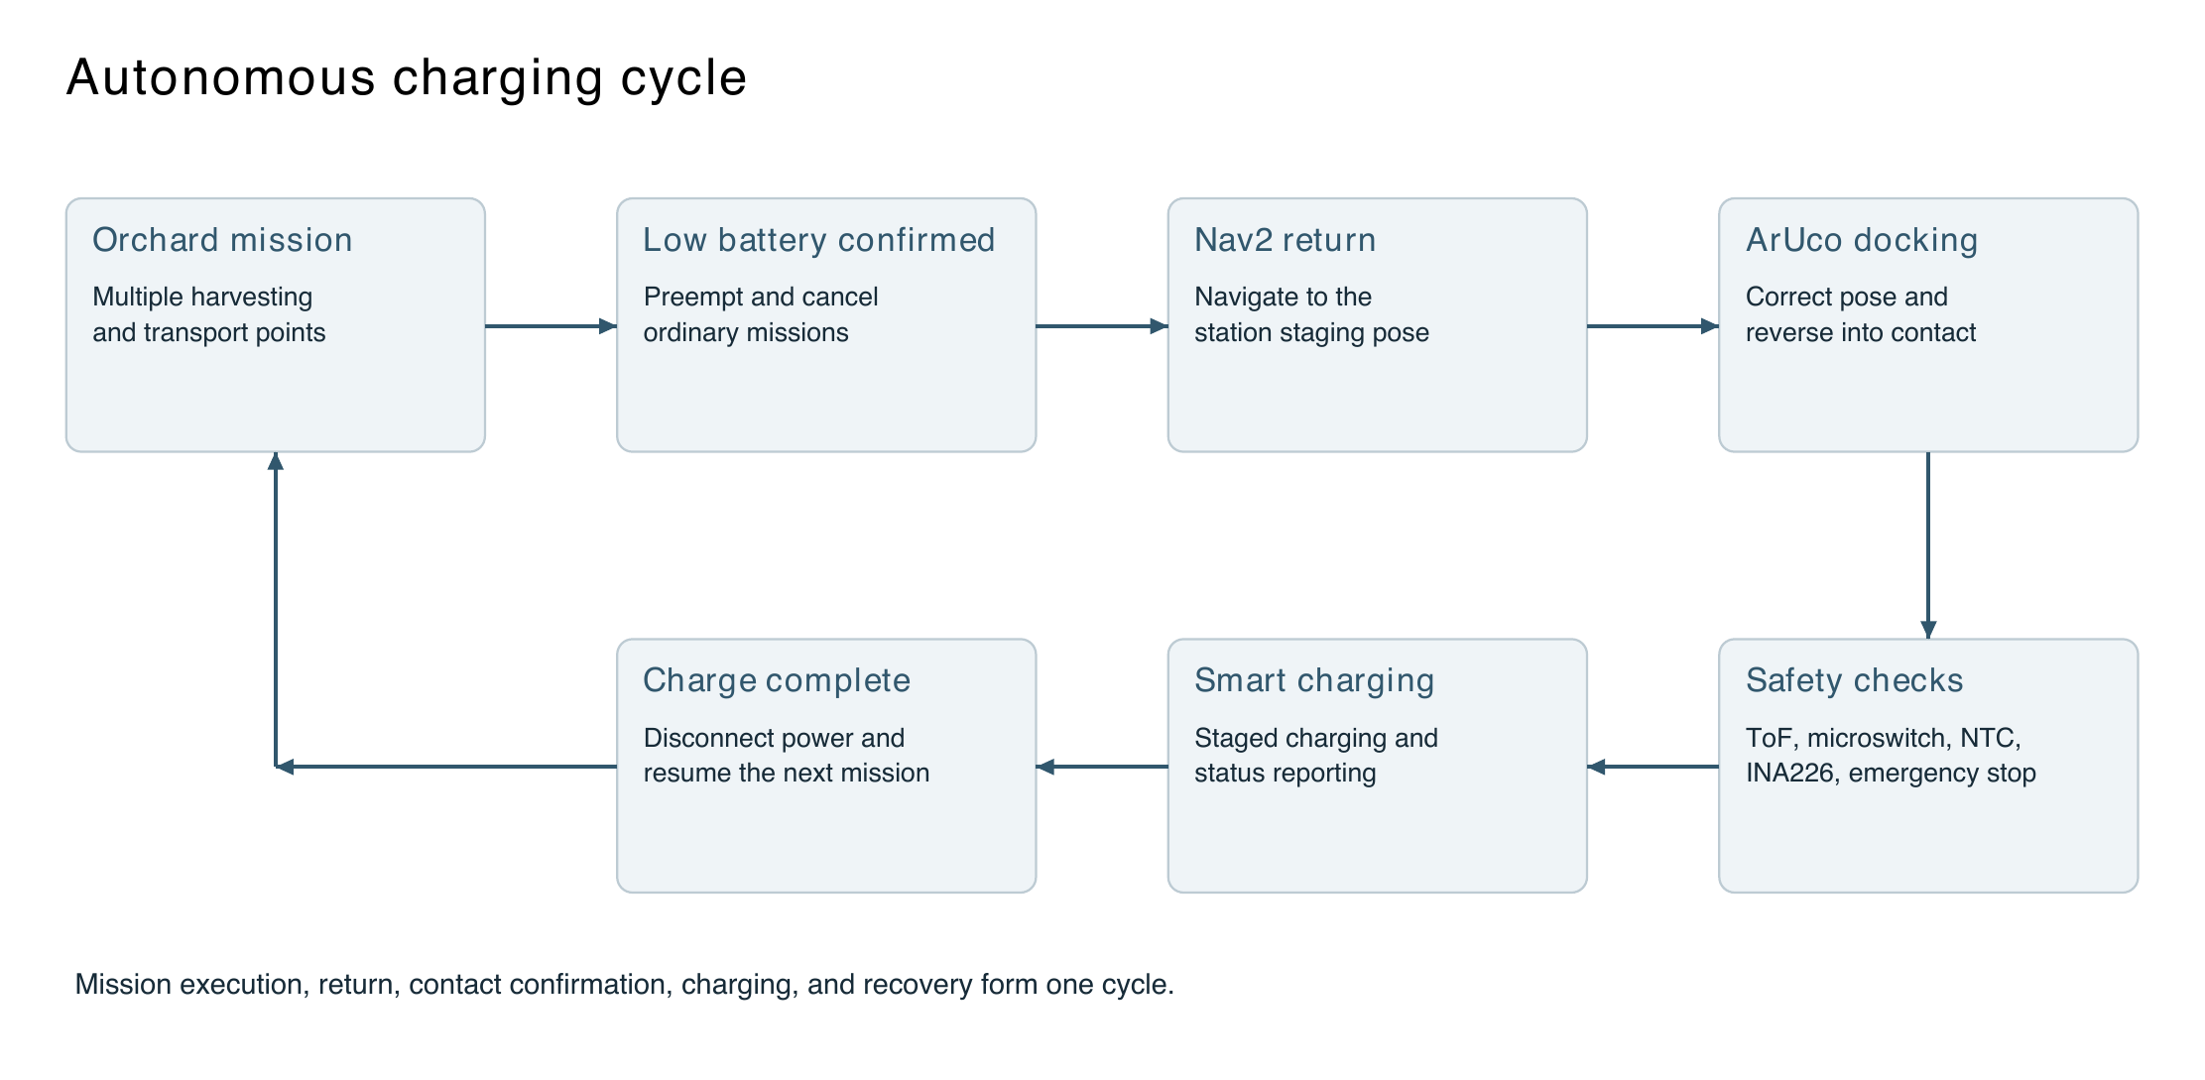
Figure 1-1 Orchard robot mission and autonomous charging cycle

1.2 System Requirements for Orchard Operation

1.2.1 Autonomous Movement in Complex Environments
Orchard routes can include narrow rows, uneven ground, canopy occlusion, changing light, and local obstacles. The harvesting robot must maintain localization within its operating area, visit multiple picking or transfer points in sequence, and return autonomously. Mission points must correspond to real map positions. Paths and final poses must respect Ackermann steering constraints, and low-battery return must take priority over ordinary harvesting missions. Chapters 3 and 4 describe the map dimensions, coordinate transforms, and navigation parameters.

1.2.2 Close Range Docking and Stable Contact
Global navigation brings the vehicle near the station, where the ArUco docking program takes control for the final low-speed approach. Spring-supported copper plates with foam cushioning reduce damage from repeated contact and compensate for errors caused by map localization, parking pose, and uneven ground. ToF distance measurements and a microswitch jointly confirm docking. The main charging circuit is energized only after vehicle position, contact, and electrical conditions remain valid, enabling safe autonomous charging.

1.2.3 Unattended Safety and Management
The station defaults to a de-energized state. An absent vehicle, unstable contact, abnormal temperature, an offline sensor, or an emergency stop opens the main charging relay and pauses charging. The web interface and planning algorithms cannot bypass the local interlocks. Network commands take effect only after the controller verifies the physical station state. The web platform displays return, docking, charging, completion, and fault states and records voltage, current, power, and temperature changes.
The autonomous charging process has six stages: mission preemption, return navigation, visual docking, mechanical position confirmation, electrical safety checks, and charging-state management. Each stage has explicit inputs, outputs, and exception handling. This prevents a single sensor from determining whether power is applied and provides individual checkpoints for full-system integration.

1.3 Gaps in Existing Orchard Robot Charging Systems

1.3.1 Disconnected Work and Charging Workflows
Orchard robot prototypes often validate navigation, harvesting, or charging separately without unified mission scheduling. Low battery may fail to preempt an active harvesting task, or a new ordinary task may arrive during return. Reaching the vicinity of the station also does not establish mechanical contact. This project connects battery triggering to charge completion through a staged process. Table 1-1 lists the problems and corresponding methods.
Table 1-1 Mission and charging workflow problems and responses
Problem | Effect in orchard operation | Project response
Inconsistent coordinates | Differences among web click coordinates, map coordinates, TF, and the chassis reference point cause systematic goal offsets. | Recover original image pixels, apply the pixel-to-map transform, and assign one publisher to each TF link.
Conflicting mission priorities | New waypoints may preempt navigation after the charging return has started. | Use /return_to_charge_active as a persistent gate and prioritize charging return over ordinary missions.
Unreachable Ackermann poses | Goals specify position alone or require rotation in place. | Infer or explicitly specify yaw and align Smac Hybrid-A*, MPPI, and minimum turning-radius settings.
Staging arrival does not establish charging contact | Nav2 goal tolerances cannot guarantee that the copper contacts engage. | Use ArUco for close-range docking and multiple station sensors for charging interlocks.

1.3.2 Docking Charging and Management Problems
Parking errors, vehicle motion, dust, and contact-surface conditions can affect conductive charging in orchards. Distance sensing or a single switch alone may permit poor contact, overheating, or unintended contact with energized terminals. Direct remote relay control could also allow network or software failures to cross the local safety boundary. Without state records, faults are harder to trace. Table 1-2 connects these problems to the project's mechanical, electrical, and management measures.
Table 1-2 Docking charging and management problems and responses
Problem | Effect in orchard operation | Project response
Unreliable contact | Distance sensing or a single switch alone can miss poor contact and resulting heating. | Combine ToF and microswitch confirmation and use an NTC to monitor copper-contact heating directly.
Unobserved electrical hazards | Overvoltage, overcurrent, reverse polarity, and transient spikes can damage equipment. | Layer INA226 monitoring, a fuse, a parallel TVS diode, XL74610 protection, and a relay.
Remote control exceeds its authority | Direct relay activation by the web interface or AI would bypass physical checks. | Accept only high-level remote requests; retain final authority in the ESP32 state machine.
Poor charging timing | The battery may remain full too early, miss low-price periods, or lack charge at departure. | Charge initially to 80%, wait, top up before departure, and display time-of-use tariff guidance.
Hard-to-interpret information | Raw JSON, status codes, and individual samples are difficult for users to interpret. | Provide live status, historical trends, and AI-generated weekly reports based on operating data.
The project derives its autonomous charging requirements from orchard production scale and continuous-operation needs. It addresses gaps in mission preemption, close-range docking, reliable contact, safety interlocks, and state management through task scheduling, ArUco guidance, compliant copper contacts with cushioning, dual ToF and microswitch confirmation, an ESP32 state machine, and web management. Chapter 2 explains the design features; Chapters 3 and 4 describe functionality and implementation.

1.4 Project Objectives and Implementation Scope

1.4.1 Design Objectives
Integrate environment modeling, waypoint work, low-battery preemption, global return, visual docking, safe charging, and mission resumption into a complete operating cycle.
Use ROS 2, Nav2, Smac Hybrid-A*, MPPI, and FollowWaypoints for Ackermann-compatible waypoint missions and return navigation.
Use the OV9281 camera, ArUco, and PnP to estimate relative position and dock through low-speed reverse control.
Use the ESP32-S3, ToF, microswitch, INA226, NTC, and emergency stop to keep undocked contacts de-energized and interrupt charging on faults.
Use a web interface, FastAPI, and SQLite for status display, data storage, and tariff management, with external DeepSeek analysis for charging plans and operational reports.

1.4.2 Implementation and Integration Scope
Vehicle-level integration covers mission navigation, low-battery return, ArUco docking, mechanical confirmation, safe charging, and web management. Waypoint and return functions share a workspace and parameter set. Mission gating, occupancy and safety-radius checks, cancellation confirmation, and docking feedback are part of the task-management chain. The ArUco controller subscribes to /start_docking and returns docking_complete to AutoChargeManager after docking, enabling transitions from work to return, docking, charging, and completion.

2 Design Features and Innovations

2.1 A Complete Operating Cycle for Orchard Harvesting

2.1.1 Coordinating Environment Tasks and Energy
The design incorporates energy status into the robot's mission lifecycle. The map defines the operating space, waypoints define destinations, and Mission/AutoCharge management selects the active task. ArUco guidance and the station handle charging, while the web platform presents and manages operating status. These responsibilities reduce conflicts between modules and help locate faults in coordinates, navigation, docking, contact, or charging.

2.1.2 Global Navigation with Nav2 and Precise Docking with ArUco
Nav2 handles planning, local control, and obstacle avoidance at map scale, but its navigation accuracy alone is insufficient for the centimeter-scale contact alignment required by the copper plates. The system separates map-level return from marker-based close-range docking. Navigation reaches a staging pose; ArUco estimates lateral offset x, camera-to-marker distance z, and the yaw angle between the camera and marker normals, then guides the final reverse approach. A state machine coordinates the two algorithms at their respective scales and simplifies tuning.

2.2 Waypoint Navigation for an Ackermann Chassis

2.2.1 Traceable Pixel to Map Coordinate Conversion
The web interface selects points in image pixels, while Nav2 uses metric map coordinates. Conversion accounts for original image height, map resolution, origin, and origin_yaw, using pixel centers rather than simple scaling. Each frontend point therefore has an explicit calculation path, reducing systematic errors from browser scaling, inverted y axes, or half-pixel offsets.

2.2.2 Heading Completion and Consistent Kinematics
For intermediate waypoints without yaw, WaypointSubscriber computes atan2 from the current point toward the next. The final point retains the most recent heading. Both planner and controller use Ackermann models; the project configuration uses Smac Hybrid-A* and MPPI. Accounting for heading and turning radius supports the vehicle's motion constraints in orchard lanes, narrow doorways, and charging areas.

2.3 Layered Safety through Multiple Sensors

2.3.1 Distance Sensing and Mechanical Position Confirmation
The station's ToF sensor measures distance to a reference plate mounted at the rear of the robot. A reading within the configured docking range indicates that the vehicle is near the charging position. The plate provides a stable ranging surface and reduces fluctuations caused by differences in body geometry, material, or gaps.
The microswitch confirms whether the insulated central actuator has reached its specified position, indicating mechanical engagement of the copper contacts. Correct docking requires both a valid ToF distance and a continuously pressed microswitch for 250 ms.
The relay closes and charging begins only after distance, mechanical position, electrical parameters, temperature, emergency-stop state, and all other start conditions remain valid for 600 ms. This filters brief vehicle motion, ranging fluctuations, and switch bounce, avoiding premature energization and repeated relay switching.

2.3.2 Electrical Monitoring Contact Temperature and Emergency Stop
The INA226 measures main-circuit voltage, current, and power during charging and sends the data to the ESP32-S3. The controller checks for abnormal voltage, overcurrent, or abnormal power and opens the relay immediately when a fault is detected.
A 10 kΩ NTC thermistor with a Beta value of 3950 K is installed near the positive copper contact. Its divider voltage is converted to contact-area temperature and sent to the ESP32-S3. Charging output is cut off above the configured limit to prevent continued operation with overheated contacts.
The emergency stop uses normally closed (NC) contacts and a pull-up at the input. The circuit is closed during normal operation. Pressing the emergency stop or breaking its wiring produces the stop level at the GPIO, causing the ESP32-S3 to release the relay. Manual emergency stops and open-circuit faults are therefore both treated as safe shutdown conditions. Figure 2-1 shows the layers of distance, mechanical, electrical, temperature, and emergency-stop protection.
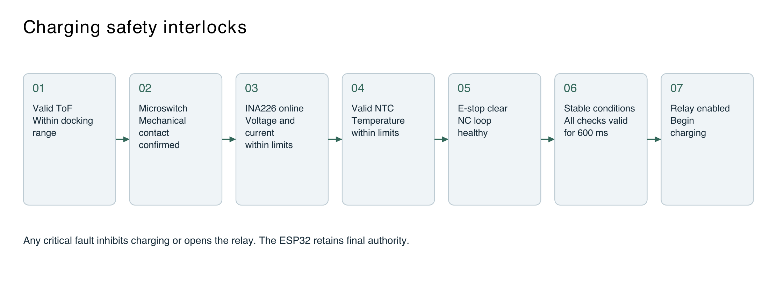
Figure 2-1 Charging safety layers based on multiple sensors

2.4 Separating Local Safety from Cloud Functions

2.4.1 Final Safety Authority on the ESP32
The web interface, backend, and language model can issue only high-level commands such as REQUEST_START_CHARGE, STOP_CHARGING, CLEAR_FAULT, and QUERY_STATUS. A start request clears the stop latch and initiates local reassessment; it cannot close the relay directly. Faults in web logic, networking, or model output therefore cannot bypass the ToF, microswitch, INA226, NTC, or emergency-stop conditions.

2.4.2 Nonblocking Networking and Latched Stop
HTTP uploads and command polling run in a separate FreeRTOS network task, allowing the ESP32 main loop to continue checking safety. Telemetry uploads occur every 5 s, commands are polled every 1.5 s, and HTTP requests time out after 500 ms. STOP_CHARGING has the highest priority and latches the stopped condition so that a vehicle still pressing the microswitch cannot immediately restart charging after a web stop request.

2.5 Time of Use Tariffs and Personalized Charging Stages

2.5.1 Location Based Tariffs and Verifiable Data
The browser can obtain the user's location for regional identification by the backend. If a live tariff interface is configured, the system queries it by latitude and longitude. Otherwise, it uses a local cache containing the region, source, and verification date. If the detected region differs from the cached region, the interface clears the specific rates and displays Pending verification. This prevents the model from presenting unverified tariff information and reduces errors caused by model hallucination.

2.5.2 Initial Charging to 80 Percent and Departure Top Up
The system uses a language model to analyze the past 30 days of charging sessions and departure records and estimate the usual departure time. It first limits the initial charging target to no more than 80% to protect the battery, then waits before a final top-up. Battery capacity, the remaining target difference, maximum power, and expected departure time determine when that top-up begins. The strategy aims to reach the user's target before departure while avoiding prolonged storage at full charge. Figure 2-2 shows the process.
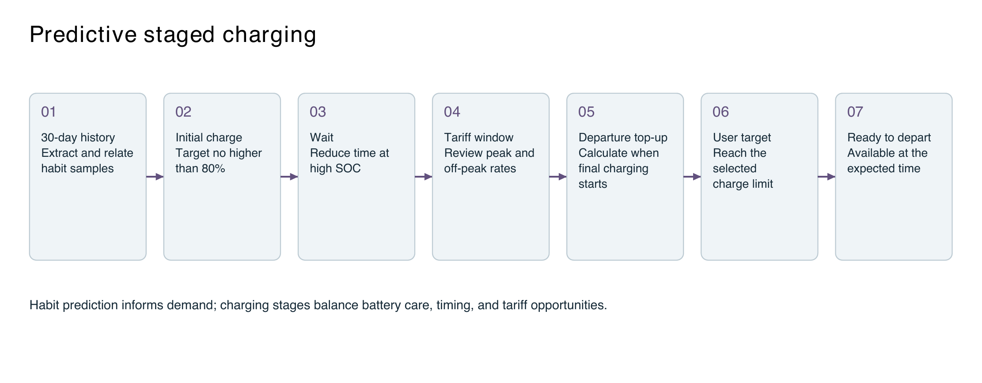
Figure 2-2 Staged charging based on predicted departure habits

2.6 Language Model Analysis and Local Fallback Methods
An external language model predicts charging habits and prepares weekly reports but has no role in relay safety decisions. If the API is unconfigured, networking fails, the output format is invalid, or conclusions cannot be verified, the system falls back to local analysis and calculation rules. Reports merge consecutive abnormal samples into separate events. Without SOH, cycle-count, or cell-voltage-difference data, abnormal readings are treated as discrete samples and are not used to infer battery life.

2.7 Mechanical PCB and Power Circuit Design
The station control circuit is divided into controller, distance sensing, mechanical confirmation, electrical monitoring, contact-temperature sensing, emergency-stop, and audiovisual interface modules. Figure 2-3 shows the circuit schematic, including the sensor interfaces to the ESP32-S3 and the functional separation of control power from the main charging circuit.
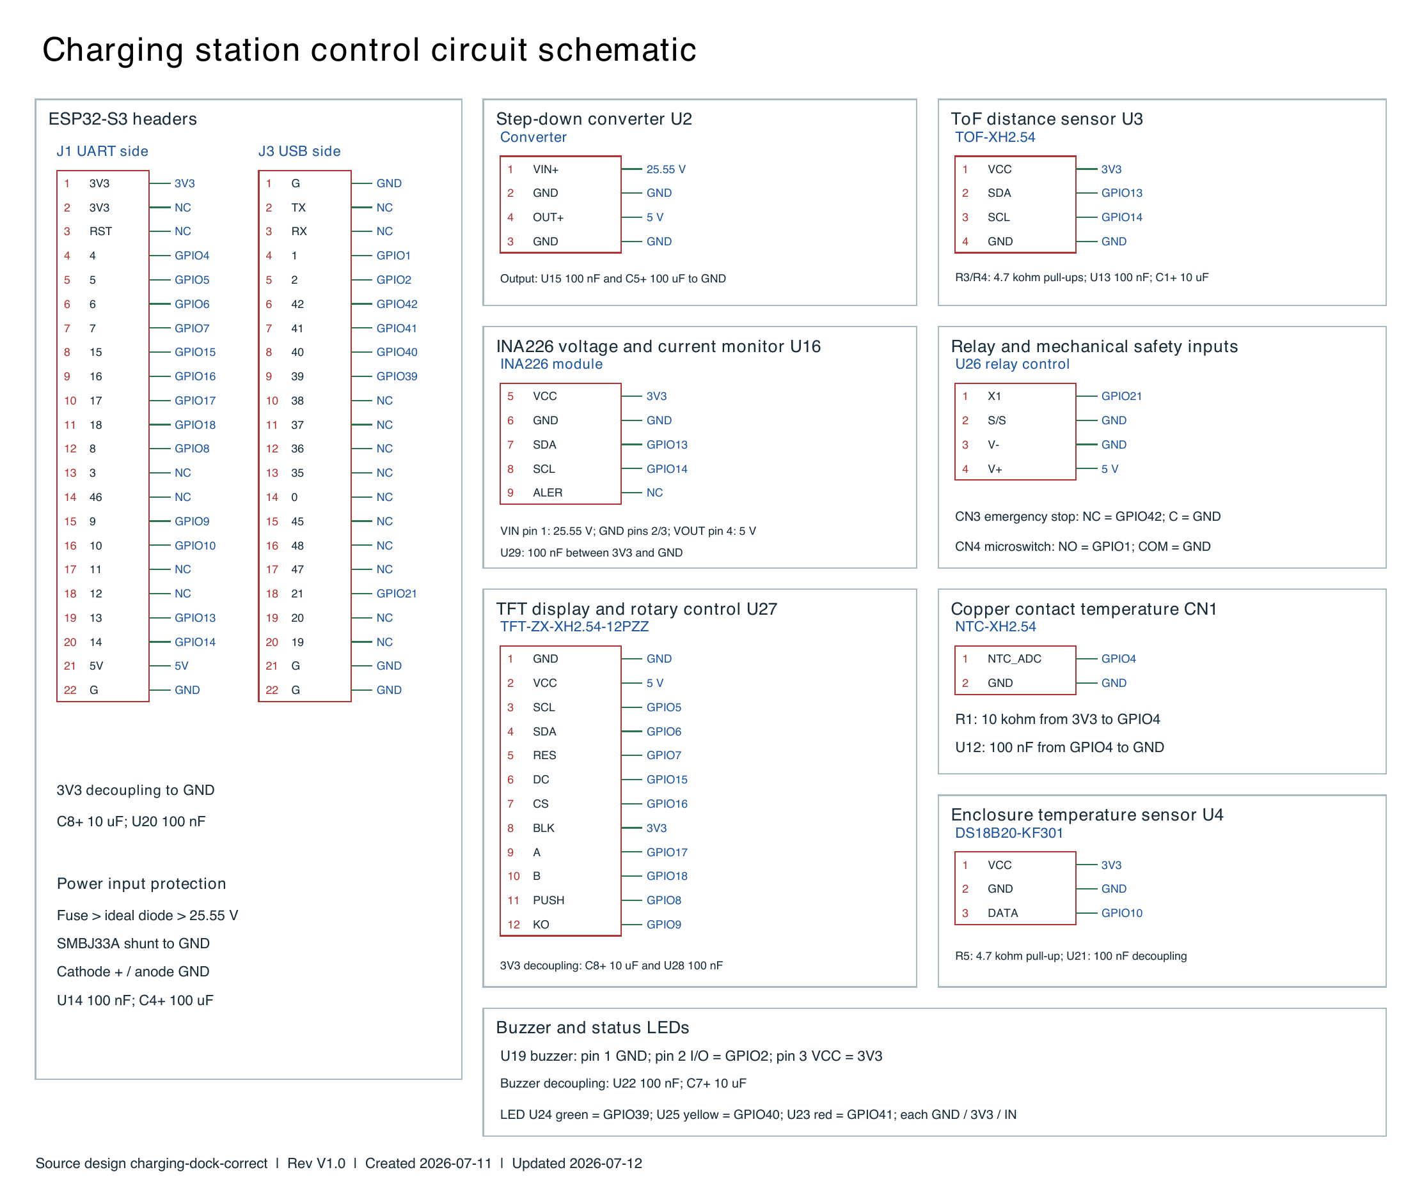
Figure 2-3 Charging station circuit schematic with English labels
Figure 2-4 shows the PCB layout. Electrical connections are routed between modules, with trace widths selected for the current carried by each path.
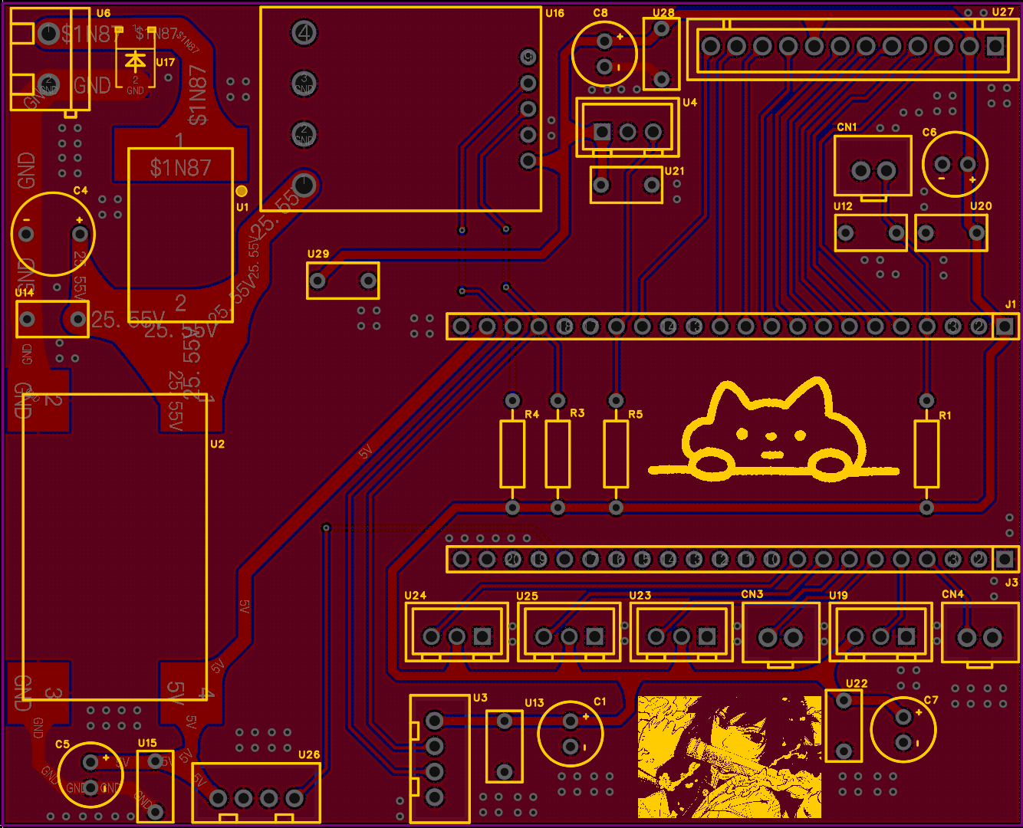
Figure 2-4 Charging station PCB layout
Figure 2-5 shows the fabricated PCB after layout, prototyping, soldering, and interface checks. The board has been installed in the station and used for continuity checks, sensor acquisition, relay control, vehicle docking, and charging under load.
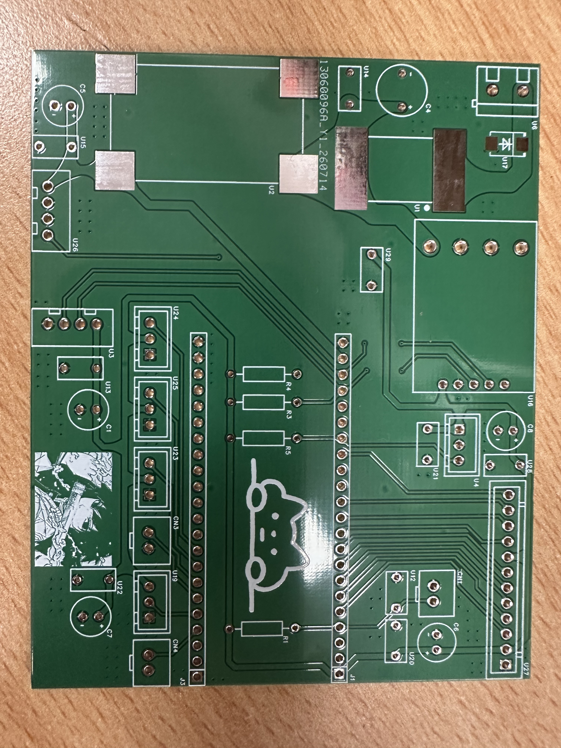
Figure 2-5 Fabricated charging station PCB

2.7.1 Charging Contacts and Docking Detection
The positive and negative compliant copper plates carry charging current to the vehicle. Their elastic supports maintain pressure against the vehicle contacts and compensate for small parking offsets through compliant movement.
The plastic actuator between the vehicle's two rear copper contacts carries no current; it only presses the microswitch. When the vehicle docks and pushes the actuator to its required position, the switch sends a position-confirmation signal. The actuator is insulated because it sits between the positive and negative plates, preventing an accidental short circuit.
Charging and position detection are mechanically independent: the plates carry current, while the actuator and microswitch establish docking position. Contact pressure and actuator travel can be adjusted separately during commissioning.
During operation, the microswitch first confirms docking, and the INA226 then verifies charging voltage and current. Combining mechanical position checks with electrical monitoring reduces false confirmation and improves charging reliability.

2.7.2 Power Protection and High Current Wiring
The charger's positive output first passes through an external fuse. A downstream short circuit or severe overcurrent opens the main circuit, preventing sustained heating of wiring and power components.
An SMBJ33A unidirectional TVS diode is connected in parallel after the fuse, with its anode at the main negative rail and cathode at the positive rail. It suppresses transient voltage spikes caused by relay switching or wiring disturbances and protects downstream components.
The main current then passes through the XL74610 ideal-diode module, INA226 current-sensing path, and relay contacts. The XL74610 prevents reverse current with less voltage drop than a conventional diode. The INA226 monitors main-circuit voltage, charging current, and power; the relay connects or disconnects the charging circuit.
An external heavy-gauge wire connects the INA226 path to the relay COM terminal, keeping charging current away from the ESP32, small-signal interfaces, and thin PCB traces. The ESP32 performs state evaluation, data acquisition, and relay control. This arrangement reduces voltage drop and localized heating and simplifies troubleshooting, maintenance, and component replacement.

3 Functional Design

3.1 Environment Modeling and Localization

3.1.1 Occupancy Grid Loading and Localization
The system navigates on an existing occupancy grid of an orchard or test site. map_server provides /map, AMCL estimates the robot pose on that map, and Livox sensing plus odometry/EKF support localization and local obstacle avoidance. Environment modeling produces a navigable map containing resolution, dimensions, origin, and occupancy data, rather than only a display image.

3.1.2 TF Chain and Navigation Reference
Each transform from map to odom, odom to the vehicle body, and the body to livox_frame has one publisher. Nav2 robot_base_frame, EKF base_link_frame, and the physical chassis control reference must agree. Waypoint frame_id is fixed to map, and all task inputs are converted to that frame before execution.

3.2 Missions with Multiple Waypoints

3.2.1 Web Map Selection and JSON Input
The frontend collects mission points on the original map image and sends JSON through /waypoint_points_json. The protocol uses a points array; each point contains pixel_x, pixel_y, and optional yaw and name fields. After display scaling, the frontend converts clicks back to original image pixels before transmission to avoid scale-dependent position errors.

3.2.2 Coordinate Conversion Heading Generation and Execution
WaypointChecker subscribes to /map, reads metadata, converts pixels to map coordinates, and publishes /nav2_waypoints. WaypointSubscriber converts the PoseArray to a PoseStamped array, completes missing yaw values, and calls /follow_waypoints. Nav2 Waypoint Follower executes points in order and reports current_waypoint. The missed_waypoints result identifies goals that were not reached. Figure 3-1 shows the relationship between ordinary waypoint missions and low-battery return.
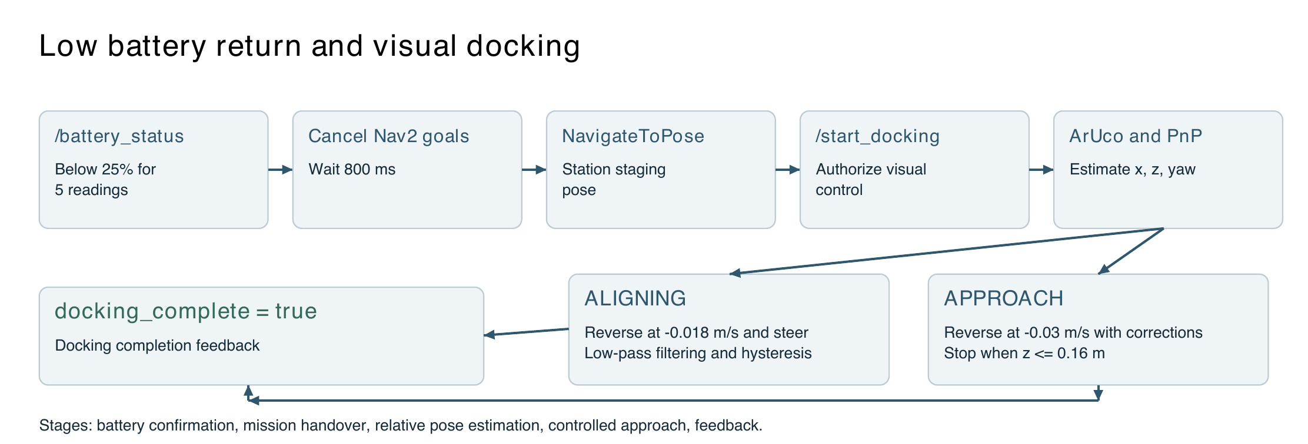
Figure 3-1 Ordinary waypoint missions and low-battery return

3.3 Mission Preemption and Return at Low Battery

3.3.1 Consecutive Threshold Checks and Hysteresis
AutoChargeManager subscribes to /battery_status by default and uses BatteryState.percentage when use_voltage is false. The default low threshold is 0.25, with five consecutive qualifying readings required to trigger return. A reset threshold of 0.35 provides hysteresis and prevents a single fluctuating sample from repeatedly switching between work and return.

3.3.2 Mission Cancellation Return Retries and Staging
On low-battery triggering, the manager publishes /return_to_charge_active, cancels three possible navigation goal types, waits a fixed 800 ms, and sends the station staging pose. After successful navigation, it publishes /start_docking and hands control to the close-range docking module.

3.4 ArUco Visual Docking

3.4.1 Marker Detection and PnP Pose Estimation
The rear OV9281 captures 1280 × 720 images and detects marker ID 0 from DICT_4X4_50. Camera intrinsics, distortion coefficients, and the measured marker side length define four 3D corners. The program first uses SOLVEPNP_IPPE_SQUARE, falling back to SOLVEPNP_ITERATIVE if necessary. It obtains translation x, y, z and computes yaw between the camera and marker normals.

3.4.2 Slow Reverse Motion Filtering and Stop Criteria
The controller applies first-order low-pass filters to x and yaw, dual-threshold hysteresis when entering or leaving alignment mode, and a rate limit on angular.z. For larger errors it reverses and steers at −0.018 m/s. Once approximately centered, it reverses at −0.03 m/s with smaller corrections. It continuously publishes zero velocity when z ≤ 0.16 m or /robot_charging_flag is true.

3.5 Local Charging Safety

3.5.1 Conditions for Starting Charging
After visual docking, the ESP32 keeps the relay open while checking the emergency-stop circuit, microswitch, ToF distance, INA226 voltage and current, and NTC temperature. The relay closes only after all conditions remain stable for 600 ms.

3.5.2 Fault Shutdown and Recovery
During charging, emergency stop, severe overtemperature, loss of a critical sensor, or microswitch release takes priority and cuts power. Ordinary transient anomalies require brief confirmation to prevent relay chatter. CLEAR_FAULT succeeds only after the physical fault has cleared; the remote interface cannot clear a fault that remains present.

3.6 Web Management

3.6.1 Status Monitoring and Historical Trends
The web home page displays estimated vehicle SOC, charge limit, station power, contact temperature, contact status, emergency stop, relay state, estimated completion time, and smart-charging stage. SQLite stores vehicle voltage, estimated SOC, and other telemetry for analysis and charts of SOC, power, and temperature.

3.6.2 Tariffs Charging Plans and Weekly Reports
Users can set an 80%–100% charge limit, usual departure time, and smart-charging preference. The interface shows the current tariff period, reference rate, next low-price window, source, and verification date. The language model generates a weekly report using seven days of operating data and 30 days of habits. It organizes the report into key findings, charging habits, charging performance, tariff analysis, risks, actions, and data coverage.

4 System Implementation

4.1 Overall Technical Architecture

4.1.1 Robot Station and Server Data Flows
The system consists of the robot navigation chain, visual docking chain, ESP32 station, web interface, FastAPI and SQLite services, and external tariff or language-model services. Ordinary missions proceed from web-selected points to FollowWaypoints. Low-battery messages reach AutoChargeManager through the battery-state topic. The visual controller publishes /cmd_vel. The ESP32 uploads local telemetry and polls high-level commands over HTTP. The web interface obtains robot voltage and charging flags through rosbridge. Figure 4-1 shows the overall workflow and data relationships. The configured low-battery topic is /battery_status, as specified in Sections 3.3 and 4.4.
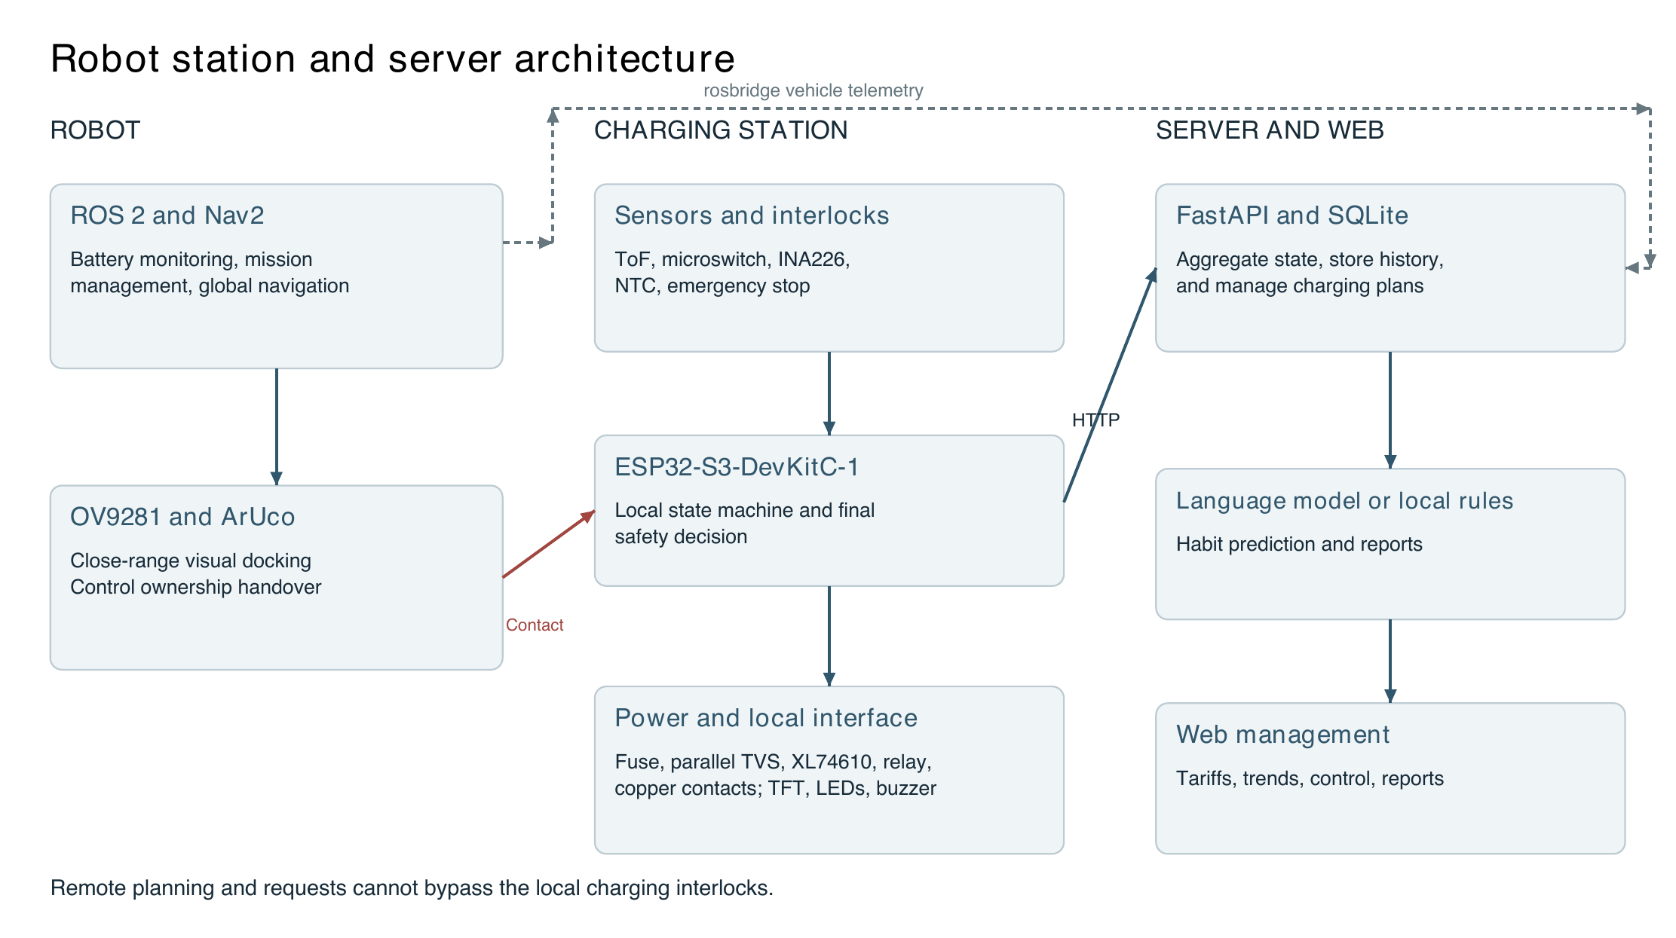
Figure 4-1 Overall system workflow and data links

4.1.2 Integrated Robot and Charging Station Hardware
The physical system includes the harvesting robot, rear camera, compliant copper docking contacts, ESP32-S3 station, and web management interface. Operation proceeds through staging arrival, ArUco detection, corrected low-speed reversing, copper-contact engagement, microswitch and ToF confirmation, relay activation, and telemetry upload. Each stage corresponds to an explicit system state.
Figure 4-2 shows the assembled robot and station. The vehicle carries navigation computing, power, and chassis-control equipment. The station occupies a fixed docking location and provides a visual marker for close-range guidance.
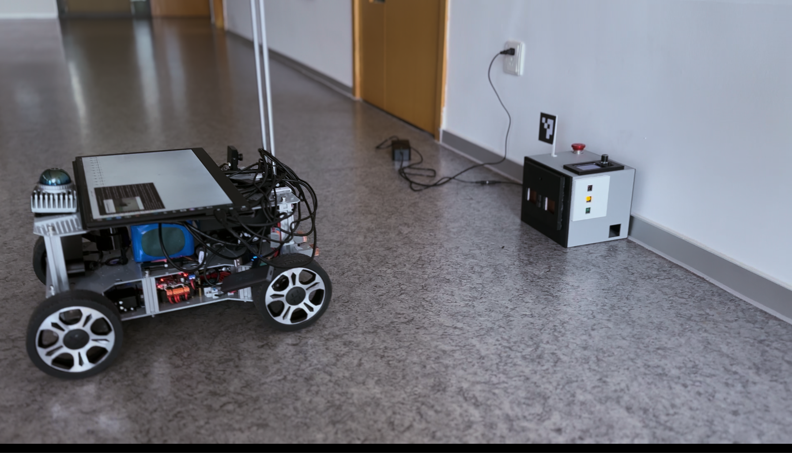
Figure 4-2 Autonomous charging robot and station platform
As shown in Figure 4-3, the station front contains positive and negative compliant copper contacts and a central insulated actuator. The top integrates the visual marker, emergency stop, TFT display, and operating knob. The plates conduct charging current; the actuator only presses the microswitch, keeping electrical contact separate from mechanical position detection.
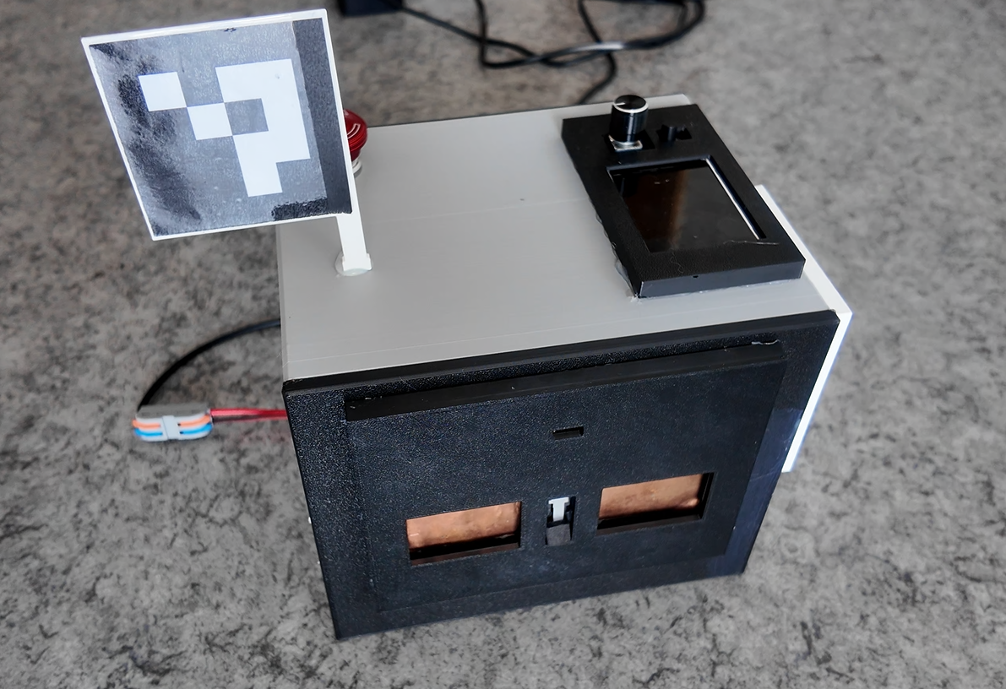
Figure 4-3 Charging station exterior and docking mechanism
Figure 4-4 shows the vehicle in contact with the station. Its rear docking face engages the station after visual control ends. ToF distance, microswitch state, emergency stop, copper-contact temperature, and electrical parameters then jointly determine whether charging is permitted.
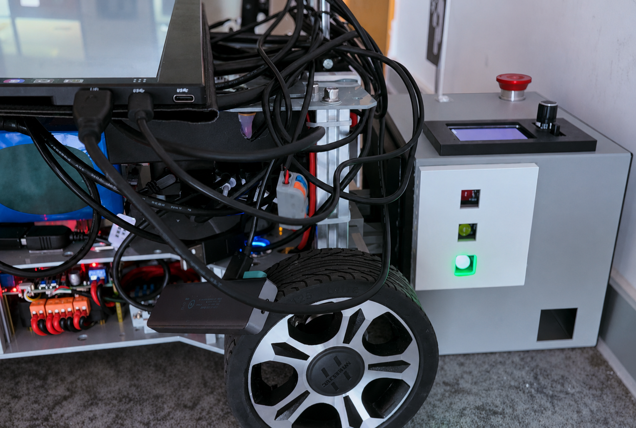
Figure 4-4 Physical robot and station after autonomous docking

4.2 Environment Modeling and Nav2 Baseline

4.2.1 Map Localization Planning and Control Configuration
Table 4-1 Navigation system baseline
Item | Recorded configuration or requirement
Operating environment and middleware | ROS 2 Humble; Nav2 built from source
Chassis model | Ackermann chassis; planning and control must respect the minimum turning radius
Map | Existing Livox occupancy grid; example: 456 × 800 cells, 0.05 m/cell, origin ≈ [−17.3, −4.65, 0]
Localization | AMCL provides map → odom; robot_localization/EKF provides odom → vehicle body
Planning and control | Smac Hybrid-A* and MPPI with consistent Ackermann kinematic parameters
Mission interfaces | FollowWaypoints for waypoint missions; NavigateToPose for low-battery return

4.2.2 TF Chain and Coordinate Frame Constraints
map → [AMCL] → odom → [EKF/odometry] → dummy_link or base_footprint → [static TF] → livox_frame
Each link must have one publisher. Duplicate map → odom or odom → body publishers can make Nav2 drift on the map even when waypoints are correct. All mission points use the map frame. The station staging pose must also be measured on the physical robot's map rather than left at the default 0, 0, 0.

4.3 Waypoint Navigation Implementation

4.3.1 Nodes Topics and Action Interfaces
Table 4-2 Waypoint subsystem interfaces
Node or program | Input | Output and responsibility
nav2_waypoint_checker_cpp | /map, /waypoint_points_json | Parse JSON; convert pixels to map coordinates; publish /nav2_waypoints as PoseArray
nav2_waypoint_subscriber_cpp | /nav2_waypoints, Path, append | Complete yaw; convert to PoseStamped[]; call /follow_waypoints
nav2_waypoint_publisher_cpp | Command-line x y yaw | Publish goals for integration checks without the web interface
Nav2 Waypoint Follower | FollowWaypoints Goal | Execute goals sequentially and report current_waypoint and missed_waypoints

4.3.2 Pixel to Map Coordinate Conversion
Let H be the original image height, r the map resolution, (o_x, o_y) the map origin, and θ the origin yaw. The implementation converts pixel centers rather than pixel upper-left corners:
$${local}_{x} = (u + 0.5) × r$$
$${local}_{y} = (H − v − 0.5) × r$$
$${map }_{x}= o_{x} + cosθ × {local}_{x} − sinθ ×{local}_{y}$$
$${map }_{y}= o_{y} + sinθ × {local}_{x} + cosθ ×{local}_{y}$$
When origin_yaw = 0, the equations reduce to map_x = o_x + (u + 0.5)r and map_y = o_y + (H − v − 0.5)r. At the project resolution of 0.05 m/cell, the half-pixel center correction is 0.025 m. Figure 4-5 shows the image axes, pixel coordinates, and map conversion.
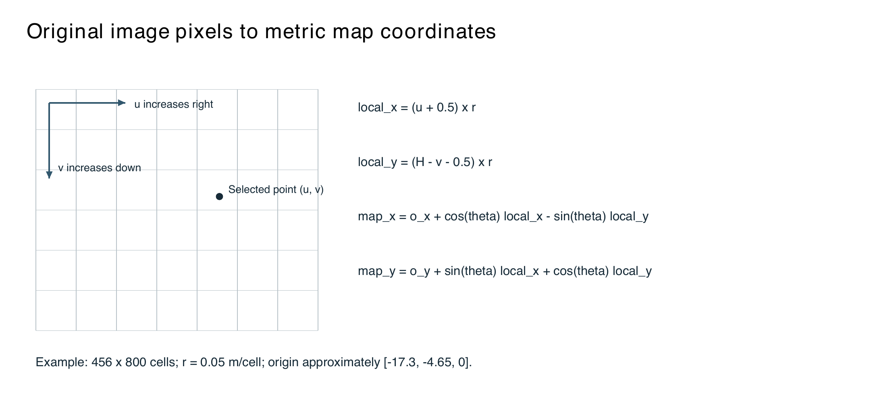
Figure 4-5 Original image pixels to map coordinates

4.3.3 Heading Completion and FollowWaypoints
WaypointSubscriber treats an all-zero quaternion as missing yaw. Intermediate headings use atan2 toward the next point; the last point retains the most recent heading. A single point without yaw defaults to 0 rad. Intermediate corridor points can use inferred headings, but final goals near a charging station or narrow doorway should receive explicit yaw from the frontend. Goal acceptance only means the action server accepted the request. The entire mission is complete only when current_waypoint progresses, the final result is SUCCEEDED, and missed_waypoints is empty.

4.3.4 Safety Checks and Mission Arbitration
The waypoint module checks image boundaries, occupancy, unknown cells, and a 0.30 m safety radius. OccupancyGrid.data is used to validate mission points. During charging return, WaypointSubscriber reads /return_to_charge_active and continuously blocks ordinary missions, giving return and charging the highest priority.

4.4 Automatic Return at Low Battery

4.4.1 AutoChargeManager States and Parameters
Table 4-3 Key low-battery return parameters
Parameter | Default value | Meaning
battery_topic | /battery_status | BatteryState input
use_voltage | false | Use percentage in the range 0–1 by default
low_threshold | 0.25 | Low-battery threshold of 25%
reset_threshold | 0.35 | Reset hysteresis threshold of 35%
confirm_count | 5 | Number of consecutive low readings
cancel_wait_ms | 800 ms | Fixed wait after sending cancellation requests
max_return_retries | 2 | Additional retries; at most three attempts in total
staging_x/y/yaw | 0/0/0 by default | Configured against the physical robot's map

4.4.2 Cancelling Ordinary Missions and Using NavigateToPose
After confirming low battery, the node enters CANCELING, publishes return_active = true, and calls cancel_all_goals on /navigate_to_pose, /navigate_through_poses, and /follow_waypoints. After the fixed delay, it sends a NavigateToPose goal for the staging pose. ABORTED, CANCELED, or an unavailable server causes a retry after 2 s. Once retries are exhausted, the node enters FAILED and retains the low-battery lock.

4.4.3 Docking Trigger and Integrated Operation
When NavigateToPose succeeds, the manager publishes /start_docking = true. aruco_docking3.py receives control authorization and begins close-range docking. On completion, the controller publishes docking_complete; it also provides timeout handling, bounded retries, and error codes. The mission manager arbitrates /cmd_vel ownership to connect low-battery triggering, return, visual docking, and safe charging in one sequence.

4.5 OV9281 Calibration and ArUco Docking

4.5.1 Camera Calibration Procedure and Results
The camera_test directory uses an 11 × 8 inner-corner checkerboard with 10 mm squares at a fixed camera resolution of 1280 × 720. Calibration collected 31 valid images at different poses. OpenCV calibrateCamera solves for intrinsics and distortion, followed by reprojection-error calculation.
Table 4-4 OV9281 calibration results
Item | Result
Image size | 1280 × 720
Focal length fx / fy | 916.9450 / 917.0080
Principal point cx / cy | 666.3835 / 345.0076
Distortion coefficients | [0.04678922, −0.06804788, 0.00068632, 0.00011322, 0.00403198]
RMS | 0.13130584
Mean reprojection error | 0.01395080
Valid images | 31
Figure 4-6 shows the photographed calibration board, detected corners, and ArUco target used for docking. It illustrates how the camera intrinsics were obtained and identifies the target used in subsequent pose estimation.
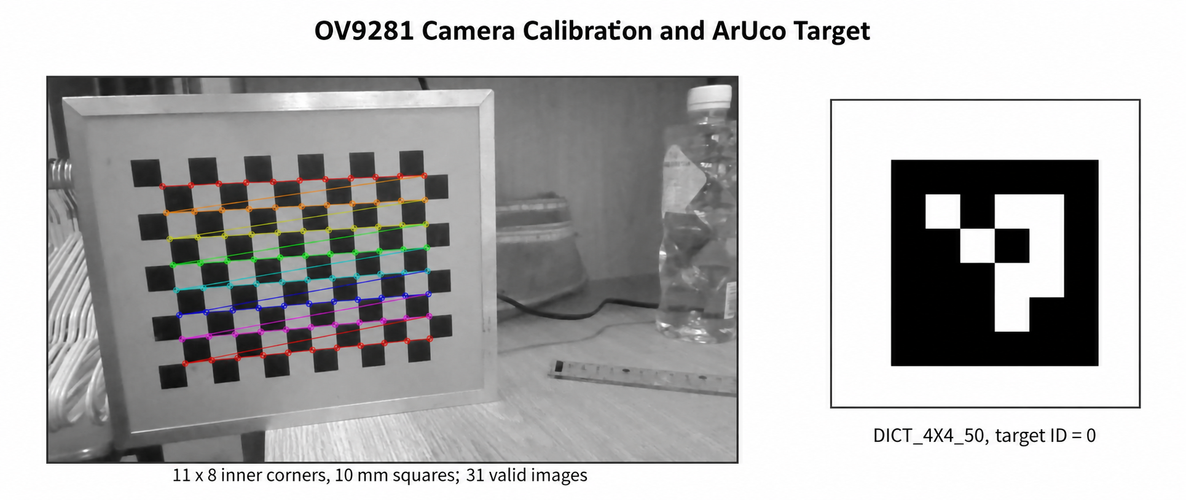
Figure 4-6 OV9281 checkerboard calibration and ArUco target

4.5.2 ArUco PnP Pose Estimation
The controller uses DICT_4X4_50 with target ID 0. MARKER_LENGTH is 0.068 m, measured across the black encoded square; the white border is excluded. After detecting four image corners, the program constructs four 3D points around the marker center and solves:
$$s [u v 1]ᵀ = K [R | t] [X Y Z 1]ᵀ$$
$$t = [x y z]ᵀ, distance = \sqrt{(x² + y² + z²)}, bearing = atan2(x, z)$$
The program first uses IPPE_SQUARE for the planar square and falls back to ITERATIVE on failure. Here x is lateral displacement relative to the camera optical axis, and z is distance along that axis.

4.5.3 Visual Control Strategy and Parameters
Table 4-5 ArUco docking control parameters
Parameter | Current setting | Purpose
MAX_DOCK_DISTANCE | 3.0 m | Wait for Nav2 beyond this distance
STOP_DISTANCE | 0.16 m | Stop when this distance is reached
ALIGN_ENTER / EXIT | 0.030 / 0.018 m | Hysteresis thresholds for entering and leaving alignment mode
POSE_FILTER_ALPHA | 0.25 | First-order low-pass filtering of x and yaw
BEARING_DEADBAND | 1.2° | Set small angular errors to zero
ALIGN_REVERSE_SPEED | −0.018 m/s | Reverse slowly while steering for larger errors
REVERSE_SPEED | −0.03 m/s | Normal reverse speed once approximately centered
MAX_TURN_SPEED | 0.12 rad/s | Maximum steering command
ANGULAR_SLEW_RATE | 0.35 rad/s² | Limit the rate of change of the steering command
CMD_PUBLISH_HZ | 15 Hz | Velocity publication frequency

4.6 ESP32 S3 Charging Station Implementation

4.6.1 Hardware Modules and Pin Connections
Table 4-6 Main charging station hardware modules
Module | Function | Interface or connection
ESP32-S3-DevKitC-1 | Sensor acquisition, state machine, Wi-Fi, display, and control | ESP32-S3-WROOM-1
VL53L1X ToF | Close-range distance and validity checks | I2C: SDA GPIO13, SCL GPIO14
Microswitch | Mechanical position confirmation through insulated actuator | GPIO1, active low
INA226 | Bus voltage, current, and power | I2C address 0x40; 0.01 Ω shunt resistor
NTC | Copper-contact temperature | GPIO4 ADC; 10 kΩ, B = 3950
Emergency stop | Highest-priority manual stop | GPIO42, normally closed wiring
Optoisolated relay | Switch the positive main charging conductor | GPIO21; normally open COM–NO contacts
TFT and knob | Local status and parameter display | SPI GPIO5/6/7/15/16; knob GPIO17/18/8/9
LEDs and buzzer | Status, heartbeat, warnings, and faults | LEDs GPIO39/40/41; buzzer GPIO2

4.6.2 NTC Measurement of Copper Contact Temperature
The NTC is connected as a voltage divider. A 10 kΩ fixed resistor connects to 3.3 V, with the NTC between the resistor and ground. The junction connects to the GPIO4 ADC input. The divider voltage is used to calculate NTC resistance and convert it to temperature.
To reduce supply fluctuations and ADC noise, the firmware averages 16 consecutive readings per measurement. It also retains raw ADC values, divider voltage, and calculated NTC resistance for sensor and wiring diagnostics.
NTC resistance is calculated as follows:
$$R_{NTC}=R_{fixed}\frac{V_{ADC}}{V_{CC}−V_{ADC}}$$
where:
$$R_{fixed}=10,000 Ω, V_{CC}=3300 mV$$
Therefore:
$$R_{NTC}=10000×\frac{V_{ADC}}{3300−V_{ADC}}$$
Temperature is then calculated using the NTC Beta model:
$$\frac{1}{T}=\frac{1}{T_{0}}+\frac{1}{B}\ln\left(\frac{R_{NTC}}{R_{0}}\right)$$
The system checks measurement validity. An ADC voltage near 0 V or 3.3 V, or a calculated temperature outside −40 to 125 °C, indicates a wiring fault or invalid measurement.
The thresholds have been tested and calibrated. At 45 °C, the system issues a temperature warning. At 55 °C, it stops charging and enters overtemperature protection. Figure 4-7 shows the divider measurement and temperature-conversion process.
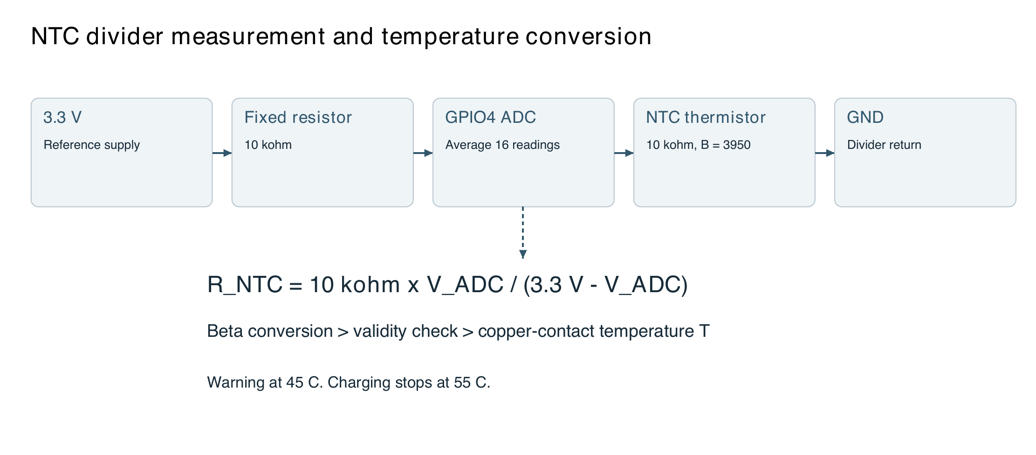
Figure 4-7 NTC divider measurement and temperature conversion

4.6.3 Local Safety State Machine
The ESP32 state machine contains IDLE, WAIT_CAR, POSITION_CHECK, SAFETY_CHECK, READY_TO_CHARGE, CHARGING, COMPLETE, STOPPED, and FAULT. At startup, the relay is forced open. Charging is permitted only after all safety conditions remain valid for 600 ms. After entering CHARGING, the controller requires at least 60 s of charging before evaluating completion. Completion is detected when bus voltage is approximately 23 V or higher but no more than 28.0 V and absolute current remains below the configured threshold, approximately 0.2 A, for 90 s. The relay then opens and the state changes to COMPLETE. Figure 4-8 shows the state machine.
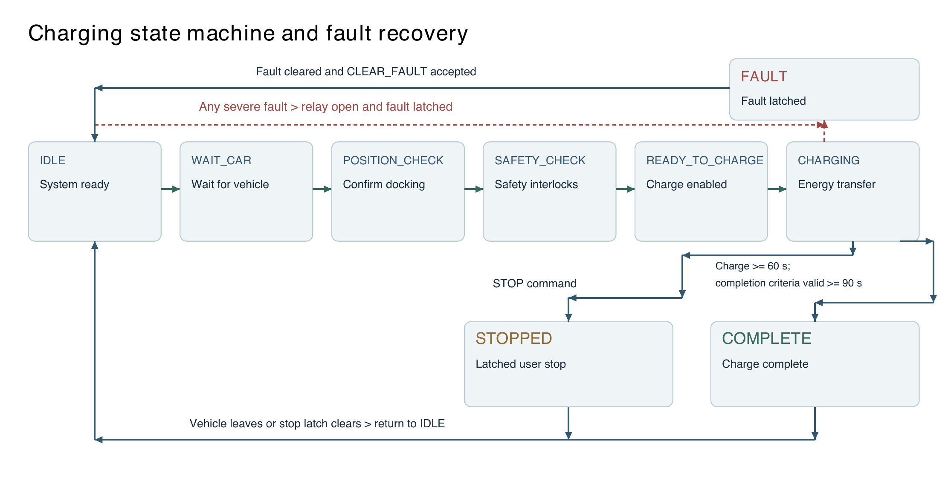
Figure 4-8 ESP32 charging startup and fault shutdown interlocks
Figure 4-9 shows the measured response to an emergency stop. The TFT displays State = FAULT, Fault = EMERGENCY_STOP, E-Stop = ACTIVE, Relay = OFF, and Buzzer = ALARM, confirming relay disconnection and an audible alarm state.
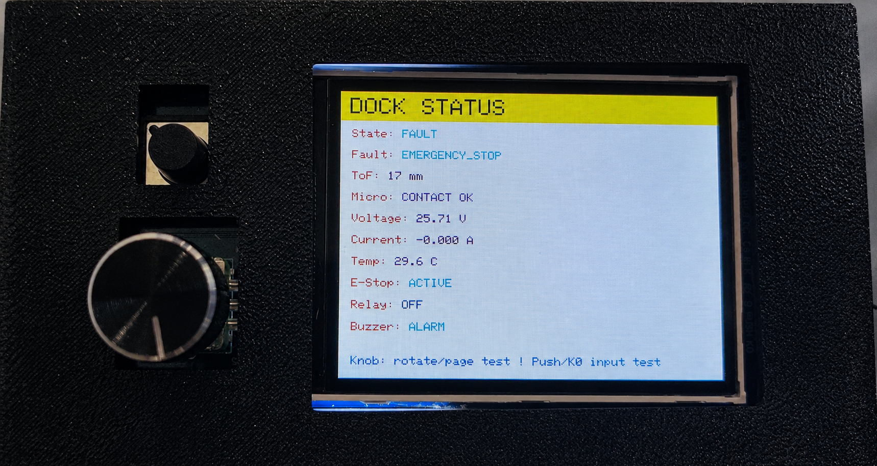
Figure 4-9 Safe shutdown state after an emergency stop

4.6.4 Main Power Circuit and Parallel TVS Protection
The original charger's positive output connects first to the external fuse. Its output node is FUSE_OUT+. An SMBJ33A unidirectional TVS diode is connected between FUSE_OUT+ and main-circuit GND, with cathode at FUSE_OUT+ and anode at GND. The TVS is off during normal charging and conducts during a transient overvoltage to clamp the spike. It does not carry the normal charging current.
FUSE_OUT+ connects in sequence to the XL74610 ideal-diode module, the INA226 shunt, the relay's normally open COM–NO contacts, and the positive compliant copper plate. The XL74610 blocks reverse current. The INA226 senses the shunt voltage drop to measure charging voltage, current, and power. The relay controls the main circuit.
The negative plate connects directly to main-circuit GND, forming a low-resistance return to charger negative. Power ground and control-signal ground follow separate routes and join at one point, reducing charging-current interference with the ESP32 and sensors. Figure 4-10 shows the component order and parallel TVS connection.
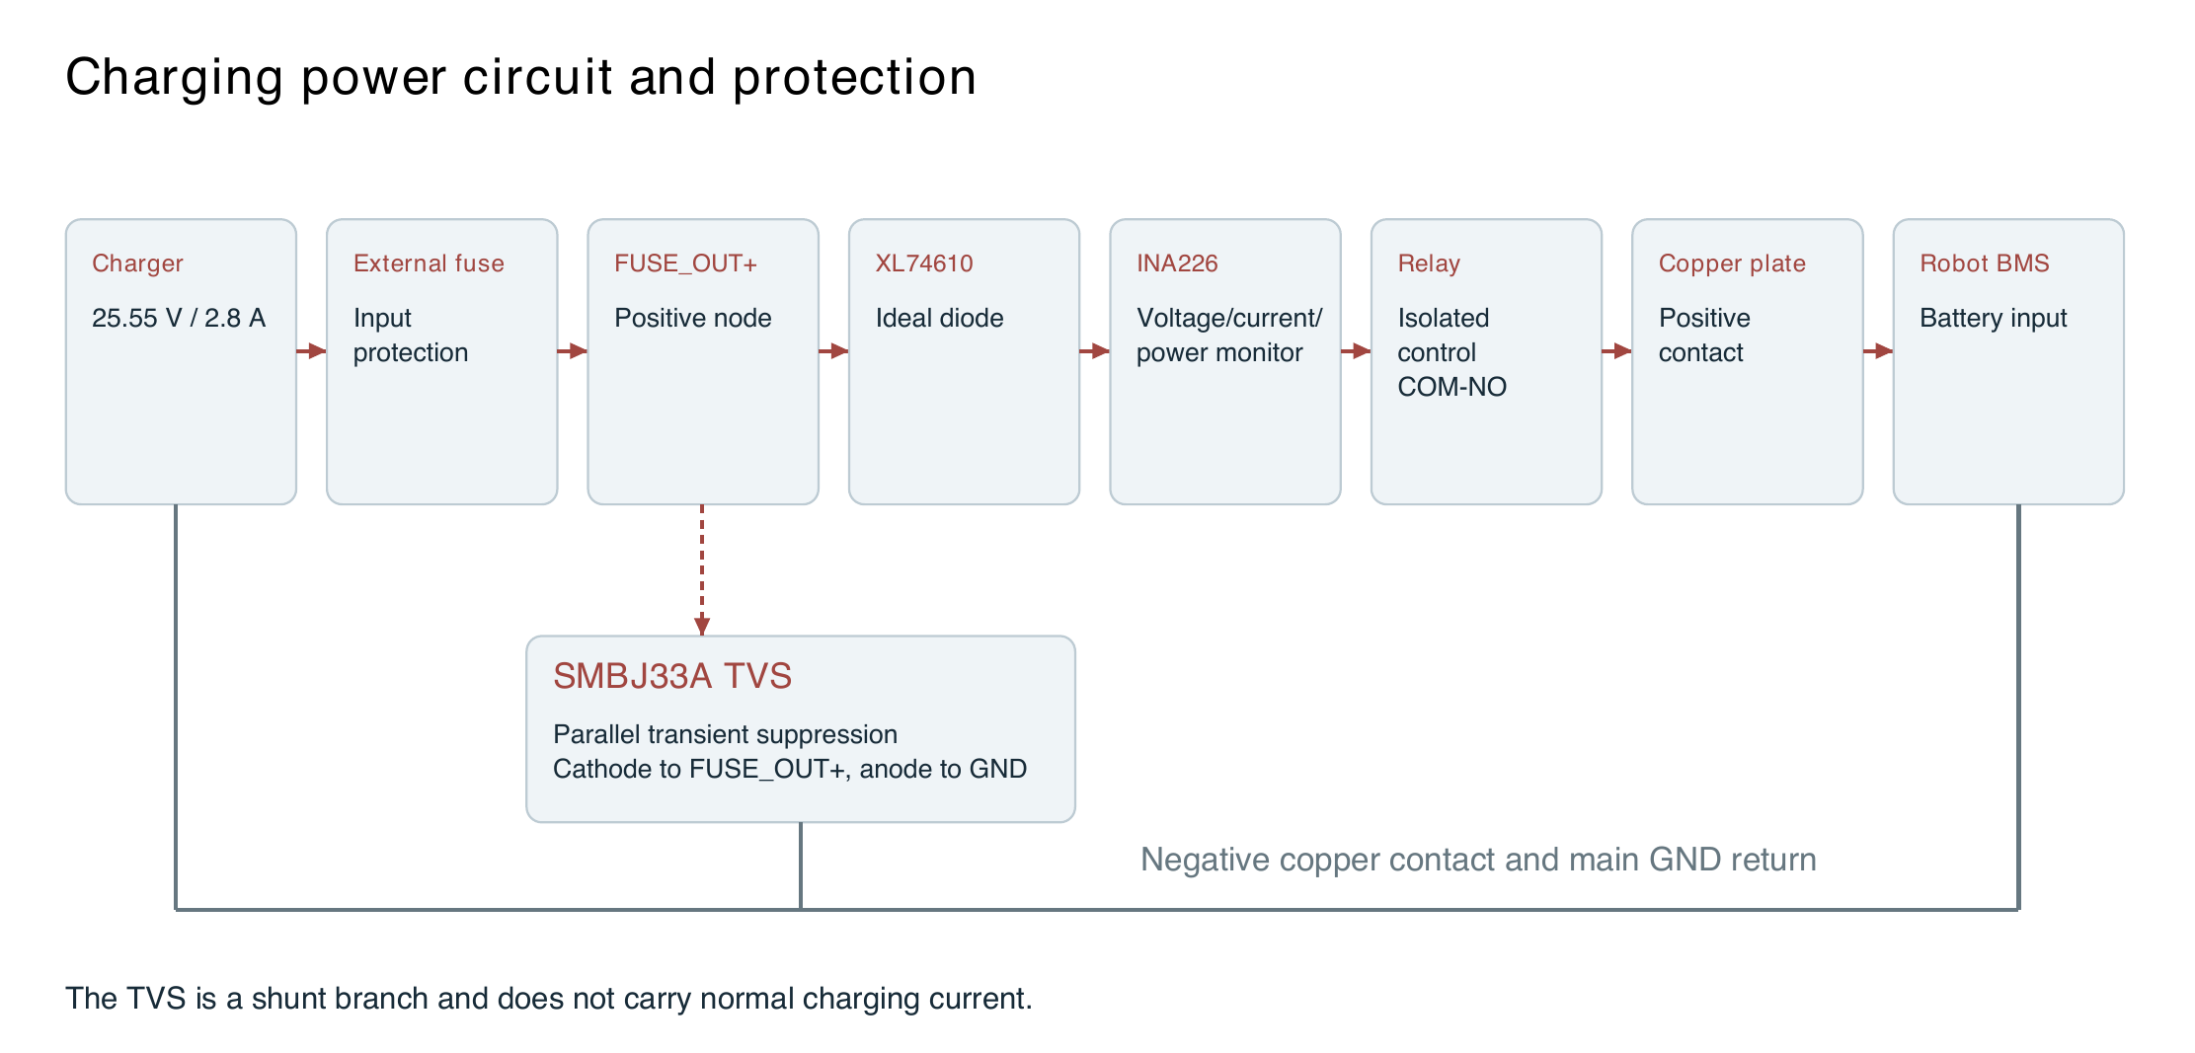
Figure 4-10 Main power circuit and parallel TVS connection

4.6.5 Wi Fi Telemetry and High Level Commands
The ESP32 connects to Wi-Fi after a 3 s startup delay. The current firmware backend address is http://192.168.43.253:8000. It uploads the latest state to POST /api/status every 5 s and retrieves commands from GET /api/command/poll every 1.5 s, with a 500 ms HTTP timeout. The upload queue retains only the latest snapshot so reconnection does not trigger a backlog of stale data.

4.7 Web FastAPI and SQLite Implementation

4.7.1 Robot Data through ROSBridge
The Auto_charge frontend connects to the robot through a rosbridge WebSocket, using port 9090 by default. The implementation subscribes to /PowerVoltage (std_msgs/Float32) and /robot_charging_flag (std_msgs/Bool). It estimates SOC from vehicle voltage using the existing 24 V/6S piecewise curve. The station INA226 voltage is not used for SOC conversion.
Table 4-7 Vehicle voltage to estimated SOC curve
Voltage in V | Estimated SOC in percent
21.0 | 0
21.6 | 10
22.2 | 20
22.8 | 35
23.4 | 50
24.0 | 65
24.6 | 80
25.2 | 100

4.7.2 State Aggregation Interfaces and Database
Table 4-8 Main FastAPI interfaces
Interface | Function
POST /api/status | Receive local ESP32 telemetry
GET /api/status | Aggregate station state, vehicle data, completion estimate, and charging plan
POST /api/vehicle/status | Store vehicle voltage and curve-based estimated SOC
POST /api/config/smart-charge | Enable or disable smart charging and generate a plan
POST /api/location, GET /api/tariff | Location and tariff lookup
POST /api/report/generate | Generate a weekly report
POST /api/command/start|stop|clear-fault | Enqueue high-level commands
GET /api/command/poll | Retrieve pending commands for the ESP32
Table 4-9 Main SQLite tables
Table | Stored data
telemetry | ESP32 state, distance, microswitch, emergency stop, INA226, NTC, relay, and faults
vehicle_telemetry | Vehicle voltage, estimated SOC, and charging state
charge_sessions | Complete sessions derived from charging-state transitions
vehicle_events | Habit samples such as ROS connection and disconnection events
user_config | Charge limit, capacity, maximum power, and usual departure time
smart_charge_plans / runtime | Plans, stages, explanations, and most recent command
command_queue | High-level commands awaiting ESP32 polling
saved_location / ai_reports | Location, tariff context, and reports
Figure 4-11 shows the web charging dashboard. The illustrated state is Charging, with live power of 60.0 W, device temperature of 29.6 °C, stable contact, normal emergency-stop status, and no system fault. It also provides a charge-limit setting and SOC, power, and temperature trends.
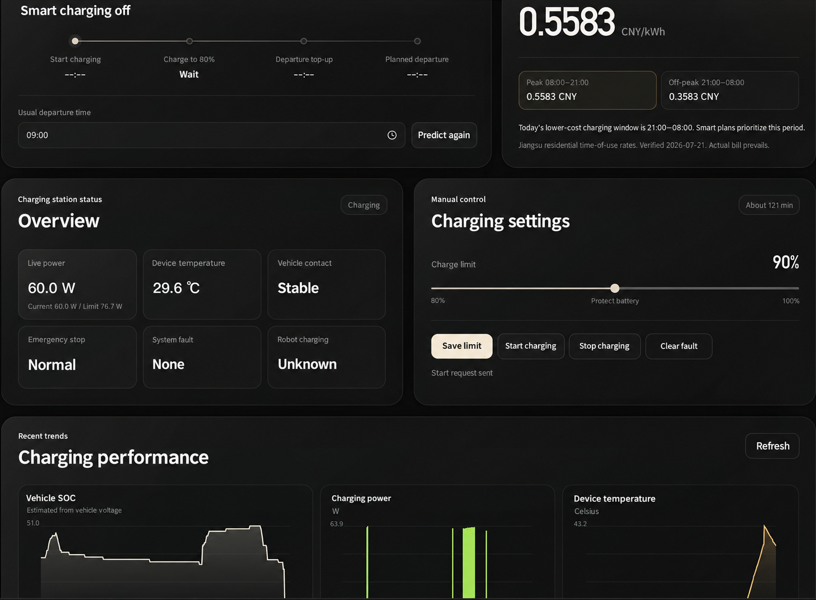
Figure 4-11 Web charging status and control interface with English labels

4.7.3 Charging Plans Tariffs and AI Reports
The backend reads 30 days of sessions and offline-event samples, using DeepSeek or a local median-time rule to generate a plan. The initial target is min(80%, user limit). Top-up duration is estimated from capacity, the target difference, and maximum power, with a 1.25 margin factor. Completion-time estimation uses web-estimated SOC as progress and live station power as the delivery rate, applying weights of 1.2 for 80%–90% and 1.5 for 90%–100%.
The tariff service first uses a configurable live interface; otherwise, it reads tariff_config.json. The model analyzes only structured data provided by the backend and does not independently search for rates. It cannot directly control the relay. Invalid output structures or unverifiable conclusions trigger a local-report fallback.

4.8 Reliability Verification and Test Plan

4.8.1 Tests by Subsystem
Table 4-10 System test plan
Test | Method | Recorded metrics | Acceptance criteria
Localization | Record TF and laser/map alignment in corridors, doorways, and the charging area. | Localization error, TF continuity, AMCL state | No duplicate TF; stable map and sensor alignment
Waypoints | Submit two or three points at different display scales. | Converted coordinates, yaw, current_waypoint, missed_waypoints | Consistent sequence with no silently lost points
Low-battery return | Publish consecutive battery readings above and below the threshold. | Trigger count, cancellation result, return retries | No trigger for confirm_count − 1 samples; one trigger on the fifth
Visual docking | Vary initial x, z, and yaw offsets. | Final distance, lateral error, duration, stopped state | Stable arrival within contact tolerance followed by a stop
Safety interlocks | Individually disconnect ToF, microswitch, NTC, INA226, and emergency-stop circuits. | Relay state, fault code, response time | No energization or immediate disconnection on a critical fault
Network failure | Disconnect Wi-Fi or the backend. | Main loop, safety state, recovery behavior | Network blocking does not interrupt local safety checks
Smart charging | Simulate SOC, power, departure time, and tariffs. | Stage transitions, command deduplication, time estimates | Correct stop at the charge limit or when safety conditions fail

4.8.2 Event Definitions and Acceptance Records
System tests record five distinct events: staging arrival, visual stopping-distance arrival, stable contact, relay closure, and detected charging. Coverage includes repeated waypoint missions, low-battery return, and visual docking from different initial offsets. Records include docking outcome, duration, maximum temperature, fault-shutdown response, and failure cause.

5 Mechanical Design Integration and Applications

5.1 Industrial Design and Mechanical Modeling

5.1.1 Enclosure Layout and Functional Areas
The enclosure front carries positive and negative compliant copper plates and openings for the central microswitch and ToF sensor. The emergency stop, TFT, and status LEDs are placed on the top or side. Internally, high-current, low-voltage-control, and service areas are separated. The fuse, TVS, ideal diode, INA226, and relay follow the main power path, while the ESP32 and small-signal sensors are kept away from high-current connections. Figure 5-1 shows the front structure and component locations.
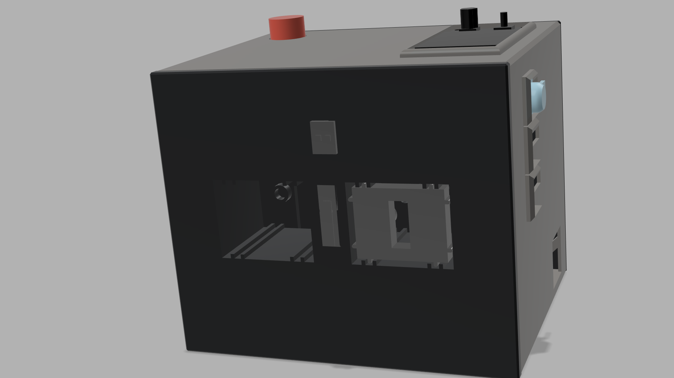
Figure 5-1 Front enclosure model of the charging station

5.1.2 Modular Assembly and Maintenance
Removable panels and modular brackets allow replacement of the ESP32, relay, INA226, step-down module, and sensors. Copper plates, springs, and the actuator have been tolerance-adjusted to the vehicle interface. The camera view avoids reflections and occlusion, and the ArUco black encoded area matches the configured marker size. Figure 5-2 shows the assembly relationship among enclosure, panels, and internal modules.
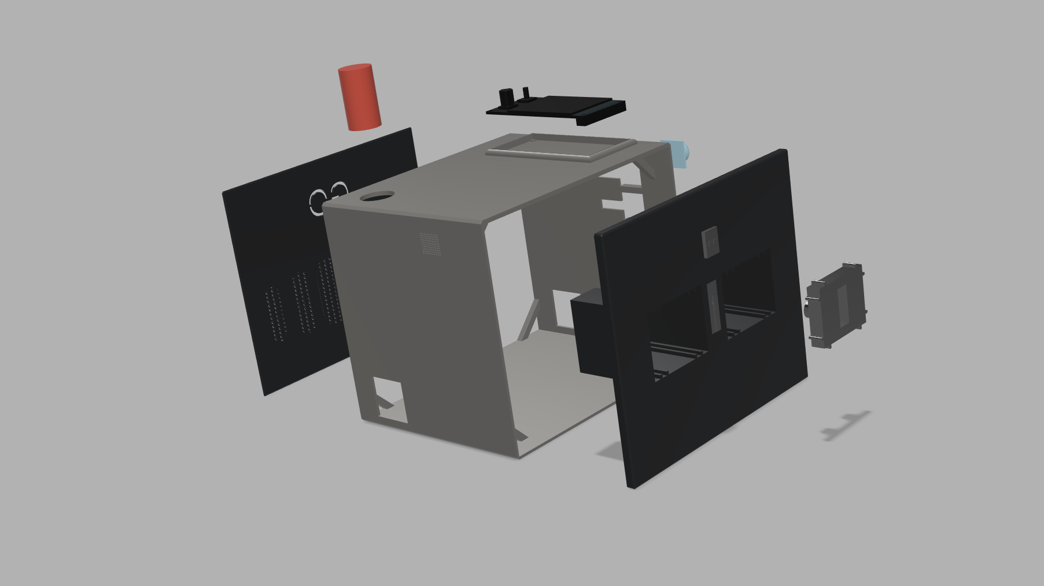
Figure 5-2 Exploded charging station enclosure model

5.2 Main Components
Table 5-1 Main components and maintenance characteristics
Category | Main components or algorithms | Characteristics
Control and interaction | ESP32-S3-DevKitC-1, TFT, LEDs, buzzer | Standard modules for replacement and local diagnostics
Navigation and vision | OV9281 camera and ArUco marker | Separate global and close-range relative localization
Position sensing | VL53L1X and microswitch | Complementary distance and mechanical confirmation
Electrical and temperature sensing | INA226, NTC, emergency stop | Monitor, calibrate, and diagnose critical measurements
Power protection | Fuse, SMBJ33A, XL74610, optoisolated relay, step-down module | Separate protection for transients, reverse current, overcurrent, and control isolation
Contacts and structure | Compliant copper plates, insulated actuator, springs, enclosure, and brackets | Customized to the vehicle interface
Software and services | ROS 2, Nav2, OpenCV, FastAPI, SQLite | Mainly open-source technologies for reproduction and extension

5.3 System Implementation and Integration Results

5.3.1 Implementation and Interface Integration
Table 5-2 Implementation and integration status
Module | Implementation status
Map and Nav2 baseline | Map parameters, TF constraints, Smac Hybrid-A*, and MPPI configured
Waypoint navigation | JSON input, pixel-to-map conversion, PoseArray, yaw completion, and FollowWaypoints implemented
Low-battery return | Consecutive thresholds, cancellation, NavigateToPose, retries, and /start_docking implemented
Camera calibration | 31 valid images; intrinsics and distortion files generated
ArUco docking controller | Independent detection, PnP, low-pass filtering and hysteresis, /cmd_vel, and charging-flag stop
ESP32 charging station | NTC, ToF, microswitch, INA226, emergency stop, state machine, Wi-Fi, and command-handling code
Web management | FastAPI, SQLite, ROSBridge, tariffs, charging plans, and AI report code

5.3.2 System Integration and Parameter Calibration
1. Waypoint and low-battery return functions share one workspace, branch, launch configuration, and parameter set.
2. Persistent waypoint gating during return, occupancy-grid and safety-radius checks, and cancellation confirmation are integrated into mission management.
3. aruco_docking.py subscribes to /start_docking and supplies completion, timeout, reverse retry, and error-code feedback. The mission manager switches /cmd_vel ownership between Nav2 and visual docking.
4. Battery data is managed consistently: /PowerVoltage supplies web SOC display, /battery_status triggers return, and the backend retains source labels while presenting a unified state.
5. ArUco MARKER_LENGTH is set to 0.068 m for the physical black encoded area. STOP_DISTANCE and copper-contact geometry have been calibrated on the vehicle.
6. NTC thresholds, the INA226 fallback charge-completion threshold, staging pose, and station mechanical tolerances have been calibrated using vehicle data.

5.4 Application Value and Future Development

5.4.1 Value for Orchard Operation
Annual agricultural robot sales worldwide are already measured in tens of thousands, while China's fruit industry combines large production volumes, concentrated harvest windows, and intensive labor demand. Autonomous charging therefore has a practical engineering role. By organizing missions around available energy, the system reduces the need to locate robots, connect chargers, and supervise overnight charging, supporting 24-hour readiness and scheduled continuous work. The same framework can also reuse map selection, mission preemption, staging, visual docking, and safe charging in greenhouses, warehouses, and campus delivery routes.

5.4.2 Expansion Capabilities
The task and communication architecture supports further development. Mission Manager arbitrates ordinary and return tasks. Dock Action reports docking stage, error, retry count, and fault codes. Waypoint input includes an OccupancyGrid safety-radius check. The backend and ROS nodes continue receiving robot data when the web page is closed, supporting unattended operation. Interfaces are also reserved for authentication, HTTPS, command auditing, dual NTC sensors, contact-resistance trends, and optimization with measured tariffs.

5.5 Cost per Charging Station
The cost estimate uses the actual installed quantities for one completed station. Table 5-3 divides the materials into electronics, wiring and connectors, and mechanical fabrication.
Table 5-3 Material cost per charging station
Category | Main items | Cost in CNY
Electronics | ESP32-S3 controller, TFT and knob, ToF, microswitch, INA226, NTC, emergency stop, relay, TVS, XL74610, step-down module, LEDs, buzzer, PCB, and soldering supplies | Approx. 350
Wiring and connectors | 18 AWG power wire, 24 AWG signal wire, XT30U connectors, XH2.54 harnesses, KF301 terminals, fuse holder, crimp terminals, and heat-shrink tubing | Approx. 70
Mechanical fabrication | Copper contacts, springs and foam cushioning, insulating parts, fasteners, ArUco marker, and 3D-printed enclosure material | Approx. 180
Total | Materials for one charging station | Approx. 600

References
[1] International Federation of Robotics. Executive Summary World Robotics 2025 Service Robots. Online report, 2025. https://ifr.org/img/worldrobotics/Executive_Summary_WR_2025_Service_Robots.pdf
[2] Department of Agricultural Mechanization, Ministry of Agriculture. Report on the Development of Agricultural Mechanization Science and Technology in China 2015–2016 Part Four. Online report, March 22, 2018. https://njhs.moa.gov.cn/qcjxhtjxd/201803/t20180322_6297041.htm
[3] General Office of the Ministry of Industry and Information Technology and General Office of the Ministry of Agriculture and Rural Affairs. Notice on the Selection of Typical Robot Application Scenarios in Agriculture. Online notice, June 16, 2026. https://njhs.moa.gov.cn/tzggjzcjd/202606/t20260616_6485036.htm

