Librarian Census Report

UP School of Library and Information Studies

2022-07-19

The University of the Philippines School of Library and Information Studies (UPSLIS) conducted a study of Philippine Librarians from November 2018 to October 2019. This endeavor was the first-ever wide-scale study undertaken to collect the occupational profile of Librarians in the Philippines. The survey was designed to be an online questionnaire via Mentimeter and was presented for dissemination during the 2018 Philippine Librarians Association Inc. (PLAI) Congress at Novotel in Quezon City. To further disseminate, the link was posted on the UPSLIS Facebook account and was shared to library association group pages. A total of 685 responses were recorded which is only 7.5% of the almost 9000 registered librarians in the Philippines but can be used in making statistical inference with a 4% margin of error.

# Question: Are you currently a licensed librarian (R.A. 9246) ?

* Yes, I have a valid and up-to-date PRC license for librarians
* No, I have not renewed my license
* No, I have never taken any licensure examination for librarians and/or never applied for a PRC license for librarians

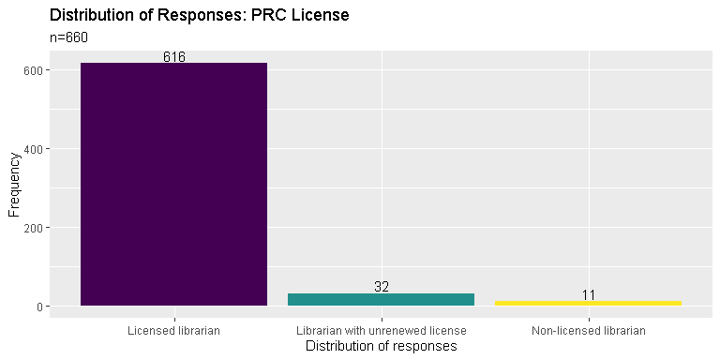

## Question: Are you currently residing in the Philippines?

* Yes, I am currently residing and staying in the Philippines
* No, I am in the Philippines right now but only for vacation
* No, I am currently residing outside the Philippines

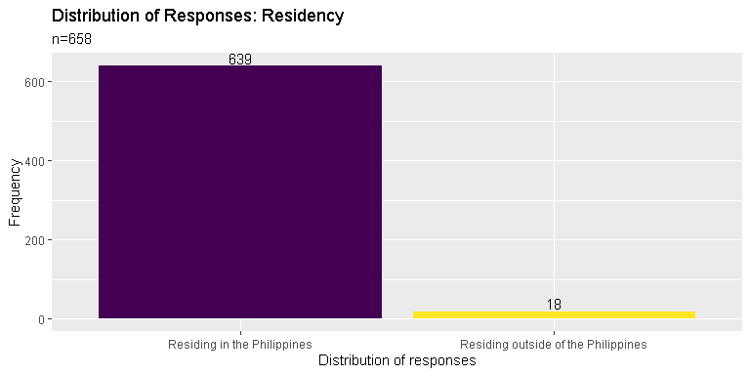

## Question: Kindly indicate which gender you identify the most

* Man
* Woman
* LGBTQ+
* Prefer not to say

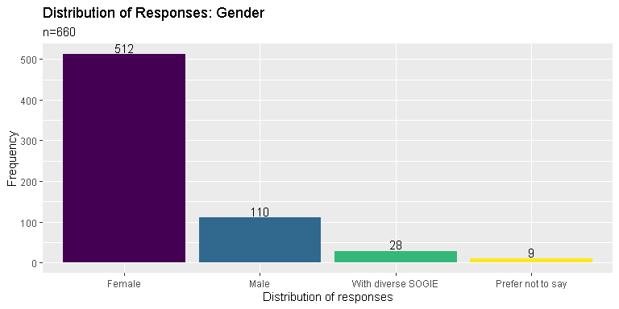

## Question: Kindly indicate your age

## Min. 1st Qu. Median Mean 3rd Qu. Max. NA's   
## 18.0 25.0 31.0 33.8 40.0 100.0 24

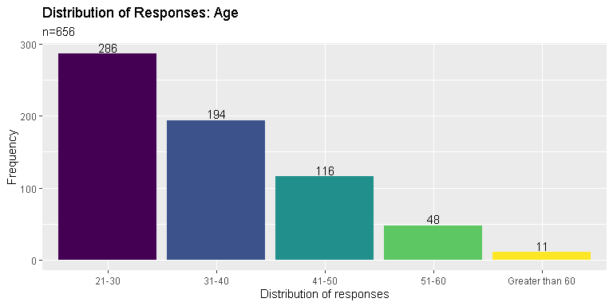

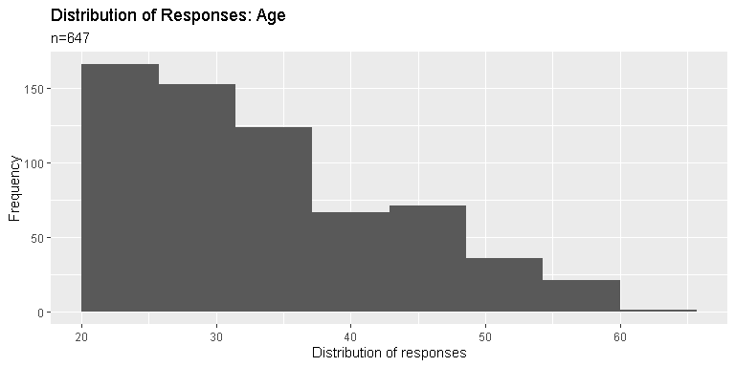

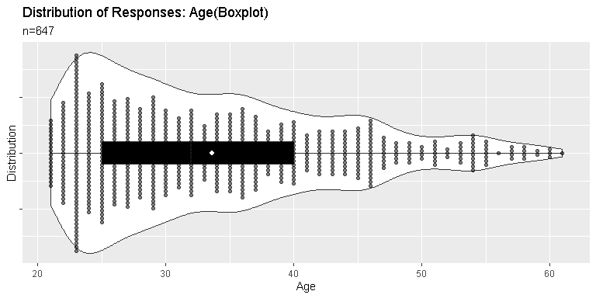

## Question: Are you currently employed and/or working?

* Yes, I am currently employed by an institution, agency, individual or similar.
* Yes, I am currently self-employed and/or doing freelance and consultancy work.
* No, I am currently not working for reasons other than retirement.
* No, I am a retiree.

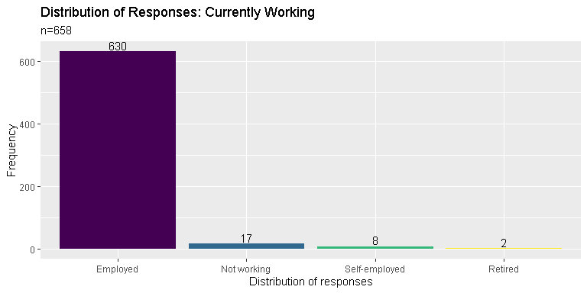

## Question: Kindly indicate the setting, field or industry you are primarily working in

* library
* archives and/or records management
* academic institution (non-librarian position)
* information technology, computer science, software / database engineering and other similar line of work
* museum and heritage work
* social services

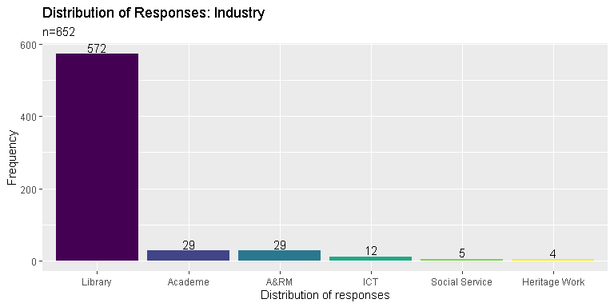

## Question: How long have you been working as a professional after passing the licensure exam for librarians (cumulative years)

## Min. 1st Qu. Median Mean 3rd Qu. Max. NA's   
## 1.00 3.00 7.00 9.21 14.00 60.00 34

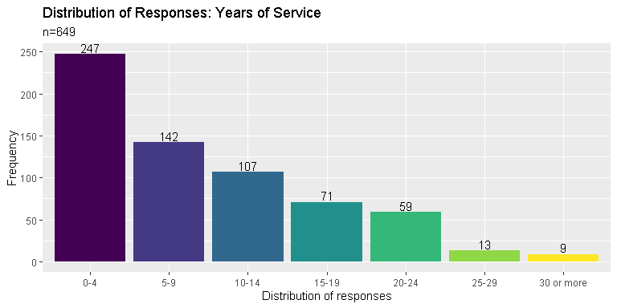

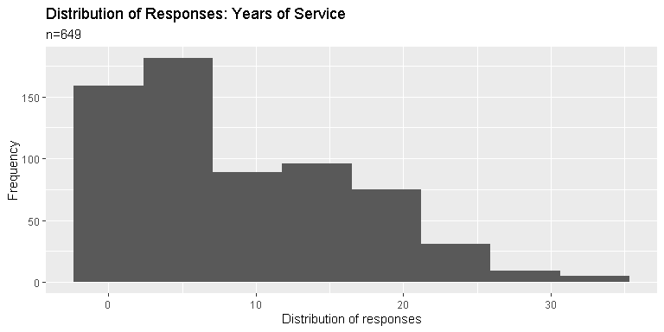

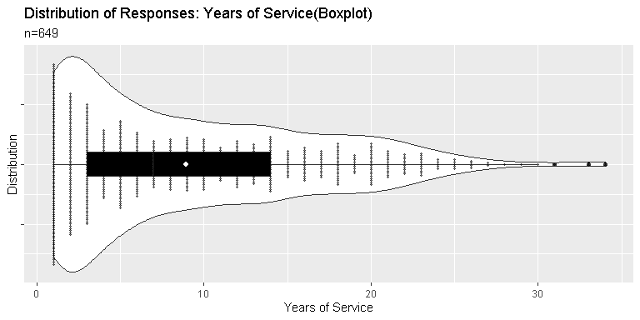

## Question: Kindly indicate the type of institution (in terms of ownership) you are primarily working in

* government
* private (in-house)
* private (BPO)
* non-profit

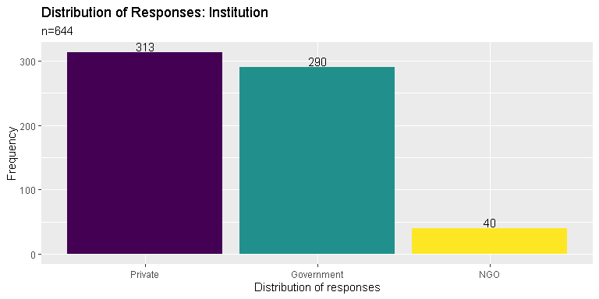

## Question: Kindly indicate your current tenure status

* permanent
* contractual
* voluntary work
* job order (J.O.)
* self-employed, freelancing or working with multiple institutions

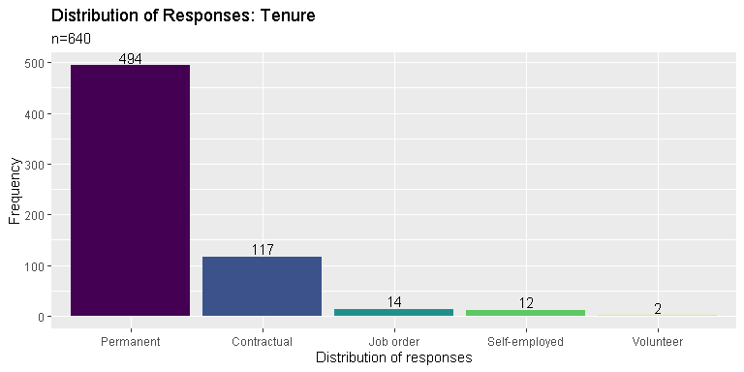

## Question: Kindly indicate your current monthly gross salary or income range (before deductions)

## Min. 1st Qu. Median Mean 3rd Qu. Max. NA's   
## 1.0 17.0 22.0 26.9 30.0 100.0 122

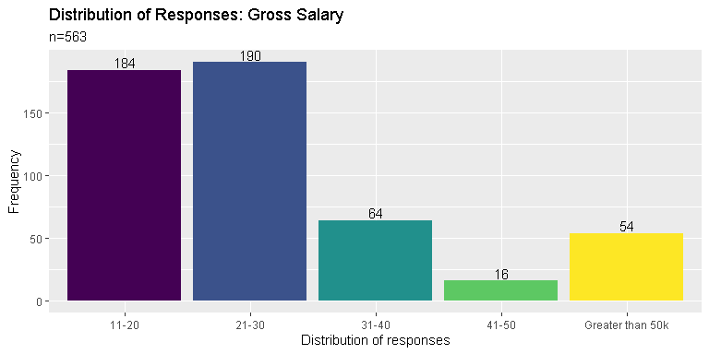

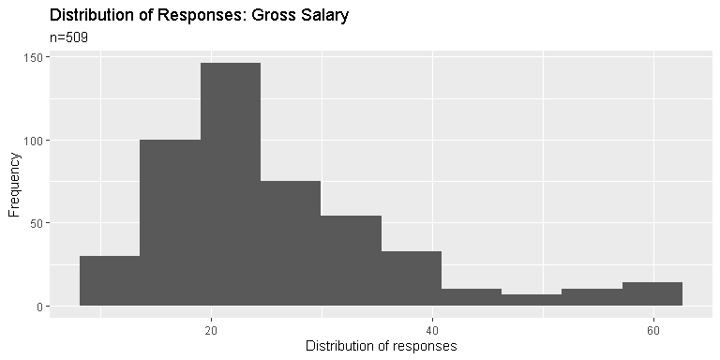

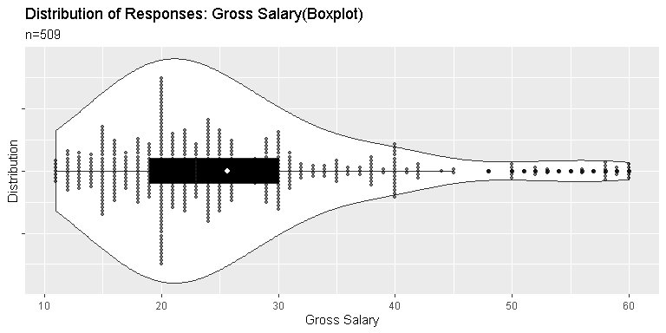

## Kindly indicate your current monthly net salary or income range (after deductions)

## Min. 1st Qu. Median Mean 3rd Qu. Max. NA's   
## 1.0 12.0 18.0 21.1 24.0 100.0 134

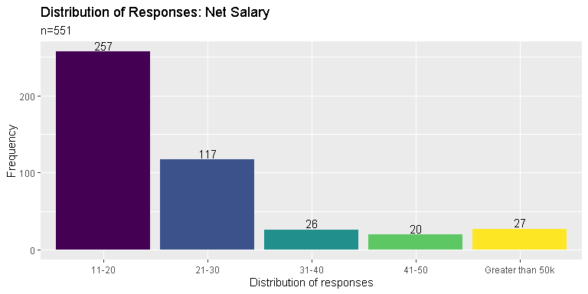

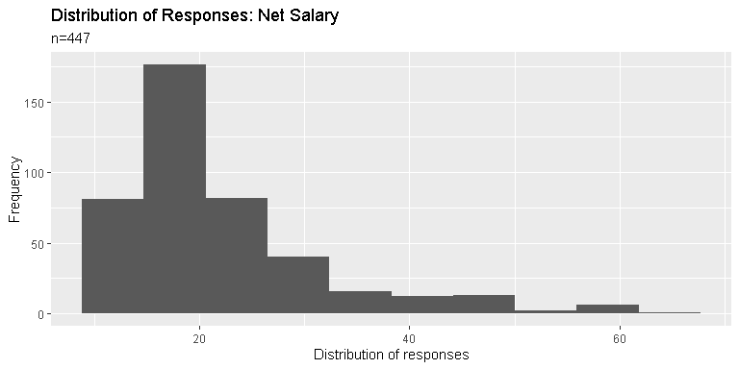

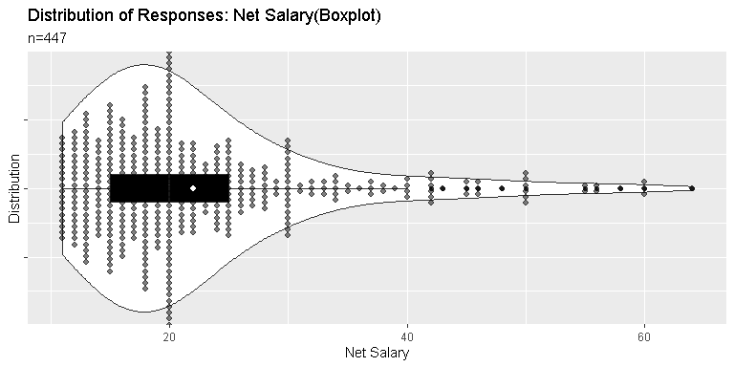

## Question: Kindly indicate additional benefits, if any (please check all that apply)

* free shuttle service
* night differential pay
* paid vacation and/or sick leaves
* health card and/or insurance other than PhilHealth
* monetary allowances
* NONE / Not Applicable

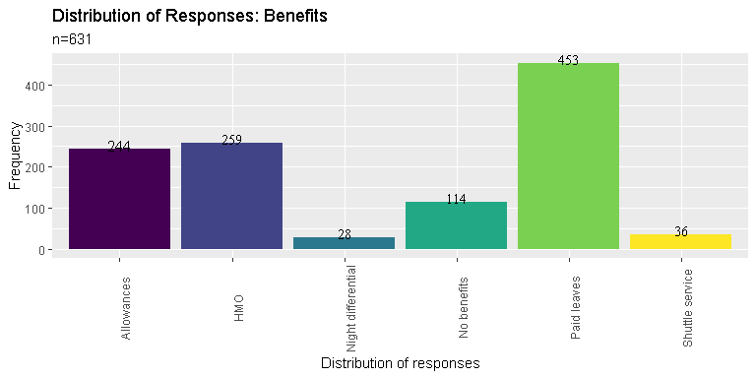

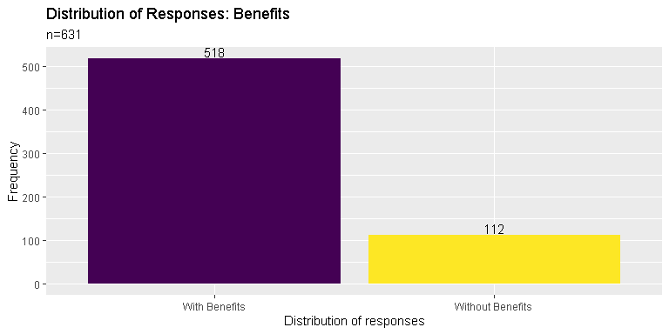

## Question: Other benefits not mentioned in the previous page

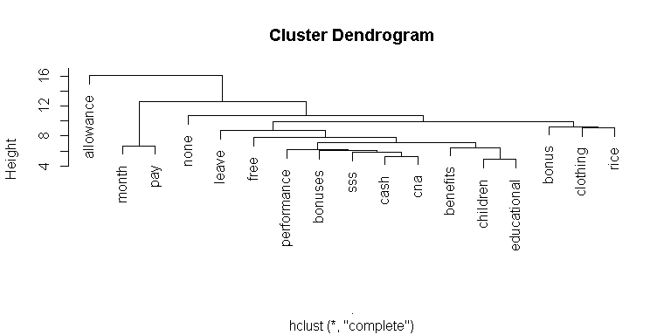

## Question: What kind of materials are you currently working with? Kindly check all that applies.

* hardcopy theses and dissertations
* hardcopy books / pamphlets / etc
* electronic material (digital titles, digital archives, etc)
* law materials and resources
* archives (physical)
* data sets
* institutional files and records
* NA

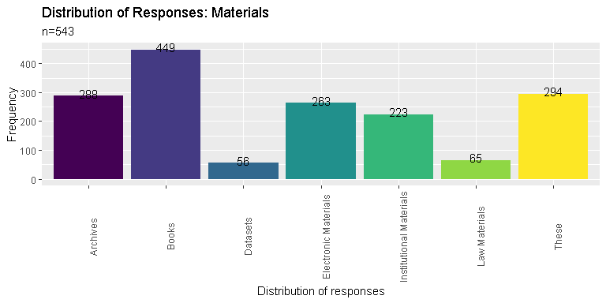

## Question: Kindly indicate your current work position

* entry level / junior staff
* regular / senior staff (non-supervisory)
* supervisory / mid-management level
* upper management level / top tier executive
* consultant / freelancer / self-employed

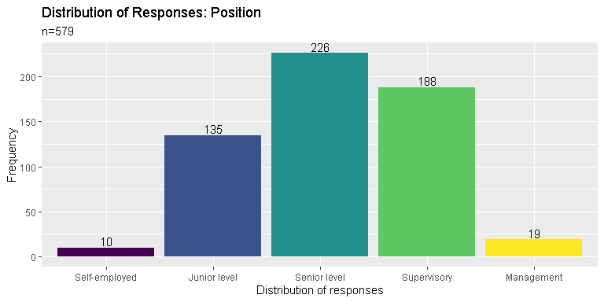

## Question: Within the next five (5) years, do you see your self working in the same industry?

* Yes
* No (planning to shift to other fields or industry)
* Maybe / Undecided

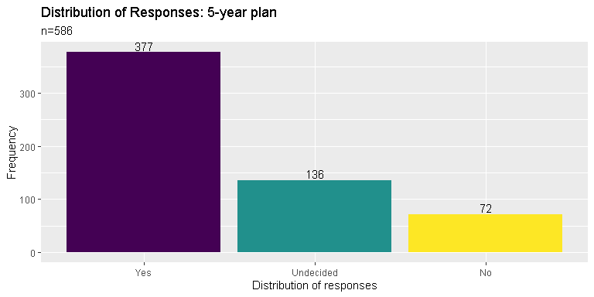

## Question: If your answer was NO or MAYBE in the previous page, indicate the field you wish to pursue

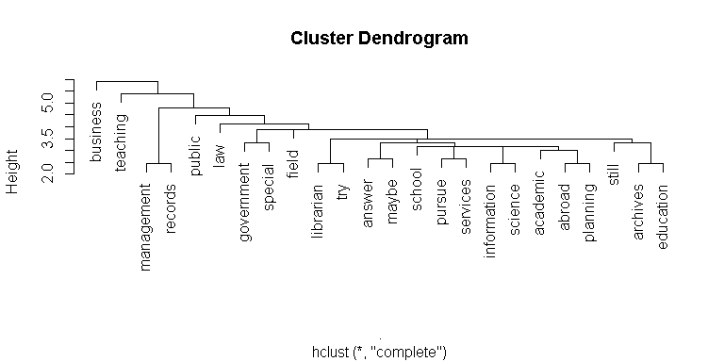

## Question: Kindly indicate your highest educational attainment

* High School
* Bachelor’s degree (BLIS)
* Bachelor’s degree (non-BLIS)
* Master’s degree (MLIS)
* Master’s degree (non-MLIS)
* Juris Doctor / Bachelor of Laws
* Doctor of Philosophy (Ph.D)

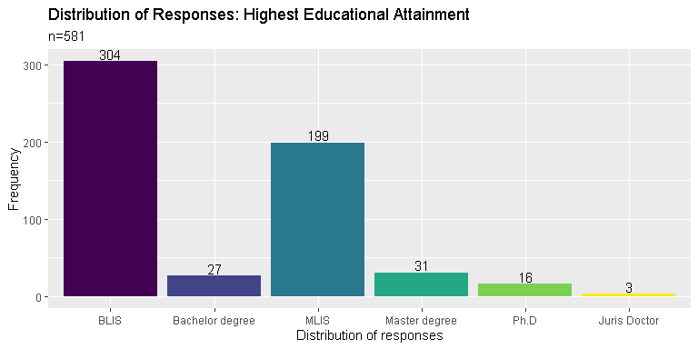

## Question: Are you currently enrolled in formal studies? (Short Courses, Certificate Program, Diploma Program, Master Program, PhD)

* Yes
* No

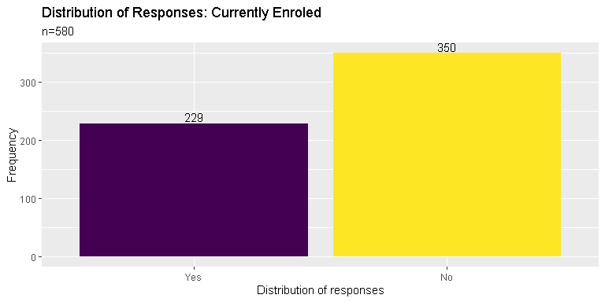

## Question: If your answer was YES, indicate the degree you are currently completing

* Short | Certificate | Diploma Program
* Bachelor’s degree (BLIS)
* Master’s degree (MLIS)
* Master’s degree (non-MLIS)
* Juris Doctor / Bachelor of Laws
* Doctor of Philosophy (Ph.D)
* Post-graduate Certificate or Diploma (LIS)
* Post-graduate Certificate or Diploma (non-LIS)

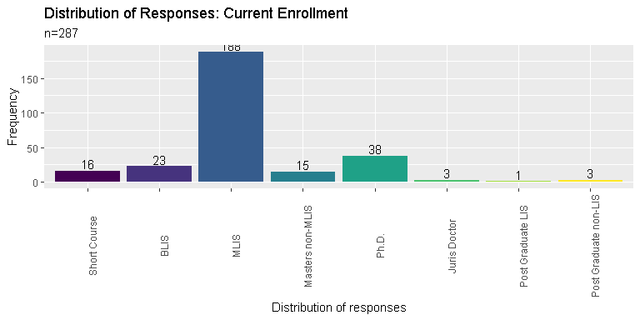

## Question: Are you planning to study again in a formal university setting within the next five (5) years?

* Yes
* No
* Maybe

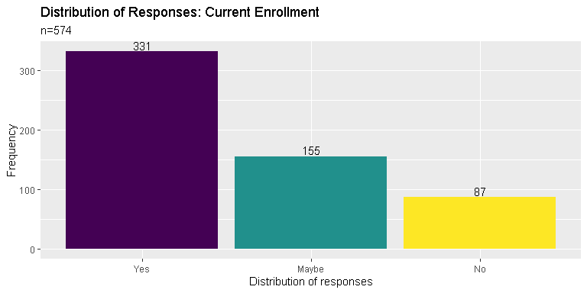

## Question: If your answer was YES, kindly provide the degree you wish to study within the next five (5) years

* Short | Certificate | Diploma Program
* Bachelor’s degree (BLIS)
* Master’s degree (MLIS)
* Master’s degree (non-MLIS)
* Juris Doctor / Bachelor of Laws
* Doctor of Philosophy (Ph.D)
* Post-graduate Certificate or Diploma (LIS)
* Post-graduate Certificate or Diploma (non-LIS)

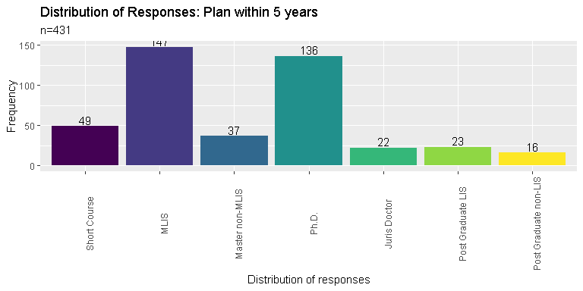

## Question: Where do you usually acquire your CPD trainings in LIS? Kindly check all that applies

* within the work place (in-house trainings)
* government facilitated trainings and symposiums
* trainings and symposiums facilitated by private entities, individuals and/or corporations
* NA (Have not attended CPD Trainings yet)

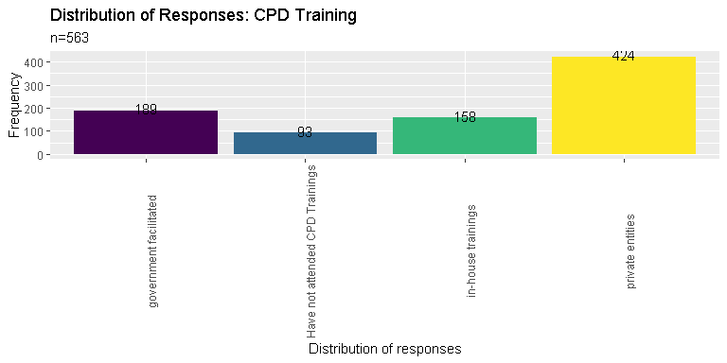

## Where do you usually get funding or support for your trainings in LIS?

* from the work place (private sponsorship)
* from the government (scholarships, free trainings and seminars, etc)
* personal funding (personally attended trainings and symposiums and shouldered most of the expenses)
* NA (Have not attended CPD Trainings yet)

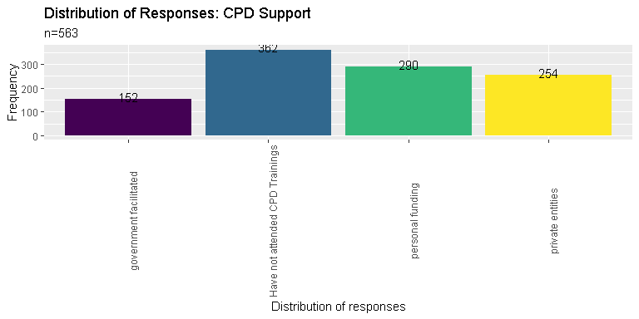

## Question: Are you satisfied with the amount of CPD trainings you have attended for the last two (2) years?

* Yes, the amount of trainings I received within the last two (2) years is enough.
* No, the amount of trainings I received within the last two (2) years is not enough.
* No, the amount of trainings received within the last two (2) years is too much.
* Maybe
* NA (Have not attended CPD Trainings yet)

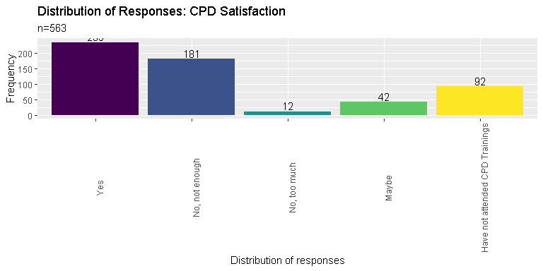

## Question: Kindly indicate any challenges you encounter when fulfilling the required CPD trainings

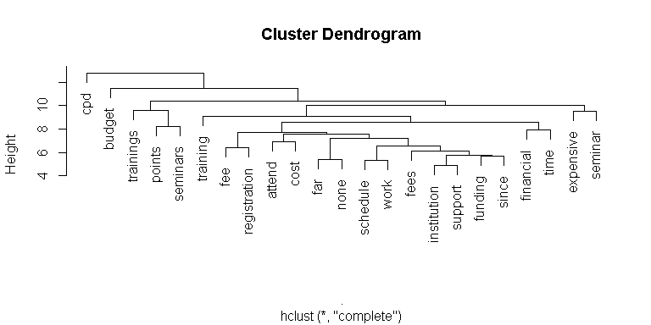

## Kindly indicate any topics you wish to explore in future trainings

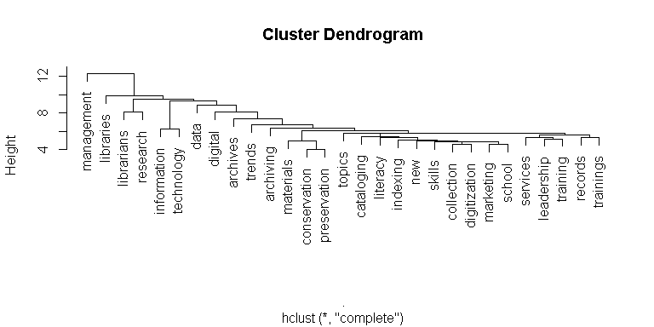

## Kindly indicate your primary work location

* NCR
* Region I
* Region II
* CAR
* Region III
* Region IV
* Region V
* Region VI
* Region VII
* Region VIII
* Region IX
* Region X
* Region XI
* Region XII
* CARAGA
* ARMM

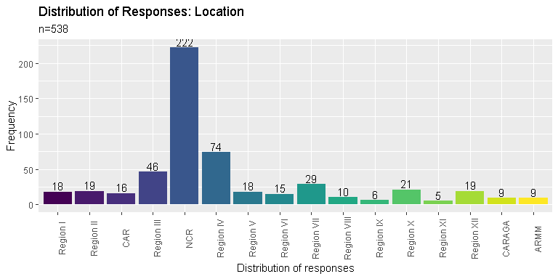

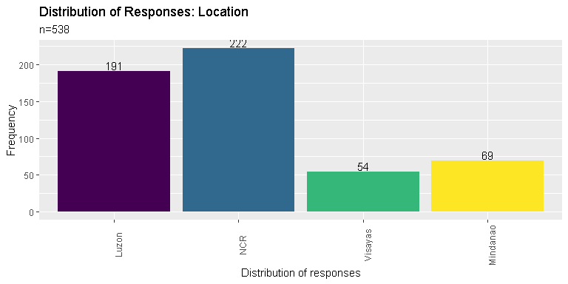

## Question: Have you moved out of your original / permanent residence in order to work on your current work place?

* Yes
* No

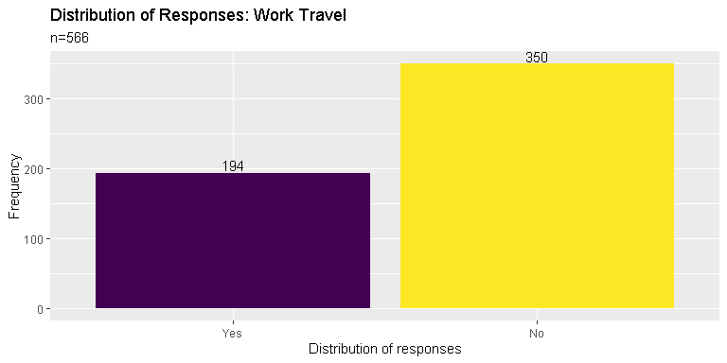

## Is Filipino / Tagalog your native language?

* Yes
* No

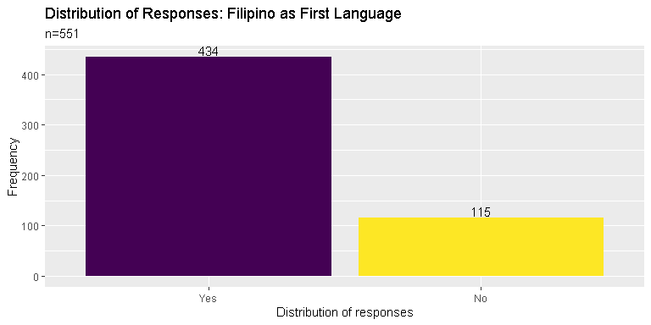

## Kindly check the local languages or dialects you can speak on a conversational level other than Filipino / Tagalog

* Ilocano
* Cebuano
* Ilonggo
* Kapampangan
* Pangasinense
* Waray
* Bicolano
* Others

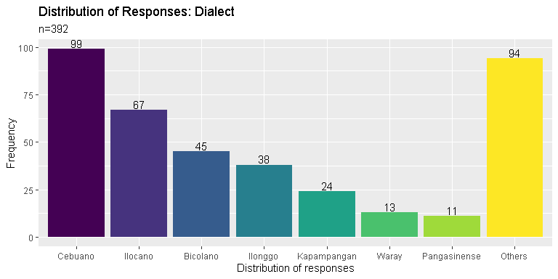

## Kindly indicate any foreign languages or dialects you can speak on a conversational level other than English (if any)

## spanish french ilonggo korean chinese ilocano bahasa chavacano   
## 24 9 8 8 6 6 4 4   
## ibaloi mandarin   
## 4 4

## Kindly indicate the type of library you are currently working in

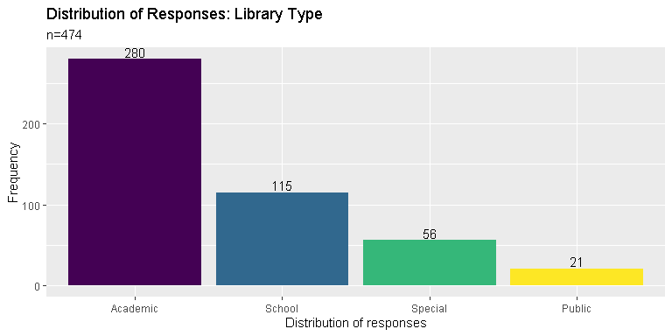

## Other than being a librarian, what other roles do you serve in your institution/ organization?

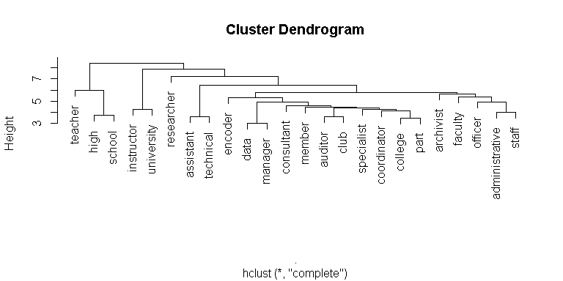

## Kindly indicate your current work position

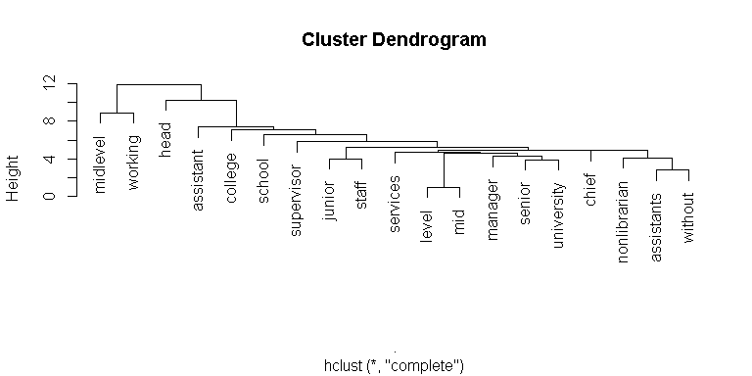

## Kindly indicate your primary job / designation inside the library

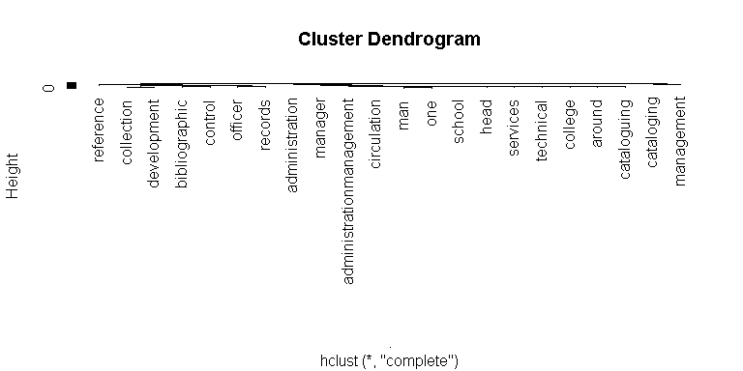

## Kindly indicate your current / existing professional affiliations

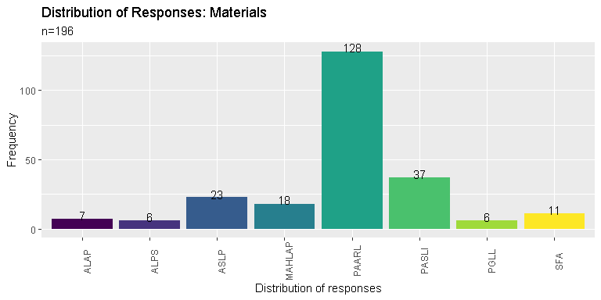

## Kindly indicate what factors influence your decision when it comes to joining a professional organization?

