2019 Librarian Survey Report

### UP School of Library and Information Studies

The University of the Philippines School of Library and Information Studies (UPSLIS) conducted a study of Philippine Librarians from November 2018 to October 2019. This endeavor was the first-ever wide-scale study undertaken to collect the occupational profile of Librarians in the Philippines. The survey was designed to be an online questionnaire via Mentimeter. It was presented for dissemination during the 2018 Philippine Librarians Association Inc. (PLAI) Congress at Novotel in Quezon City. To further disseminate, the link was posted on the UPSLIS Facebook account and was shared on library association group pages. A total of 684 responses were recorded that can serve as a population estimate with a 4% margin of error.

Table of Contents

Background 4

Methodology 4

Instrument 4

Data Gathering 4

Data Cleaning and Preparation 5

Summary of responses 7

Question: Are you currently a licensed librarian (R.A. 9246) ? 7

Question: Are you currently residing in the Philippines? 7

Question: Kindly indicate which gender you identify the most 8

Question: Kindly indicate your age 8

Question: Are you currently employed and/or working? 9

Question: Kindly indicate the setting, field or industry you are primarily working in 10

Question: How long have you been working as a professional after passing the licensure exam for librarians (cumulative years) 11

Question: Kindly indicate the type of institution (in terms of ownership) you are primarily working in 12

Question: Kindly indicate your current tenure status 12

Question: Kindly indicate your current monthly gross salary or income range (before deductions) 13

Kindly indicate your current monthly net salary or income range (after deductions) 14

Question: Kindly indicate additional benefits, if any (please check all that apply) 16

Question: Other benefits not mentioned in the previous page 17

Question: What kind of materials are you currently working with? Kindly check all that applies. 17

Question: Kindly indicate your current work position 18

Question: Within the next five (5) years, do you see your self working in the same industry? 18

Question: If your answer was NO or MAYBE in the previous page, indicate the field you wish to pursue 19

Question: Kindly indicate your highest educational attainment 19

Question: Are you currently enrolled in formal studies? (Short Courses, Certificate Program, Diploma Program, Master Program, PhD) 20

Question: If your answer was YES, indicate the degree you are currently completing 20

Question: Are you planning to study again in a formal university setting within the next five (5) years? 21

Question: If your answer was YES, kindly provide the degree you wish to study within the next five (5) years 21

Question: Where do you usually acquire your CPD trainings in LIS? Kindly check all that applies 22

Where do you usually get funding or support for your trainings in LIS? 23

Question: Are you satisfied with the amount of CPD trainings you have attended for the last two (2) years? 23

Question: Kindly indicate any challenges you encounter when fulfilling the required CPD trainings 24

Kindly indicate any topics you wish to explore in future trainings 25

Kindly indicate your primary work location 25

Question: Have you moved out of your original / permanent residence in order to work on your current work place? 26

Is Filipino / Tagalog your native language? 27

Kindly check the local languages or dialects you can speak on a conversational level other than Filipino / Tagalog 27

Kindly indicate any foreign languages or dialects you can speak on a conversational level other than English (if any) 28

Kindly indicate the type of library you are currently working in 28

Other than being a librarian, what other roles do you serve in your institution/ organization? 29

Kindly indicate your current work position 29

Kindly indicate your primary job / designation inside the library 30

Kindly indicate your current / existing professional affiliations 30

Kindly indicate what factors influence your decision when it comes to joining a professional organization? 31

Report’s Reproducibility and Reuse 32

Accompanying Materials 32

Reference 33

# Background

In 2015, UPSLIS conducted a study to determine the status of archives and records management practitioners in the Philippines. The survey was funded by the National Committee on Archives of the National Commission for Culture and the Arts. The data gathered served as the first comprehensive data of archives and records managers concerning their education, work, and prospects, similar to what this study endeavored to accomplish. The findings became the basis for subsequent training programs for records managers and archivists. The UPSLIS endeavored to conduct the same for librarians with the said accomplishment.

In 2017, Taban (2018) developed a tool for occupational profiling specific to librarians through her undergraduate thesis Occupational Census Profiling Tool for Librarians in the Philippines. This research serves as the tool for this study. Taban's research was guided by Labaw's (1981) framework in the questionnaire design formulation. Labaw posits that the basic principle is for the respondents to define which questions, words, and concepts, among others, can be included. This framework indicates that several pre-tests should be conducted to determine a suitable questionnaire design. With three sets of questionnaires tested among several respondents, the study determined the appropriate ordering of questions, categorization of questions, suitable options or responses, and the like. The third cycle or the third run of the questionnaire was the most appropriate set of questions used in this project.

# Methodology

The study adopted an exploratory, descriptive approach to provide a snapshot of an occupational baseline profile of Filipino Librarians. The project proponents aimed to highlight patterns, outliers, and other observations through the summarization and visualization of the data.

## Instrument

The questionnaire was developed in 2017 through Taban's (2018) thesis. Its goal was to determine the minimum set of questions that would comprise an occupational census questionnaire for librarians. She subsequently tested three questionnaires among several respondents, for which she made revisions based on determining issues and concerns. This study is the first wide-scale survey using the tool, and it may still be revised for improvement. The online tool also has its pros and cons. While it may be convenient distribution, it can also be limited to only those with internet access and digital technologies. We can also interpret outliers as possible incorrect input due to the respondents' unfamiliarity with the tool.

## Data Gathering

The researchers opted to use Mentimeter to provide a real-time visualization report of the data gathered. Also, as presented at a conference, it was hoped that a quick view of the data could be delivered after the participants responded. However, due to lack of time, the questionnaire was only introduced during the 2018 PLAI Congress along with the link. The researchers also posted the survey link in the official Facebook group of the different PLAI regional councils to collect responses from librarians who were not present during the PLAI Congress 2018. A total of 684 responses were recorded that can be used in making statistical inferences with a 4% margin of error.

## Data Cleaning and Preparation

Data collected using Mentimeter were exported via CSV. Upon inspection, the Dataset produces a data frame with 684 rows of individual data and 67 variables.

## Rows: 684 Columns: 67  
## ── Column specification ────────────────────────────────────────────────────────  
## Delimiter: ","  
## chr (62): licensed, philippines, gender, working, industry, institution, ten...  
## dbl (5): voter, age, years_service, gross_salary, net_salary  
##   
## ℹ Use `spec()` to retrieve the full column specification for this data.  
## ℹ Specify the column types or set `show_col_types = FALSE` to quiet this message.

## [1] "voter" "licensed" "philippines"   
## [4] "gender" "age" "working"   
## [7] "industry" "years_service" "institution"   
## [10] "tenure" "gross_salary" "net_salary"   
## [13] "benefits1" "benefits2" "benefits3"   
## [16] "benefits4" "benefits5" "otherbenefits1"   
## [19] "otherbenefits2" "otherbenefits3" "otherbenefits4"   
## [22] "materials1" "materials2" "materials3"   
## [25] "materials4" "materials5" "materials6"   
## [28] "materials7" "othermaterials1" "othermaterials2"   
## [31] "othermaterials3" "othermaterials4" "position"   
## [34] "fiveyears" "pursue" "education"   
## [37] "enrolled" "completing" "study_again"   
## [40] "5yearsdegree" "cpd1" "cpd2"   
## [43] "cpd3" "cpd4" "cpdsupport1"   
## [46] "cpdsupport2" "cpdsupport3" "cpdsatisfaction"   
## [49] "cpdbarriers1" "cpdbarriers2" "cpdbarriers3"   
## [52] "topics1" "topics2" "topics3"   
## [55] "topics4" "topics5" "location"   
## [58] "worktravel" "filipino" "dialect"   
## [61] "foreignlang" "type" "roles"   
## [64] "institutionposition" "primaryjob" "affiliation"   
## [67] "factor"

Rows that only contained timestamp data were deleted as these represents individuals who tried to answer the census but never push through answering majority of the questions. Most of the categorical variables were converted from character type to factor type to reflect the nature of the questionnaire. Categorical variables were also summarized using a bar graphs to highlight the nominal frequency of the responses. Numerical variables were summarized by:

* defining a class interval and creating a bar graph
* through a histogram
* through overlapping a boxplot, violinplot, and dotplot

Statiscal measures were reported unfiltered but the visualizations have the outliers trimmed so that the graphs will not be skewed. Refer to the Codebook on how the numerical variables were trimmed.

For open-ended questions, the researchers use a text-mining approach to analyze the general sentiment of the respondents. Word count and proximity measures were used to generate a dendrogram.

The researchers also created additional variables to ease the process of summarizing the data. For example, a variable age_group was created to convert the numerical nature of librarians age to the following categories:

* 21 to 30
* 31 to 40
* 41 to 50
* 51 to 60
* Greater than 60

The data were processed using:

* RStudio 2022.02.3+492 “Prairie Trillium” Release (1db809b8323ba0a87c148d16eb84efe39a8e7785, 2022-05-20) for Windows (RStudio Team, 2022)
* R-4.2.1 language (R Core Team, 2022)
* tidyverse package version 1.3.2 (Wickham et al., 2019)
* tm package version: 0.7-8 (Feinerer & Hornik, 2020)

# Summary of responses

## Question: Are you currently a licensed librarian (R.A. 9246) ?

* Yes, I have a valid and up-to-date PRC license for librarians
* No, I have not renewed my license
* No, I have never taken any licensure examination for librarians and/or never applied for a PRC license for librarians

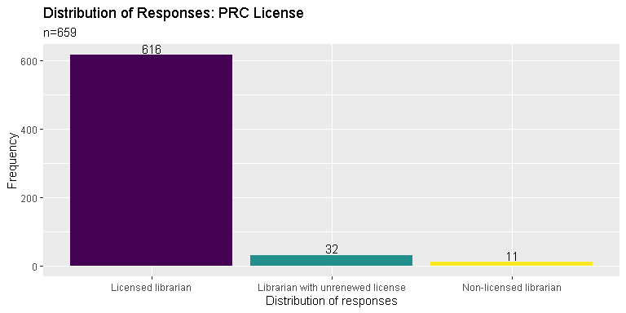

## Question: Are you currently residing in the Philippines?

* Yes, I am currently residing and staying in the Philippines
* No, I am in the Philippines right now but only for vacation
* No, I am currently residing outside the Philippines

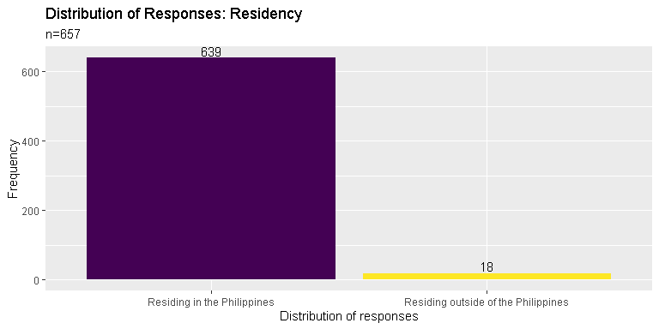

## Question: Kindly indicate which gender you identify the most

* Man
* Woman
* LGBTQ+
* Prefer not to say

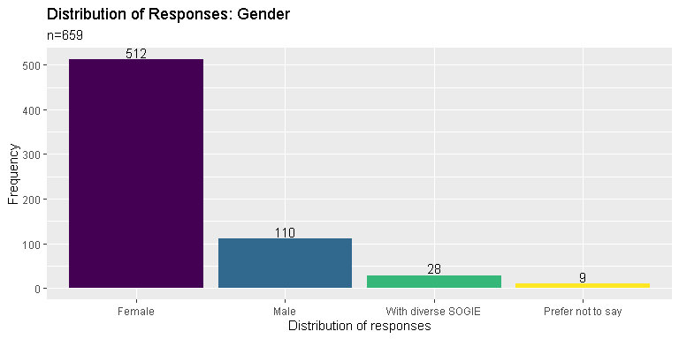

## Question: Kindly indicate your age

## Min. 1st Qu. Median Mean 3rd Qu. Max. NA's   
## 18.0 25.0 31.0 33.8 40.0 100.0 24

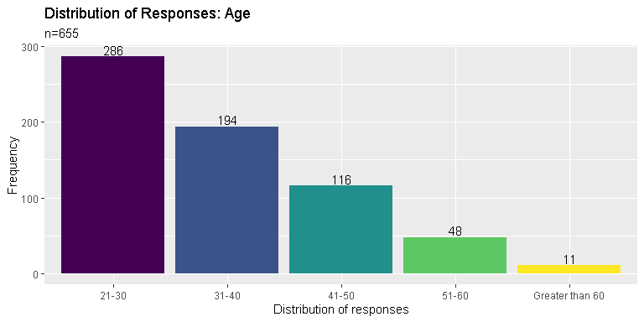

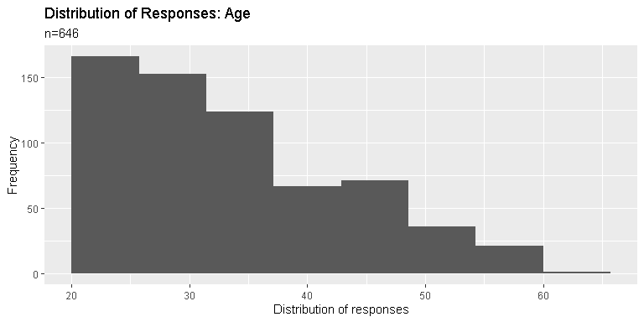

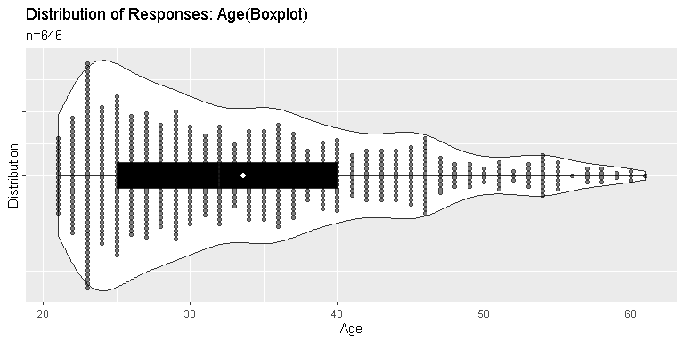

## Question: Are you currently employed and/or working?

* Yes, I am currently employed by an institution, agency, individual or similar.
* Yes, I am currently self-employed and/or doing freelance and consultancy work.
* No, I am currently not working for reasons other than retirement.
* No, I am a retiree.

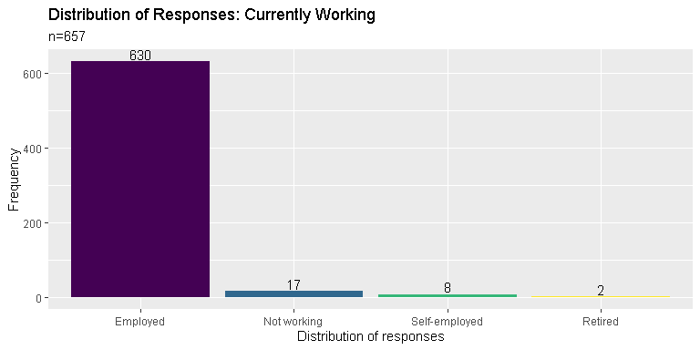

## Question: Kindly indicate the setting, field or industry you are primarily working in

* library
* archives and/or records management
* academic institution (non-librarian position)
* information technology, computer science, software / database engineering and other similar line of work
* museum and heritage work
* social services

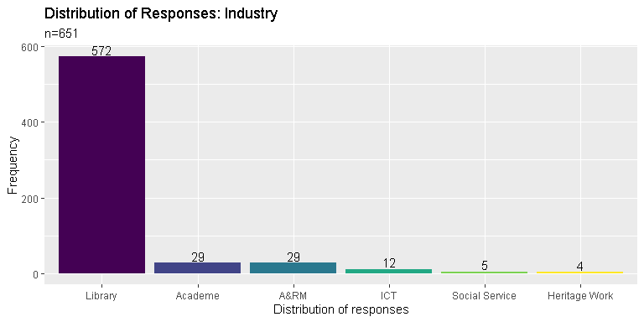

## Question: How long have you been working as a professional after passing the licensure exam for librarians (cumulative years)

## Min. 1st Qu. Median Mean 3rd Qu. Max. NA's   
## 1.00 3.00 7.00 9.21 14.00 60.00 34

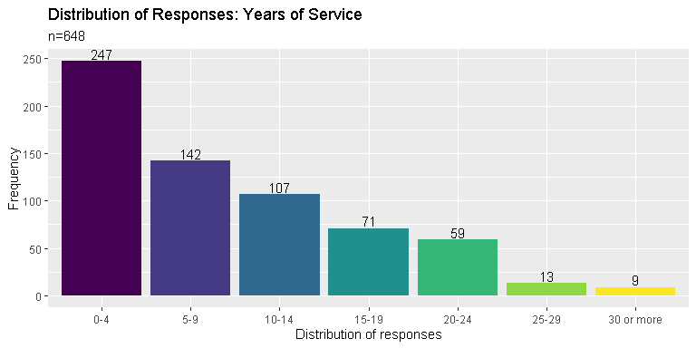

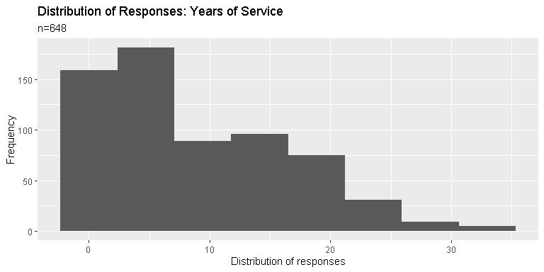

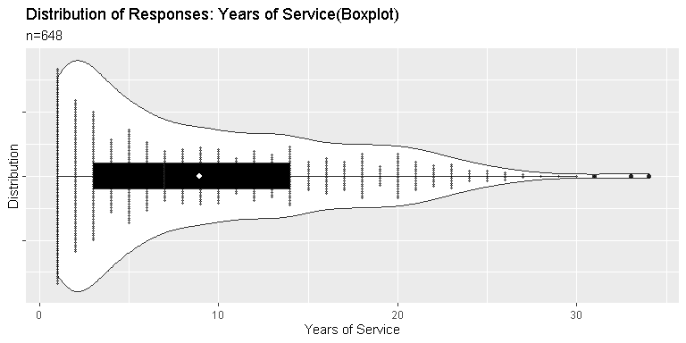

## Question: Kindly indicate the type of institution (in terms of ownership) you are primarily working in

* government
* private (in-house)
* private (BPO)
* non-profit

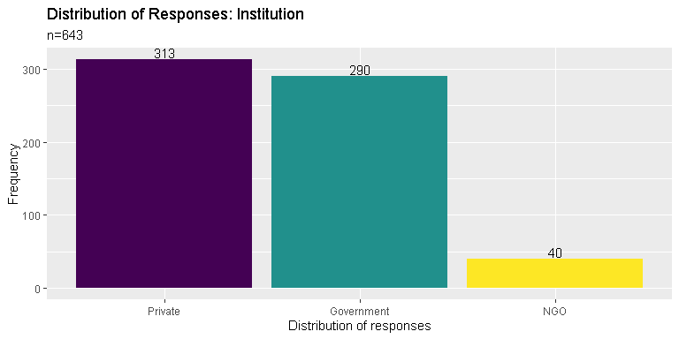

## Question: Kindly indicate your current tenure status

* permanent
* contractual
* voluntary work
* job order (J.O.)
* self-employed, freelancing or working with multiple institutions

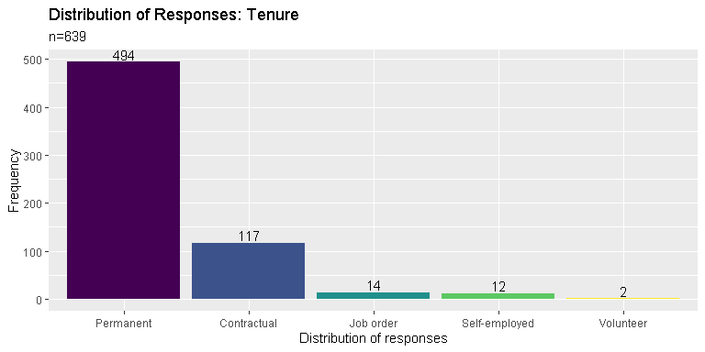

## Question: Kindly indicate your current monthly gross salary or income range (before deductions)

## Min. 1st Qu. Median Mean 3rd Qu. Max. NA's   
## 1.0 17.0 22.0 26.9 30.0 100.0 122

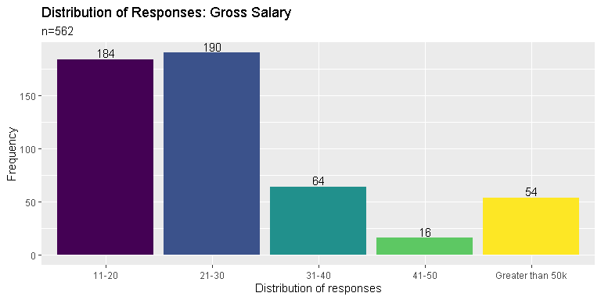

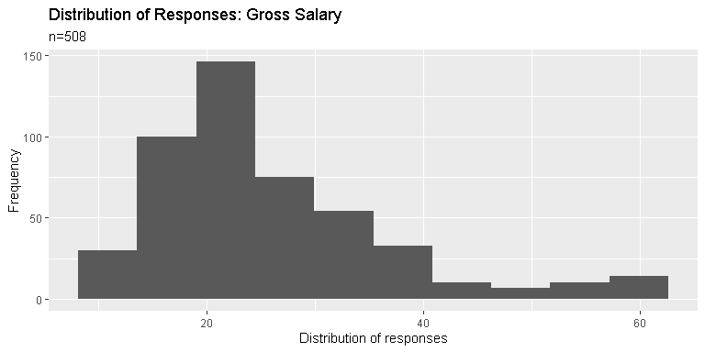

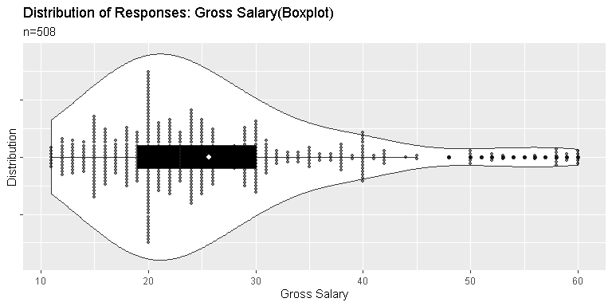

## Kindly indicate your current monthly net salary or income range (after deductions)

## Min. 1st Qu. Median Mean 3rd Qu. Max. NA's   
## 1.0 12.0 18.0 21.1 24.0 100.0 134

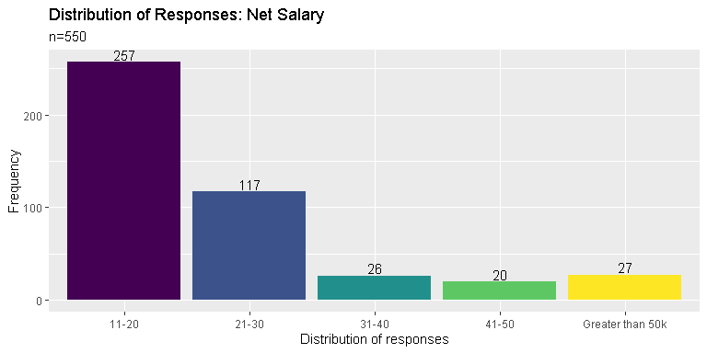

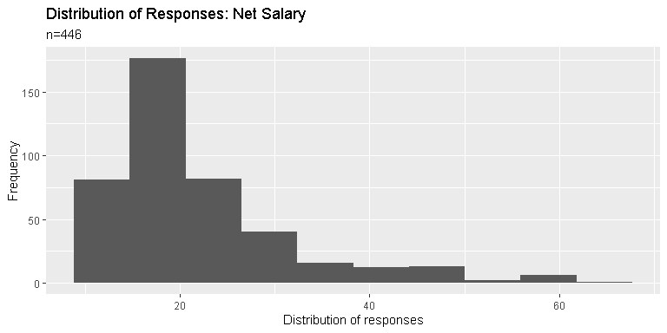

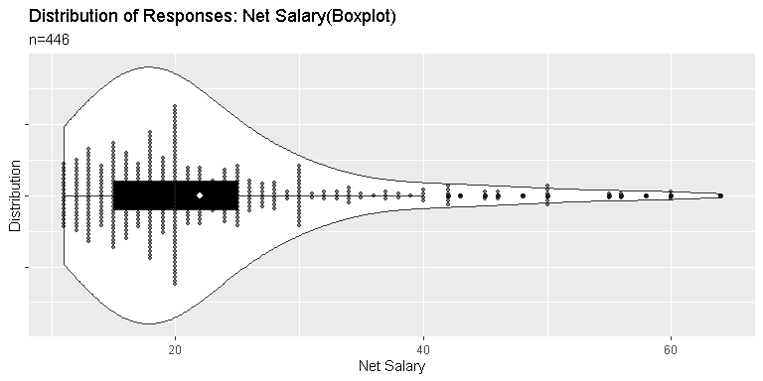

## Question: Kindly indicate additional benefits, if any (please check all that apply)

* free shuttle service
* night differential pay
* paid vacation and/or sick leaves
* health card and/or insurance other than PhilHealth
* monetary allowances
* NONE / Not Applicable

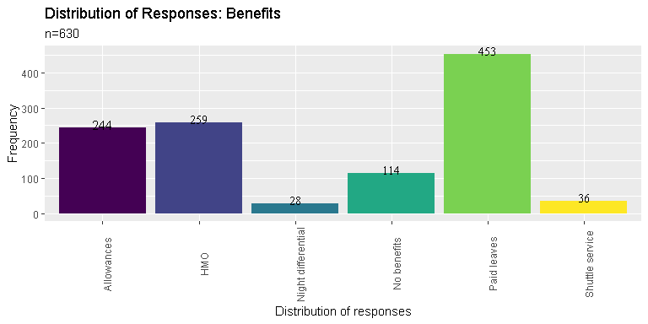

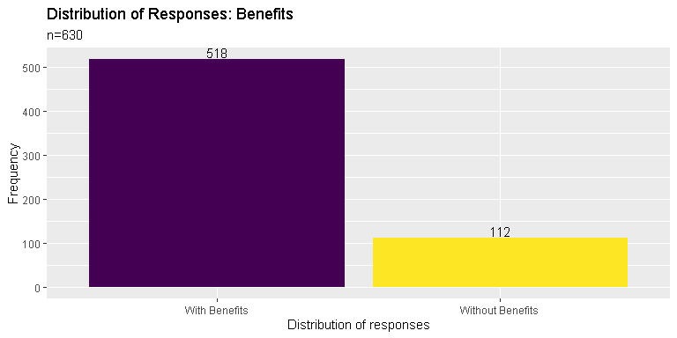

## Question: Other benefits not mentioned in the previous page

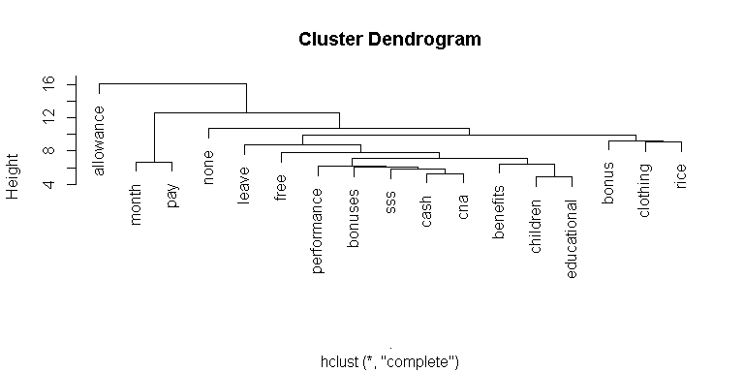

## Question: What kind of materials are you currently working with? Kindly check all that applies.

* hardcopy theses and dissertations
* hardcopy books / pamphlets / etc
* electronic material (digital titles, digital archives, etc)
* law materials and resources
* archives (physical)
* data sets
* institutional files and records
* NA

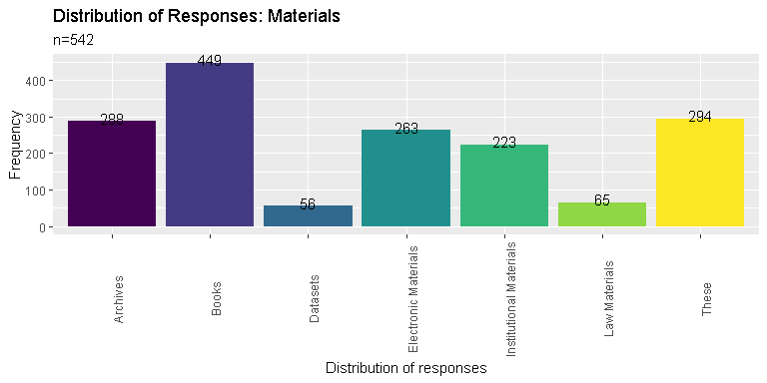

## Question: Kindly indicate your current work position

* entry level / junior staff
* regular / senior staff (non-supervisory)
* supervisory / mid-management level
* upper management level / top tier executive
* consultant / freelancer / self-employed

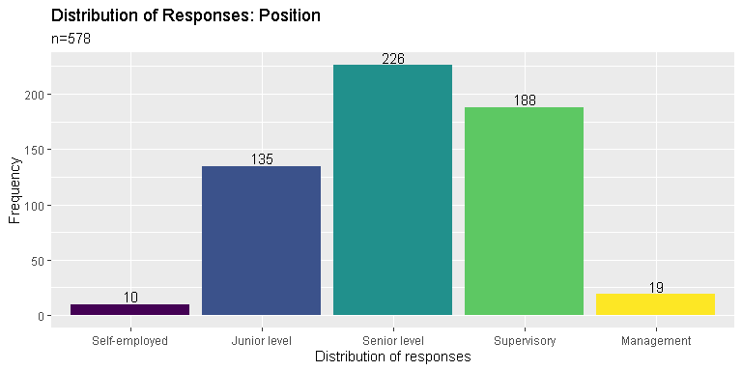

## Question: Within the next five (5) years, do you see your self working in the same industry?

* Yes
* No (planning to shift to other fields or industry)
* Maybe / Undecided

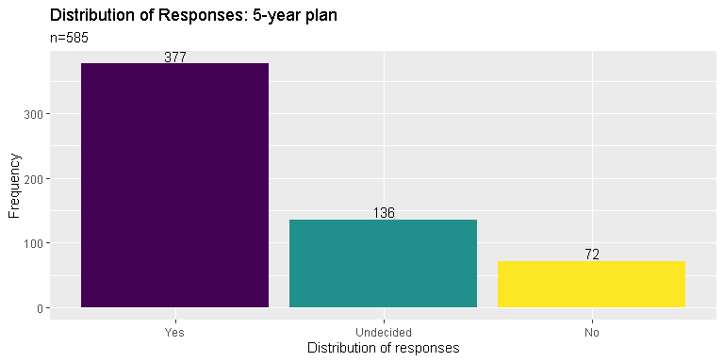

## Question: If your answer was NO or MAYBE in the previous page, indicate the field you wish to pursue

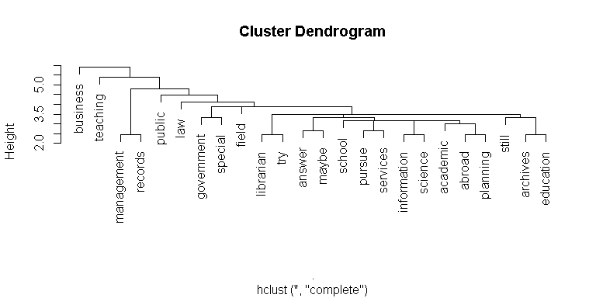

## Question: Kindly indicate your highest educational attainment

* High School
* Bachelor's degree (BLIS)
* Bachelor's degree (non-BLIS)
* Master's degree (MLIS)
* Master's degree (non-MLIS)
* Juris Doctor / Bachelor of Laws
* Doctor of Philosophy (Ph.D)

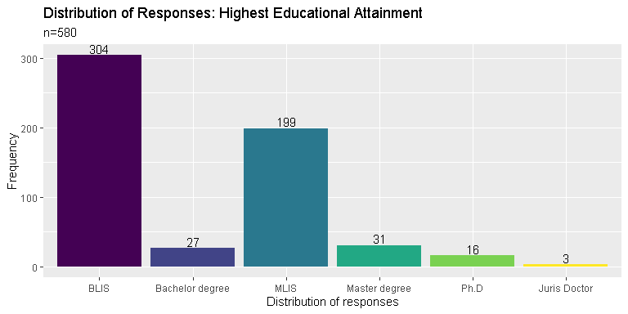

## Question: Are you currently enrolled in formal studies? (Short Courses, Certificate Program, Diploma Program, Master Program, PhD)

* Yes
* No

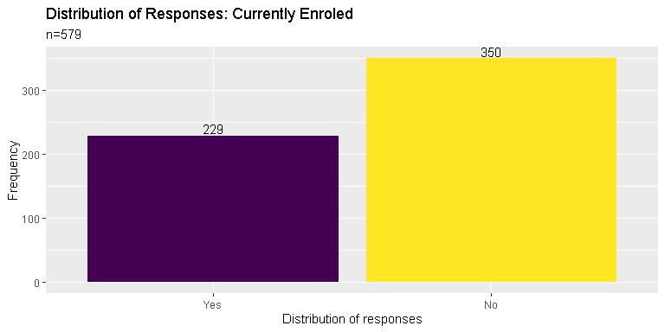

## Question: If your answer was YES, indicate the degree you are currently completing

* Short | Certificate | Diploma Program
* Bachelor's degree (BLIS)
* Master's degree (MLIS)
* Master's degree (non-MLIS)
* Juris Doctor / Bachelor of Laws
* Doctor of Philosophy (Ph.D)
* Post-graduate Certificate or Diploma (LIS)
* Post-graduate Certificate or Diploma (non-LIS)

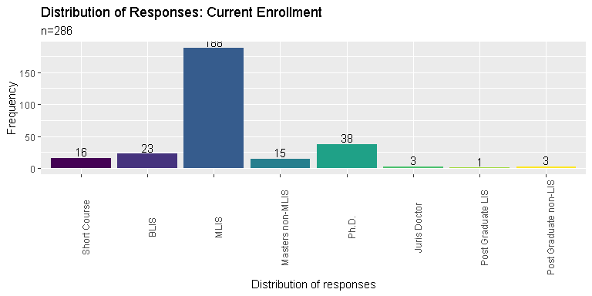

## Question: Are you planning to study again in a formal university setting within the next five (5) years?

* Yes
* No
* Maybe

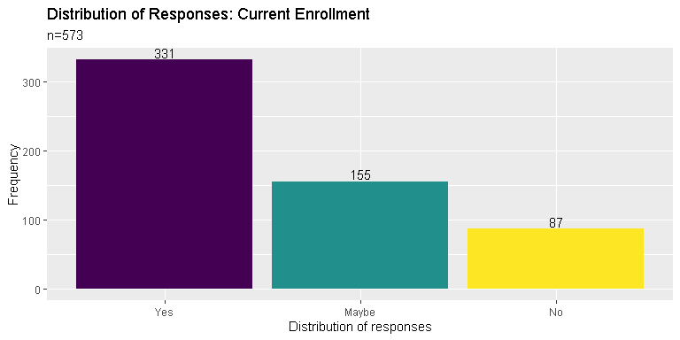

## Question: If your answer was YES, kindly provide the degree you wish to study within the next five (5) years

* Short | Certificate | Diploma Program
* Bachelor's degree (BLIS)
* Master's degree (MLIS)
* Master's degree (non-MLIS)
* Juris Doctor / Bachelor of Laws
* Doctor of Philosophy (Ph.D)
* Post-graduate Certificate or Diploma (LIS)
* Post-graduate Certificate or Diploma (non-LIS)

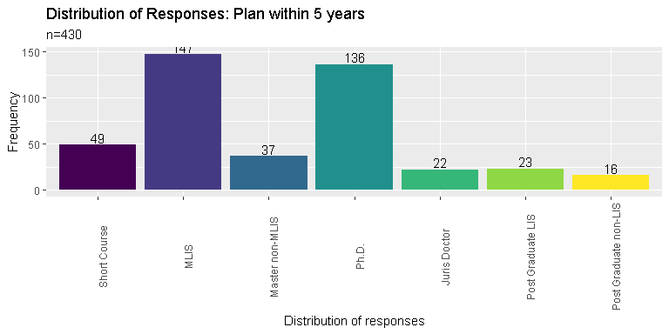

## Question: Where do you usually acquire your CPD trainings in LIS? Kindly check all that applies

* within the work place (in-house trainings)
* government facilitated trainings and symposiums
* trainings and symposiums facilitated by private entities, individuals and/or corporations
* NA (Have not attended CPD Trainings yet)

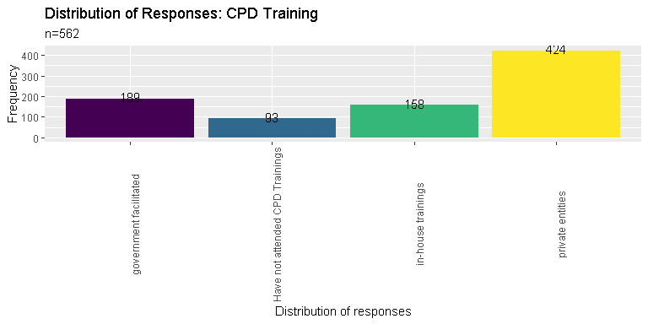

## Where do you usually get funding or support for your trainings in LIS?

* from the work place (private sponsorship)
* from the government (scholarships, free trainings and seminars, etc)
* personal funding (personally attended trainings and symposiums and shouldered most of the expenses)
* NA (Have not attended CPD Trainings yet)

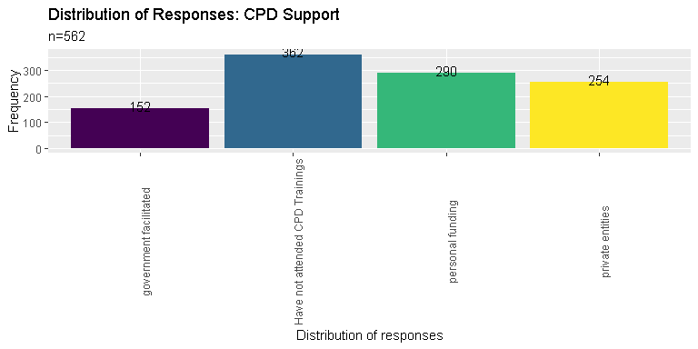

## Question: Are you satisfied with the amount of CPD trainings you have attended for the last two (2) years?

* Yes, the amount of trainings I received within the last two (2) years is enough.
* No, the amount of trainings I received within the last two (2) years is not enough.
* No, the amount of trainings received within the last two (2) years is too much.
* Maybe
* NA (Have not attended CPD Trainings yet)

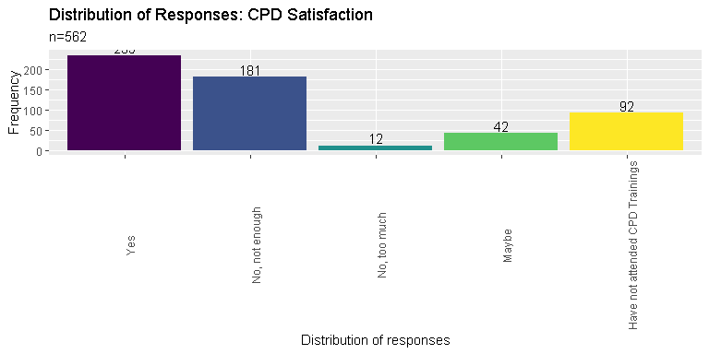

## Question: Kindly indicate any challenges you encounter when fulfilling the required CPD trainings

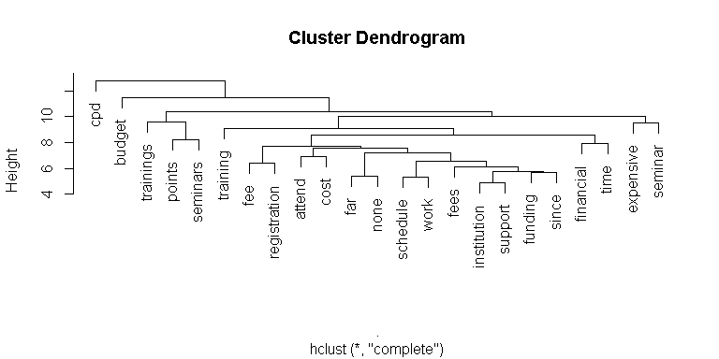

## Kindly indicate any topics you wish to explore in future trainings

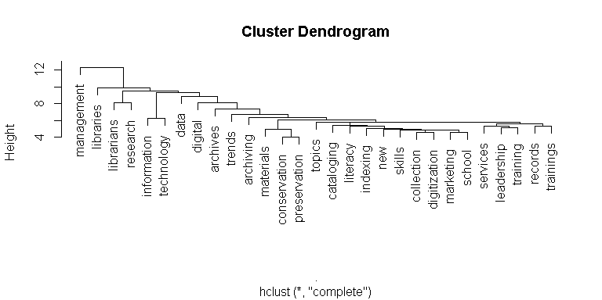

## Kindly indicate your primary work location

* NCR
* Region I
* Region II
* CAR
* Region III
* Region IV
* Region V
* Region VI
* Region VII
* Region VIII
* Region IX
* Region X
* Region XI
* Region XII
* CARAGA
* ARMM

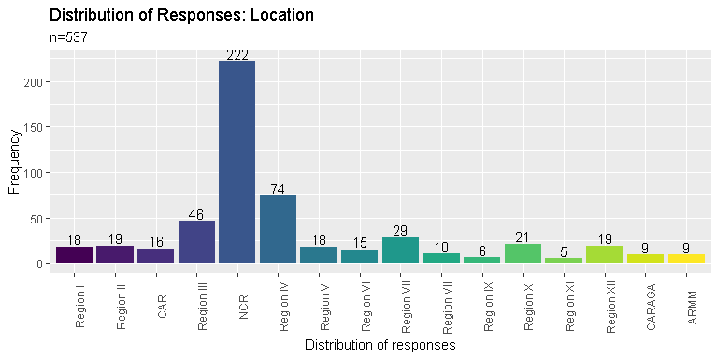

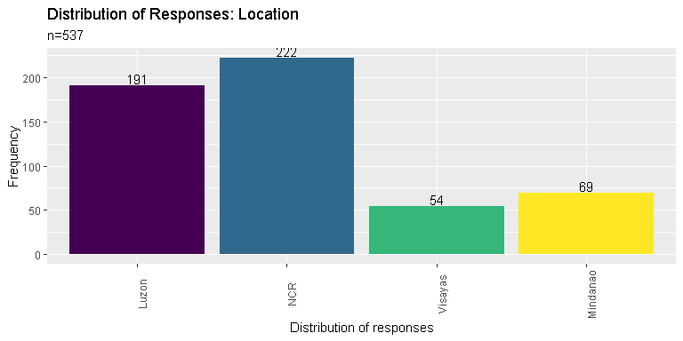

## Question: Have you moved out of your original / permanent residence in order to work on your current work place?

* Yes
* No

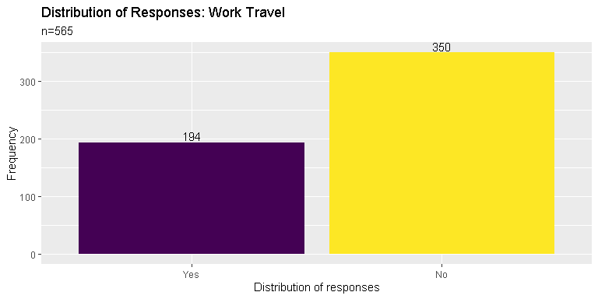

## Is Filipino / Tagalog your native language?

* Yes
* No

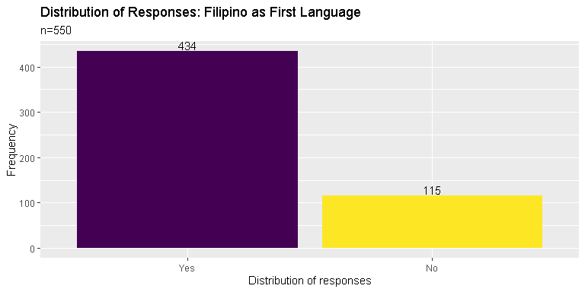

## Kindly check the local languages or dialects you can speak on a conversational level other than Filipino / Tagalog

* Ilocano
* Cebuano
* Ilonggo
* Kapampangan
* Pangasinense
* Waray
* Bicolano
* Others

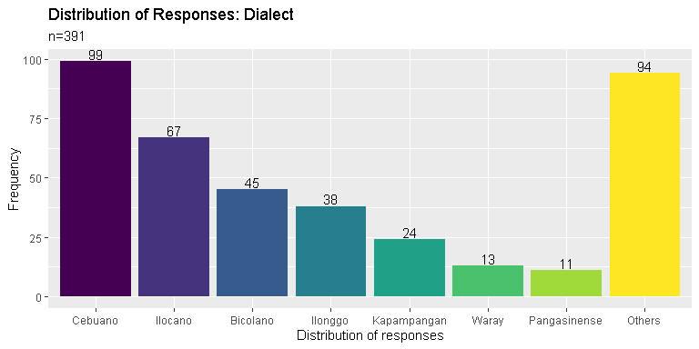

## Kindly indicate any foreign languages or dialects you can speak on a conversational level other than English (if any)

## spanish french ilonggo korean chinese ilocano bahasa chavacano   
## 24 9 8 8 6 6 4 4   
## ibaloi mandarin   
## 4 4

## Kindly indicate the type of library you are currently working in

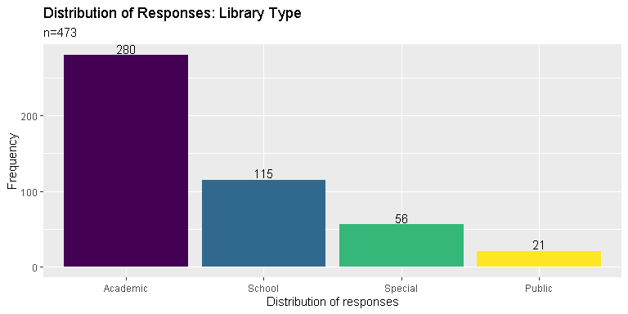

## Other than being a librarian, what other roles do you serve in your institution/ organization?

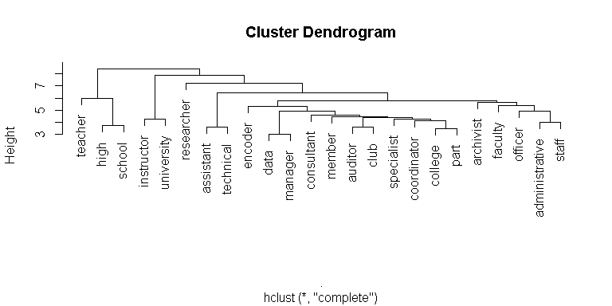

## Kindly indicate your current work position

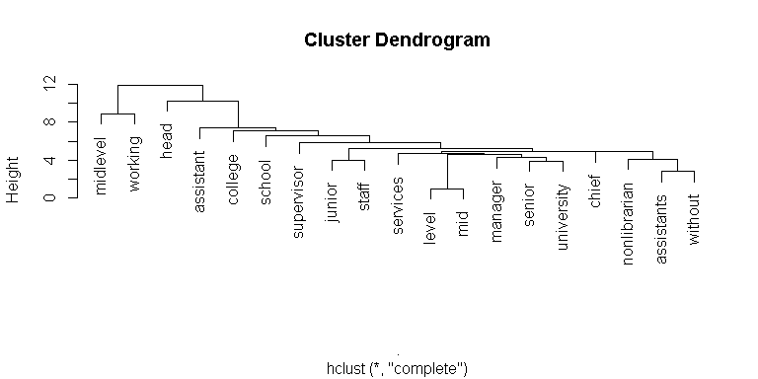

## Kindly indicate your primary job / designation inside the library

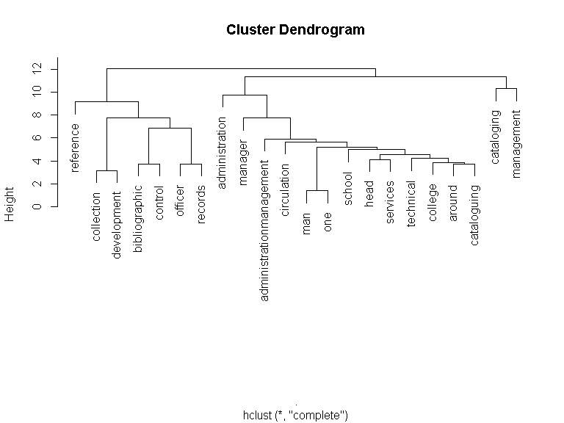

## Kindly indicate your current / existing professional affiliations

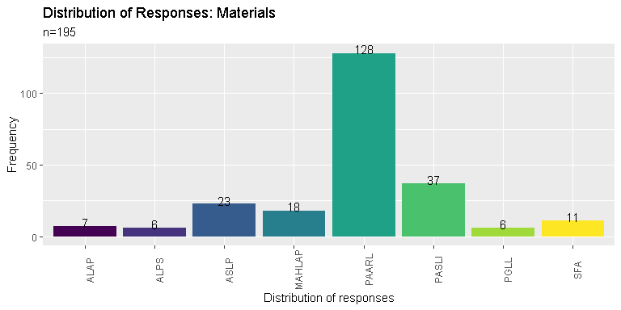

## Kindly indicate what factors influence your decision when it comes to joining a professional organization?

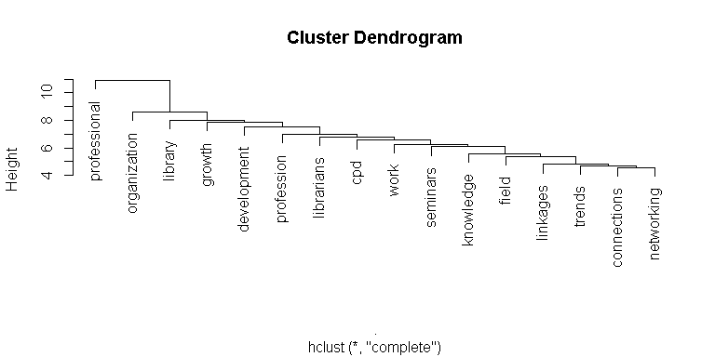

# Report's Reproducibility and Reuse

Knowledge is derived from a cumulative process that hinges on the repeated investigation of the same questions from many angles. Because each study builds on the insights produced by prior studies, the efficiency of the scientific process can be substantially compromised if the literature includes studies that report illusory results, either intentionally or unintentionally. Similarly, scientific efficiency will be compromised if failures to produce common findings are misdiagnosed as failures to reproduce earlier results or failures to replicate earlier studies when they are failures of earlier findings to generalize (Bollen et al., 2015). UPSLIS hopes that this report, together with the [raw Dataset and manual on how to process and analyze the Dataset](https://doi.org/10.5281/zenodo.6864788), will:

* Gain a deeper insight into the current state of librarians in the Philippines
* Enable other researchers to validate and extend this current project to create more follow-up and comprehensive studies
* Serve as a benchmarking tool for future LIS research
* Create opportunities for collaboration with other researchers not only in the LIS field but with other disciplines as well
* Assist policymakers and decision-makers in drafting and creating policies and guidelines that would affect the LIS profession in the Philippines.

UPSLIS also endeavors to conduct another census in five to six years to provide a complete longitudinal picture of the changes and development in the profession.

## Accompanying Materials

* [Raw Dataset](https://zenodo.org/record/6864788/files/librariancensus.csv?download=1): librariancensus.csv
* [Processed Dataset](https://zenodo.org/record/6864788/files/LibrarianCensus.rds?download=1): LibrarianCensus.rds(An R object that can be read in a R environment)
* [R markdown manual](https://zenodo.org/record/6864788/files/Librarian%20Census%20Data%20Code.Rmd?download=1): Librarian Census Data Code.Rmd (R Document that can be loaded in an R environment to access the R codes used in processing and analyzing the Dataset)
* [Word Document Manual](https://zenodo.org/record/6864788/files/Librarian-Census-Data-Code.docx?download=1): Librarian-Census-Data-Code.docx (A MS Word document version of the R Markdown manual)
* [HTML File Manual](https://zenodo.org/record/6864788/files/Librarian-Census-Data-Code.html?download=1): Librarian-Census-Data-Code.html (A HTML version of the R Markdown manual)

# Reference

Bollen, K., Cacioppo, J., Kaplan, R., Krosnick, J., & Olds, J. (2015). *Social, behavioral, and economic sciences perspectives on robust and reliable science* (p. 12). National Science Foundation. <https://nsf.gov/sbe/AC_Materials/SBE_Robust_and_Reliable_Research_Report.pdf>

Feinerer, I., & Hornik, K. (2020). *Tm: Text mining package*. <https://CRAN.R-project.org/package=tm>

Labaw, P. J. (1981). *Advanced questionnaire design / patricia j. labaw.* Abt Books.

R Core Team. (2022). *R: A language and environment for statistical computing*. R Foundation for Statistical Computing. <https://www.R-project.org/>

RStudio Team. (2022). *RStudio: Integrated development environment for r*. RStudio, PBC. <http://www.rstudio.com/>

Taban, K. O. (2018). *Occupational census profiling tool for librarians in the philippines* (Y. T. P. Santos, Ed.) [PhD thesis, Thesis (Bachelor of Library; Information Science); School of Library; Information Studies, University of the Philippines Diliman]. <https://digitalarchives.upd.edu.ph/item/26221>

Wickham, H., Averick, M., Bryan, J., Chang, W., McGowan, L. D., Françoi, R., Grolemun, G., Haye, A., Henr, L., Heste, J., Kuh, M., Pederse, T. L., Mille, E., Bach, S. M., Müll, K., Jeroen Oo, David Robins, Dana Paige Seid, Vitalie Spi, … Hiroaki Yutani. (2019). Welcome to the tidyverse. *Journal of Open Source Software*, *4*(43), 1686. <https://doi.org/10.21105/joss.01686>