**Practical No.02**

**Aim: Study and implementation of Platform as a Service**

**Theory:**Platform as a Service (PaaS) provides a runtime environment. It allows programmers to easily create, test, run, and deploy web applications. You can purchase these applications from a cloud service provider on a pay-as-per use basis and access them using the Internet connection. In PaaS, back end scalability is managed by the cloud service provider, so end- users do not need to worry about managing the infrastructure.

PaaS includes infrastructure (servers, storage, and networking) and platform (middleware, development tools, database management systems, business intelligence, and more) to support the web application life cycle.

**Example:** Google App Engine, Force.com, Joyent, Azure.

PaaS providers provide the Programming languages, Application frameworks, Databases, and Other tools:

1. Programming languages

PaaS providers provide various programming languages for the developers to develop the applications. Some popular programming languages provided by PaaS providers are Java, PHP, Ruby, Perl, and Go.

2. Application frameworks

PaaS providers provide application frameworks to easily understand the application development. Some popular application frameworks provided by PaaS providers are Node.js, Drupal, Joomla, WordPress, Spring, Play, Rack, and Zend.

3. Databases

PaaS providers provide various databases such as ClearDB, PostgreSQL, MongoDB, and Redis to communicate with the applications.

4. Other tools

PaaS providers provide various other tools that are required to develop, test, and deploy the applications.

**Method and Steps:**

1. Using KVM.

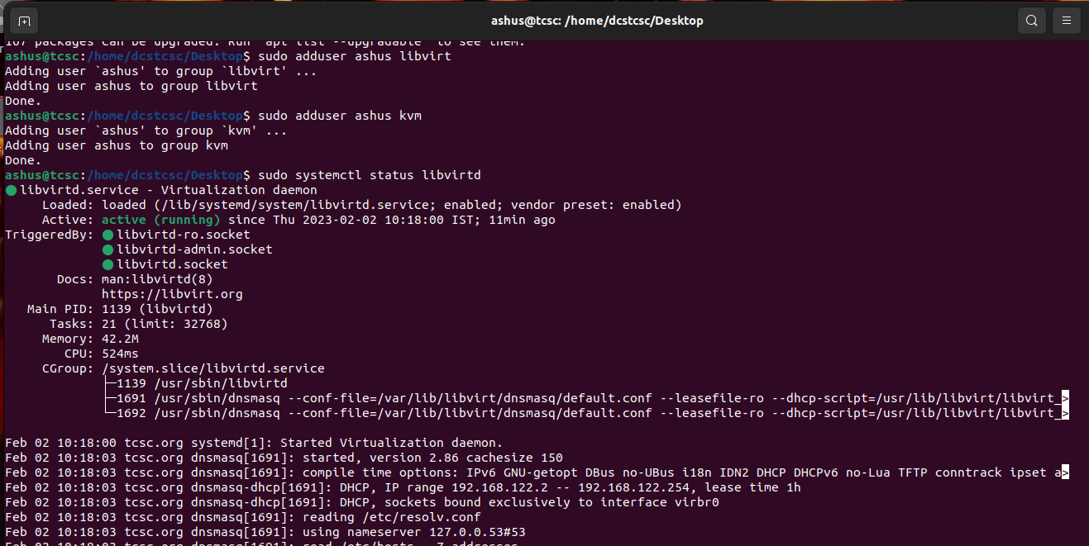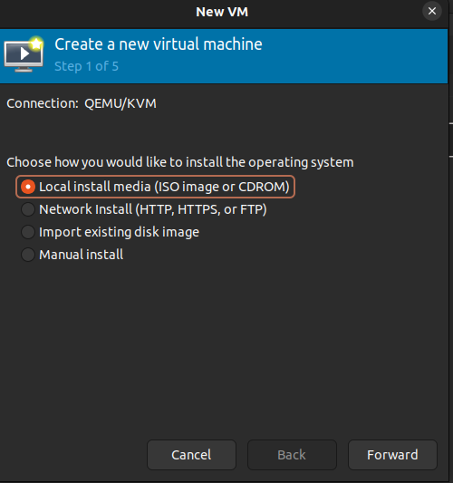

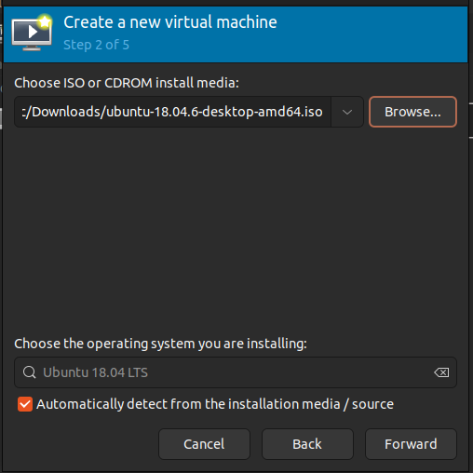

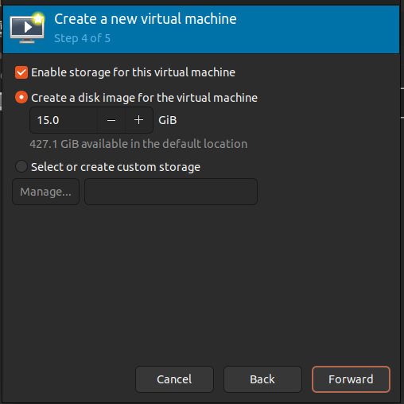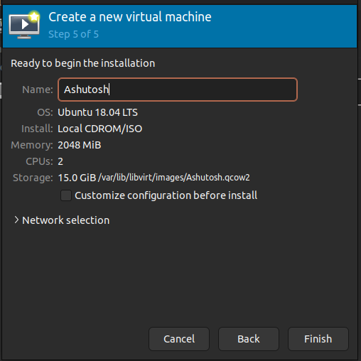

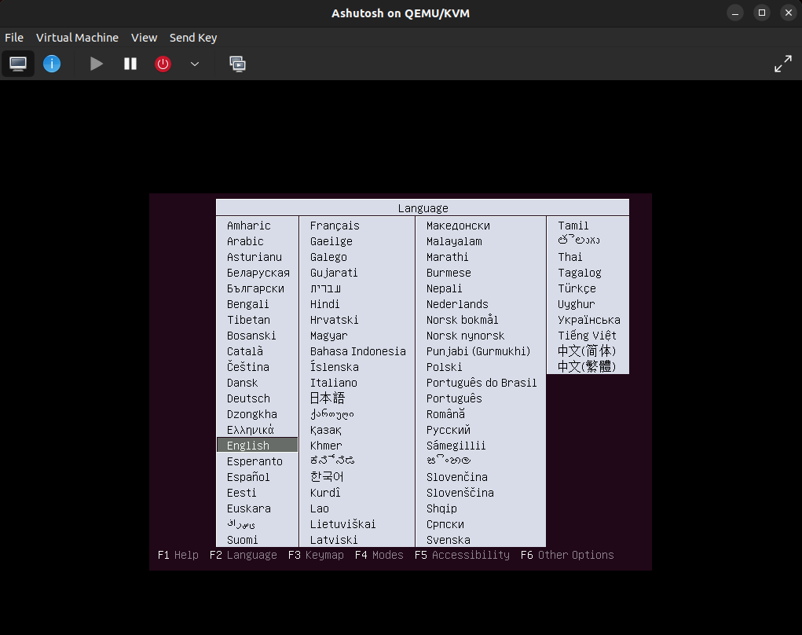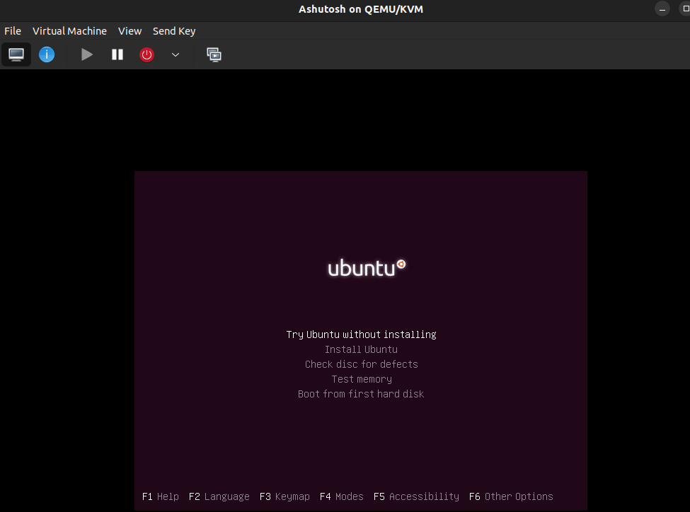

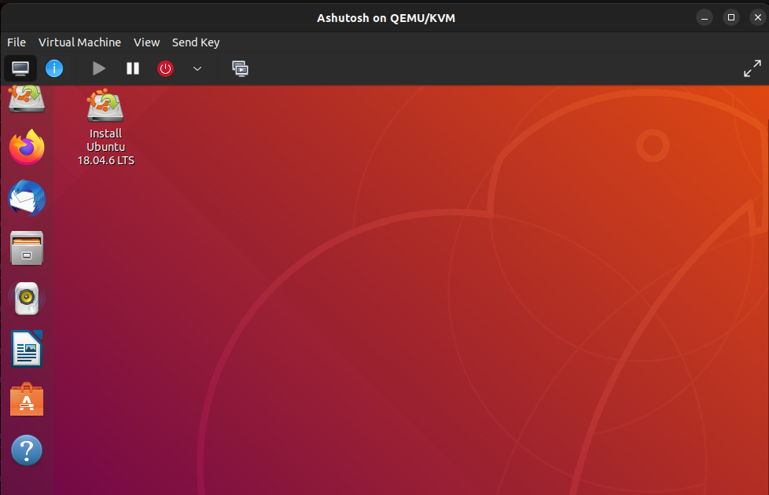

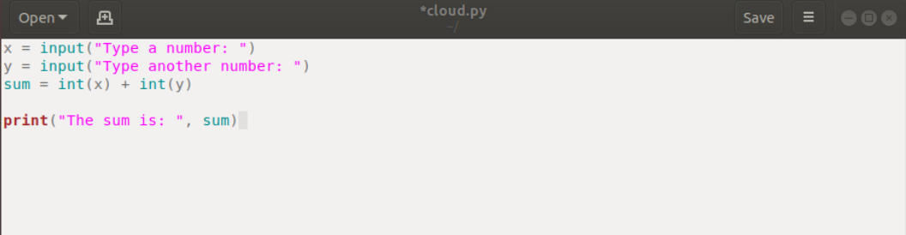

**CONCLUSION :**

**There are the following advantages of PaaS -Simplified Development , Lower risk, Prebuilt business functionality, Instant community, Scalability**

**Disadvantages of PaaS cloud computing layer - Vendor lock-in , Data Privacy, Integration with the rest of the systems applications.**