**Aim:** Study and implementation of Single-Sign-On

(SSO).

**THEORY :**

• Single sign-on (SSO) is a session and user authentication service that permits a user to use one set of login credentials (e.g., name and password) to access multiple applications

• The service authenticates the end user for all the applications the user has been given rights to and eliminates further prompts when the user switches applications during the same session. On the back end, SSO is helpful for logging user activities as well as monitoring user accounts.

• In a basic web SSO service, an agent module on the application server retrieves the specific authentication credentials for an individual user from a dedicated SSO policy server, while authenticating the user against a user repositorysuch as a lightweight directory access protocol (LDAP) directory.

Procedure:- Step1:got to the following link <https://auth0.com/learn/how-to-implement> single-sign-on/

Step2:click on try autho for free → fill the details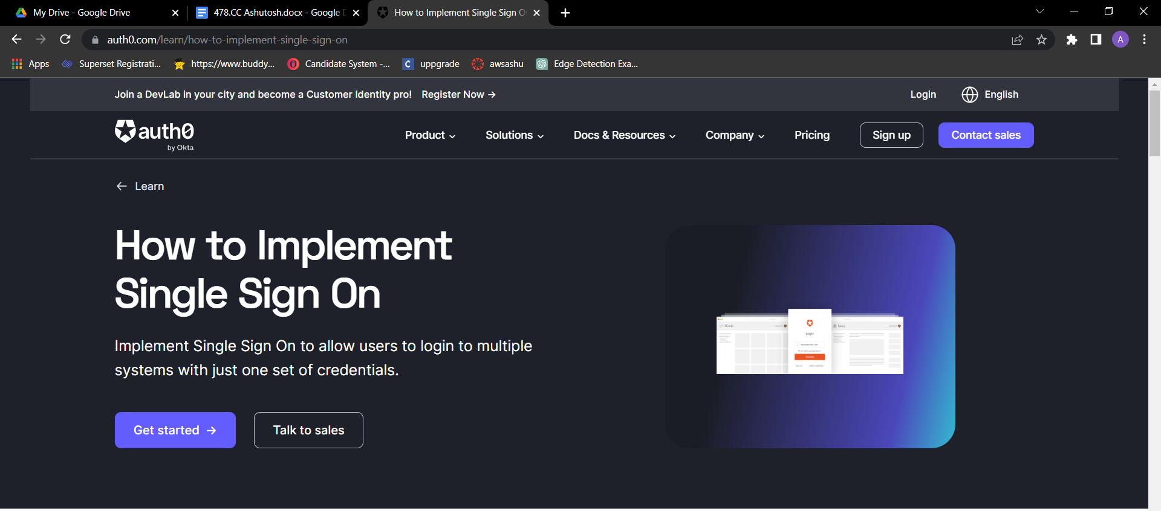

Step3: Provide the username and Password and click on Signup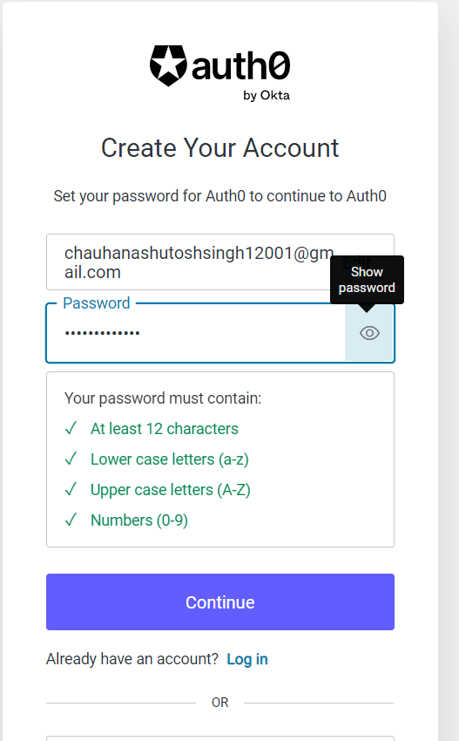



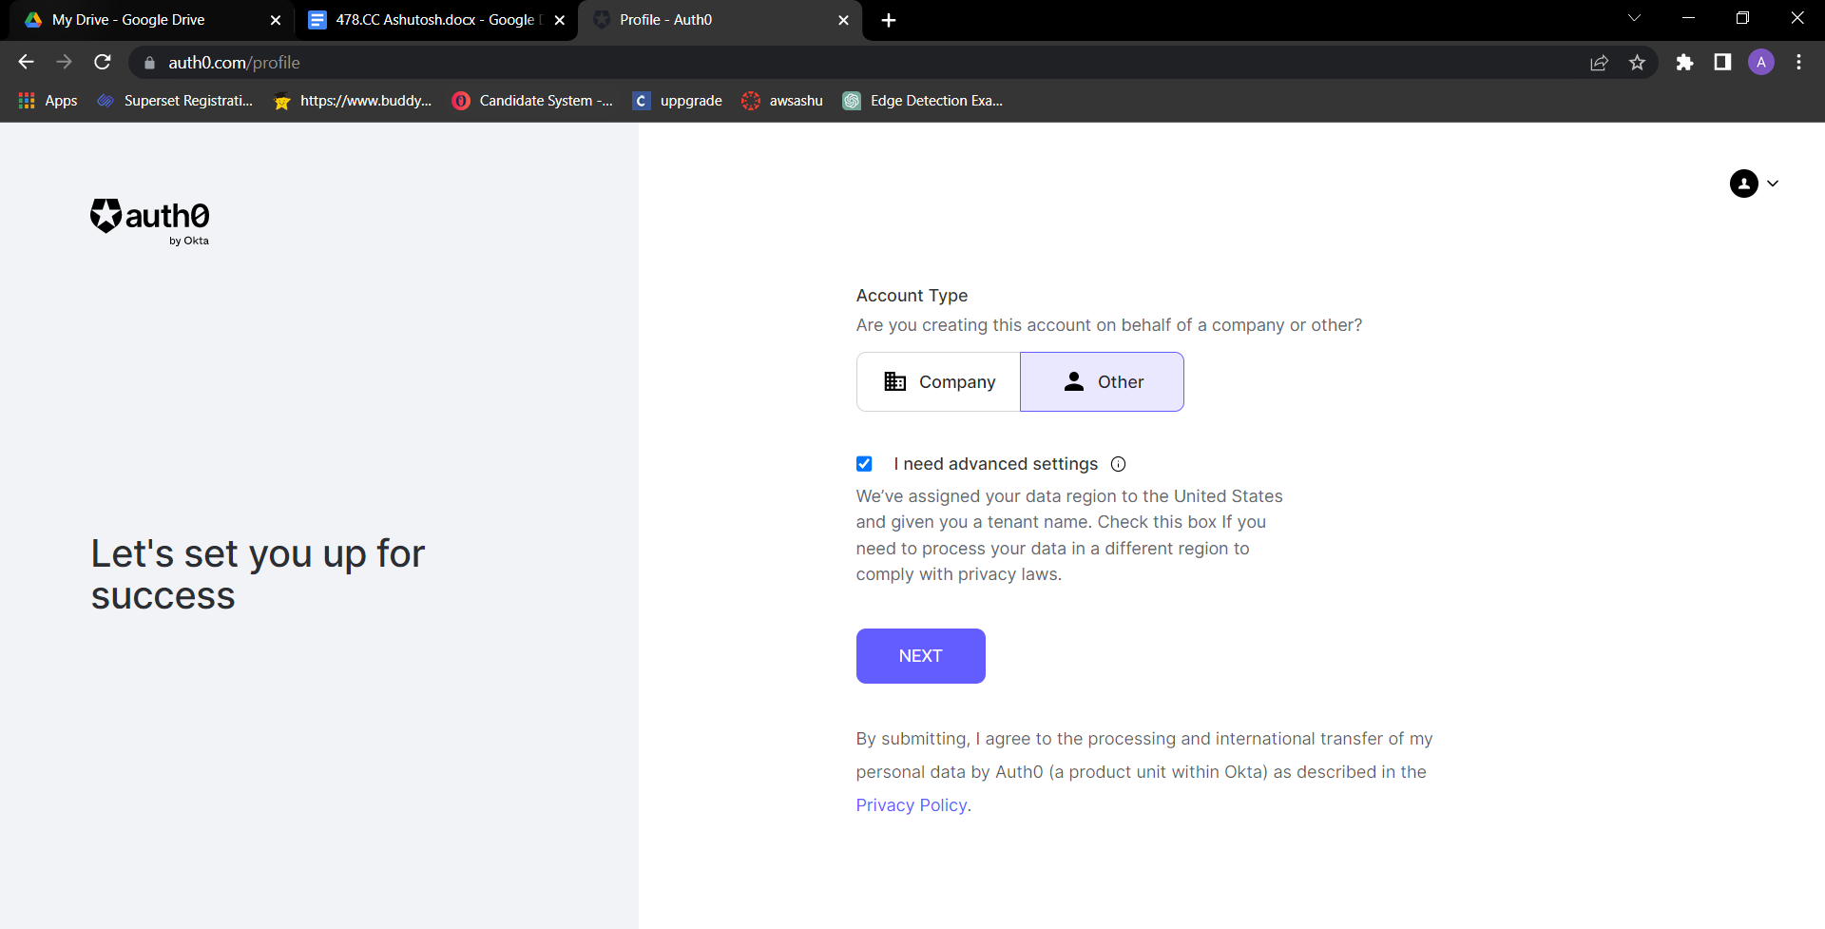

Step 4: Provide the tenant name and click on next

Step5: Fill all the Details and click on create account

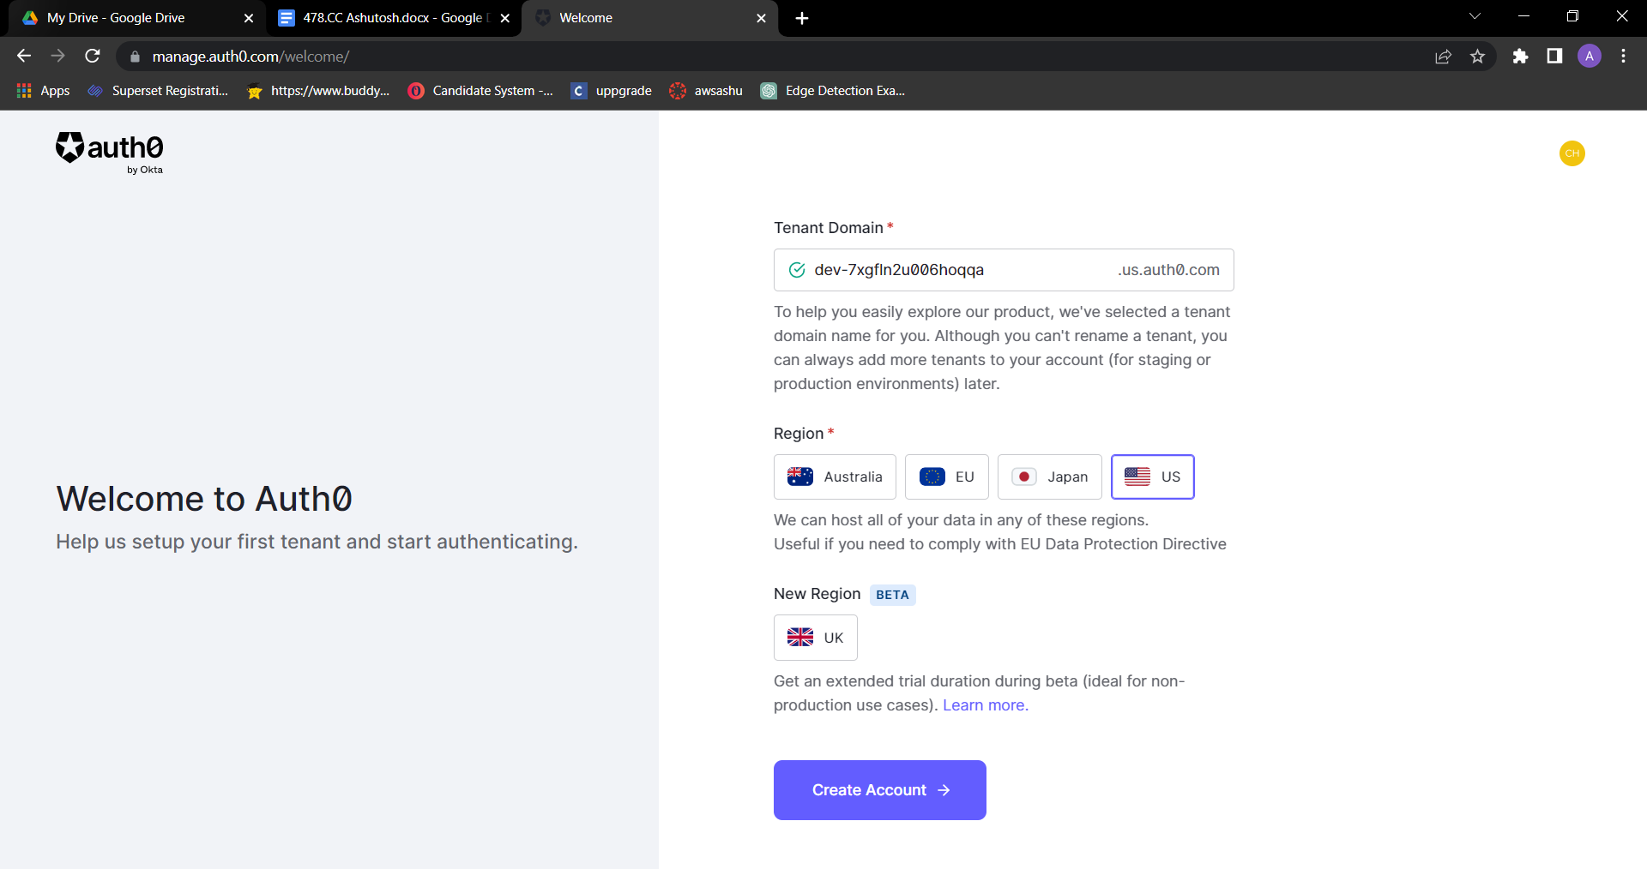

Step6: In this step you will get Dashbord . First create one user

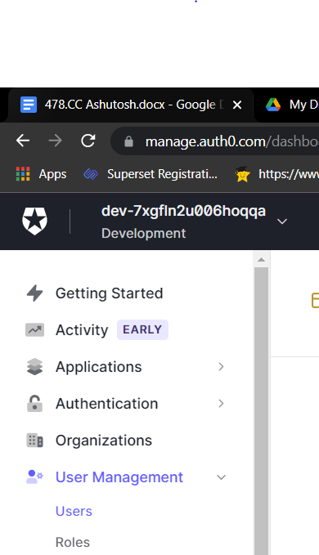

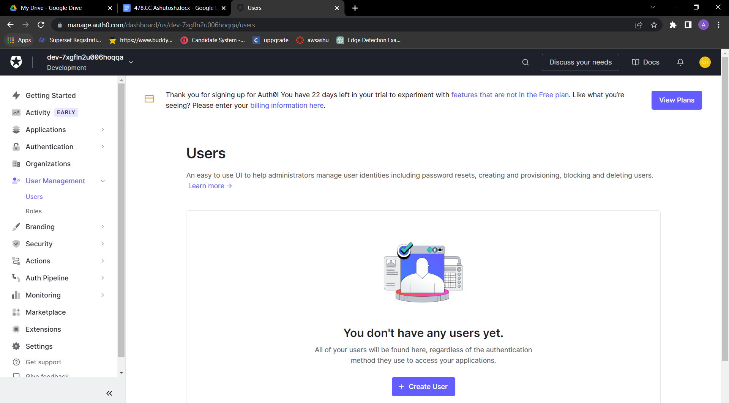

Step 7: click on create user

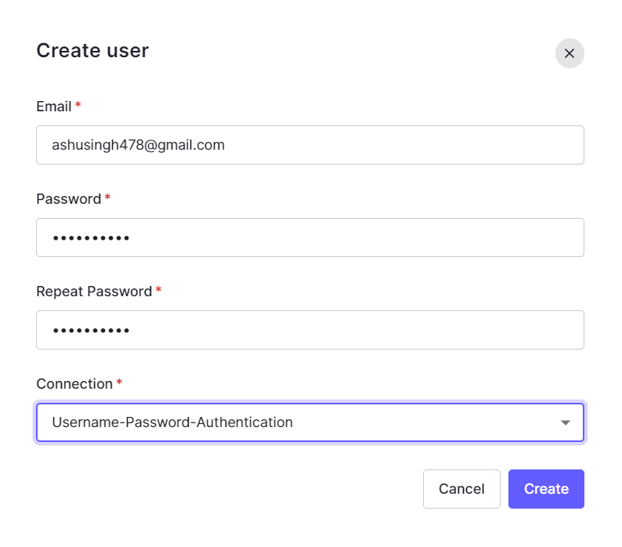Step 8: fill all the details and click on save

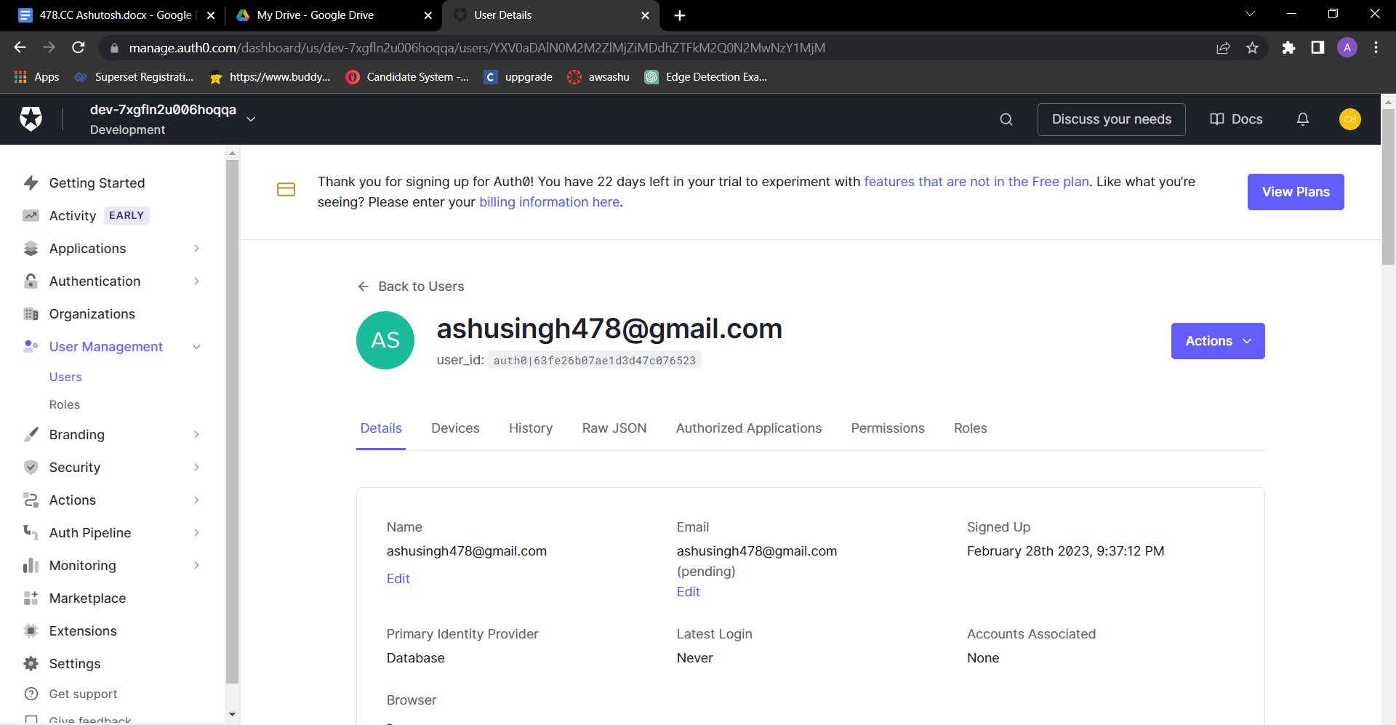

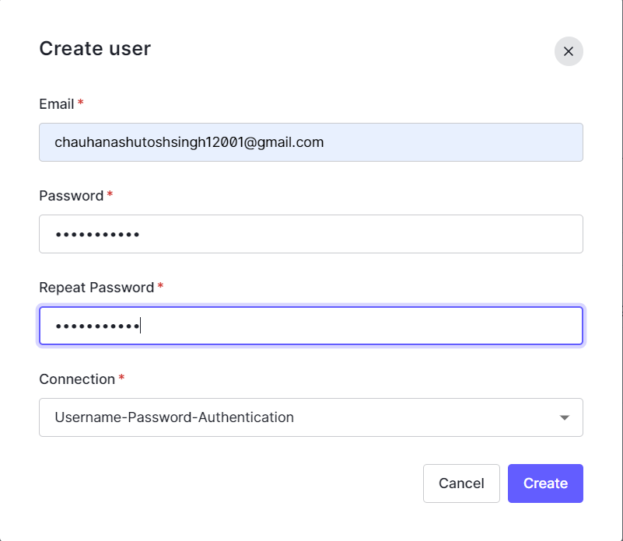



**RESULTS :**

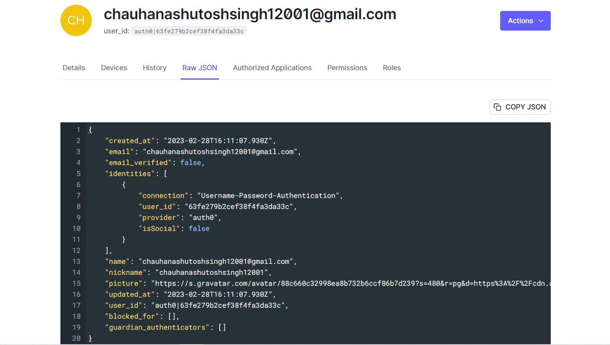

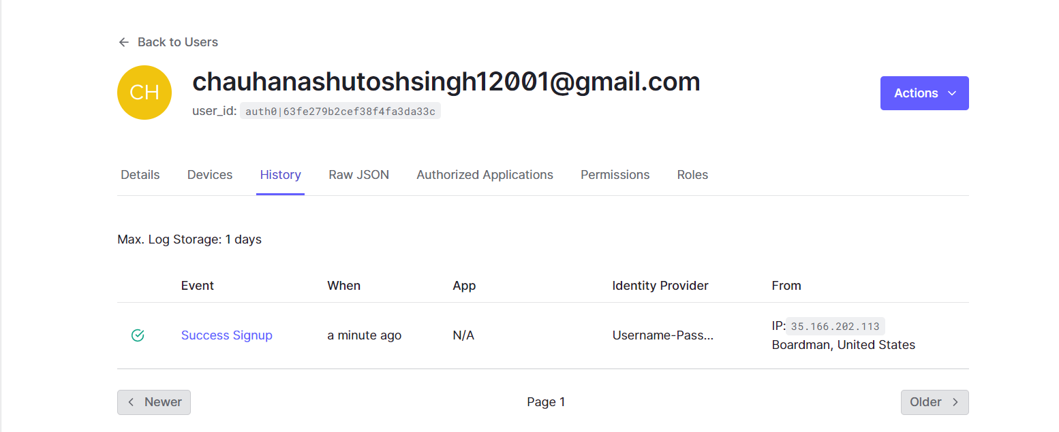



**Verification Mail :**

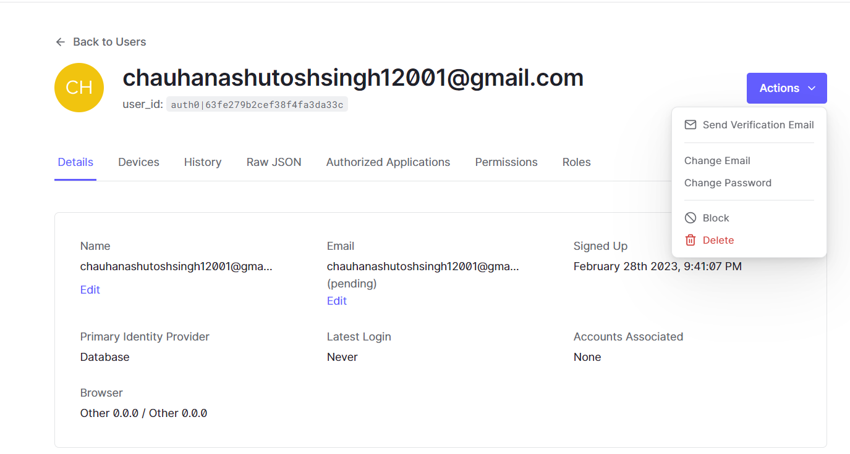



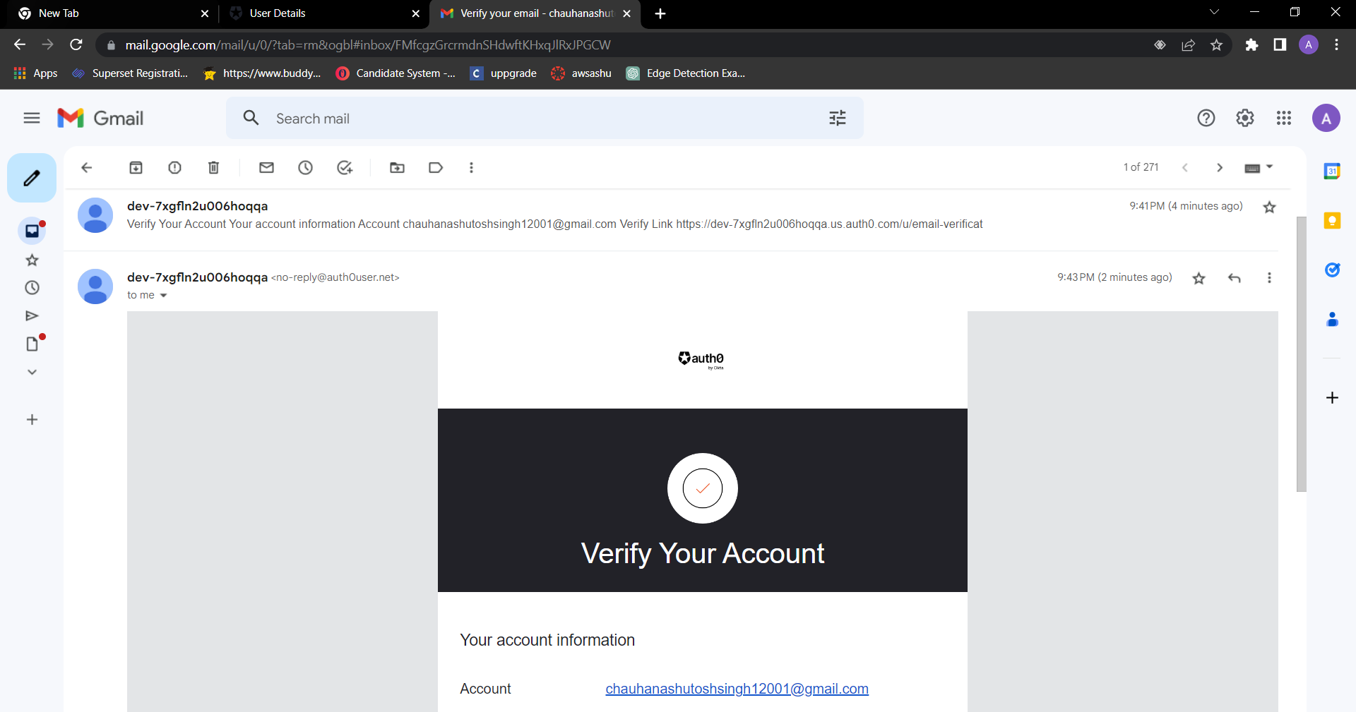

**MAIL VERIFIED:**

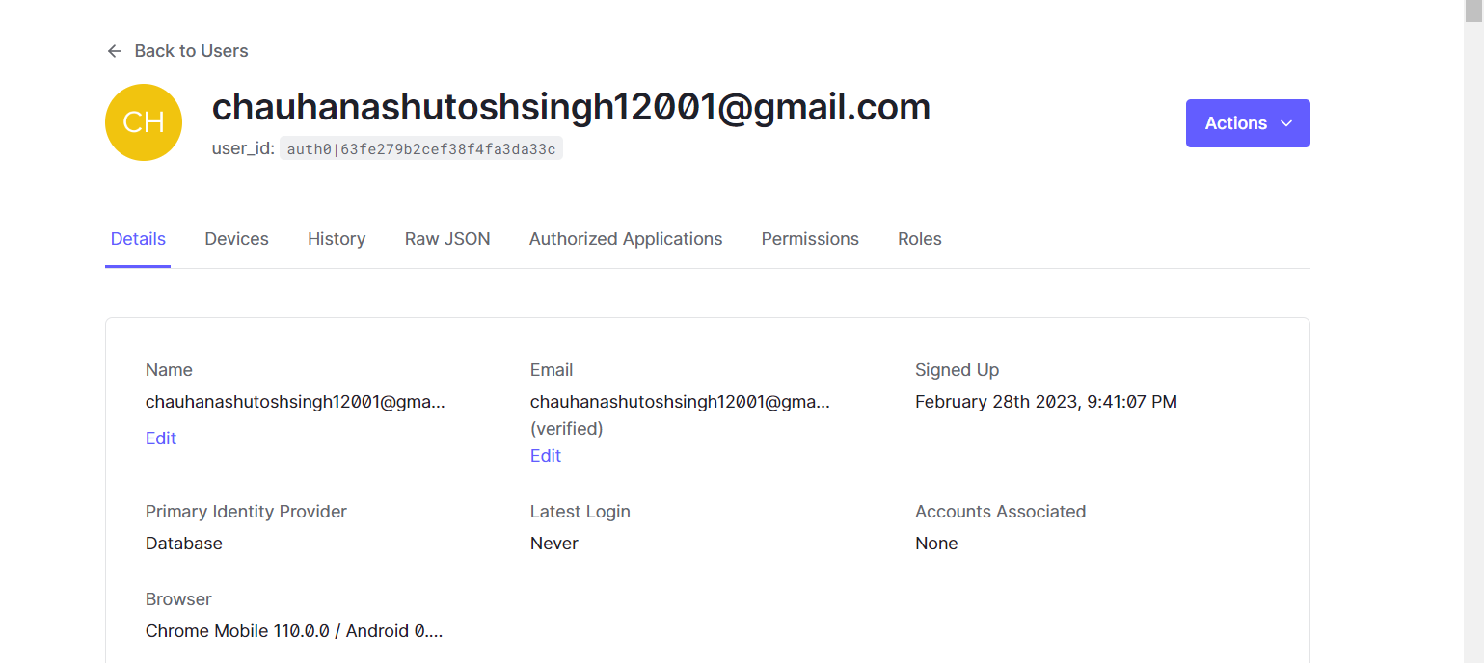



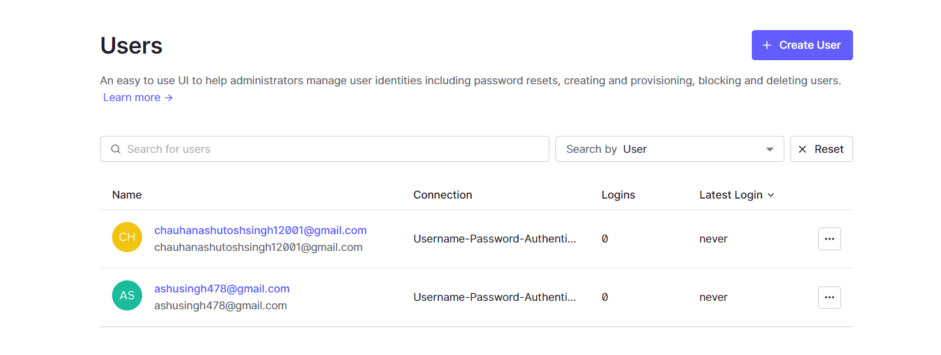



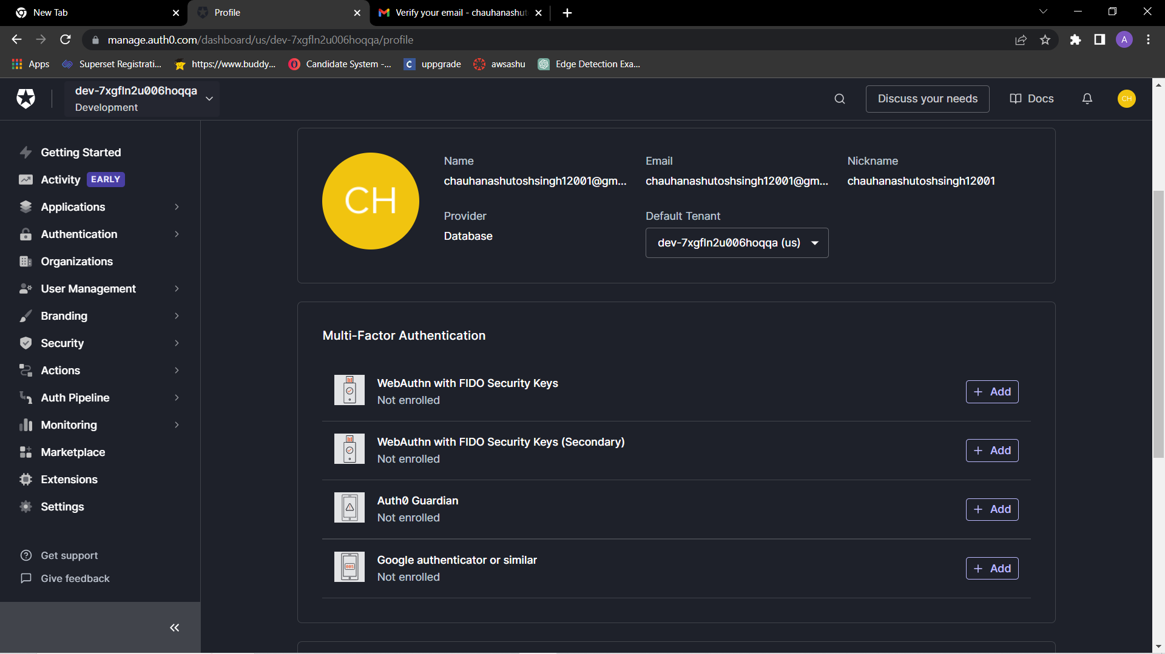



**BYAWS/.**

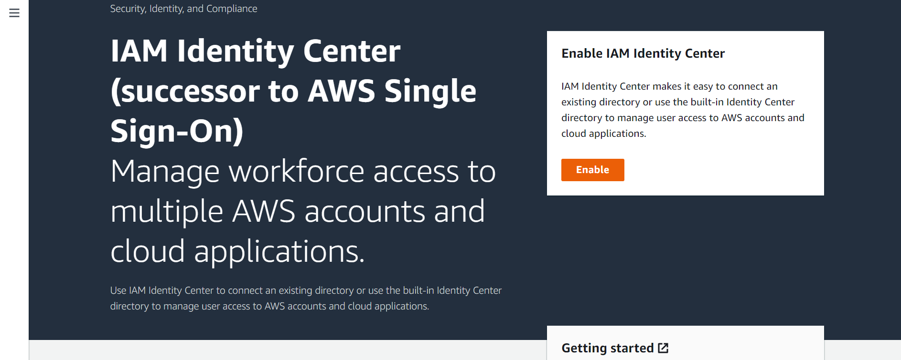

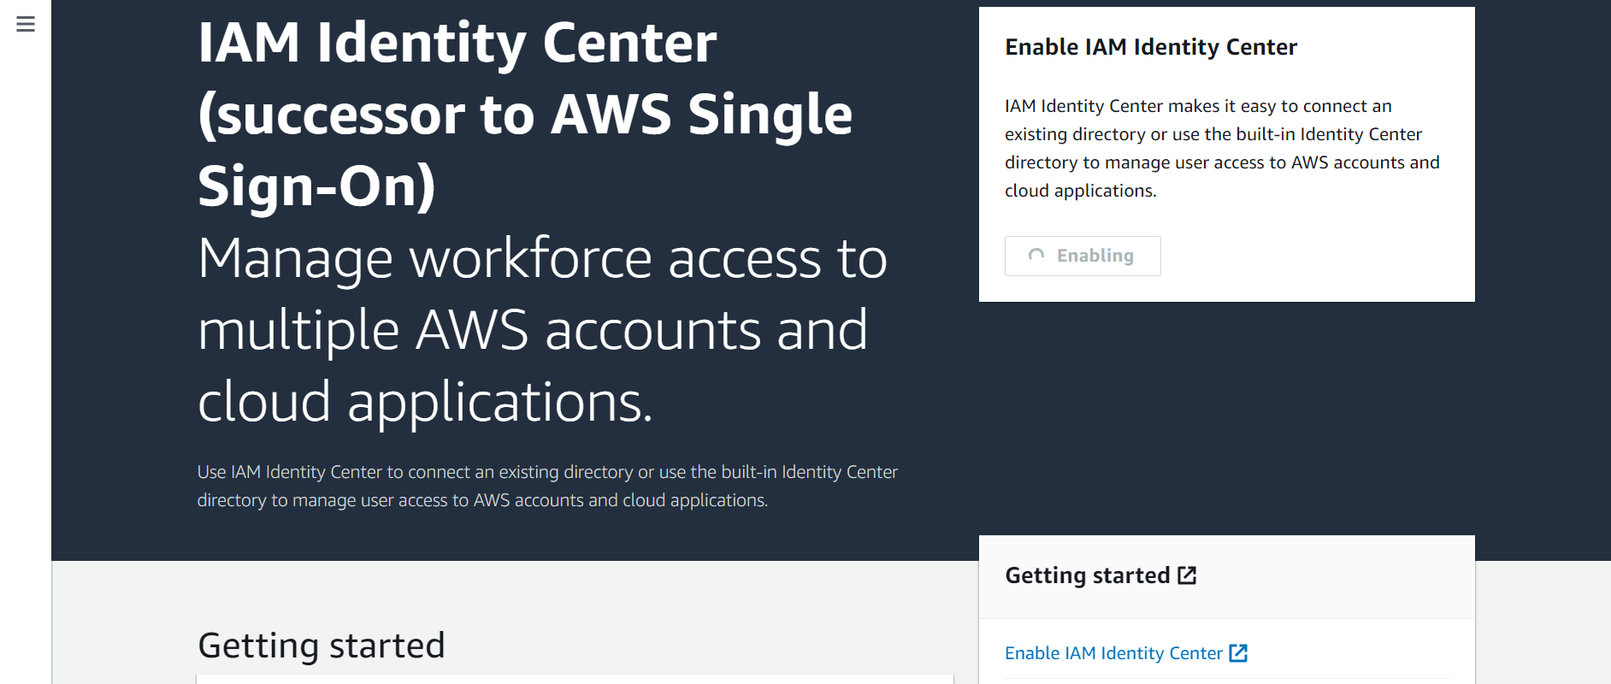

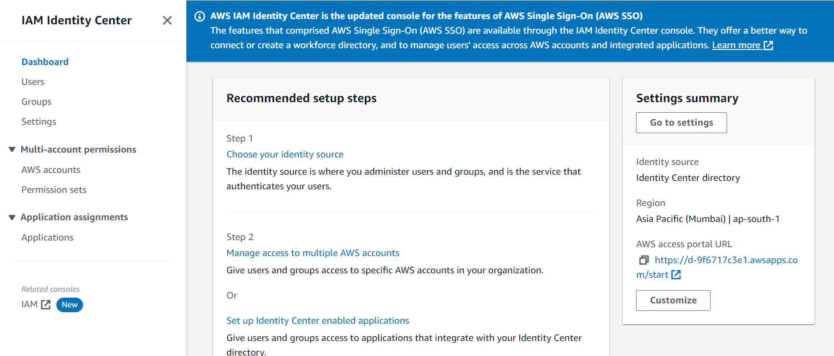

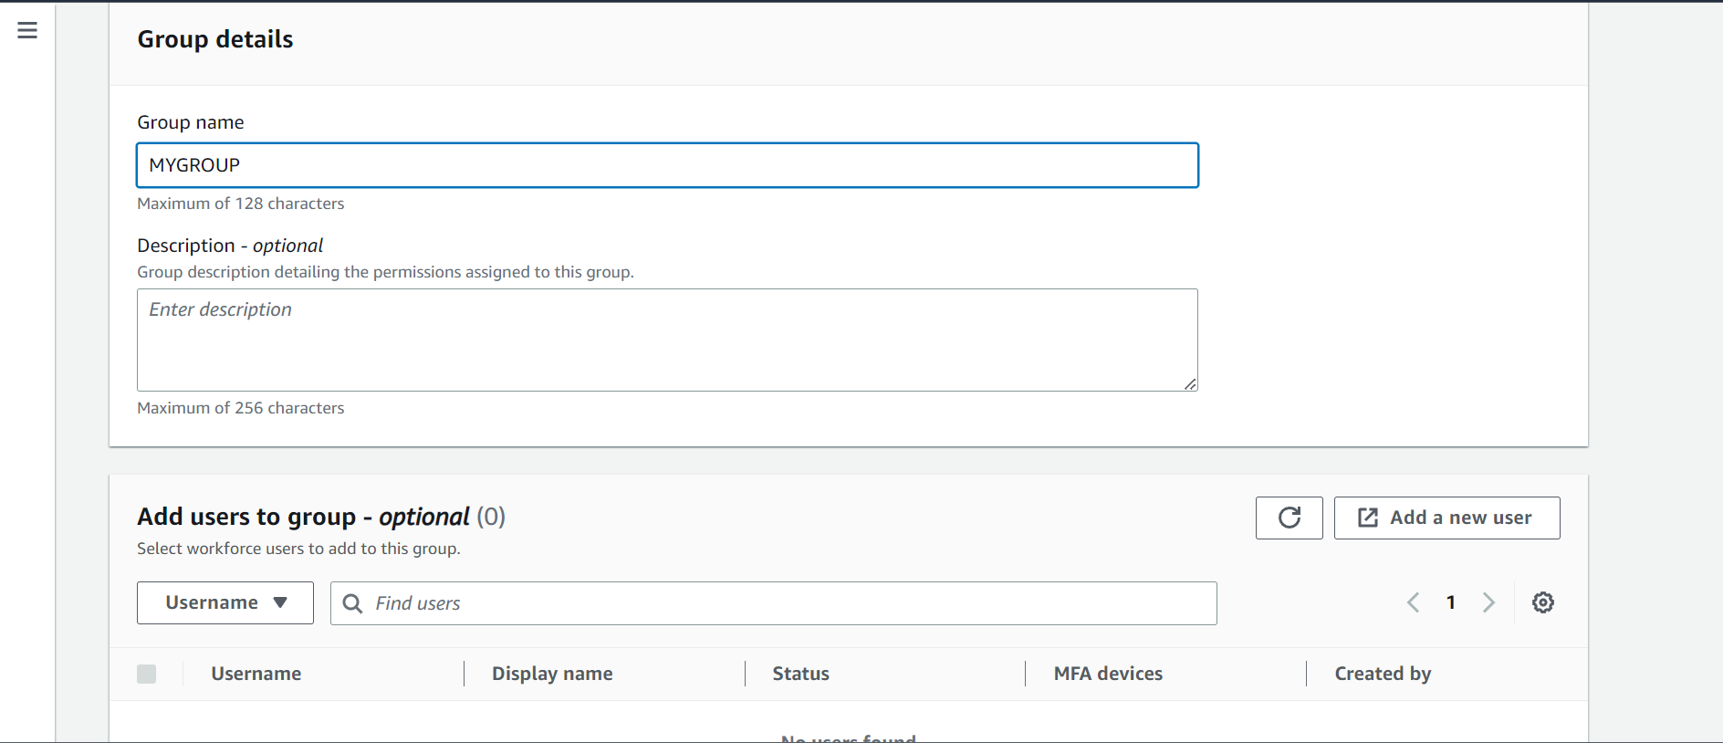

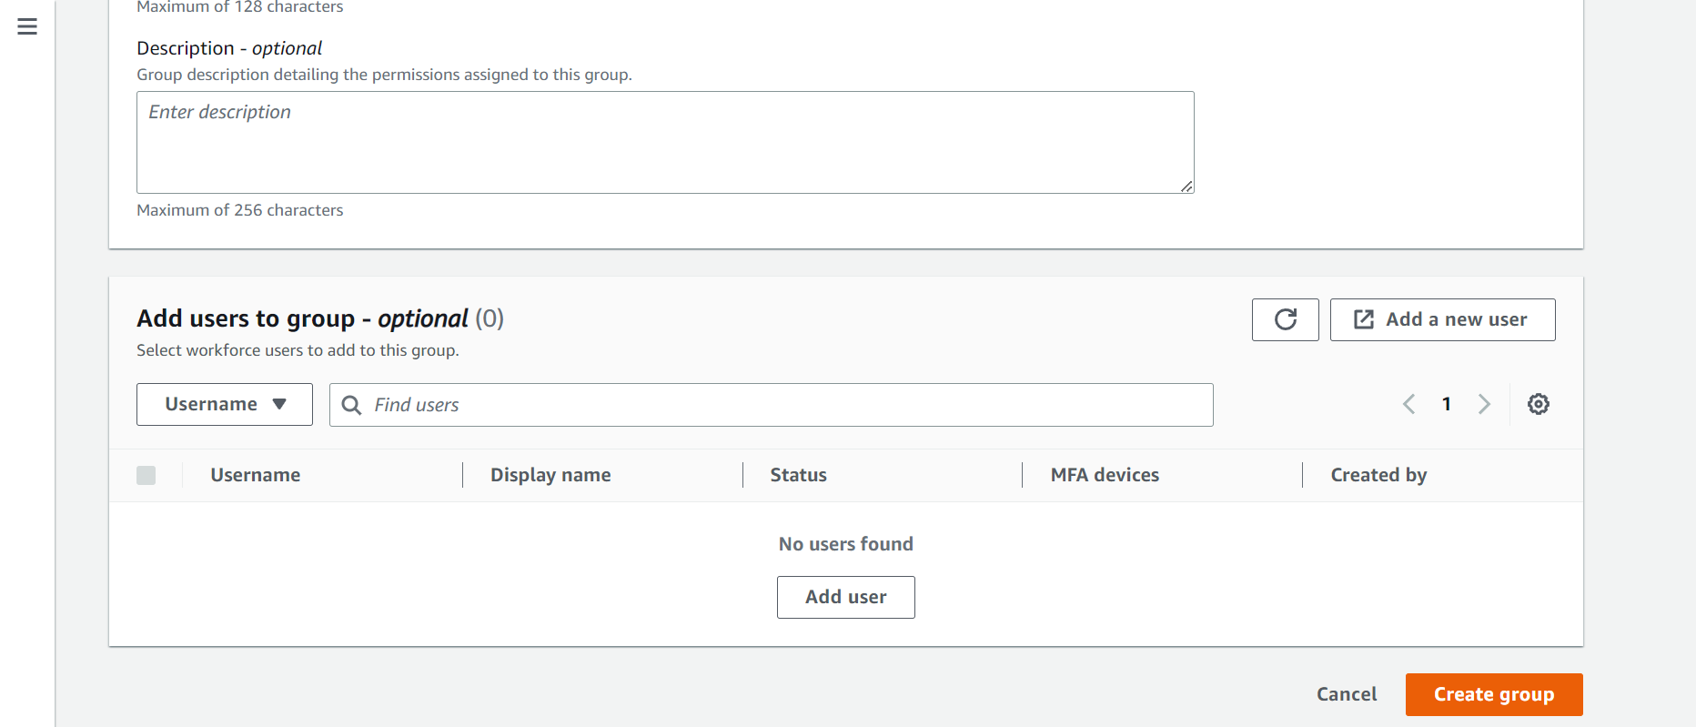

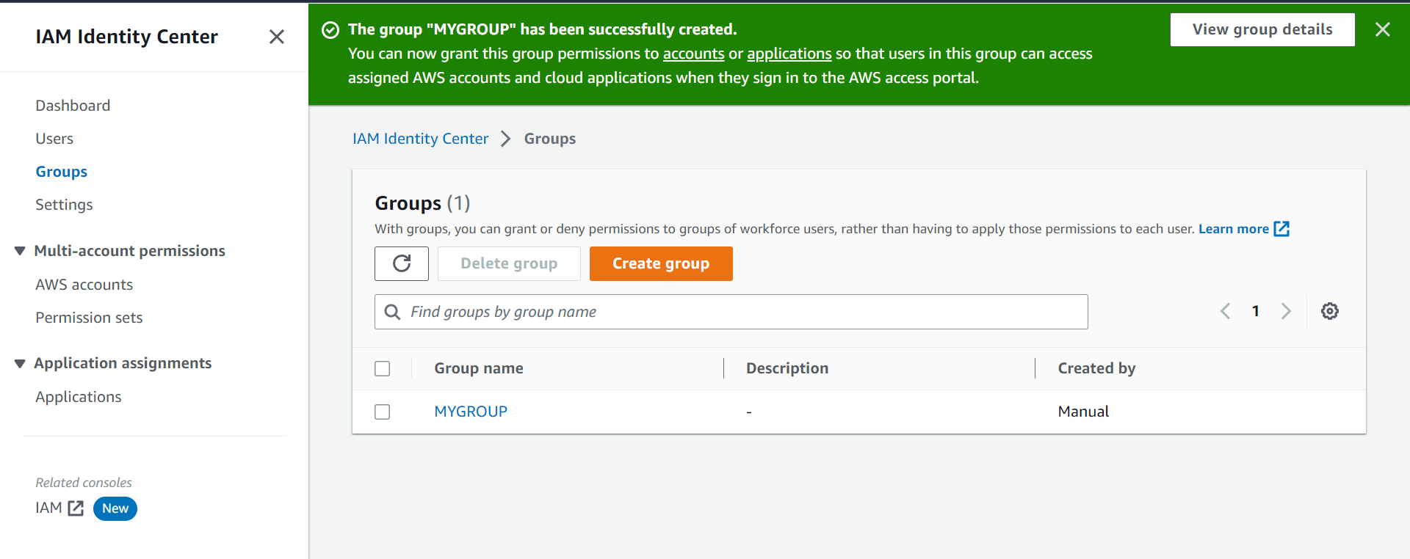

Create users

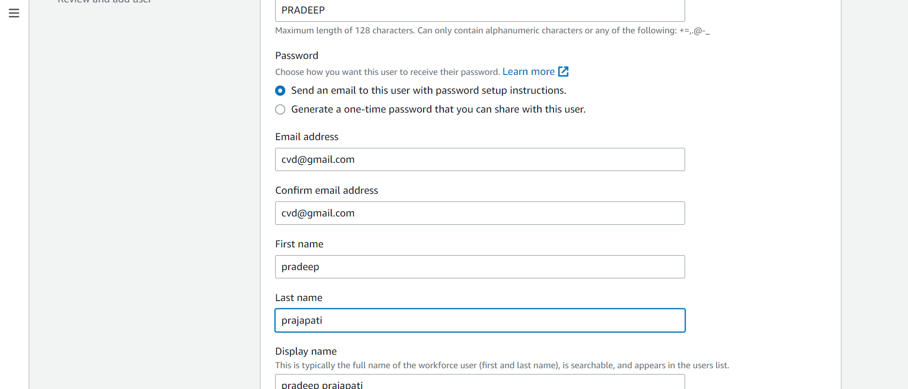

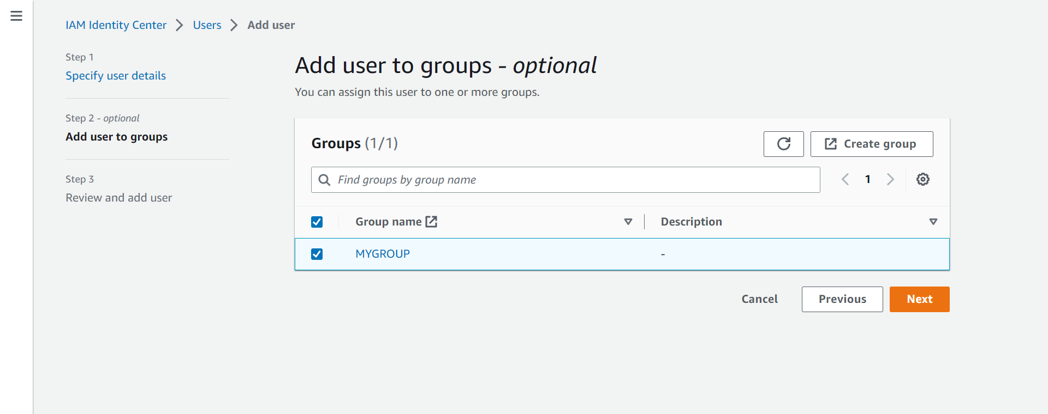

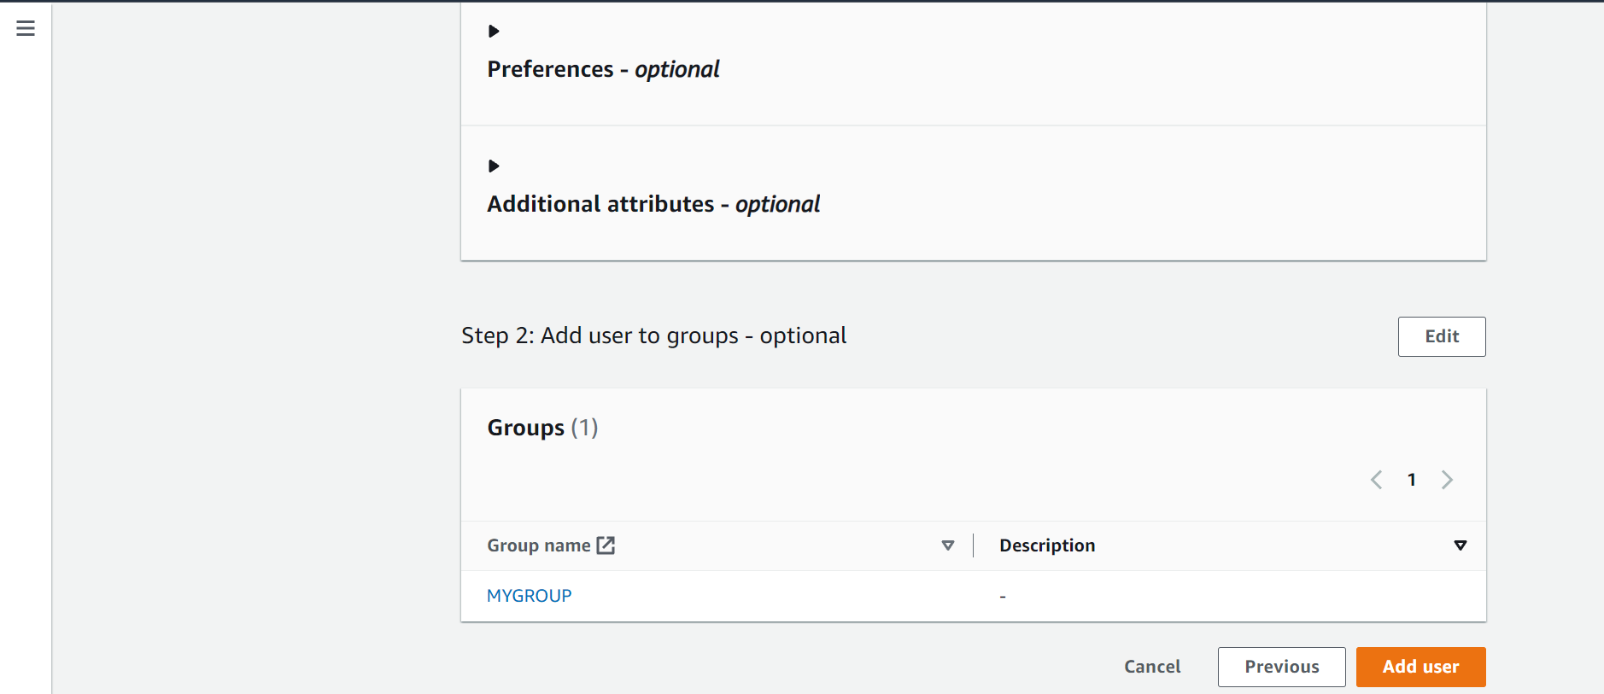

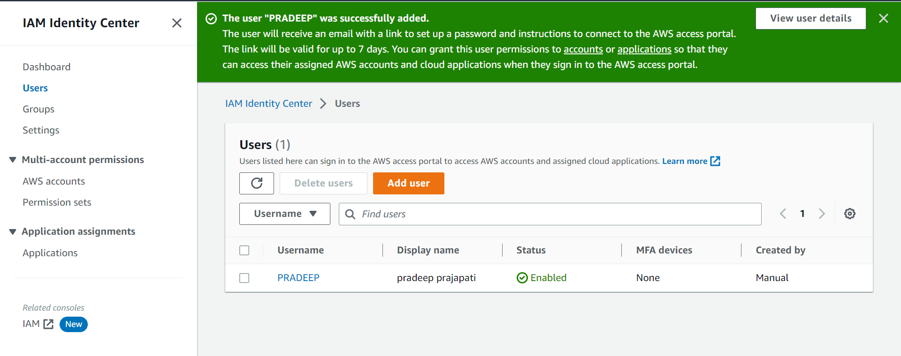

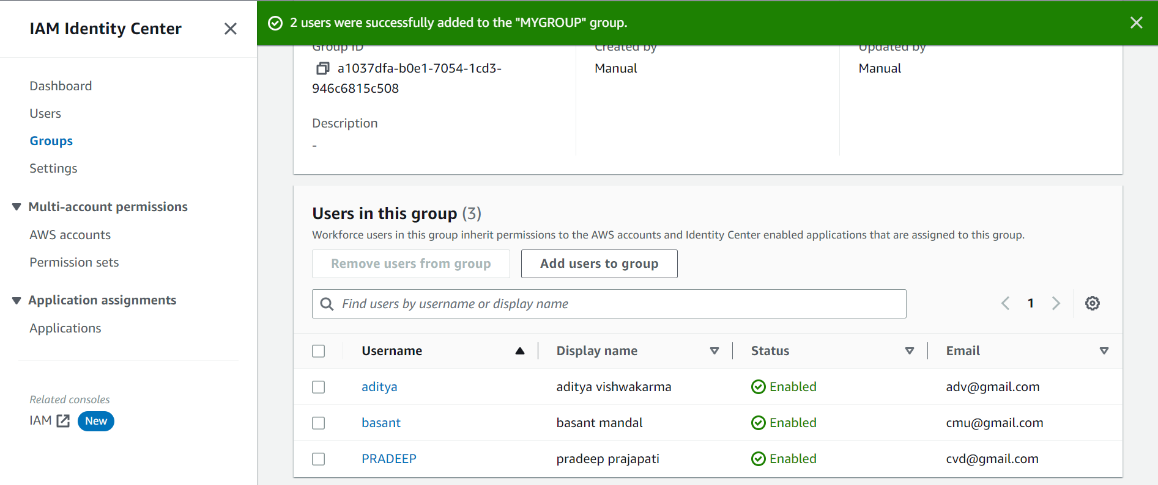

**CONCLUSION** : Succesfully implemented Single-Sign-On(SSO).