**Practical No 4**

**Aim: Study and implementation of Storage as a Service**

**Theory:** Storage as a service (STaaS) is a managed service in which the provider supplies the customer with access to a data storage platform. The service can be [delivered on premises](https://www.techtarget.com/searchstorage/feature/On-premises-STaaS-shifts-storage-buying-to-Opex-model) from infrastructure that is dedicated to a single customer, or it can be delivered from the public cloud as a shared service that's purchased by subscription and is billed according to one or more usage metrics.

STaaS customers access individual storage services through standard system interface protocols or application program interfaces ([APIs](https://www.techtarget.com/searchapparchitecture/definition/application-program-interface-API)). Typical offerings include bare-metal storage capacity; raw storage volumes; network file systems; storage objects; and storage applications that support file sharing and [backup](https://www.techtarget.com/searchdatabackup/definition/backup) lifecycle management.

Storage as a service was originally seen as a cost-effective way for small and mid-size businesses that lacked the technical personnel and capital budget to implement and maintain their own storage infrastructure. Today, companies of all sizes use storage as a service.

**Storage as a service in cloud computing**

Instead of storing data on-premises, organizations that use STaaS will typically utilize a [public cloud](https://www.techtarget.com/searchcloudcomputing/definition/public-cloud) for storage and backup needs. Public cloud storage may also use different storage methods for STaaS. These storage methods include backup and restore, disaster recovery, block storage, SSD storage, object storage and bulk data transfer. Backup and restore refers to the backing up of data to the cloud, which provides protection in case of data loss. Disaster recovery may refer to protecting and replicating data from virtual machines ([VMs](https://searchservervirtualization.techtarget.com/definition/virtual-machine)).

[Block storage](https://www.techtarget.com/searchstorage/definition/block-storage) enables customers to provision block storage volumes for lower-latency [I/O](https://www.techtarget.com/whatis/definition/input-output-I-O). SSD storage is another storage type that is typically used for intensive read/write and I/O operations. Object storage systems are used in data analytics, disaster recovery and cloud applications and tend to have high latency. Cold storage is used to create and configure stored data quickly. Bulk data transfers will use disks and other hardware to transfer data.

**Methods and Steps:**

1. Google Drive

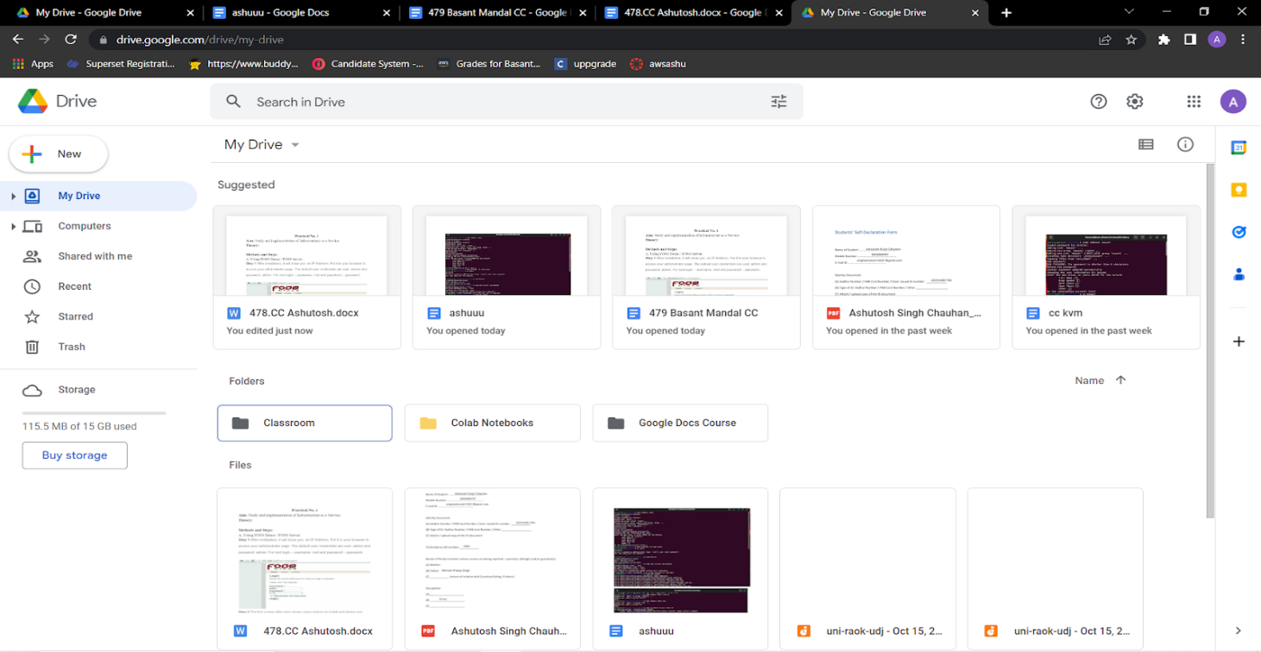 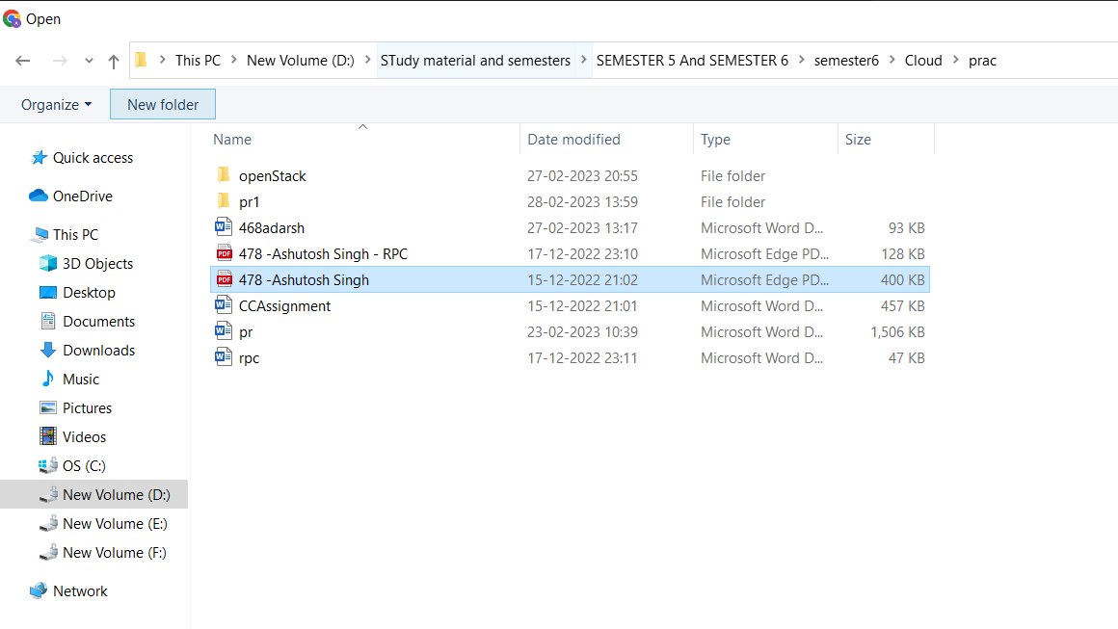 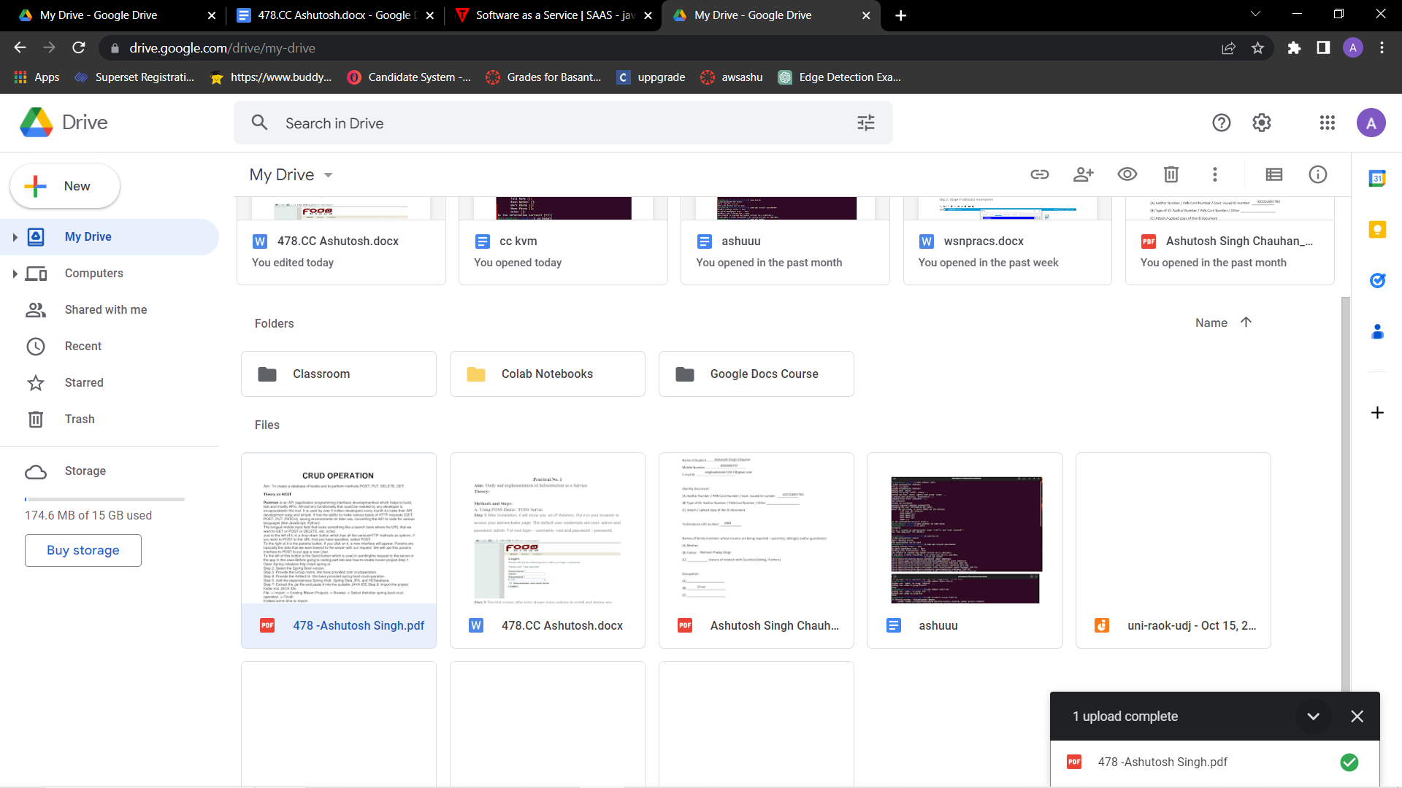

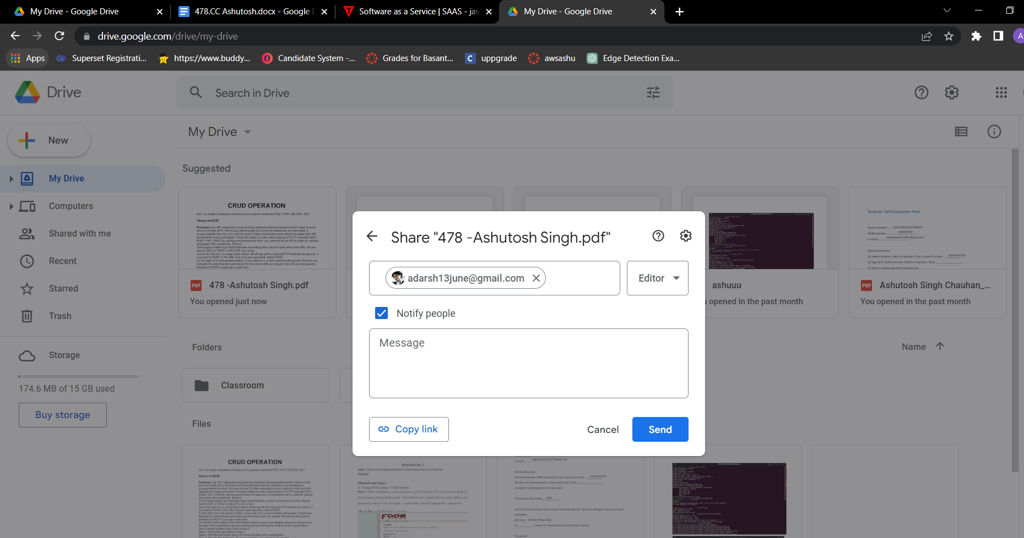

B. OwnCloud (Offline)

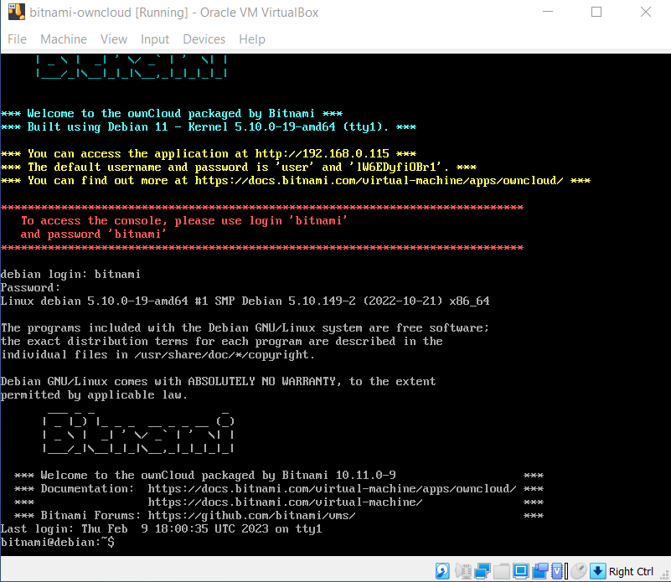

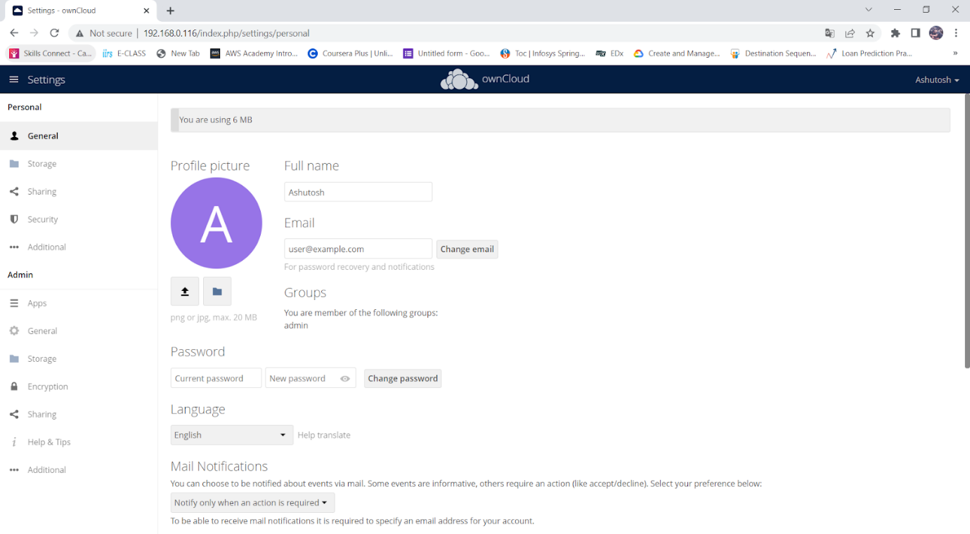

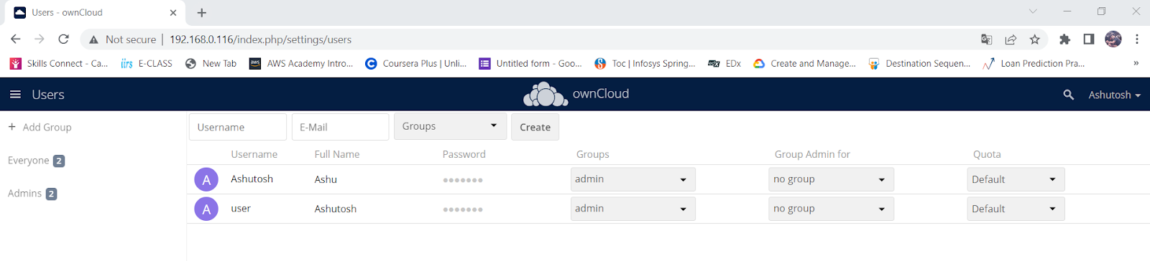

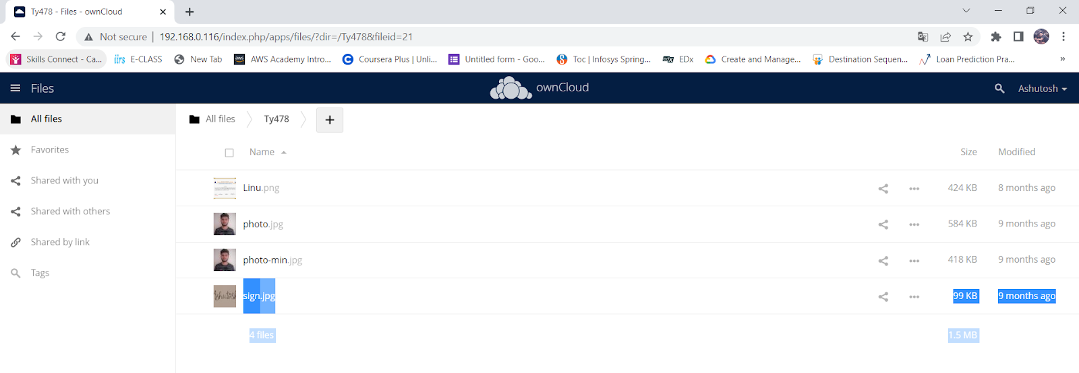

C. Owncloud (Online)

Demo.owncloud.org

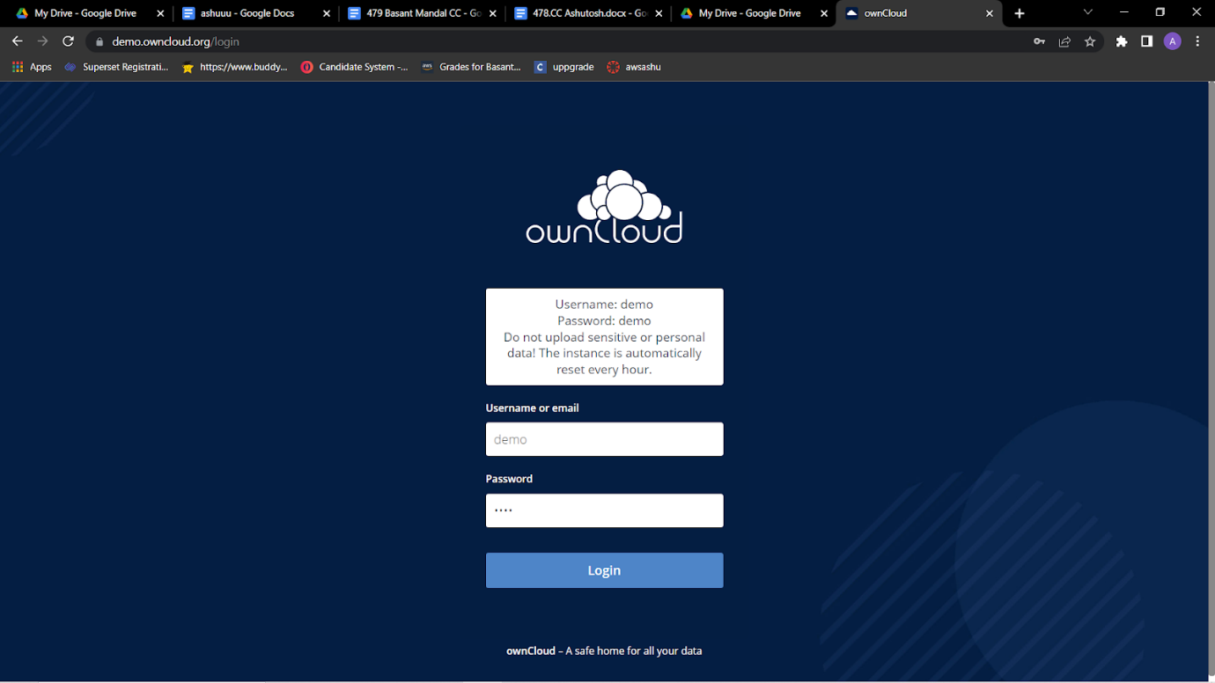

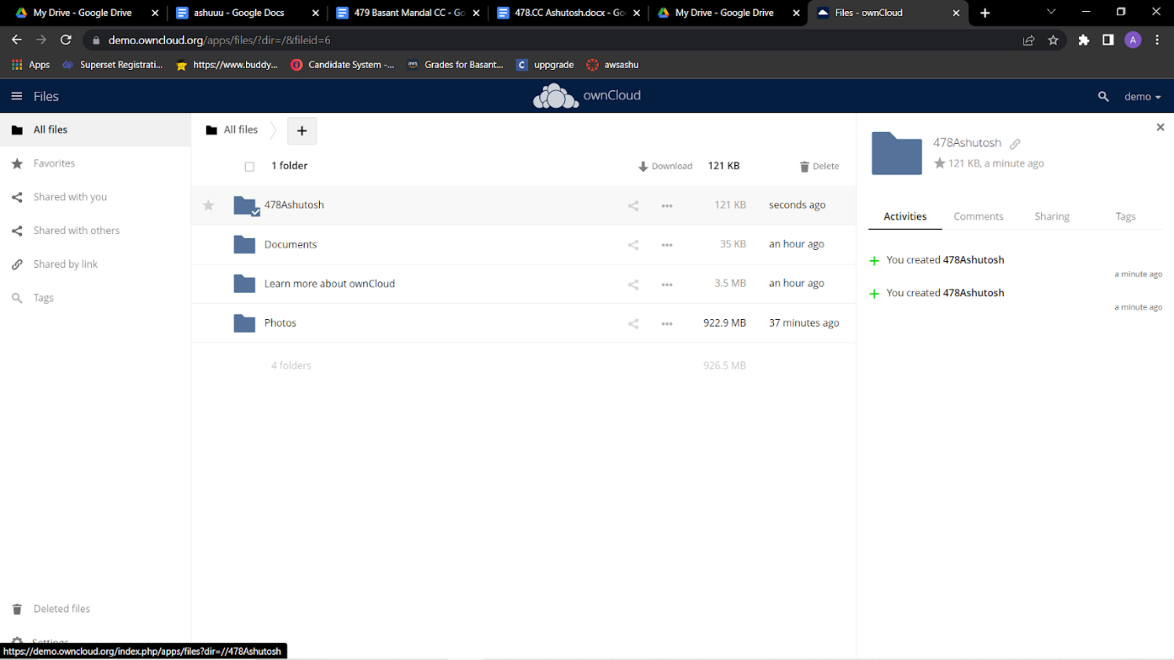

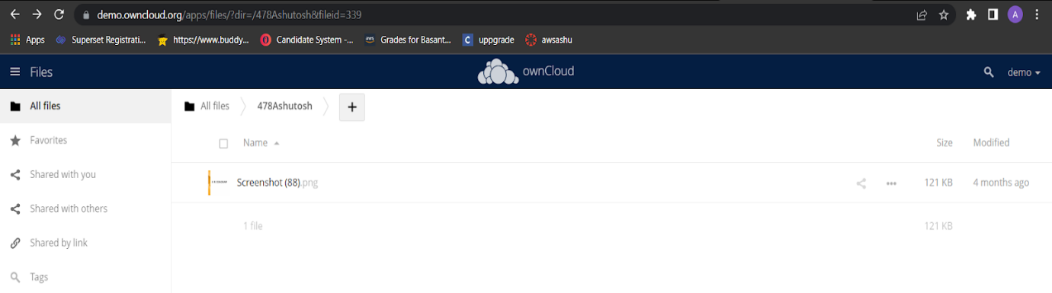

**CONCLUSION :**

**Advantages of STaaS**

Key advantages to STaaS in the enterprise include the following:

* Storage costs. Personnel, hardware and physical storage space expenses are reduced.
* Disaster recovery. Having multiple copies of data stored in different locations can better enable disaster recovery measures.
* Scalability. With most public cloud services, users only pay for the resources that they use.
* Syncing. Files can be automatically synced across multiple devices.
* Security. Security can be both an advantage and a disadvantage, as security methods may change per vendor. Data tends to be encrypted during transmission and while at rest.