**Dipen Delvadiya**

**Lab – 1**

**ITMD – 455**

**James Papademas**

**Screenshots:**

1. **Icon on Home screen:**

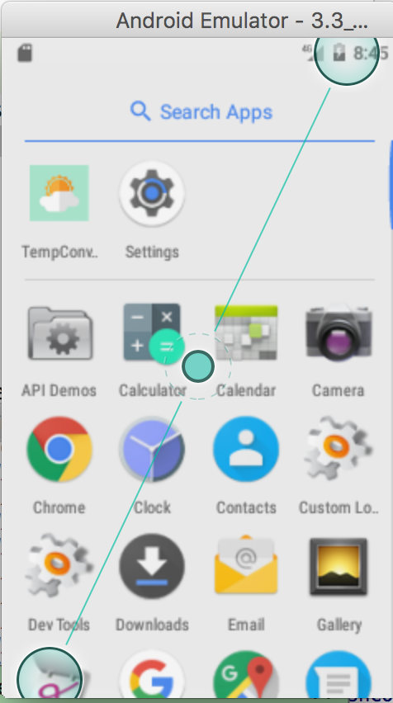

1. **Converting 30 C to F:**

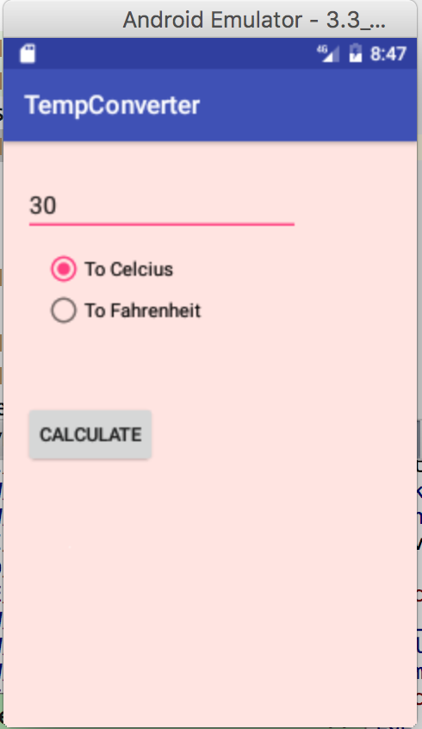 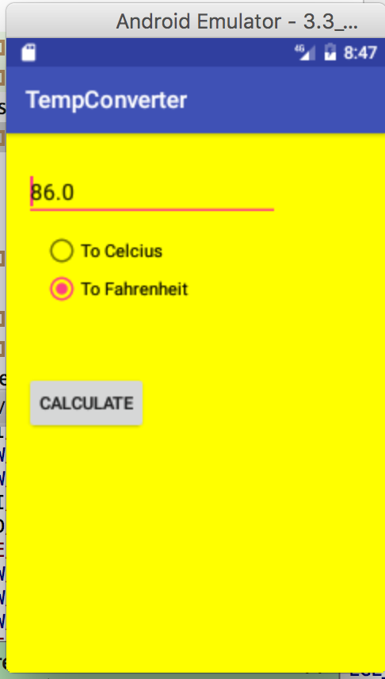

1. **Converting really cold temp**

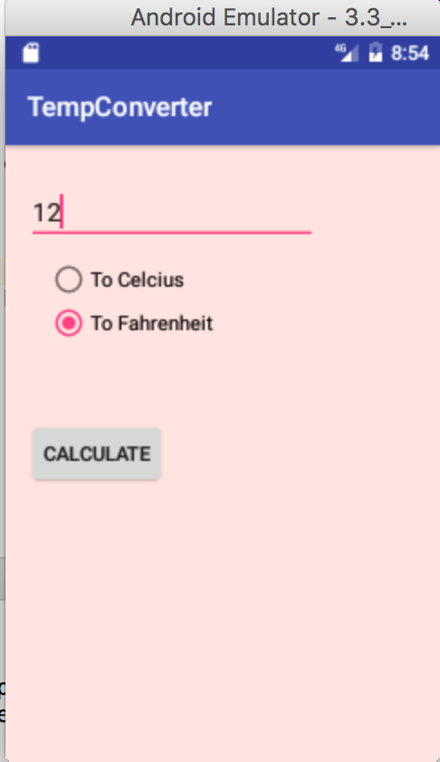 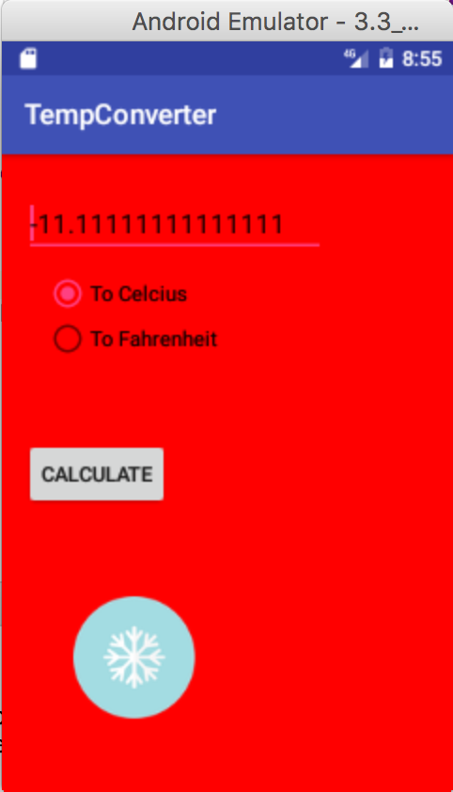

1. **Converting very warm temp:**

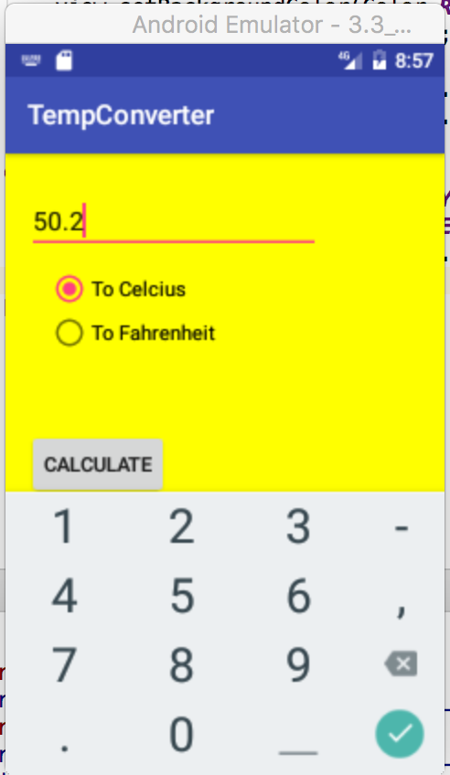 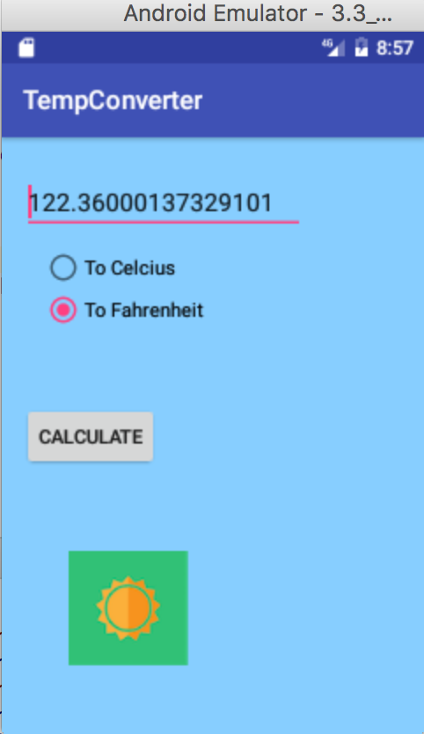

1. **Converting temp between 0 and 90:**

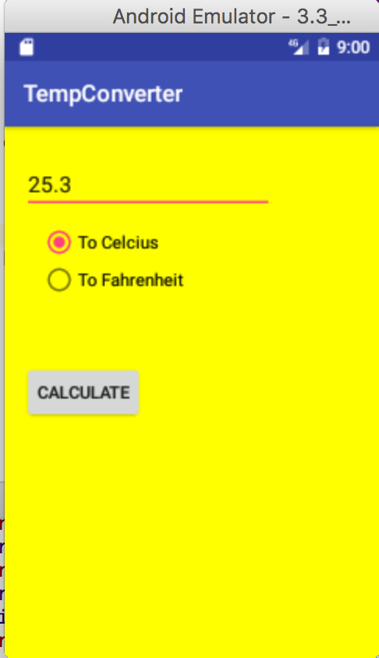 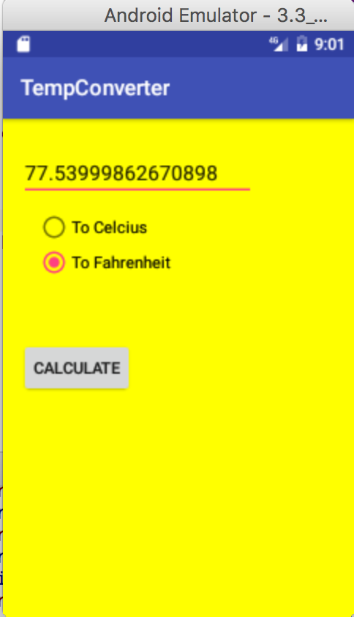

**Source Codes:**

**AndroidManifest.xml file:**

*<?***xml version="1.0" encoding="utf-8"***?>*<**manifest xmlns:android="http://schemas.android.com/apk/res/android"  
 package="com.example.dipendelvadiya.tempconverter"**>  
  
 <**application  
 android:allowBackup="true"  
  
 android:icon="@drawable/logo"  
 android:label="@string/app_name"  
 android:supportsRtl="true"  
 android:theme="@style/AppTheme"**>  
 <**activity android:name=".MainActivity"**>  
 <**intent-filter**>  
 <**action android:name="android.intent.action.MAIN"** />  
  
 <**category android:name="android.intent.category.LAUNCHER"** />  
 </**intent-filter**>  
 </**activity**>  
 </**application**>  
  
</**manifest**>

**Convertutil.java**

*/**  
 * Created by dipendelvadiya on 1/21/17.  
 */***public class** ConverterUtil {  
  
 */**  
 \** ***@param fahrenheit*** *\** ***@return*** *\*/  
 // converts to celsius* **public static double** convertFahrenheitToCelsius(**float** fahrenheit)  
 {  
 **return** ((fahrenheit - 32) * 5.0 / 9.0);  
 }  
  
 */**  
 \** ***@param celsius*** *\** ***@return*** *\*/  
 // converts to fahrenheit* **public static double** convertCelsiusToFahrenheit(**float** celsius) {  
 **return** (celsius * (9 / 5.0)) + 32;  
 }  
}

**MainActivity.java**

**package** com.example.dipendelvadiya.tempconverter;  
  
**import** android.graphics.Color;  
**import** android.os.Bundle;  
**import** android.support.v7.app.AppCompatActivity;  
**import** android.view.View;  
**import** android.widget.EditText;  
**import** android.widget.ImageView;  
**import** android.widget.RadioButton;  
**import** android.widget.Toast;  
  
  
**public class** MainActivity **extends** AppCompatActivity {  
  
 ImageView **iv**; *//create iv object to manipulate image view* **private** EditText **text**;  
 View **view**; *//create object to manipulate background color* @Override  
 **protected void** onCreate(Bundle savedInstanceState) {  
 **super**.onCreate(savedInstanceState);  
 setContentView(R.layout.***activity_main***);  
 **text** = (EditText) findViewById(R.id.***editText***);  
 }  
  
 **public void** onClick(View view) {  
 **switch** (view.getId()) {  
 **case** R.id.***button8***:  
 RadioButton celsiusButton = (RadioButton)  
 findViewById(R.id.***radioButton6***);  
 RadioButton fahrenheitButton = (RadioButton)  
 findViewById(R.id.***radioButton5***);  
 **if** (**text**.getText().length() == 0) {  
 Toast.*makeText*(**this**, **"Please enter a valid number"**,  
 Toast.***LENGTH_LONG***).show();  
 **return**;  
 }  
 **float** inputValue = Float.*parseFloat*(**text**.getText().toString());  
 **if** (celsiusButton.isChecked()) {  
 **text**.setText(String.*valueOf*(ConverterUtil.*convertCelsiusToFahrenheit*(inputValue)));  
 celsiusButton.setChecked(**false**);  
 fahrenheitButton.setChecked(**true**);  
 } **else** {  
 **text**.setText(String.*valueOf*(ConverterUtil.*convertFahrenheitToCelsius*(inputValue)));  
 fahrenheitButton.setChecked(**false**);  
 celsiusButton.setChecked(**true**);  
 }  
  
 *//grab CURRENT result value now in Text Field* inputValue = Float.*parseFloat*(**text**.getText().toString());  
 view = findViewById(R.id.***activity_main***);  
 **iv**=(ImageView) findViewById(R.id.***imageView***);  
 **if** (inputValue>90){  
 *//set hex color to skyblue* view.setBackgroundColor(Color.*parseColor*(**"#87ceff"**));  
 **iv**.setVisibility(View.***VISIBLE***);  
 *//clear any prior image* ((ImageView) **iv**.findViewById(R.id.***imageView***)).setImageResource(0);  
 **iv**.setImageResource(R.drawable.***sunny***); *//show sun on image* }  
 **else if** (inputValue < 0)  
 {  
 view.setBackgroundColor(Color.***RED***); *//to set background red* **iv**.setVisibility(View.***VISIBLE***);  
 *//clear any prior image* ((ImageView) **iv**.findViewById(R.id.***imageView***)).setImageResource(0);  
 **iv**.setImageResource(R.drawable.***cold***);  
 }  
 **else** {  
 view.setBackgroundColor(Color.***YELLOW***);*//to set Background yellow* **iv**.setVisibility(View.***INVISIBLE***);  
 ((ImageView) **iv**.findViewById(R.id.***imageView***)).setImageResource(0);  
 }  
 **break**;  
 }  
 }  
}

**activity_main.xml:**

*<?***xml version="1.0" encoding="utf-8"***?>*<**RelativeLayout xmlns:android="http://schemas.android.com/apk/res/android"  
 xmlns:app="http://schemas.android.com/apk/res-auto"  
 xmlns:tools="http://schemas.android.com/tools"  
 android:id="@+id/activity_main"  
 android:layout_width="match_parent"  
 android:layout_height="match_parent"  
 android:paddingBottom="@dimen/activity_vertical_margin"  
 android:paddingLeft="@dimen/activity_horizontal_margin"  
 android:paddingRight="@dimen/activity_horizontal_margin"  
 android:paddingTop="@dimen/activity_vertical_margin"  
 tools:context="com.example.dipendelvadiya.tempconverter.MainActivity"  
 android:background="@color/myColor"**>  
  
 <**EditText  
 android:layout_width="wrap_content"  
 android:layout_height="wrap_content"  
 android:inputType="numberSigned|numberDecimal"  
 android:ems="10"  
 android:layout_alignParentTop="true"  
 android:layout_alignParentStart="true"  
 android:layout_marginTop="11dp"  
 android:id="@+id/editText"  
 android:focusable="true"** />  
  
 <**RadioGroup  
 android:layout_width="wrap_content"  
 android:layout_height="wrap_content"  
 android:layout_below="@+id/editText"  
 android:layout_alignParentStart="true"  
 android:layout_marginStart="14dp"  
 android:layout_marginTop="11dp"  
 android:id="@+id/radioGroup"**>  
  
 <**RadioButton  
 android:text="@string/celcius"  
 android:layout_width="wrap_content"  
 android:layout_height="wrap_content"  
 android:id="@+id/radioButton6"  
 android:layout_weight="1"  
 android:checked="true"** />  
  
 <**RadioButton  
 android:text="@string/fahrenheit"  
 android:layout_width="wrap_content"  
 android:layout_height="wrap_content"  
 android:id="@+id/radioButton5"  
 android:layout_weight="1"** />  
 </**RadioGroup**>  
  
 <**Button  
 android:layout_width="wrap_content"  
 android:layout_height="wrap_content"  
 android:layout_centerVertical="true"  
 android:layout_alignParentStart="true"  
 android:id="@+id/button8"  
 android:onClick="onClick"  
 android:text="@string/calc"** />  
  
 <**ImageView  
 android:layout_width="wrap_content"  
 android:layout_height="wrap_content"  
 app:srcCompat="@android:drawable/screen_background_light_transparent"  
 android:layout_below="@+id/button8"  
 android:layout_alignStart="@+id/radioGroup"  
 android:layout_marginStart="20dp"  
 android:layout_marginTop="62dp"  
 android:id="@+id/imageView"** />  
  
</**RelativeLayout**>

**strings.xml**

<**resources**>  
 <**string name="app_name"**>TempConverter</**string**>  
 <**color name="myColor"**>#FFE4E1</**color**>  
 <**string name="celcius"**>To Celcius</**string**>  
 <**string name="fahrenheit"**>To Fahrenheit</**string**>  
 <**string name="calc"**>Calculate</**string**>  
  
</**resources**>