**Dipen Delvadiya**

**ITMD – 455**

**Lab – 5**

**James Papademas**

**Snapshots of Output:**

1. **Output of 3rd question 2. If user gets all the questions correct**

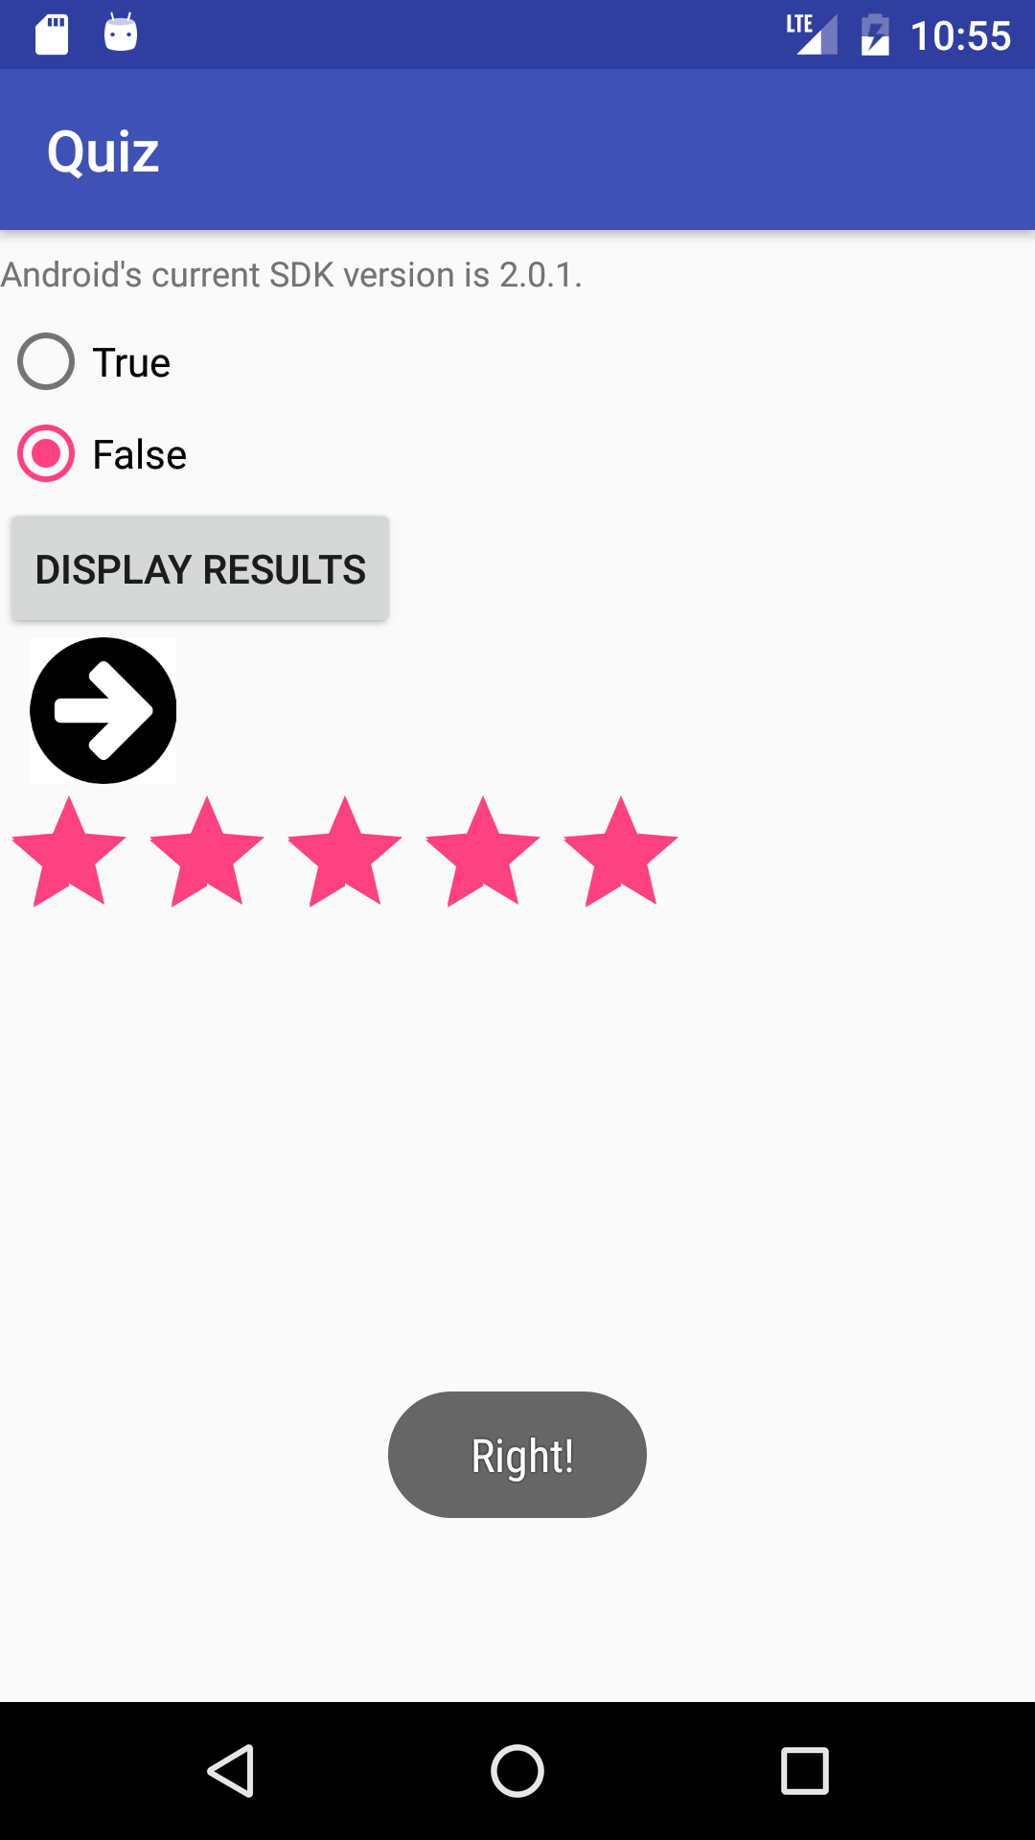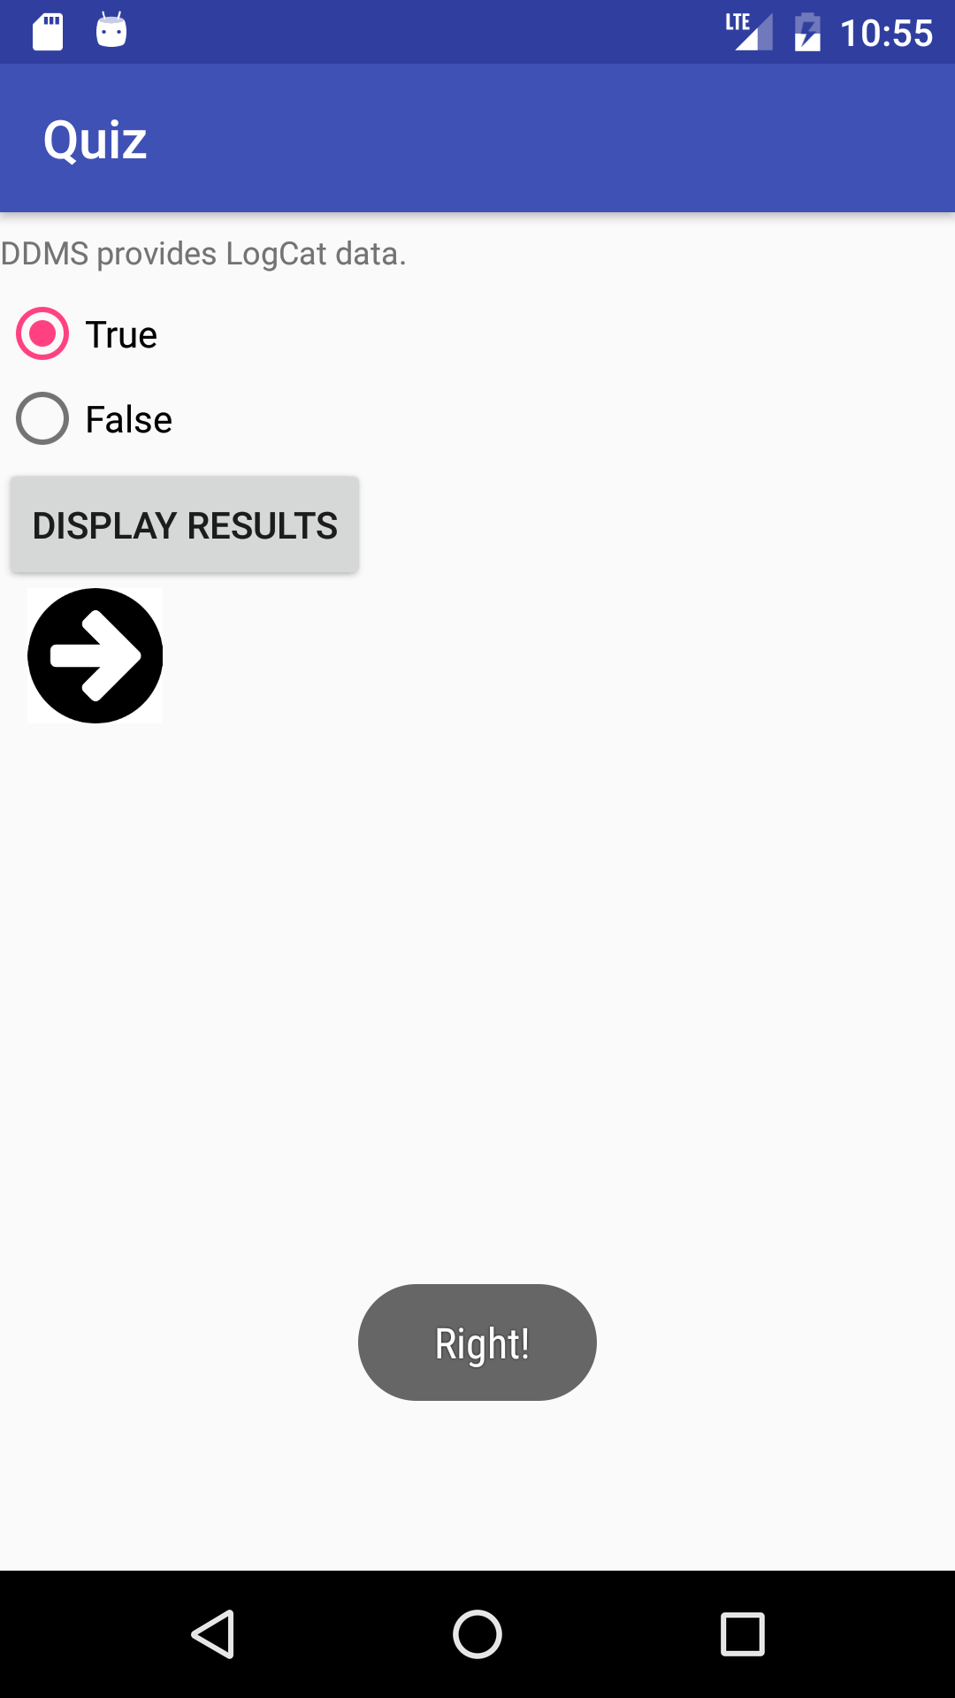

**Source Codes:**

**MainActivity.java**

**package** com.example.dipendelvadiya.quiz;  
  
**import** android.app.Activity;  
**import** android.app.ProgressDialog;  
**import** android.os.AsyncTask;  
**import** android.os.Bundle;  
**import** android.support.v7.app.AppCompatActivity;  
**import** android.view.View;  
**import** android.view.View.OnClickListener;  
**import** android.widget.Button;  
**import** android.widget.ImageView;  
**import** android.widget.RadioButton;  
**import** android.widget.RadioGroup;  
**import** android.widget.RatingBar;  
**import** android.widget.TextView;  
**import** android.widget.Toast;  
  
**import** java.io.BufferedReader;  
**import** java.io.InputStream;  
**import** java.io.InputStreamReader;  
**import** java.net.HttpURLConnection;  
**import** java.net.URL;  
**import** java.util.ArrayList;  
  
  
**public class** MainActivity **extends** AppCompatActivity {  
 Activity **context**;  
 TextView **txtview**;  
 ProgressDialog **pd**;  
  
 ArrayList<String> **stringList** = **new** ArrayList<String>();  
  
 **static int** *questionNum* = 0;  
 **int count** = 0;  
  
 **private** RadioGroup **radioQuestions**;  
 **private** RadioButton **radioButton**;  
  
 ImageView **image**;  
  
 @Override  
 **protected void** onCreate(Bundle savedInstanceState) {  
 **super**.onCreate(savedInstanceState);  
 setContentView(R.layout.***activity_main***);  
 **context**=**this**;  
  
 BackgroundTask bt = **new** BackgroundTask();  
 bt.execute(**"http://www.papademas.net/sample.txt"**); *//grab url* }*//end onCreate  
  
 //background process to download the file from internet* **public class** BackgroundTask **extends** AsyncTask<String, Integer, Void> {  
  
 **protected void** onPreExecute() {  
 **super**.onPreExecute();  
 *//display progress dialog* **pd** = **new** ProgressDialog(**context**);  
 **pd**.setTitle(**"Reading the text file"**);  
 **pd**.setMessage(**"Please wait."**);  
 **pd**.setCancelable(**true**);  
 **pd**.setIndeterminate(**false**);  
 **pd**.show();  
  
 }  
  
 **protected** Void doInBackground(String... params) {  
 URL url;  
 String StringBuffer = **null**;  
 **try** {  
 *//create url object to point to the file location on internet* url = **new** URL(params[0]);  
 *//make a request to server* HttpURLConnection con = (HttpURLConnection) url.openConnection();  
 *//get InputStream instance* InputStream is = con.getInputStream();  
 *//create BufferedReader object* BufferedReader br = **new** BufferedReader(**new** InputStreamReader(is));  
  
 *//read content of the file line by line & add it to Stringbuffer* **while** ((StringBuffer = br.readLine()) != **null**) {  
 **stringList**.add(StringBuffer); *//add to Arraylist* }  
  
 br.close();  
  
 } **catch** (Exception e) {  
 e.printStackTrace();  
 *//close dialog if error occurs* **if** (**pd** != **null**) **pd**.dismiss();  
 }  
  
 **return null**;  
  
 }  
  
 **protected void** onPostExecute(Void result) {  
 *//close dialog* **if** (**pd** != **null**)  
 **pd**.dismiss();  
 **txtview** = (TextView) findViewById(R.id.***textView1***);  
 *//display read text in TextVeiw* **txtview**.setText(**stringList**.get(0));  
 startQuiz();  
  
 }  
 }*//end BackgroundTask class* **public void** startQuiz() {  
 buttonListener();  
 }  
  
 **public void** buttonListener() {  
  
 Button btnDisplay;  
 **final** RatingBar rb = (RatingBar) findViewById(R.id.***ratingBar***);  
 rb.setVisibility(View.***GONE***);  
  
 **radioQuestions** = (RadioGroup) findViewById(R.id.***radioQuestions***);  
 btnDisplay = (Button) findViewById(R.id.***btnDisplay***);  
 btnDisplay.setOnClickListener(**new** OnClickListener() {  
  
 @Override  
 **public void** onClick(View v) {  
  
 *// get selected radio button from radioGroup* **int** selectedId = **radioQuestions**.getCheckedRadioButtonId();  
  
 *// find the radiobutton by returned id* **radioButton** = (RadioButton) findViewById(selectedId);  
  
 **switch** (*questionNum*) {  
 **case** 0:  
 *//verify if result matches the right button selection  
 //i.e., (True or false!)* **if** (**radioButton**.getText().equals(**"True"**)) {  
 Toast.*makeText*(MainActivity.**this**,  
 **" Right!"**, Toast.***LENGTH_SHORT***).show();  
 **count** = **count** + 1;  
 }  
 **else** Toast.*makeText*(MainActivity.**this**,  
 **" Wrong!"**, Toast.***LENGTH_SHORT***).show();  
 **break**;  
 **case** 1:  
 *//verify if result matches the right button selection  
 //i.e., (True or false!)* **if** (**radioButton**.getText().equals(**"False"**)) {  
 Toast.*makeText*(MainActivity.**this**,  
 **" Right!"**, Toast.***LENGTH_SHORT***).show();  
 **count** = **count** + 1;  
 }  
 **else** Toast.*makeText*(MainActivity.**this**,  
 **" Wrong!"**, Toast.***LENGTH_SHORT***).show();  
 **break**;  
 *//finish switch cases 2-4* **case** 2:  
 *//verify if result matches the right button selection  
 //i.e., (True or false!)* **if** (**radioButton**.getText().equals(**"True"**)) {  
 Toast.*makeText*(MainActivity.**this**,  
 **" Right!"**, Toast.***LENGTH_SHORT***).show();  
 **count** = **count** + 1;  
 }  
 **else** Toast.*makeText*(MainActivity.**this**,  
 **" Wrong!"**, Toast.***LENGTH_SHORT***).show();  
 **break**;  
 **case** 3:  
 *//verify if result matches the right button selection  
 //i.e., (True or false!)* **if** (**radioButton**.getText().equals(**"False"**)) {  
 Toast.*makeText*(MainActivity.**this**,  
 **" Right!"**, Toast.***LENGTH_LONG***).show();  
 **count** = **count** + 1;  
 }  
 **else** Toast.*makeText*(MainActivity.**this**,  
 **" Wrong!"**, Toast.***LENGTH_SHORT***).show();  
 **break**;  
 **case** 4:  
 *//verify if result matches the right button selection  
 //i.e., (True or false!)* **if** (**radioButton**.getText().equals(**"False"**)) {  
 Toast.*makeText*(MainActivity.**this**,  
 **" Right!"**, Toast.***LENGTH_SHORT***).show();  
 **count** = **count** + 1;  
 rb.setVisibility(View.***VISIBLE***);  
 rb.setRating(**count**);  
 }  
 **else** Toast.*makeText*(MainActivity.**this**,  
 **" Wrong!"**, Toast.***LENGTH_SHORT***).show();  
 **break**;  
 }*//end switch* }  
 });  
 imageListener();  
 }*//end buttonListener* **public void** imageListener() {  
 **image** = (ImageView) findViewById(R.id.***imageView1***);  
 **image**.setOnClickListener(**new** View.OnClickListener() {  
  
 @Override  
 **public void** onClick(View view) {  
 *// get new question for viewing* **if** (*questionNum* == 4) {  
 *//reset count to -1 to start first question again  
 questionNum* = -1;  
 }  
 **txtview**.setText(**stringList**.get(++*questionNum*));  
 *//reset radio button (radioTrue) to default* **radioQuestions**.check(R.id.***radioTrue***);  
 }  
 });  
 }*//end imageListener*}*//end activity*

**AndroidManifest.xml**

*<?***xml version="1.0" encoding="utf-8"***?>*<**manifest xmlns:android="http://schemas.android.com/apk/res/android"  
 package="com.example.dipendelvadiya.quiz"**>  
 <**uses-permission android:name="android.permission.INTERNET"**/>  
 <**application  
 android:allowBackup="true"  
 android:icon="@mipmap/ic_launcher"  
 android:label="@string/app_name"  
 android:roundIcon="@mipmap/ic_launcher_round"  
 android:supportsRtl="true"  
 android:theme="@style/AppTheme"**>  
 <**activity android:name=".MainActivity"**>  
 <**intent-filter**>  
 <**action android:name="android.intent.action.MAIN"** />  
  
 <**category android:name="android.intent.category.LAUNCHER"** />  
 </**intent-filter**>  
 </**activity**>  
 </**application**>  
  
</**manifest**>