**Dipen Delvadiya**

**ITMD – 455**

**Lab – 6**

**James Papademas**

**04-05-2017**

**Screenshots:**

1. Screenshot Showing My Name:

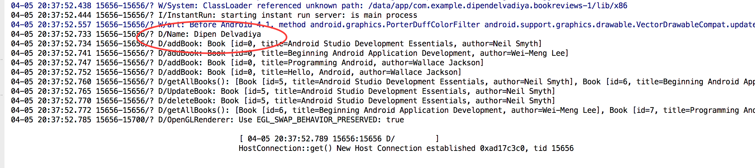

1. Screenshot Showing Updated 4th record

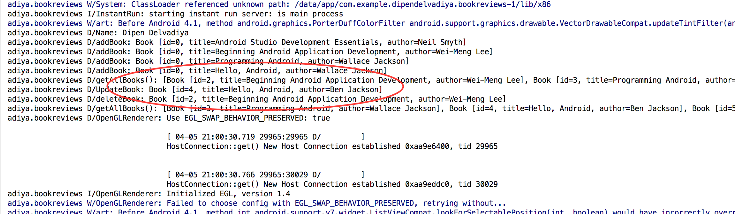

1. Snapshot Showing Totals:

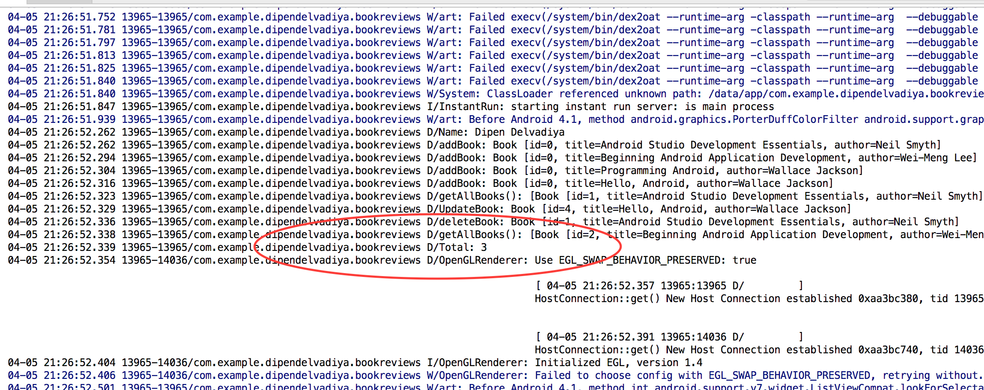

**Source Codes:**

**Book.java:**

**package** com.example.dipendelvadiya.bookreviews;  
  
*/**  
 * Created by dipendelvadiya on 4/5/17.  
 */***public class** Book {  
 **private int id**;  
 **private** String **title**;  
 **private** String **author**;  
  
 **public** Book(){}  
  
 **public** Book(String title, String author) {  
 **super**();  
 **this**.**title** = title;  
 **this**.**author** = author;  
 }  
 *//getters & setters* **public int** getId() { **return id**; }  
 **public void** setId(**int** id) { **this**.**id** = id; }  
 **public** String getTitle() { **return title**; }  
 **public void** setTitle(String title) { **this**.**title** = title; }  
 **public** String getAuthor() { **return author**; }  
 **public void** setAuthor(String author) { **this**.**author** = author;}  
  
 @Override  
 **public** String toString() {  
 **return "Book [id="** + **id** + **", title="** + **title** + **", author="** + **author** + **"]"**;  
 }  
  
}

**MainActivity.java:**

**package** com.example.dipendelvadiya.bookreviews;  
  
**import** android.support.v7.app.AppCompatActivity;  
**import** android.os.Bundle;  
**import** android.util.Log;  
  
**import** java.util.List;  
  
  
**public class** MainActivity **extends** AppCompatActivity {  
  
 @Override  
 **protected void** onCreate(Bundle savedInstanceState) {  
 **super**.onCreate(savedInstanceState);  
 setContentView(R.layout.***activity_main***);  
  
 SqlHelper db = **new** SqlHelper(**this**);  
  
 */** CRUD Operations **/  
 // add Books* Log.*d*(**"Name"**, **"Dipen Delvadiya"**);  
 db.addBook(**new** Book(**"Android Studio Development Essentials"**, **"Neil Smyth"**));  
 db.addBook(**new** Book(**"Beginning Android Application Development"**, **"Wei-Meng Lee"**));  
 db.addBook(**new** Book(**"Programming Android"**, **"Wallace Jackson"**));  
 db.addBook(**new** Book(**"Hello, Android"**, **"Wallace Jackson"**));  
  
 *// get all books* List<Book> list = db.getAllBooks();  
  
 *// update one book* **int** j = db.updateBook(list.get(3), **"Hello, Android"**, **"Ben Jackson"**);  
  
 *// delete one book* db.deleteBook(list.get(0));  
  
 *// get all books* db.getAllBooks();  
 Log.*d*(**"Total"**, String.*valueOf*(db.getIds()));  
 }  
}

**SqlHelper.java:**

**package** com.example.dipendelvadiya.bookreviews;  
  
*/**  
 * Created by dipendelvadiya on 4/5/17.  
 */***import** java.util.LinkedList;  
**import** java.util.List;  
  
**import** android.content.ContentValues;  
**import** android.content.Context;  
**import** android.database.Cursor;  
**import** android.database.sqlite.SQLiteDatabase;  
**import** android.database.sqlite.SQLiteOpenHelper;  
**import** android.util.Log;  
  
**public class** SqlHelper **extends** SQLiteOpenHelper {  
  
 *// Database Version* **private static final int *DATABASE_VERSION*** = 4;  
 *// Database Name* **private static final** String ***DATABASE_NAME*** = **"BookDB"**;  
  
 *// Books table name* **private static final** String ***TABLE_BOOKS*** = **"books"**;  
  
 *// Books Table Columns names* **private static final** String ***KEY_ID*** = **"id"**;  
 **private static final** String ***KEY_TITLE*** = **"title"**;  
 **private static final** String ***KEY_AUTHOR*** = **"author"**;  
  
 **public** SqlHelper(Context context) {  
 **super**(context, ***DATABASE_NAME***, **null**, ***DATABASE_VERSION***);  
 }  
 @Override  
 **public void** onCreate(SQLiteDatabase db) {  
 *// SQL statement to create book table* String CREATE_BOOK_TABLE = **"CREATE TABLE books ( "** +  
 **"id INTEGER PRIMARY KEY AUTOINCREMENT, "** +  
 **"title TEXT, "**+  
 **"author TEXT )"**;  
  
 *// create books table* db.execSQL(CREATE_BOOK_TABLE);  
 }  
 @Override  
 **public void** onUpgrade(SQLiteDatabase db, **int** oldVersion, **int** newVersion) {  
 *// Drop older books table if existed* db.execSQL(**"DROP TABLE IF EXISTS books"**);  
  
 *// create fresh books table* **this**.onCreate(db);  
 }  
 */*CRUD operations (create "add", read "get", update, delete) */* **public void** addBook(Book book){  
 Log.*d*(**"addBook"**, book.toString());  
 *// 1. get reference to writable DB* SQLiteDatabase db = **this**.getWritableDatabase();  
  
 *// 2. create ContentValues to add key "column"/value* ContentValues values = **new** ContentValues();  
 values.put(***KEY_TITLE***, book.getTitle()); *// get title* values.put(***KEY_AUTHOR***, book.getAuthor()); *// get author  
  
 // 3. insert* db.insert(***TABLE_BOOKS***, *// table* **null**, *//nullColumnHack* values); *// key/value -> keys = column names/values  
  
 // 4. Close dbase* db.close();  
 }  
 *// Get All Books* **public** List<Book> getAllBooks() {  
 List<Book> books = **new** LinkedList<Book>();  
  
 *// 1. build the query* String query = **"SELECT * FROM "** + ***TABLE_BOOKS***;  
  
 *// 2. get reference to writable DB* SQLiteDatabase db = **this**.getWritableDatabase();  
 Cursor cursor = db.rawQuery(query, **null**);  
  
 *// 3. go over each row, build book and add it to list* Book book = **null**;  
 **if** (cursor.moveToFirst()) {  
 **do** {  
 book = **new** Book();  
 book.setId(Integer.*parseInt*(cursor.getString(0)));  
 book.setTitle(cursor.getString(1));  
 book.setAuthor(cursor.getString(2));  
  
 *// Add book to books* books.add(book);  
 } **while** (cursor.moveToNext());  
 }  
  
 Log.*d*(**"getAllBooks()"**, books.toString());  
  
 **return** books; *// return books* }  
 *// Updating single book* **public int** updateBook(Book book, String newTitle, String newAuthor) {  
  
 *// 1. get reference to writable DB* SQLiteDatabase db = **this**.getWritableDatabase();  
  
 *// 2. create ContentValues to add key "column"/value* ContentValues values = **new** ContentValues();  
 values.put(**"title"**, newTitle); *// get title* values.put(**"author"**, newAuthor); *// get author  
  
 // 3. updating row* **int** i = db.update(***TABLE_BOOKS***, *//table* values, *// column/value* ***KEY_ID***+**" = ?"**, *// selections* **new** String[] { String.*valueOf*(book.getId()) }); *//selection args  
 // 4. close dbase* db.close();  
 Log.*d*(**"UpdateBook"**, book.toString());  
 **return** i;  
  
 }  
 *// Deleting single book* **public void** deleteBook(Book book) {  
  
 *// 1. get reference to writable DB* SQLiteDatabase db = **this**.getWritableDatabase();  
  
 *// 2. delete* db.delete(***TABLE_BOOKS***,  
 ***KEY_ID***+**" = ?"**,  
 **new** String[] { String.*valueOf*(book.getId()) });  
  
 *// 3. close* db.close();  
  
 Log.*d*(**"deleteBook"**, book.toString());  
 }  
  
 **public int** getIds()  
 {  
 String selectQuery = **"SELECT id FROM books"**;  
 SQLiteDatabase database = **this**.getReadableDatabase();  
 Cursor c = database.rawQuery(selectQuery, **null**);  
 c.moveToFirst();  
 **int** total = c.getCount();  
  
 **return** total;  
 }  
  
}

**activity_main.xml:**

*<?***xml version="1.0" encoding="utf-8"***?>*<**android.support.constraint.ConstraintLayout xmlns:android="http://schemas.android.com/apk/res/android"  
 xmlns:app="http://schemas.android.com/apk/res-auto"  
 xmlns:tools="http://schemas.android.com/tools"  
 android:layout_width="match_parent"  
 android:layout_height="match_parent"  
 tools:context="com.example.dipendelvadiya.bookreviews.MainActivity"**>  
  
 <**TextView  
 android:layout_width="wrap_content"  
 android:layout_height="wrap_content"  
 android:text="Hello World!"  
 app:layout_constraintBottom_toBottomOf="parent"  
 app:layout_constraintLeft_toLeftOf="parent"  
 app:layout_constraintRight_toRightOf="parent"  
 app:layout_constraintTop_toTopOf="parent"** />  
  
</**android.support.constraint.ConstraintLayout**>