**Dipen Delvadiya**

**Lab – 08**

**ITMD – 455**

**James Papademas**

**Snapshots:**

1. **When app is launched**

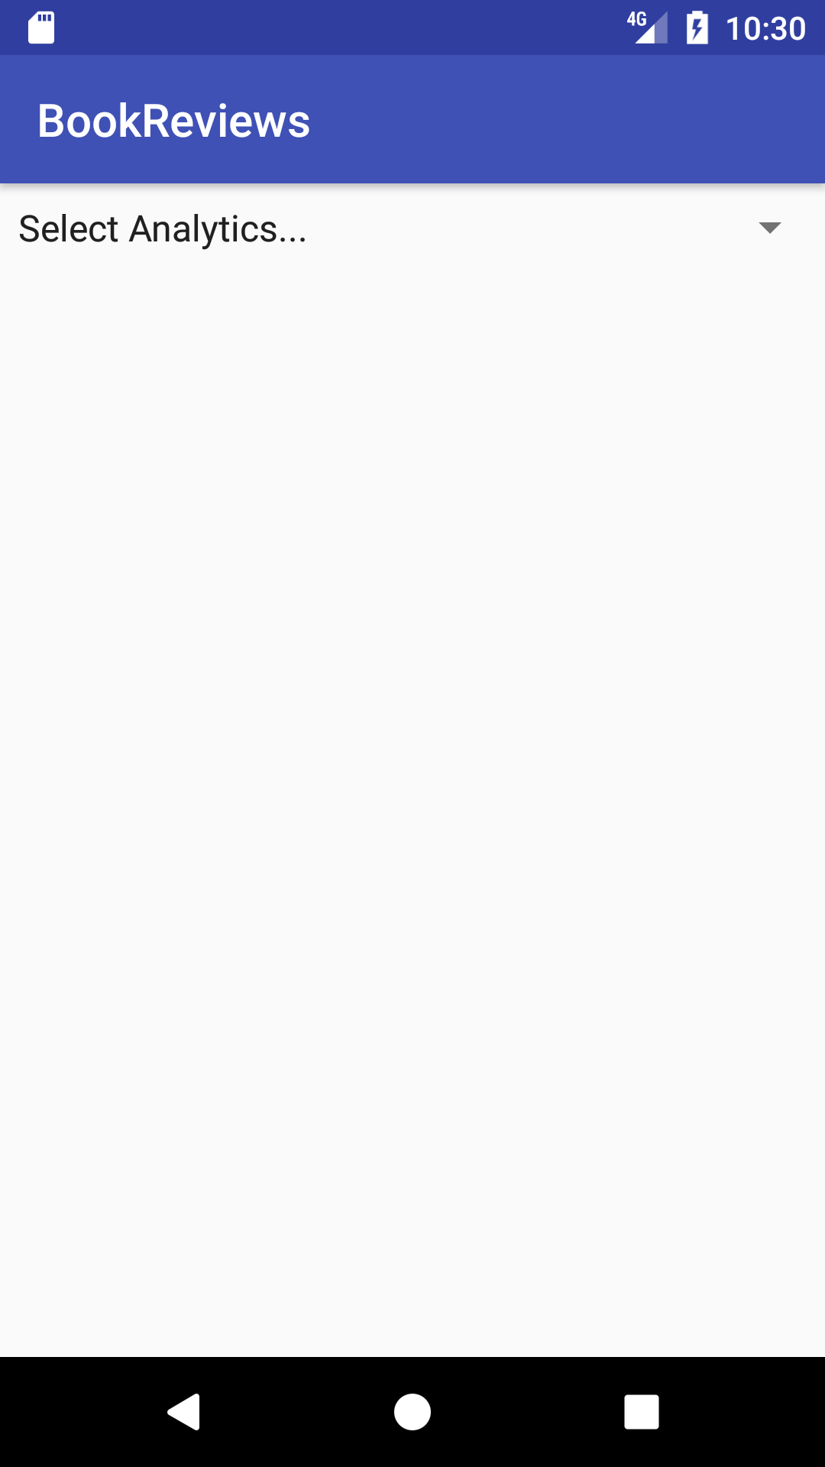

1. **Get Highest Rated Title**

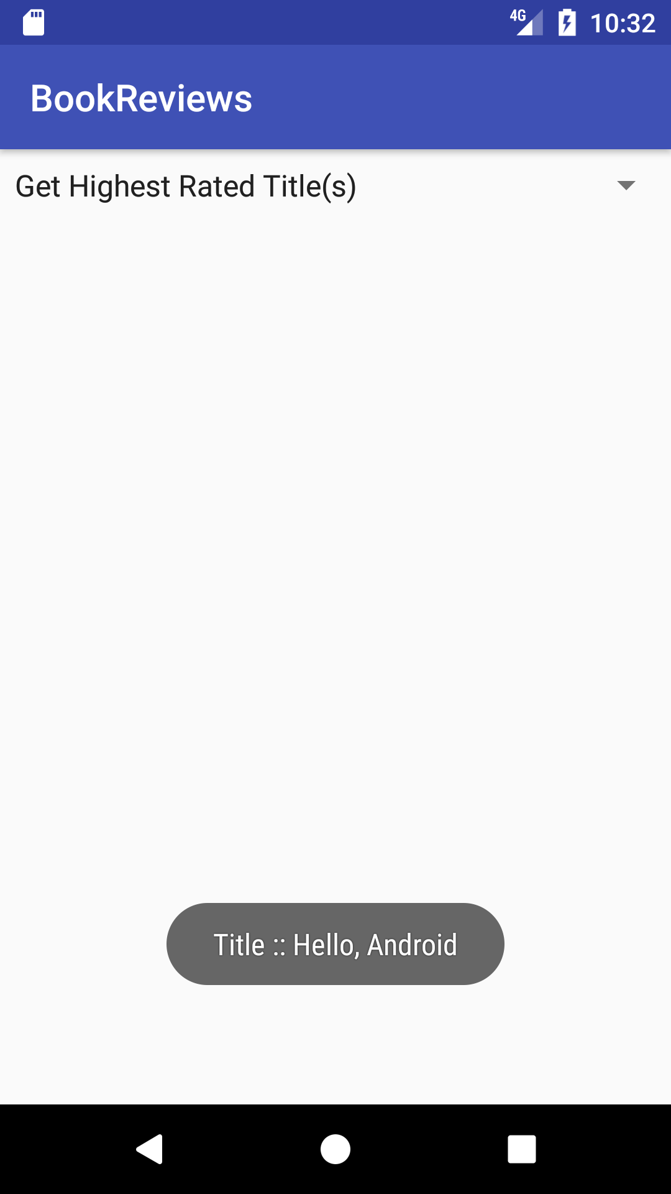

1. **Get lowest rated title**

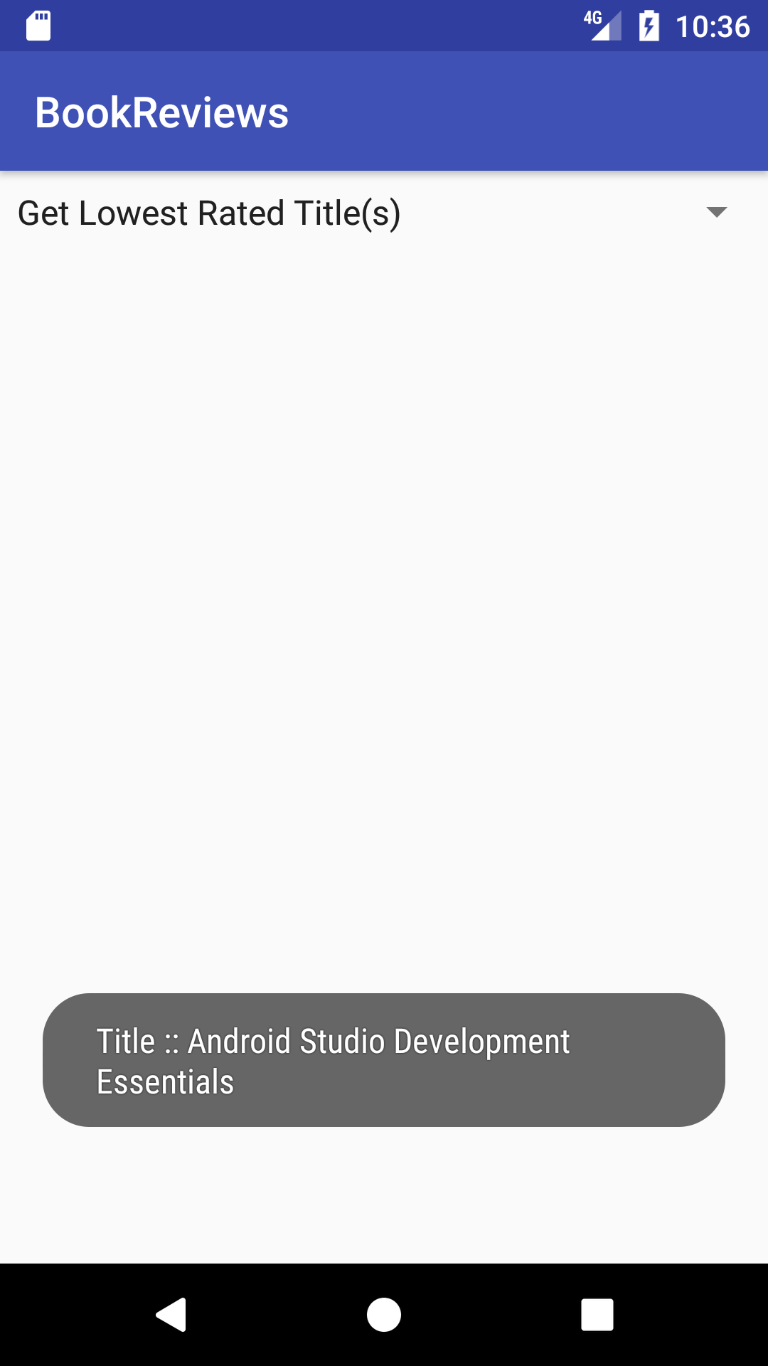

1. **Get record count**

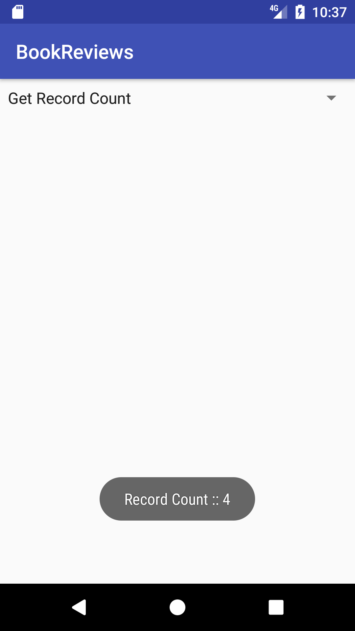

1. **Retrieve titles from Android**

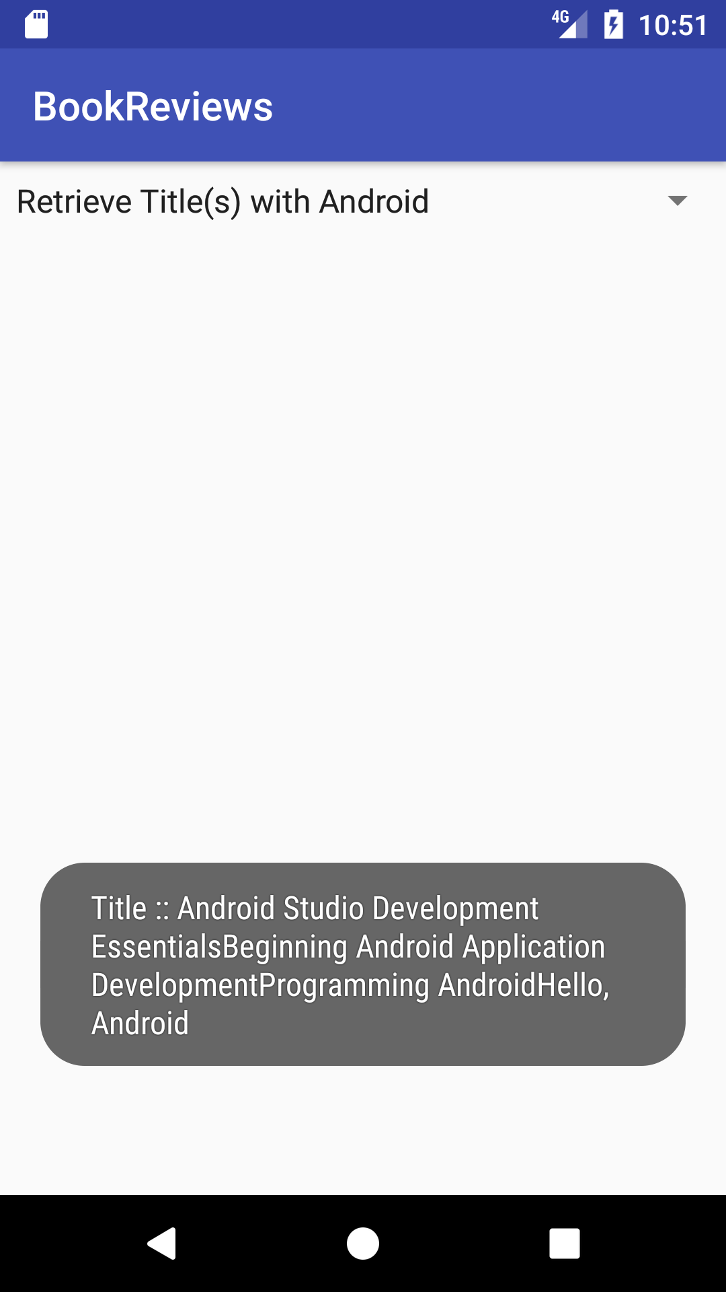

**Source Codes:**

**Book.java:**

**package** com.example.dipendelvadiya.bookreviews;  
  
*/**  
 * Created by dipendelvadiya on 4/25/17.  
 */***public class** Book {  
  
 **private** String **rating**;  
 **private int id**;  
 **private** String **title**;  
 **private** String **author**;  
  
 **public** Book(){}  
  
 **public** Book(String title, String author) {  
 **super**();  
 **this**.**title** = title;  
 **this**.**author** = author;  
 }  
 *//getters & setters* **public int** getId() { **return id**; }  
 **public void** setId(**int** id) { **this**.**id** = id; }  
 **public** String getTitle() { **return title**; }  
 **public void** setTitle(String title) { **this**.**title** = title; }  
 **public** String getAuthor() { **return author**; }  
 **public void** setAuthor(String author) { **this**.**author** = author;}  
 **public void** setRating(String rating) { **this**.**rating** = rating; }  
 **public** String getRating() { **return** rating; }  
  
  
 @Override  
 **public** String toString() {  
 **return "Book [id="** + **id** + **", title="** + **title** + **", author="** + **author** + **", rating="** + **rating** + **"]"**;  
 }  
  
}

**ListAdapter.java:**

**package** com.example.dipendelvadiya.bookreviews;  
  
*/**  
 * Created by dipendelvadiya on 4/25/17.  
 */***import** java.util.List;  
**import** android.content.Context;  
**import** android.view.LayoutInflater;  
**import** android.view.View;  
**import** android.view.ViewGroup;  
**import** android.widget.ArrayAdapter;  
**import** android.widget.RatingBar;  
**import** android.widget.TextView;  
  
**public class** ListAdapter **extends** ArrayAdapter<Book> {  
  
 **private** List<Book> **items**;  
  
 **public** ListAdapter(Context context, **int** textViewResourceId) {  
 **super**(context, textViewResourceId);  
 }  
 **public** ListAdapter(Context context, **int** resource, List<Book> items) {  
 **super**(context, resource, items);  
  
 **this**.**items** = items;  
 }  
  
 @Override  
 **public** View getView(**int** position, View convertView, ViewGroup parent) {  
  
 View v = convertView;  
  
 **if** (v == **null**) {  
  
 LayoutInflater vi;  
 vi = LayoutInflater.*from*(getContext());  
 v = vi.inflate(R.layout.***itemlistrow***, **null**);  
 }  
  
 Book p = getItem(position);  
  
 **if** (p != **null**) {  
  
 TextView tt = (TextView) v.findViewById(R.id.***_id***);  
 TextView tt1 = (TextView) v.findViewById(R.id.***title***);  
 TextView tt3 = (TextView) v.findViewById(R.id.***author***);  
 RatingBar rb = (RatingBar) v.findViewById(R.id.***rating***);  
  
 **if** (tt != **null**) {  
 tt.setText(**""** + p.getId());  
 }  
 **if** (tt1 != **null**) {  
 tt1.setText(p.getTitle());  
 }  
 **if** (tt3 != **null**) {  
 tt3.setText(p.getAuthor());  
 }  
 **if** (rb != **null**) {  
 **float** rating = Float.*parseFloat*(p.getRating());  
 rb.setRating(rating);  
 }  
 }  
  
 **return** v;  
 }  
}

**Mainactivity.java:**

**package** com.example.dipendelvadiya.bookreviews;  
  
**import** android.support.v7.app.AppCompatActivity;  
**import** android.os.Bundle;  
**import** android.util.Log;  
**import** android.view.View;  
**import** android.widget.AdapterView;  
**import** android.widget.ArrayAdapter;  
**import** android.widget.ListView;  
**import** android.widget.Spinner;  
**import** android.widget.Toast;  
  
**import** java.util.ArrayList;  
**import** java.util.Collections;  
**import** java.util.Comparator;  
**import** java.util.List;  
  
**public class** MainActivity **extends** AppCompatActivity **implements** AdapterView.OnItemSelectedListener {  
  
 SqlHelper **db**;  
 @Override  
 **protected void** onCreate(Bundle savedInstanceState) {  
 **super**.onCreate(savedInstanceState);  
 **db** = **new** SqlHelper(**this**);  
 setContentView(R.layout.***activity_main***);  
  
 *// SqlHelper db = new SqlHelper(this);  
 // SqlHelper db = new SqlHelper(this);  
 /** CRUD Operations **/  
 // add Books  
 //Log.d("Name", "Dipen Delvadiya");  
 //db.addBook(new Book("Android Studio Development Essentials", "Neil Smyth"));  
 //db.addBook(new Book("Beginning Android Application Development", "Wei-Meng Lee"));  
 //db.addBook(new Book("Programming Android", "Wallace Jackson"));  
 //db.addBook(new Book("Hello, Android", "Wallace Jackson"));  
  
 // get all books  
 //List<Book> list = db.getAllBooks();  
  
 // update one book  
 //int j = db.updateBook(list.get(3), "Hello, Android", "Ben Jackson");  
  
 // delete one book  
 //db.deleteBook(list.get(3));  
  
 // get all books  
 //db.getAllBooks();  
 //ListView listContent = (ListView) findViewById(R.id.list);  
 //list = new ArrayList<Book>();  
 //list=db.getAllBooks();  
  
//get data from the table by the ListAdapter  
 //ListAdapter customAdapter = new ListAdapter(this, R.layout.itemlistrow,list);  
 //listContent.setAdapter(customAdapter);  
 // Spinner element* Spinner spinner;  
 *// Spinner element* spinner = (Spinner) findViewById(R.id.***spinner***);  
  
 *//Create spinner item listing* List<String> blist = **new** ArrayList<String>();  
 blist.add(**"Get Highest Rated Title(s)"**);  
 blist.add(**"Get Lowest Rated Title(s)"**);  
 blist.add(**"Retrieve Title(s) with Android"**);  
 blist.add(**"Get Record Count"**);  
  
 *//Sort list in Alphabetical order* Collections.*sort*(blist, **new** Comparator<String>() {  
 @Override  
 **public int** compare(String lhs, String rhs) {  
 **return** lhs.compareTo(rhs);  
 }  
 });  
 blist.add(0, **"Select Analytics..."**);  
  
 ArrayAdapter<String> adapter = **new** ArrayAdapter<String>(MainActivity.**this**,  
 android.R.layout.***simple_spinner_item***, blist);  
 adapter.setDropDownViewResource(android.R.layout.***simple_spinner_dropdown_item***);  
 spinner.setAdapter(adapter);  
 spinner.setWillNotDraw(**false**);  
 spinner.setOnItemSelectedListener(**this**);  
 }  
  
 @Override  
 **public void** onItemSelected(AdapterView<?> arg0, View arg1, **int** position,  
 **long** arg3) {  
  
 **switch** (position) {  
 **case** 1:  
 *//get query result for Highest rated title(s)  
 // display query result(s) in a Toast message* Toast.*makeText*(**this**, **"Title :: "** + **db**.getRatingMax(),  
 Toast.***LENGTH_LONG***).show();  
 **break**;  
 **case** 2:  
 *//get query result for lowest rated title(s)  
 // display query result(s) in a Toast message* Toast.*makeText*(**this**, **"Title :: "** + **db**.getRatingMin(),  
 Toast.***LENGTH_LONG***).show();  
 **break**;  
 **case** 3:  
 Toast.*makeText*(**this**, **"Record Count :: "** + **db**.getTotal(),  
 Toast.***LENGTH_LONG***).show();  
 **break**;  
 **case** 4:  
 Toast.*makeText*(**this**, **"Title :: "** + **db**.getBooks(),  
 Toast.***LENGTH_LONG***).show();  
 **break**;  
 }  
  
 }  
 @Override  
 **public void** onNothingSelected(AdapterView<?> arg0) {  
 }  
  
}

**SqlHelper.java:**

**package** com.example.dipendelvadiya.bookreviews;  
  
*/**  
 * Created by dipendelvadiya on 4/25/17.  
 */***import** java.util.LinkedList;  
**import** java.util.List;  
  
**import** android.content.ContentValues;  
**import** android.content.Context;  
**import** android.database.Cursor;  
**import** android.database.sqlite.SQLiteDatabase;  
**import** android.database.sqlite.SQLiteOpenHelper;  
**import** android.util.Log;  
  
**public class** SqlHelper **extends** SQLiteOpenHelper {  
  
 *// Database Version* **private static final int *DATABASE_VERSION*** = 14;  
 *// Database Name* **private static final** String ***DATABASE_NAME*** = **"BookDB"**;  
  
 *// Books table name* **private static final** String ***TABLE_BOOKS*** = **"books"**;  
  
 *// Books Table Columns names* **private static final** String ***KEY_ID*** = **"id"**;  
 **private static final** String ***KEY_TITLE*** = **"title"**;  
 **private static final** String ***KEY_AUTHOR*** = **"author"**;  
  
 **public** SqlHelper(Context context) {  
 **super**(context, ***DATABASE_NAME***, **null**, ***DATABASE_VERSION***);  
 }  
 @Override  
 **public void** onCreate(SQLiteDatabase db) {  
 *// SQL statement to create book table* String CREATE_BOOK_TABLE = **"CREATE TABLE books ( "** +  
 **"id INTEGER PRIMARY KEY AUTOINCREMENT, "** +  
 **"title TEXT, "**+  
 **"author TEXT )"**;  
  
 *// create books table* db.execSQL(CREATE_BOOK_TABLE);  
 }  
 @Override  
 **public void** onUpgrade(SQLiteDatabase db, **int** oldVersion, **int** newVersion) {  
 *// Drop older books table if existed* db.execSQL(**"DROP TABLE IF EXISTS books"**);  
  
 *// create fresh books table* **this**.onCreate(db);  
 String upgradeQuery = **"ALTER TABLE books ADD COLUMN rating TEXT"**;  
 **if** (oldVersion == 13 && newVersion == 14)  
 db.execSQL(upgradeQuery);  
  
 }  
 */*CRUD operations (create "add", read "get", update, delete) */* **public void** addBook(Book book){  
 Log.*d*(**"addBook"**, book.toString());  
 *// 1. get reference to writable DB* SQLiteDatabase db = **this**.getWritableDatabase();  
  
 *// 2. create ContentValues to add key "column"/value* ContentValues values = **new** ContentValues();  
 values.put(***KEY_TITLE***, book.getTitle()); *// get title* values.put(***KEY_AUTHOR***, book.getAuthor()); *// get author  
  
 // 3. insert* db.insert(***TABLE_BOOKS***, *// table* **null**, *//nullColumnHack* values); *// key/value -> keys = column names/values  
  
 // 4. Close dbase* db.close();  
 }  
 *// Get All Books* **public** List<Book> getAllBooks() {  
 List<Book> books = **new** LinkedList<Book>();  
  
 *// 1. build the query* String query = **"SELECT * FROM "** + ***TABLE_BOOKS***;  
  
 *// 2. get reference to writable DB* SQLiteDatabase db = **this**.getWritableDatabase();  
 Cursor cursor = db.rawQuery(query, **null**);  
  
 *// 3. go over each row, build book and add it to list* Book book = **null**;  
 **if** (cursor.moveToFirst()) {  
 **do** {  
 book = **new** Book();  
 book.setId(Integer.*parseInt*(cursor.getString(0)));  
 book.setTitle(cursor.getString(1));  
 book.setAuthor(cursor.getString(2));  
 book.setRating(cursor.getString(3));  
 *// Add book to books* books.add(book);  
 } **while** (cursor.moveToNext());  
 }  
  
 Log.*d*(**"getAllBooks()"**, books.toString());  
  
 **return** books; *// return books* }  
 *// Updating single book* **public int** updateBook(Book book, String newTitle, String newAuthor) {  
  
 *// 1. get reference to writable DB* SQLiteDatabase db = **this**.getWritableDatabase();  
  
 *// 2. create ContentValues to add key "column"/value* ContentValues values = **new** ContentValues();  
 values.put(**"title"**, newTitle); *// get title* values.put(**"author"**, newAuthor); *// get author  
  
 // 3. updating row* **int** i = db.update(***TABLE_BOOKS***, *//table* values, *// column/value* ***KEY_ID***+**" = ?"**, *// selections* **new** String[] { String.*valueOf*(book.getId()) }); *//selection args  
 // 4. close dbase* db.close();  
 Log.*d*(**"UpdateBook"**, book.toString());  
 **return** i;  
  
 }  
 *// Deleting single book* **public void** deleteBook(Book book) {  
  
 *// 1. get reference to writable DB* SQLiteDatabase db = **this**.getWritableDatabase();  
  
 *// 2. delete* db.delete(***TABLE_BOOKS***,  
 ***KEY_ID***+**" = ?"**,  
 **new** String[] { String.*valueOf*(book.getId()) });  
  
 *// 3. close* db.close();  
  
 Log.*d*(**"deleteBook"**, book.toString());  
 }  
  
 **public** String getRatingMax() {  
 StringBuilder s = **new** StringBuilder();  
 String selectQuery = **" SELECT * FROM books WHERE id=(SELECT max(id) FROM books) "**;  
 SQLiteDatabase db = **this**.getReadableDatabase();  
 Cursor cursor = db.rawQuery(selectQuery,**null**);  
 **if** (cursor.moveToFirst()) {  
 **do** {  
 s.append(cursor.getString(1)); *//get author's value* } **while** (cursor.moveToNext());  
 }  
 cursor.close();  
 db.close();  
 **return** s.toString();  
 }  
  
 **public** String getRatingMin() {  
 StringBuilder s = **new** StringBuilder();  
 String selectQuery = **" SELECT * FROM books WHERE id=(SELECT min(id) FROM books) "**;  
 SQLiteDatabase db = **this**.getReadableDatabase();  
 Cursor cursor = db.rawQuery(selectQuery,**null**);  
 **if** (cursor.moveToFirst()) {  
 **do** {  
 s.append(cursor.getString(1)); *//get author's value* } **while** (cursor.moveToNext());  
 }  
 cursor.close();  
 db.close();  
 **return** s.toString();  
 }  
  
 **public int** getTotal()  
 {  
 String selectQuery = **"SELECT id FROM books"**;  
 SQLiteDatabase database = **this**.getReadableDatabase();  
 Cursor c = database.rawQuery(selectQuery, **null**);  
 c.moveToFirst();  
 **int** total = c.getCount();  
  
 **return** total;  
 }  
  
 **public** String getBooks() {  
 StringBuilder s = **new** StringBuilder();  
 String selectQuery = **" SELECT * FROM books"**;  
 SQLiteDatabase db = **this**.getReadableDatabase();  
 Cursor cursor = db.rawQuery(selectQuery,**null**);  
 **if** (cursor.moveToFirst()) {  
 **do** {  
 s.append(cursor.getString(1)); *//get author's value* } **while** (cursor.moveToNext());  
 }  
 cursor.close();  
 db.close();  
 **return** s.toString();  
 }  
}

**activity_main.xml:**

<**LinearLayout xmlns:android="http://schemas.android.com/apk/res/android"  
 xmlns:tools="http://schemas.android.com/tools"  
 android:layout_width="match_parent"  
 android:layout_height="match_parent"  
 android:baselineAligned="false"  
 android:orientation="vertical"  
 android:weightSum="1"**>  
  
 <**Spinner  
 android:id="@+id/spinner"  
 android:layout_width="match_parent"  
 android:layout_height="wrap_content"  
 android:layout_weight="0.03"** />  
</**LinearLayout**>

**itemlistrow.xml:**

*<?***xml version="1.0" encoding="utf-8"***?>*<**LinearLayout xmlns:android="http://schemas.android.com/apk/res/android"  
 android:layout_width="fill_parent"  
 android:layout_height="fill_parent"  
 android:orientation="vertical"** >  
 <**TextView android:textColor="#000"  
 android:id="@+id/_id"  
 android:layout_width="fill_parent"  
 android:layout_height="wrap_content"  
 android:text="id" android:textStyle="bold"  
 android:gravity="left"  
 android:layout_weight="1"  
 android:typeface="monospace"  
 android:height="40sp"** />  
  
 <**TextView android:textColor="#000"  
 android:id="@+id/title"  
 android:layout_width="fill_parent"  
 android:layout_height="wrap_content"  
 android:text="title"  
 android:layout_weight="1"  
 android:height="20sp"** />  
  
 <**TextView android:layout_height="wrap_content"  
 android:layout_width="fill_parent"  
 android:layout_weight="1"  
 android:textColor="#000"  
 android:gravity="right"  
 android:id="@+id/author"  
 android:text="author"  
 android:height="20sp"** />  
 <**RatingBar  
 android:id="@+id/rating"  
 style="?android:attr/ratingBarStyleSmall"  
 android:layout_width="wrap_content"  
 android:layout_height="wrap_content"  
 android:paddingTop="6dip"  
 android:stepSize="0.25"  
 android:numStars="5"** />  
</**LinearLayout**>