Why We Love Vintage? - Website Planning Document
Student ID: u3344415
Unit: IIT 4478/8936, Assessment 3 (HTML website design)

1. Site map
The site map follows Figure 2 of the design specifications. Each box is one page. The menu inside the nav element of every page is a nested list that follows this map, so every page is reachable from every other page.
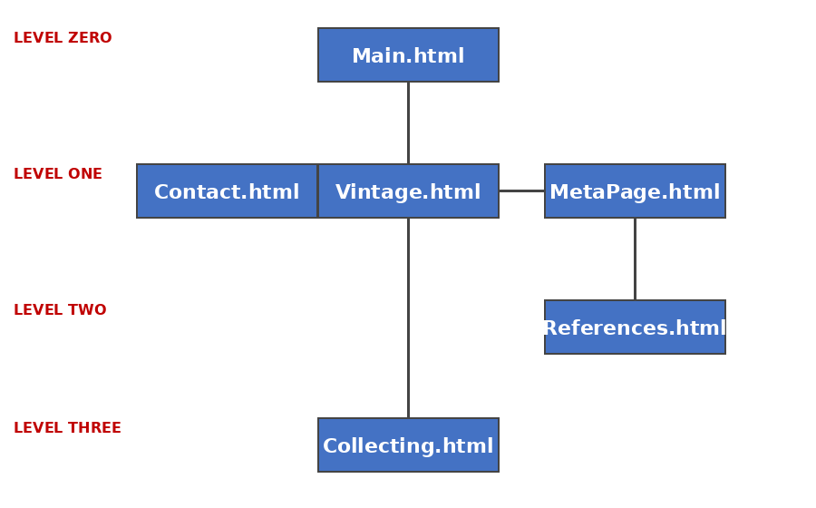
Figure 1. Site map of the website.
Page | File name | Role
Main | Main.html | Main page (Level zero)
Your choice 1 | Vintage.html | What is vintage? (Level one)
Contact | Contact.html | Contact details and form (Level one)
MetaPage | MetaPage.html | Cross-reference and validation (Level one)
References | References.html | Reference list (Level two)
Your choice 2 | Collecting.html | Collecting vintage (Level three)

2. Wireframes
From the specifications: nav on the left, then header, main and footer on the right.
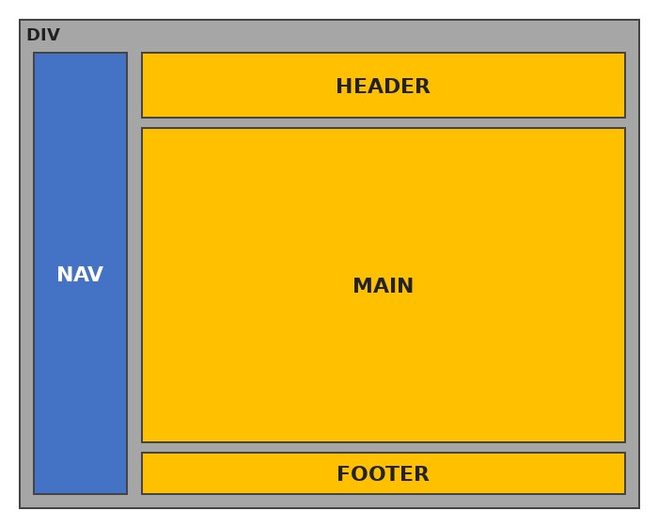
Wireframe (a) - Main.html
From the specifications: header on top, nav on the left, main and footer next to it.
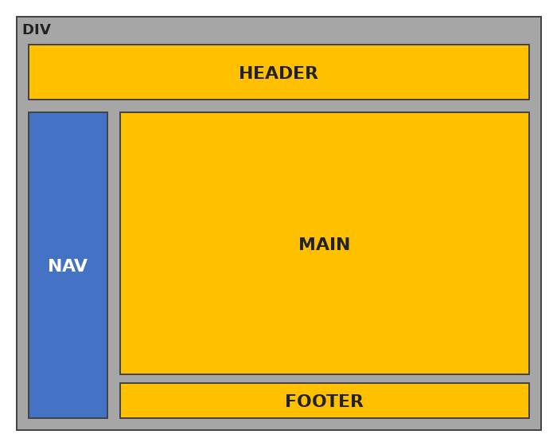
Wireframe (b) - Vintage.html, Collecting.html and MetaPage.html
My own design: the menu sits inside the header as one row of links, then main, then the footer.
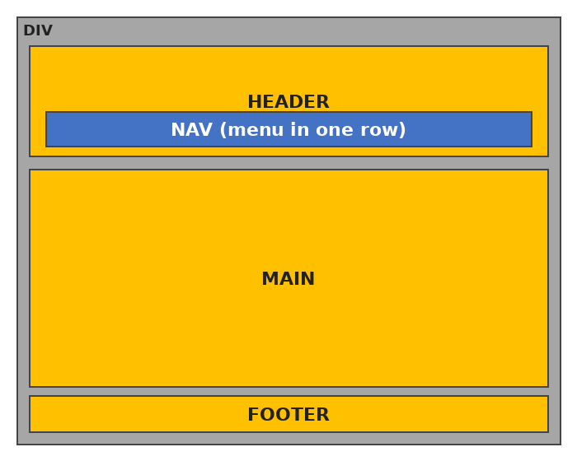
Wireframe (c) - Contact.html and References.html

3. Reference list (Harvard 2021)
- Anthropic (2026) Claude [Large language model]. Available at: https://claude.ai (Accessed: 15 October 2026).
- Hartley, L.P. (1953) The go-between. London: Hamish Hamilton.
- Pears, R. and Shields, G. (2021) Cite them right: the essential referencing guide. 12th edn. London: Bloomsbury Academic.
- University of Canberra (2026) Referencing guide - Harvard. Available at: http://canberra.libguides.com/c.php?g=599301&p=6820165 (Accessed: 15 October 2026).
- W3C (2026a) Markup validation service. Available at: https://validator.w3.org/ (Accessed: 15 October 2026).
- W3C (2026b) CSS validation service. Available at: https://jigsaw.w3.org/css-validator/ (Accessed: 15 October 2026).
- W3Schools (no date) HTML tutorial. Available at: https://www.w3schools.com/html/ (Accessed: 15 October 2026).
- W3Schools (no date) CSS tutorial. Available at: https://www.w3schools.com/css/ (Accessed: 15 October 2026).
- Wikipedia (2026a) Phonograph record. Available at: https://en.wikipedia.org/wiki/Phonograph_record (Accessed: 15 October 2026).
- Wikipedia (2026b) Typewriter. Available at: https://en.wikipedia.org/wiki/Typewriter (Accessed: 15 October 2026).
- Wikipedia (2026c) Vintage. Available at: https://en.wikipedia.org/wiki/Vintage (Accessed: 15 October 2026).
Images:
- Chavez, G. (2018) Turntable on vintage chest standing on mat [Photograph]. Wikimedia Commons. Available at: https://commons.wikimedia.org/wiki/File:Turntable_On_Vintage_Chest_Standing_On_Matt_(247221445).jpeg (Accessed: 15 October 2026). Licence: CC BY 3.0.
- Bhullargraphic (2026) Vintage Imperial typewriter, The Good Companion, close up [Photograph]. Wikimedia Commons. Available at: https://commons.wikimedia.org/wiki/File:Vintage_Imperial_Typewriter_The_Good_Companion_Close_Up.jpg (Accessed: 15 October 2026). Licence: CC BY-SA 4.0.
- Haupt, J. (2015) Vintage Yashica 35mm SLR film camera, model FX-2, made in Japan [Photograph]. Wikimedia Commons. Available at: https://commons.wikimedia.org/wiki/File:Vintage_Yashica_35mm_SLR_Film_Camera,_Model_FX-2,_Made_In_Japan_(16873299796).jpg (Accessed: 15 October 2026). Licence: CC BY-SA 2.0.
- PattayaPatrol (2026) A close-up of vintage trinkets and medals laid out on a market table with shoppers browsing in the background [Photograph]. Wikimedia Commons. Available at: https://commons.wikimedia.org/wiki/File:DFC_4364_A_close-up_of_vintage_trinkets_and_medals_laid_out_on_a_market_table_with_shoppers_browsing_in_the_background.jpg (Accessed: 15 October 2026). Licence: CC BY-SA 4.0.
- The Digital Yard Sale (2009) Old paper 2 [Photograph]. Wikimedia Commons. Available at: https://commons.wikimedia.org/wiki/File:Old_paper2.jpg (Accessed: 15 October 2026). Licence: public domain.

