|  |  |  |  |  |
| --- | --- | --- | --- | --- |
| |  | | --- | |  | |  | |  | |  | |
| L3 Cache Simulator Report  ECE 485 / Microprocessor System Design |
| Carmen Ciobanu Deborah Denhart Jeremiah Franke  12/2/2014 |

Table of Contents

L3 Cache Simulator Report 1

1. Purpose 1

2. Cache System Architecture 1

3. Assumptions and Design Considerations 2

3.1 L3 Cache 2

3.2 L2 cache 2

3.3 Shared Memory 3

3.4 Commands 3

4. Design 3

4.1 Trace File Parser 3

4.2 Commands Algorithms 3

4.3 Coherence Protocol (MESIF) 4

4.4. Line Replacement Policy (Pseudo LRU) 6

4.5. L2-L3 Inclusivity 7

4.6. Write Buffer 8

4.7. Memory 8

4.8. Statistics 8

5. Test Plan 8

5.1. Test Plan 8

5.2. Test Cases 8

6. Simulation Results 13

6.1. Trace Files 13

6.2. Results 13

6.3. Usage Statistics 13

# L3 Cache Simulator Report

## 1. Purpose

The purpose of the program is to simulate the last level cache (L3) for a processor that can be used with up to three other processors in a shared memory system.

## 2. Cache System Architecture

The system uses multilevel caches:

* Separate L1 instruction and data caches
* Unified L2 instruction and data caches
* Unified L3 instruction and data caches

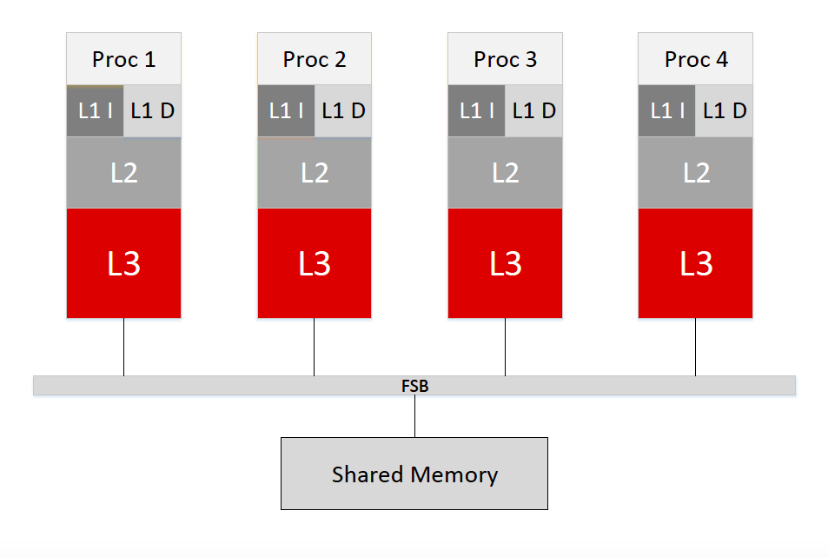

The L3 caches and memory are communicating on the FSB (Front Side Bus). The L1 and L2 are probably on the same chip as the CPU. L2 might communicate with L3 through a Back Side Bus, or L3 might also be on the same chip as the CPU.

The L1 and L2 caches as well as the DRAM shared memory are not modeled in this program. The program allows for flexible L3 cache configuration, by taking command line arguments. No command line arguments are taken for L2 cache configuration, but several assumptions are made and will be detailed in the Assumptions section of the report.

## 3. Assumptions and Design Considerations

### 3.1 L3 Cache

* The maximum L3 cache size is 4294965248 bytes
* The possible L3 line sizes (in bytes) are: 32, 64, 128, 256, 512, 1024, 2048 and is received as command line argument
* L3 number of sets must be in the range: 1 to 65535 and is received as command line argument
* L3 number of lines must be in the range: 1 to 2097151
* L3 associativity will be one of: 4, 8, 16, or 32 and is received as command line argument
* Data is not stored in the cache in this simulation
* Only tags, state bits and LRU bits are stored in the cache in this simulation
* L3 is a write-back cache (implicit for MESIF implementation)

### 3.2 L2 cache

* L2 cache parameters (associativity, line size etc.) will change depending on the changes in the L3 cache parameters in such a way that it is possible to maintain inclusivity with both L3 and L1 caches
* The ratio of L3 line size to L2 line size is 2:1
* L2 is either a write-trough cache or write-through the first time a line is modified (write once)

### 3.3 Shared Memory

* The size of the L3 line is equal to the number of bytes the DIMM can provide in a burst event
* Only one memory access will be needed to bring in an L3 cache line from DRAM

### 3.4 Commands

* In case of a write command from L2 cache, we are assuming all physical addresses generated are pointing to a line that has the permission of being written (not an instruction)

## 4. Design

### 4.1 Trace File Parser

Stuff

### 4.2 Commands Algorithms

#### 4.2.1. Commands 0, 2

Command 0 = Read Request from L2 Data Cache

Command 2 = Read Request from L2 Instruction Cache

We decided that command 0 should be equivalent to command 2, since at level 2 the instruction and data caches are unified. The actions taken as a result of receiving any of the 0 or 2 commands are identical.

#### 4.2.2. Command 1

Command 1 = Write Request L2 Data Cache

A write request coming from the L2 cache can be interpreted in one of three ways:

1. CPU write request to L1, L1 cache miss, L2 cache miss
2. L2 writes evicted line to L3
3. L2 writes modified line to L3 behaving as a write through cache the first time a line is modified

Since there is not enough granularity in the provided commands to capture all of these three different behaviors, we decided command 1 will be interpreted as a CPU write request to L1, followed by a cache miss in both L1 and L2. This behavior is more useful in emitting the correct bus operation and maintaining coherence with the other L3 caches.

#### 4.2.3. Command 3

Command 3 = Snooped Invalidate

#### 4.2.4. Command 4

Command 3 = Snooped Read Request

#### 4.2.5. Command 5

Command 3 = Snooped Write Request

#### 4.2.6. Command 6

Command 3 = Snooped Read With Intent to Modify

#### 4.2.7. Command 8

Command 8 = Clear Cache

Command 8 clears MESIF bits and implicitly invalidates all lines.

#### 4.2.8. Command 9

Command 9 = Print Contents and State of Valid Lines

Command 9 displays the tag and MESIF bits of all the valid lines and the pseudo LRU bits of the sets containing at least one valid line.

### 4.3 Coherence Protocol (MESIF)

Stuff

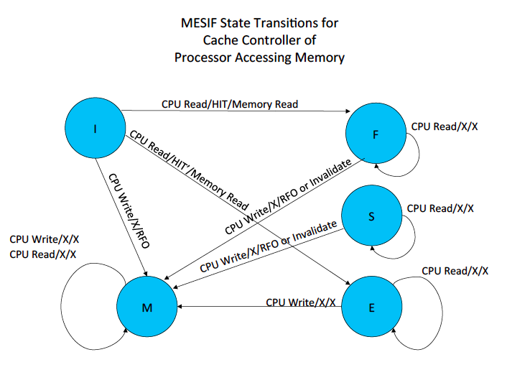

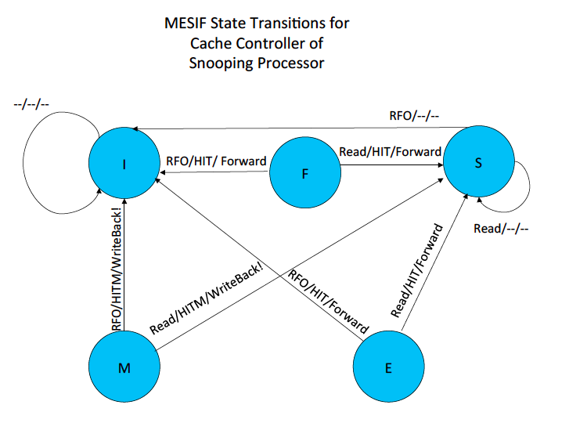

### 4.4. Line Replacement Policy (Pseudo LRU)

The line replacement policy is Pseudo LRU as per requirements. This algorithm uses fewer bits than true LRU methods (n -1 bits, where n is the cache associativity).

For cache accesses resulting in cache hit, the pseudo LRU bits are only written (set or cleared) but not read. For accesses resulting in cache miss, the pseudo LRU bits are read to select a line for eviction (if no invalid lines available), and then written again to indicate current line was most recently used.

The pseudo LRU bits write functionality is implemented with an algorithm similar to binary search. If we imagine a binary tree of pseudo LRU bits, they are numbered following the binary tree rule, where everything less than the root is found in the left branch tree and everything greater than root is found in the right branch tree. The following diagram illustrated the bit numbering used, for an example associativity of 16:

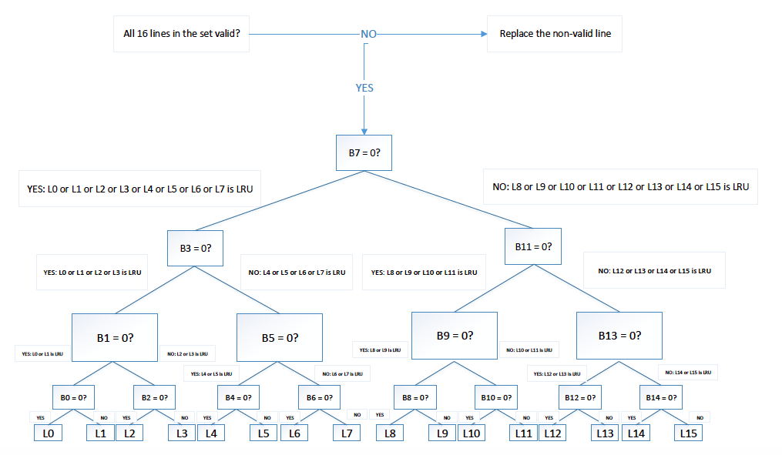

The write algorithm operates on an array containing all line indices in any set (0 to associativity - 1). It finds recursively the midpoint of the array, corresponding actually to the current bit number to set or clear. The selected bit is set if the currently accessed line number is less than or equal to the bit number, and cleared otherwise. The recursive algorithm ends when the endpoints of the interval for which the midpoint was found become equal.

The pseudo LRU bits read functionality follows the same binary search algorithm. If no invalid lines are available, a line will be selected for eviction. In order to select the pseudo LRU line, the binary search array is traversed using recursive midpoints as described above. The selected bit value is read and the decision to take the right or left array search interval is determined by this bit value.

A 0 bit value will direct the search towards the left interval, while a 1 bit value will direct the search towards the right interval. The index and value of the last queried bit will tell us which of the odd or even numbered line is the pseudo LRU (a 0 bit will return a line number identical to the bit index, while a 1 value bit will return a line number greater with 1 than the bit index).

### 4.5. L2-L3 Inclusivity

One of the project requirements is for cache L3 to maintain inclusivity with the higher level caches. Since we decided to interpret the write command (1) as a CPU write request followed by cache misses in L1 and L2, we are not going to be able to capture L2 writes to L2 due to dirty line evictions or L2 write back for the first time a line is modified. This makes keeping a set of inclusivity bits impractical.

Instead, we chose to send messages from L3 to L2 indicating a set of lines that might need to be invalidated in the L2 cache for all lines in L3, which are either evicted or invalidated (as a result of snooped invalidate and snooped RWIM bus operations). Of course, not all of these lines are in the higher level cache, but without capturing the L2 write back events, there is really no way of telling which line is also in L2.

The result of our design decision will increase the communication traffic between L2 and L3. We are assuming however L2 will receive all messages coming from L3 but will simply disregard the commands associated with addresses, which do not correspond to lines found in both L2 and L3 caches.

Finally, we need to consider the difference in line sizes between L2 and L3. Under “Assumptions”, we stated that the L3 to L2 line size ratio is always assumed to be 2:1. Under this assumption, a line eviction in L3 will have to be followed by a message to L2 indicating two of L2 lines should be invalidated, if resident in L2.

In summary, inclusivity is maintained by taking the following actions:

* Following a read/write request from L2, the desired line is places in both L2 and L3
* If an L3 line was evicted in the process, 2 lines must be invalidated from L2 if these reside in L2
* If an L3 line was invalidated as a result of snooped invalidate and snooped RWIM bus operations, 2 lines must be invalidated from L2 if these reside in L2
* If all L3 lines were invalidated as a result of a clear command, all lines must be invalidated in L2

The process of invalidating lines in L2 cannot be enforced, since we are not simulating L2, but it is signaled in the program by printing appropriate messages to the screen in the non-silent mode. Addresses of lines to be written or invalidated in L2 are provided by L3, along with the required action to be performed by L2.

### 4.6. Write Buffer

Stuff

### 4.7. Memory

The DRAM shared memory is not modeled in this program. To show when a read from memory or a write to memory is performed, a few memory function stubs are in place in the code to remind us of the current bus operation and to show which address is provided to the DIMMs in order to transfer an entire cache line in a burst.

### 4.8. Statistics

After executing the last instruction read form the trace file, the program will output cache statistics for the current trace file. The number of accesses, reads, writes, hits and misses are incremented by case only when executing commands 0, 1 or 2. The cache hit ratio is expressed as the ratio of the number of cache hits and the number of cache accesses.

## 5. Test Plan

### 5.1. Test Plan

Stuff

### 5.2. Test Cases

|  |  |  |  |  |  |
| --- | --- | --- | --- | --- | --- |
| Test Case No: | 1 | | | | |
| Title: | File Parser Test | | | | |
| Created By: |  | | | | |
| Tested by: |  | | | | |
| Feature: | File Parser | | | | |
| **Step Description** | | **Expected Result** | **PASS** | **FAIL** | **Actual Results** |
| 1. | |  |  |  |  |
| 2. | |  |  |  |  |
| 3. | |  |  |  |  |
| 4. | |  |  |  |  |
| 5. | |  |  |  |  |
| 6. | |  |  |  |  |
| 7. | |  |  |  |  |
| 8. | |  |  |  |  |
| 9. | |  |  |  |  |

|  |  |  |  |  |  |
| --- | --- | --- | --- | --- | --- |
| Test Case No: | 2 | | | | |
| Title: | Address Translation test | | | | |
| Created By: |  | | | | |
| Tested by: |  | | | | |
| Feature: | Split address into tag, index, offset correctly | | | | |
| **Step Description** | | **Expected Result** | **PASS** | **FAIL** | **Actual Results** |
| 1. | |  |  |  |  |
| 2. | |  |  |  |  |
| 3. | |  |  |  |  |
| 4. | |  |  |  |  |
| 5. | |  |  |  |  |
| 6. | |  |  |  |  |
| 7. | |  |  |  |  |
| 8. | |  |  |  |  |
| 9. | |  |  |  |  |

|  |  |  |  |  |  |
| --- | --- | --- | --- | --- | --- |
| Test Case No: | 3 | | | | |
| Title: | Line Selection Test | | | | |
| Created By: |  | | | | |
| Tested by: |  | | | | |
| Feature: | Select correctly the desired line in a set | | | | |
| **Step Description** | | **Expected Result** | **PASS** | **FAIL** | **Actual Results** |
| 1. | |  |  |  |  |
| 2. | |  |  |  |  |
| 3. | |  |  |  |  |
| 4. | |  |  |  |  |
| 5. | |  |  |  |  |
| 6. | |  |  |  |  |
| 7. | |  |  |  |  |
| 8. | |  |  |  |  |
| 9. | |  |  |  |  |

|  |  |  |  |  |  |
| --- | --- | --- | --- | --- | --- |
| Test Case No: | 4 | | | | |
| Title: | Pseudo LRU functional test | | | | |
| Created By: | Carmen Ciobanu | | | | |
| Tested by: | Carmen Ciobanu | | | | |
| Feature: | Pseudo LRU line replacement policy | | | | |
| **Step Description** | | **Expected Result** | **PASS** | **FAIL** | **Actual Results** |
| 1. Compile program in debug mode | | Program should compile without errors |  |  |  |
| 2. Run program with arguments:  #sets = 8192  Line size = 64  Associativity = 16  Trace file = “TestLRU.txt” | | Program runs, no errors |  |  |  |
| 3. Observe output to screen | | Should see program output |  |  |  |
| 4. Check first 16 output lines | | M: Available invalid line 0  M: Available invalid line 1  M: Available invalid line 2  M: Available invalid line 3  M: Available invalid line 4  M: Available invalid line 5  M: Available invalid line 6  M: Available invalid line 7  M: Available invalid line 8  M: Available invalid line 9  M: Available invalid line 10  M: Available invalid line 11  M: Available invalid line 12  M: Available invalid line 13  M: Available invalid line 14  M: Available invalid line 15 |  |  |  |
| 5. Check output line 17 | | M: Evict Line # |  |  |  |
| 6. Check output line 18 | | M: Evict Line # |  |  |  |
| 7. Check output line 19 | | H |  |  |  |
| 8. Check output line 20 | | M: Evict Line # |  |  |  |
| 9. Check output line 21 | | H |  |  |  |
|  | | H: |  |  |  |

|  |  |  |  |  |  |
| --- | --- | --- | --- | --- | --- |
| Test Case No: | 5 | | | | |
| Title: | MESIF Coherence Test | | | | |
| Created By: |  | | | | |
| Tested by: |  | | | | |
| Feature: | Cache coherence | | | | |
| **Step Description** | | **Expected Result** | **PASS** | **FAIL** | **Actual Results** |
| 1. | |  |  |  |  |
| 2. | |  |  |  |  |
| 3. | |  |  |  |  |
| 4. | |  |  |  |  |
| 5. | |  |  |  |  |
| 6. | |  |  |  |  |
| 7. | |  |  |  |  |
| 8. | |  |  |  |  |
| 9. | |  |  |  |  |

|  |  |  |  |  |  |
| --- | --- | --- | --- | --- | --- |
| Test Case No: | 6 | | | | |
| Title: | Inclusivity Test | | | | |
| Created By: | Carmen Ciobanu | | | | |
| Tested by: | Carmen Ciobanu | | | | |
| Feature: | L2-L3 inclusivity | | | | |
| **Step Description** | | **Expected Result** | **PASS** | **FAIL** | **Actual Results** |
| 1. | |  |  |  |  |
| 2. | |  |  |  |  |
| 3. | |  |  |  |  |
| 4. | |  |  |  |  |
| 5. | |  |  |  |  |
| 6. | |  |  |  |  |
| 7. | |  |  |  |  |
| 8. | |  |  |  |  |
| 9. | |  |  |  |  |

|  |  |  |  |  |  |
| --- | --- | --- | --- | --- | --- |
| Test Case No: | 7 | | | | |
| Title: | Statistics functional test | | | | |
| Created By: | Carmen Ciobanu | | | | |
| Tested by: | Carmen Ciobanu | | | | |
| Feature: | Display cache statistics at the end of current trace file | | | | |
| **Step Description** | | **Expected Result** | **PASS** | **FAIL** | **Actual Results** |
| 1. Compile program in silent mode | | Program should compile without errors |  |  |  |
| 2. Run program with arguments:  #sets = 8192  Line size = 64  Associativity = 16  Trace file = “TestStatistics.txt” | | Program runs, no errors |  |  |  |
| 3. Read screen output | | Should display Cache Architecture parameters followed by Cache Statistics parameters |  |  |  |
| 4. Check cache capacity value | |  |  |  |  |
| 5. Check cache number of sets | | 1892 |  |  |  |
| 6. Check line size | | 64 |  |  |  |
| 7. Check total # of lines | |  |  |  |  |
| 8. Check cache associativity | | 16 |  |  |  |
| 9. Check cache # reads | |  |  |  |  |
| 10. Check cache # writes | |  |  |  |  |
| 11. Check cache # accesses | |  |  |  |  |
| 12. Check cache hit ratio | |  |  |  |  |
| 13. Check cache # hits | |  |  |  |  |
| 14. Check cache # misses | |  |  |  |  |

|  |  |  |  |  |  |
| --- | --- | --- | --- | --- | --- |
| Test Case No: | 8 | | | | |
| Title: | Write Buffer Test | | | | |
| Created By: |  | | | | |
| Tested by: |  | | | | |
| Feature: | Merging Write Buffer | | | | |
| **Step Description** | | **Expected Result** | **PASS** | **FAIL** | **Actual Results** |
| 1. | |  |  |  |  |
| 2. | |  |  |  |  |
| 3. | |  |  |  |  |
| 4. | |  |  |  |  |
| 5. | |  |  |  |  |
| 6. | |  |  |  |  |
| 7. | |  |  |  |  |
| 8. | |  |  |  |  |
| 9. | |  |  |  |  |

## 6. Simulation Results

### 6.1. Trace Files

Stuff

### 6.2. Results

Stuff

### 6.3. Usage Statistics