Badminton
Scoring System:
- A badminton match is usually played in sets. A set is won by the first side to reach 11 & 15 points.
- A match is usually best of knockout or three sets.
- Initially at the school level there will be a knockout round in which player will play the 11point game. At the intern school match the point will be same 11point with knockout round, but the semi-final having, and final will be having 15point game with 3 set and final have 21-point game with 3 sets.

Event | Game Type | Sets | Point Table (Points per Set)
School Level | Elimination | No sets | 11
Inter-School | Elimination | No sets | 11
Semi-Final | Knockout | 3 sets | 15
Final | Championship | 3 sets | 21
- If in the semi-final and final, anyone of the player win the two set in continuum then 3rd set will be not played at all.
Serving:
- The server must stand inside the service court and hit the shuttlecock below the waist.
- The serve must go diagonally across the net and land in the opponent's service court.
- A player must wait until his opponent is ready before serving. If the opponent attempts a return, then he is ruled having been ready.
- The feet of both players must remain in a stationary position until the serve is made.
- Your feet can not be touching the line at this time.
Scoring in a Rally:
- Points are scored when the shuttlecock lands in the opponent's court, or if the opponent commits a fault (fails to return the shuttlecock properly).
- If the serving side wins a rally, they score a point and continue to serve. If the receiving side wins, they gain the right to serve.
Faults:
- Common faults include the shuttlecock landing outside the boundaries, not clearing the net, and other specific rules related to foot positioning during the serve or shuttlecock touch the body part of the player will consider as faults.
- The shuttle, at the instant of being hit is higher than the server’s waist or the head of the racket is higher than the servers racket hand.
- A serve or shot that lands outside the court boundaries, passes under or through the net, touches any other obstructions or a player’s body or clothing. The boundary and service lines are considered in play.
- A player touching the net or its supports with his body or racket while the shuttle is in play.
- Hitting the shuttle twice in succession by a player or team.
Change of Ends:
- Players change ends after finishing a set. This is to ensure that no player has an unfair advantage due to factors like lighting or air currents.
Continuous Play:
- Badminton is a continuous play sport, meaning that the game goes on without interruptions, except for short breaks between sets.
- These are the basic rules, and there are additional rules and regulations that cover more specific situations. It's always a good idea to familiarize yourself with the rules if you are planning to play or watch badminton matches.
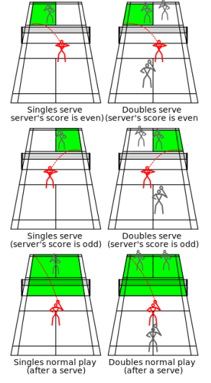
Figure - badminton service rules

