

**Realising and Applied Gaming Ecosystem**

**Research and Innovation Action**

Grant agreement no.: 644187

**D2.3 – Real-time Emotion Detection Asset - Installation tutorial**

**RAGE – WP2 – D2.3**

**DRAFT**

|  |  |
| --- | --- |
| Project Number | H2020-ICT-2014-1 |
| Actual Date | April 2017 |
| Document Author/s | Dessislava Vassileva |
| Version | 0.3 |
| Status | Draft |



This project has received funding from the European Union’s Horizon 2020

research and innovation programme under grant agreement No 644187

**About the** **Real-Time Arousal Detection Using Galvanic Skin Response Asset**

Galvanic Skin Response (GSR), also referred to Electro-Dermal Activity (EDA), Skin Conductance Response (SCR), Psycho-Galvanic Reflex (PGR), or Skin Conductance Level (SCL), is related to the activity of the sweat glands, which are regulated by the sympathetic nervous system. When being open and functioning intensively, they emit water solution (sweat) which creates channels of higher conductivity toward the deeper skin layers. EDA represents the electrical conductivity of the skin, which is directly dependent on the activity of the sweat glands, and is often used to index the autonomic arousal. GSR offers a popular and affordable way for detection of player’s arousal in adaptive digital games and other affective computing applications. The asset produces real-time features of GSR signal measured from particular player such as: mean tonic activity level, phasic activity represented by mean and maximum amplitude of skin conductance response (all in µS, i.e. micro-siemens), rate of phasic activity (response peaks/sec), SCR rise time, SCR 1/2 recovery time, and slope of tonic activity (in µS/sec). The level of arousal may be useful for emotion detection and for adaptation purposes. The asset receives a filtered raw signal from a simple, low cost biofeedback device allowing sampling rate up to 0.8Khz. Measurements are carried out with two electrodes placed on two adjacent fingers. Recording, filtering and feature extraction might be executed on a computer (server) different than the game machine, in order to speed up all the required processing. The results will be communicated from the server-side to the client component in order to be used for game adaptation.

**Document scope**

The present document provides installation instructions of Real-Time Arousal Detection Using Galvanic Skin Response asset and, next, presents how to integrate and use the asset in a Unity 3D-based C# game.

**Asset installation steps**

The asset installation process includes following steps:

1. Download from address https://github.com/ddessy/RealTimeArousalDetectionUsingGSR/tree/master/Drivers the zip file named *GSRDrivers.zip* with GSR device’s drivers;
2. Unzip the file *GSRDrivers.zip* and install drivers (from folders *SerialCOMDriver* and *drivers_ft232*) (if there are not available at your computer);
3. Download the archive file *RealTimeArousalDetectionUsingGSRBin.rar* from *https://github.com/ddessy/RealTimeArousalDetectionUsingGSR/blob/master/RealTimeArousalDetectionUsingGSRBin/RealTimeArousalDetectionUsingGSRBin.rar* with *exe* and *dll* files implementing the asset functionality;
4. Unzip the archive file an copy the asset files in a folder at your local file system;
5. Check the configuration file located at *./Resources/realTimeArousalDetectionAssetSettings.xml* and make changes for some of its settings, where is it needed;
6. Plug the sensor’s cable into the GSR measuring device.
7. Plug the USB cable into the GSR measuring device and connect the other side of the cable to a free USB port of the computer.
8. Put the two sensors on the fingers of the hand of the user. The hand should be clean and dry. In order to avoid any noise and artefacts, the hand should be hold in still static position.

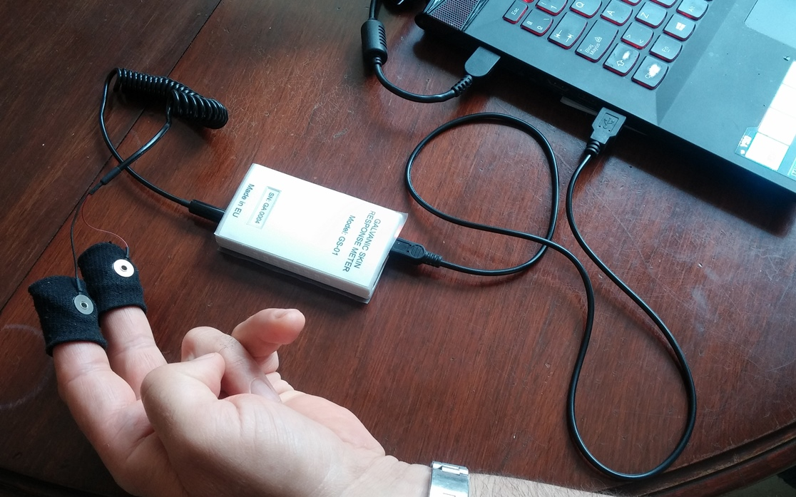

USB port

Sensor’s cable

USB cable

GSR sensors

Fig. 1: Connecting the GSR measuring device to the computer

1. If you like to run the application in background mode (with no visualization of the signals), set the value of the FormMode property in the *./Resources/realTimeArousalDetectionAssetSettings.xml* configuration file to be equal to *BackgroundMode.* Otherwise, the value should be as given below:

*<FormMode>NoBackgroundMode</FormMode>*

1. Start the *DisplayGSRSignal.exe* file by clicking onto it. The socket will be started at the port specified in the configuration file, and the device starts measuring. You can do the following:
   1. You can stop and start the socket alternatively by clicking the “Start/Stop socket” button.
   2. In order to start visualization of the GSR signal, press the “Start” button. At any moment you can stop the device by pressing the “Stop” button and, next, to start it again.
   3. You can switch on/off the visualization denoised signal visualization by check/uncheck the checkbox over the “Start” button.
   4. After stopping the device, you can use the mouse wheel in order to zoom in/out each one of the axes, while the mouse cursor is placed on graphic. For resetting the zoom on the axis X or Y, just click on the circle button in the end of the scrollbar of the corresponded axis (fig. 2).

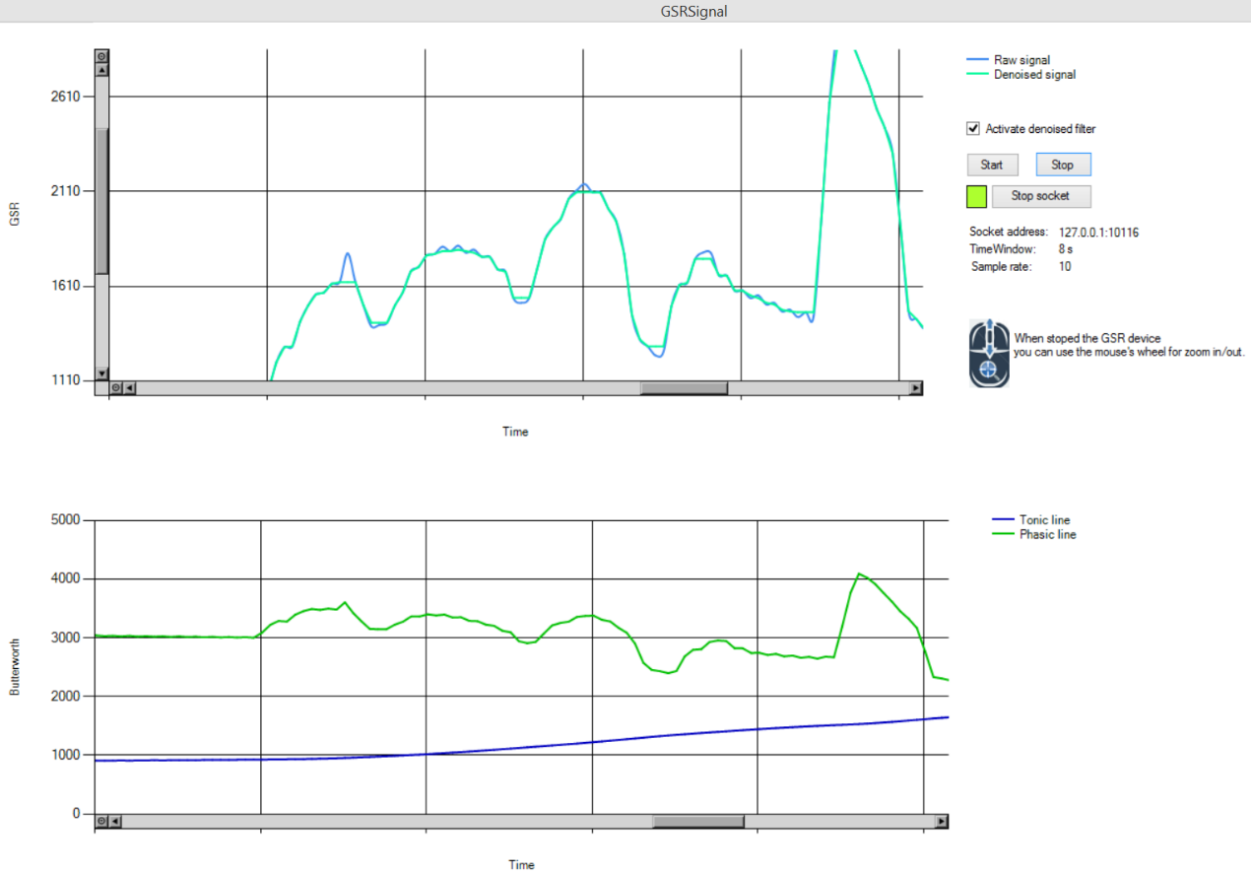

Resets zoom on Y

Resets zoom on X

Fig. 2: A screenshot of the visualization application with zoomed signal on X and Y

**Application settings**

1. **Basic application settings**

The basic application settings in *./Resources/realTimeArousalDetectionAssetSettings.xml* are as follows:

* SocketPort – the number of port of the socket that will communicate with the asset;
* SocketIPAddress – IP address of the socket that will communicate with the asset;
* COMPort – define the GSR device COM port. If it has value *N.A.*, the asset works with one random chosen COM port (but usually only one COM port is available);
* FormMode – the application run in background mode if it has value *BackgroundMode*;
* LogFile – path to the log file;
* DefaultTimeWindow - default value for the time window;
* SamplerateLabel - sample rate of the GSR device;
* ArousalLevel - number of arousal levels.

1. **Advanced application settings**

The basic application settings in *./Resources/realTimeArousalDetectionAssetSettings.xml* are as follows:

* MinGSRDeviceSignalValue - the smallest possible value that can be detected by the GSR device;
* MaxGSRDeviceSignalValue - the largest possible value that can be detected by the GSR device;
* CalibrationTimerInterval – in the calibration period it is the time interval during which the asset measures the arousal status of the current user;
* ButterworthPhasicFrequency – frequency used in the Butterworth filter for the phasic signal;
* ButterworthTonicFrequency – frequency used in the Butterworth filter for the tonic signal;
* ApplicationMode – if it has value *TestWithoutDevice* the asset works with data from a file (that is specified in the setting TestData), but not with real data from the GSR device;
* TestData – path to the file that specified the static GSR data when value of the setting ApplicationMode is *TestWithoutDevice*.

**Asset integration steps**

The asset integration process includes following steps:

1. Start the asset;
2. Check if the asset’s socket server is available;
3. Run a socket client on the address (that is stated in the setting *SocketIPAddress*) and port (that is stated in the setting *SocketPort*) specified in the application settings;
4. At the beginning send to the asset message with content *“SOCP”* for starting calibration period;
5. After the calibration period send message *“EOCP”* for ending calibration period;
6. When you need information for the status of emotional arousal of the current user send message to the asset with the content *“GET_EDA”*;
7. At the end of arousal measurement of the current user send message *“EOM”*.

**Example of a JSON object returned by the asset**

{

"SCRArousalArea": 1433323.455078125,

"SCRAmplitude": {

"Minimum": 1573,

"Maximum": 1731,

"Mean": 1659.96932515337,

"StdDeviation": 37.6450036301976,

"Count": 40.75,

"Name": "Amplitude"

},

"SCRRise": {

"Minimum": 0.99169921875,

"Maximum": 6935.13232421875,

"Mean": 47.4074355116836,

"StdDeviation": 463.337091469114,

"Count": 27.75,

"Name": "Rise time"

},

"SCRRecoveryTime": {

"Minimum": 0,

"Maximum": 16.0113525390625,

"Mean": 7.93012146288128,

"StdDeviation": 1.51291360666324,

"Count": 26.125,

"Name": "Recovery time"

},

"SCRAchievedArousalLevel": 52,

**"GeneralArousalLevel": 38**,

"TonicStatistics": {

"Slope": -0.0053473949851672508,

"MeanAmp": 1673.5,

"MinAmp": 1566,

"MaxAmp": 1707,

"StdDeviation": 52.8446780669539

},

"SCLAchievedArousalLevel": 49,

"MovingAverage": 1654.0258992805755,

"LastValue": 2977.817,

"LastMedianFilterValue": 1628,

"LastRawSignalValue": 1626,

"HighPassSignalValue": 2977.817,

"LowPassSignalValue": 1665.54

}