Kanokpoj Khakhai

96 Phra Athit Road, Chana Songkhram,

Phra Nakhon, Bangkok 10200

Tel: 08-8965-8648, 08-6568-0832

E-mail: title_21@hotmail.com

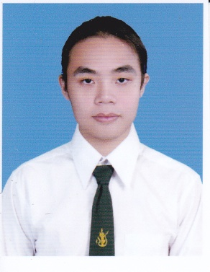

**OBJECTIVE**

To gain the full time position in English teaching or the work related to the English language in which I can adapt English skills to work, solve problems, and enhance me to have professional work experiences and possible to have the opportunity to study or get promoted

**PERSONAL INFORMATION**

|  |  |  |  |
| --- | --- | --- | --- |
| Personal Information | | | |
| Date of Birth | September 28, 1990 | **Religion** | Buddhism |
| Age | 23 years | **Marital Status** | Single |
| Nationality | Thai | **Interest** | Writing and Reading |

**EDUCATION**

**2013:** Study Master’s Degree in Teaching English as a Foreign Language (TEFL), The Language Institute of Thammasat University (LITU)**,** Thammasat University, Bangkok (every weekend)

**2009 – 2012:** Bachelor’s degree in English, Faculty of Humanities, Kasetsart University, Bangkok (Second Class Honors)

**2003 – 2008:** High School Certificate of English-French Program from Wat Rajabopit School, Bangkok

**EXPERIENCES**

**Teacher at Sakol Suksa Bang Bua Thong, Nontaburi (The first semester, 2013)**

• Teach English to Prathom 5 and Mattayom 1-3 students

**Teacher Assistant at Kasetsart University’s Self-Access Language Center Kasetsart Univeristy (The fourth year)**

• Help teachers check and edit English grammar and organizational patterns of essay for non-major students.

• Note the grammatical points that the students always produce.

• Try to make the students understand their wrong grammatical points.

**Tutor at G-Bright, the tutorial and language school, Nontaburi (2011 – 2013)**

• Teach English to the students from various levels

• Provide English teaching/learning materials

**Ticketing Staff at State of Tour (SOT), Phra Athit Road, Bangkok (2003 - 2006)**

• Reserve and sell various kinds of tickets, such as bus ticket, train ticket, flight ticket and also package tour.

• Guide the customers to the bus.

• Daily provide the tickets for the customers.

**Skills**

**Computer:** Microsoft office: Word, Excel, and PowerPoint

**Languages:** Thai (native), English (Well), and French (Fair)

**REFERENCES**

• **Asst. Prof. Montira Areepitak**

Lecturer at the department of foreign languages, faculty of Humanities,

Kasetsart University, Bangkok Tel. 0-2579-5566 ext. 1424

• **Dr. Jiraporn Dhanarattikarnnon**

Lecturer at the department of foreign languages, faculty of Humanities,

Kasetsart University, Bangkok Tel. 08-9994-0801