**Name : Miss Fontip Surasith**  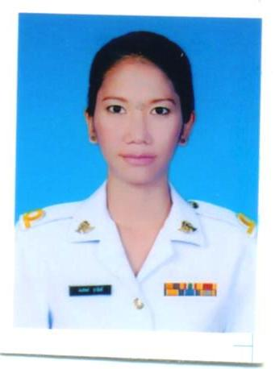

**Nationality : Thai**

**Date of Birth : July 14, 1983**

**Address : 3/531 Soi paholyotin 48 Paholyotin Rd. Bangkhen Bkk. Thailand 10220**

**Contact No. : 087-559-0239 (Mobile)**

**E-Mail :** [**sf_147@hotmail.com**](mailto:sf_147@hotmail.com)

**Height/Weight :168 cm./ 56 kg.**

**Expect : 15,000-17,500 Bht**

**EDUCATION**

1994 – 2000 Traimit Demonstation Ramkhamhaeng university School, Ramkamhaeng, Bangkok (Satitram)

2001 – 2005 Faculty of Communication Arts, Major-Advertising, Minor-Public relations, Bangkok University

2014 – Present School of Management Science, Major Accountancy, Sukhothai Tummathirat Open University

**EMPLOYMENT HISTORY**

**2005 January – August Full – time**, Designer Co-ordinator , ATELIER PICHITA ,Bkk

**Duties** include general customer service.

**2006 January –September Full – Time** ,TV. Co-Producer Sport Excite Program, V.A & SONS Co.Ltd.,Bkk

**2007 January-September Full-Time**, PR Co-ordinator Weem Communication Co.,Ltd.

**2008 Febuary-2012 November** **Full-Time**, Event Operation (Trade Fair),

Thai Leathergoods Association,Bkk

**2013 January – Present Full-Time, Royal Thai Air Force**

**PERSONAL SKILLS AND ABILITIES**

* Conscientious worker.
* Work well with others in a team environment.
* Ability to learn quickly.
* Ability to follow instructions but also ability to work independently when necessary.
* Confident manner.
* Professional attitude to all work.

**IT SKILLS**

* + - * Microsoft office
      * Adobe Illustrator
      * Adobe Photoshop
      * Internet Exploror & Outlook Express
      * Google Sketch-up

**LANGUAGE SKILLS**

* Thai Mother tongue
* English Intermediate

**ENGLISH COURSE**

April – May 2005 : General English, LTC International College, Eastbourne ,England

October 2006 – June 2007 : General and Business English and Conversation Course as part of a

Cambridge work placement, United International College, London, England

**TOEIC Score**

**Test Date : May 13, 2006**  Listening 335

Reading 160

**Total 495**

**Test Date : June 20, 2007**  Listening 360

Reading 220

**Total 580**

**INTERESTS**

In my spare time, I enjoy sport for fun such as rafting, kayaking and always work out at the gym etc.