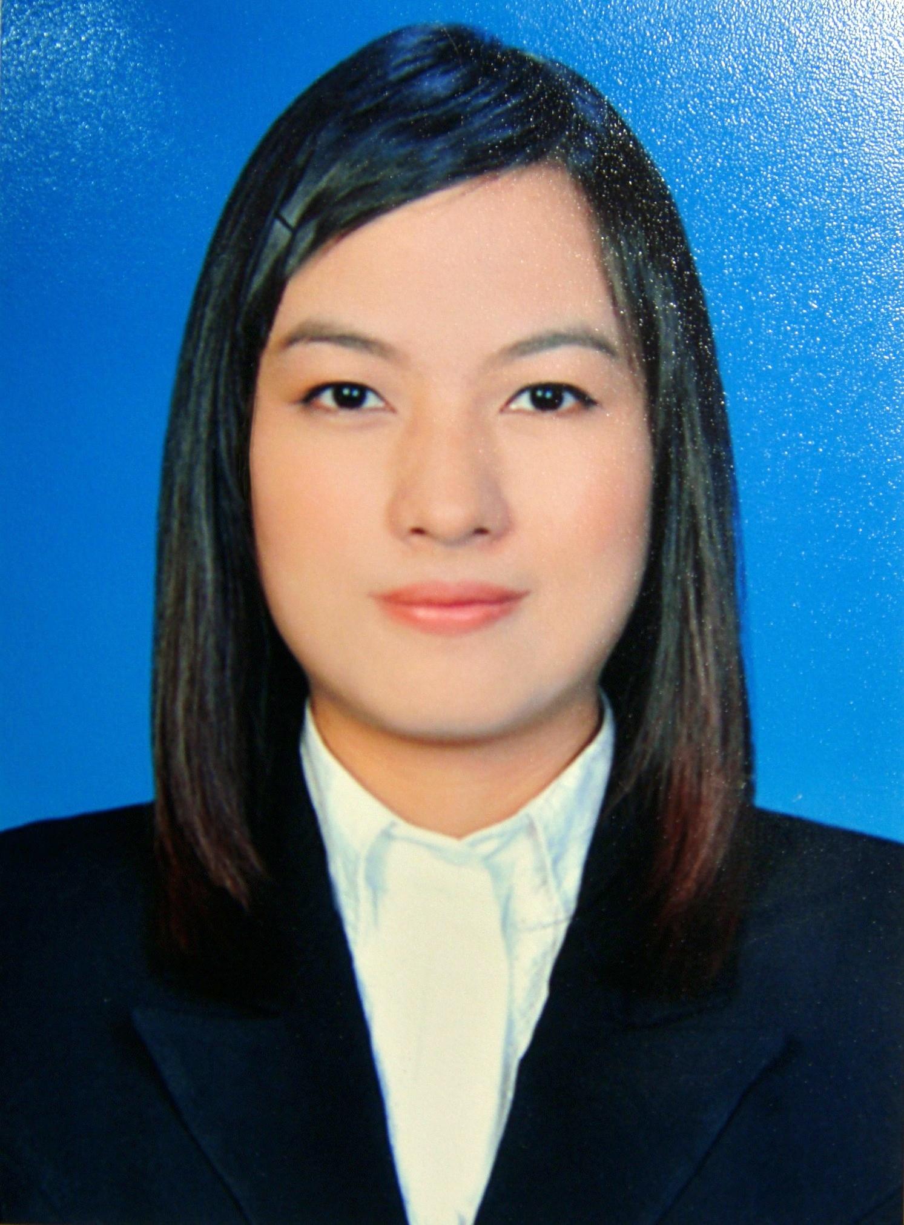**Miss Lersiri Pattarawisitsan**

**Address:** 9/189 soi Lat-pla-khao 79, Lat-pla-khao rd., Bangkhen, Bangkok 10220

**Contact Number:** 086-6493924 **E-mail**: lersiri.p@gmail.com

**Objective:** Apply for the project engineer position.

**PERSONAL INFORMATION:**

**Date of Birth**: July 19, 1990 **Age**: 24 **Height:** 168 cm **Weight**: 58 kg

**Nationality**: Thai **Race**: Thai **Religion:** Buddhism

**Birth Place:** Chiangmai **Marital Status**: Single **Hobbies/Interests**: Travelling, Swimming, Playing Guitar, Photography

**EXPERIENCE:**

May 2014 – Current Civil and Structural Engineers CO.,Ltd.

* Position: Structural Engineer
* Job Responsibilities: Building Design (e.g. house, low-rise condominium, high-rise condominium and factory)

May 2013 – April 2014 Christiani and Nielsen (Thai) Public CO.,Ltd.

* Position: Civil Engineer at Prince Mahidol Hall construction sites and Kitimas Building construction sites in Mahidol University (Salaya Campus)
* Job Responsibilities:
* Do the activities planning and manage the activities including control subcontractor to follow the schedule then monitor the activities and always adjust the schedule.
* Do the weekly progress report and do presentation for weekly site meeting with consultant and owner verified the contruction progress.
* Check the used project cost to represent the financial status and do the cost control.
* Inspect the real workshop that follow the structural workshop drawings and specification.
* Do the payment report and the engineering documents (e.g. RFA, RFI, Daily report and request to work.)
* Do Bill of Quantity and Do the material ordering schedule for ordering the materials by activities
* Contact material salesclerks and subcontractors.

Apr 2012 – June 2012 R.K.V.Engineering Consultant CO.,Ltd.

* Position: Trainee
* Job Responsibilities:
* Inspect the contractor’s work.
* Check the structural drawing and calculation.

**EDUCATION:**

2009 - 2013: CHULALONGKORN UNIVERSITY

* Bachelor of Engineering, Major: Civil Engineering
* GPA 2.54
* Senior project: Pollution management in construction sites

2005 - 2009: MONTFORT COLLEGE

* High School Diploma in Science-Math program
* GPA 3.59

**ACTIVITIES:**

2014 : Attended the Saminar in “Fire Protection System and Anchor Equipments for Concrete” by EIT & Hilti

: Attended the Saminar in “Connection Steel Design and Structural steel Construction” by EIT

2013 : Volunteer in the Voluntary Engineering Student Camp (VESC)#41 at Sukhothai

2012 : Volunteer in the Voluntary Engineering Student Camp (VESC)#40 at Pichit

: Staff in Nitad#16 Faculty of Engineering, Chulalongkorn University

: Staff in Chulavichakarn, Chulalongkorn University

2011 : Staff in Engineer CU’s Stage Drama, Visanukarmabhutra Camp 9th

: Volunteer in the Voluntary Engineering Student Camp (VESC)#39 at Surin

: Engineering Survey Camp Chulalongkorn University at Karnchanaburi

: Staff in Shadow Play #7, Faculty of Engineering, Chulalongkorn University

2010 :Staff of CU-TU traditional football 66thth

: Staff of CU-Chiangmai camp

: Actress in Engineer CU’s Stage Drama, Visanukarmabhutra Camp 8th

: Volunteer in the develop camp at WatThasala School, Chantaburi

: Staff in the Loykratong festival Performance, Faculty of Engineering, Chulalongkorn University

2009 : Player in the Loykratong festival Performance, Faculty of Engineering, Chulalongkorn University

**SKILLS:**

**Computer:** AutoCAD, Etabs, SAP2000, Microsoft Offices

**Language:** Thai, English

**REFERENCE:**

**Mr.Chanapong Tongsen :**

* Senior Structural Engineer, Civil and Structural Engineers CO.,Ltd. 089-2031695

**Mr.Damrongsak Fudulyawatjananon :**

* Project Manager at Kitimas Building Construction Site, Christianie and Nielsen PLC., 089-6998484

**Mr.Passakorn Thamprasert:**

* Project Manager at Prince Mahidol Holl Construction Site, Christianie and Nielsen PLC., 089-8954605