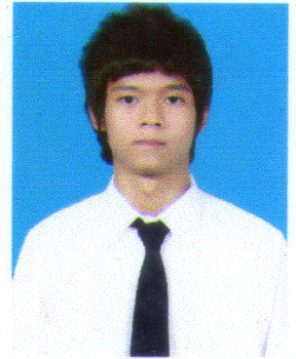**MR. PIYAWAT PETCHSIRI**

63/86 Soi. Pracharash 3, Pracharash Road, Taladkwan  
Muang, Nonthaburi 11000, Thailand  
Telephone: (66)2526-4198 Cellphone (66)86-397-0075  
E-mail: [ppetchsiri.joe@gmail.com](mailto:ppetchsiri.joe@gmail.com)

**Personal information**

* Piyawat Petchsiri
* Date of Birth: October 23rd, 1990
* Age: 22 years old
* Gender: Male
* Marital Status: Single
* Nationality: Thai
* Religion: Buddhist
* Weight: 52 Kg Height: 1.70 M.

**Education**

* **2010 - Present**: The Bachelor degree of Political Science (International Program), Thammasat University. Major: Politics and International Relations. Minor: Governance
* **2003-2009**: Suankularb Wittayalai Nonthaburi School. Major: Math-English

**Experiences**

* Intern at Office of Commercial Affairs, Royal Thai Embassy, Budapest, Hungary: 2013
* Attended Euclid High School, Ohio, USA as an exchange student 2007-2008
* Awarded: Merit Role on 2008 Academic year at Euclid High School, Ohio, The USA
* Coordinator in annual exhibition of faculty of Political Science, Thammasat University 2010
* Staff for pre-departure camp for YFU exchange student program, 2010
* Volunteer for flood relief at Kasetsart University : Thailand flood 2011
* Receptionist and coordinator at new student’s orientation (first meet) of Faculty of Political Science, Thammasat University. 2011
* Coordinator and Translator at YWCA International Bazaar at Central World, Bangkok, Thailand 2011
* Private English teacher of 5th grader: 2010-present.

**Skills**

* Language: English, Thai.
* TOEIC: 855
* Proficient knowledge in PC Software and compatible: Microsoft word, Microsoft PowerPoint, Microsoft Excel.