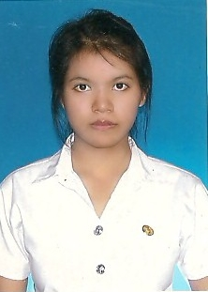**RAKCHUDA THIBORDEE**

99/5 Moo18 Khlongneung, Khlong Luang, Pathum Thani 12120

Tel. 098-385-9893

E-mail: [maydelavie@gmail.com](mailto:maydelavie@gmail.com)

**Position Sought:** Tutor

**Education:**

2011-present Bachelor’s Degree in English Language and Literature

Thammasat University (GPA 3.28)

2008-2010 Certificate of General Education, English-French Program

(Matayom 6), The Demonstration School of Silpakorn University

**Experience:**

March-July 2011 Tutor at Smart Wise Educational Center

Duties:

1. Taught elementary children
2. Prepared supplementary exercises

October-November 2008 Experience as a high school exchange student in New Zealand  
**Personal Data:**

Age: 21

Date of Birth: 6 June, 1993

Nationality: Thai

Language: Thai(Native), English(Good) and French(Fair)

Activities: Reading, gardening and meditation

**Computer skills:** Word, PowerPoint, and Photoshop

**Special qualities:** punctual, responsible and active