**Resume**

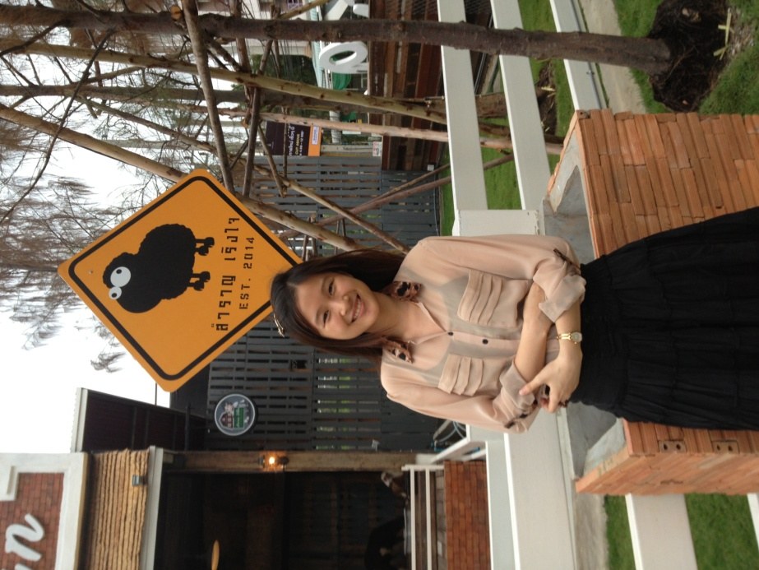Name: Miss Aroonrung Siricharoen

Nickname: Fern

4th year Student of Faculty of Arts

Student ID 544 02464 22

Personnel Information   
Birth date: 14/08/1992 Age: 21  
Nationality: Thai  
Religion: Buddhism

Address: 40/37 M.8 Tiwanon Rd. Tambon Bangphood Pakkret Nonthaburi 11120  
Phone: 089-681-1159

E-mail address: aroonrungsiri@yahoo.com  
  
Education   
High School: Triamudomsuksa School with GPA 3.84

University: Faculty of Arts, English major with GPA 3.50

Personal Interest

Hobbies: Reading, Swimming  
Working Experience: Piano teacher since 2011

Skill   
English: Speaking - Good / Listen – Good / Reading - Excellent /Writing - Good

Other Language: Japanese

English score in GAT : 128.5 out of 150

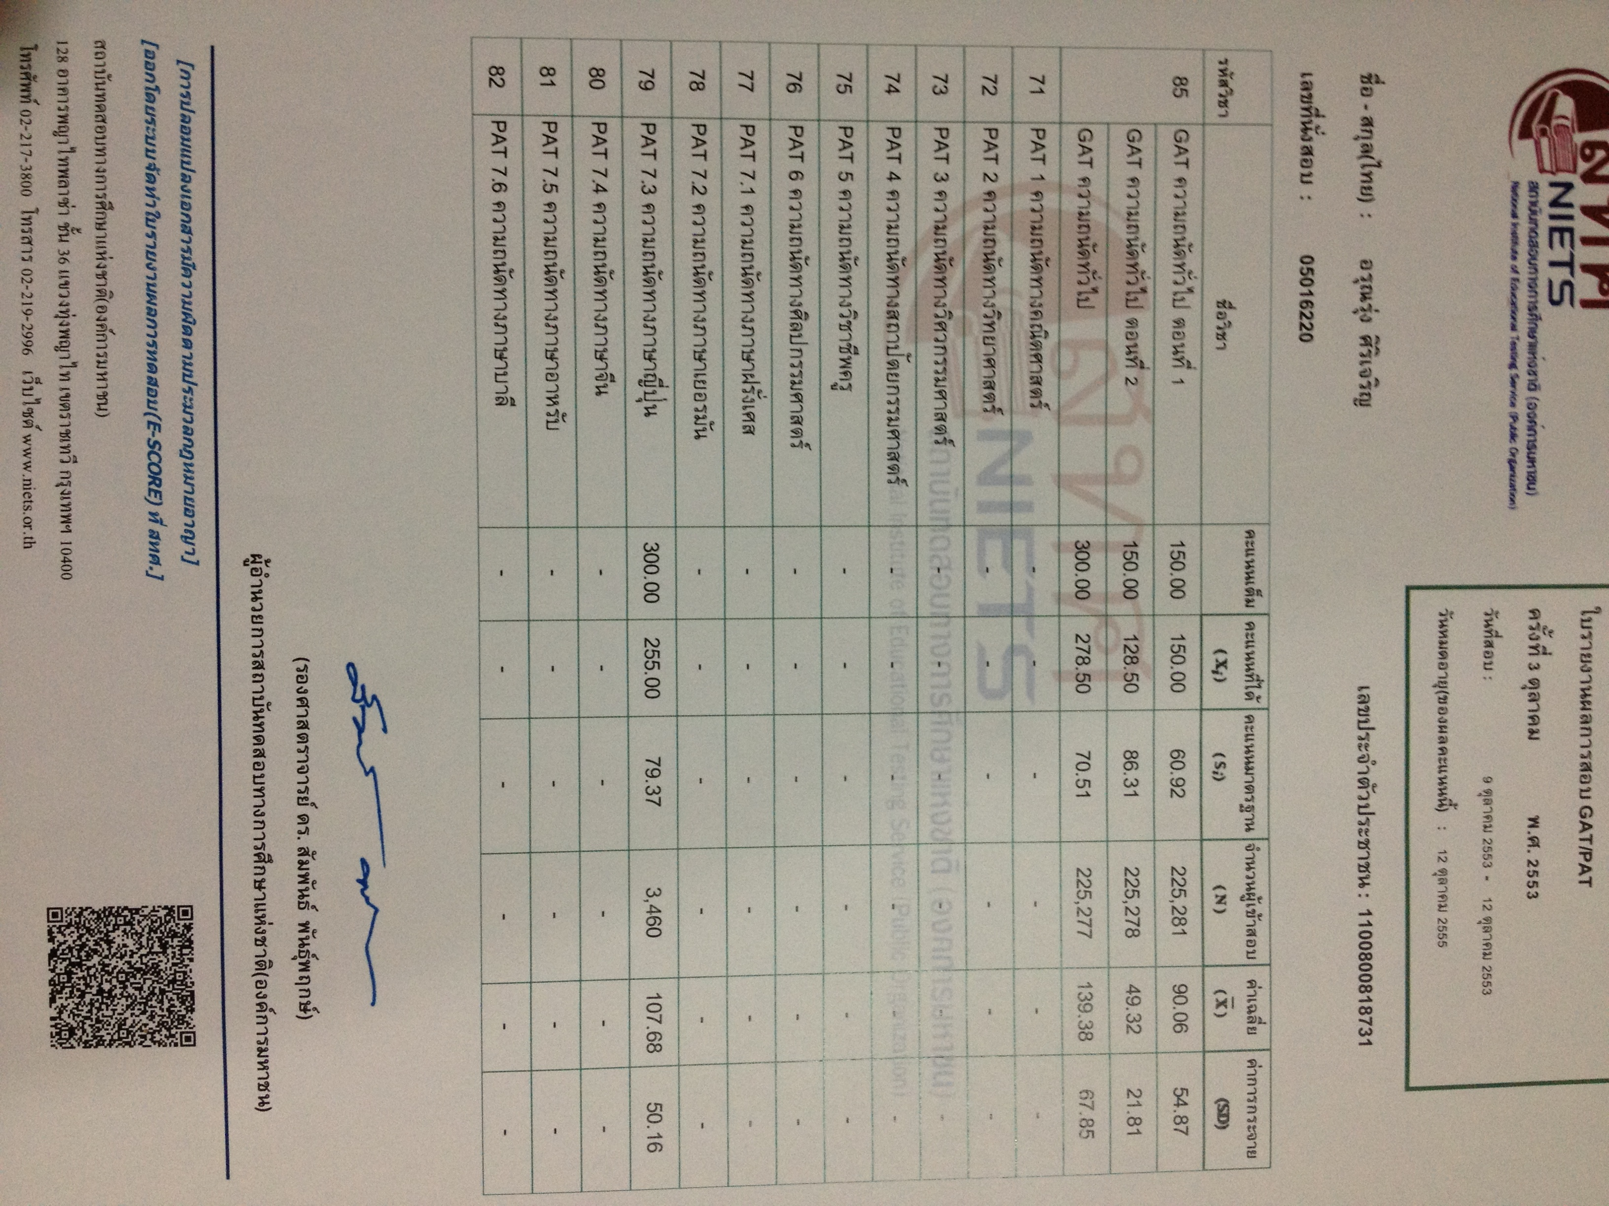

**Note to parents**

As an English major, I hope to pass on my English knowledge to students in order that they can succeed in learning English language for both educational and practical use. I will do my best to boast my students and make them love English just like I do. Since to understand a language thoroughly requires more than memorizing, I believe that entertainment such as music, movies and books can also help one comprehending language much easier. Nevertheless, daily practices and a number of exercises are still necessary for the GAT course. As a result, my teaching is to combine those mentioned methods to provide the best English knowledge for students.