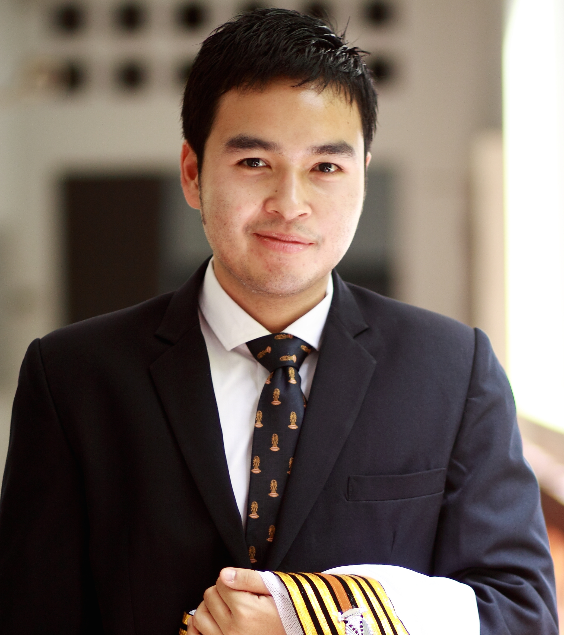**PASSAKORN INDRARUNA**

Mobile: (086) 3391010

[E-mail : oxoniandr@gmail.com](mailto:oxoniandr@gmail.com)

**Educational Background**

Year 2012 **Doctor of Philosophy in Political Science**, Institute of International Studies,

Ramkhamhaeng University (International Program)

Year 2010 **Master of Architecture**, *Chulalongkorn University*

Year 2010 **Master of Design and Planning (Human Centered Design)**, *School of*

*Architecture and design*, *King Mongkut’s University of Technology Thonburi* (International Program)

Year 2006 **Master of Business Administration (Hotel and Tourism Management)**,

*Universite de Perpignan via Domitia*, France

Year 2004 **Bachelor of Communication Arts** (Advertising), *STOU*

Year 2002 ***Year 12***, *International School of Pattaya,* Chonburi, Thailand

**Professional Experience**

April 2012 - July 2014  ***Chalearmkanchana University***

*Full time lecturer, Master of Public Administration*

***Dhurakij Pundit University International College***

*Visiting lecturer, International Business*

March 2011- March 2012 **ASEAN +3 Food Security Information System**

*Technical Coordinator and Personal Assistant to Expert*

* Perform the implementation of AFSIS and activities to develop administrative regulations of AFSIS Secretariat
* Preparing and facilitating ASEAN meetings and perform presentation, conferences and alliance management.
* Facilitate arrangements and conduct of regional meetings of ASEAN member countries, developing inter-cooperation and development of food security support networks
* Coordination with prospective partner non-government and government organizations in link with project activities
* Provision of assistance in implementing activities of Expert in target countries (Cambodia, Laos, Myanmar)

October 2009 – February 2011 **MSK Supply Company Limited**

*Sales and Marketing Manager*

* Developed a business plan and sales strategy for the market that ensures attainment of company sales goals and profitability.
* Responsible for the performance and development of the Account Executives.

June 2007 - August 2009 **Reality Ads Company Limited**

*Managing Director*

* Supervised production team consisting of graphic designers, artists and photographers.
* Conducted sales and marketing surveys of customers to determine buying pattern and demographics in property service.
* Aided in advertising production and campaigns of property service.
* Produced flyers for commercial-art customers.
* Negotiated advertising contracts

January 2007 - May 2007 **Mercure Hotel Pattaya**

*Revenue Management Trainee*

* Evaluated market demand trends, including surveying the competitors strategies
* Conducted weekly yield meetings with agenda
* Provided statistical information to Executive team members

**Computer Literacy**

Adobe Illustrator, Adobe Photoshop, 3D Max, Flash MX, Dream Weaver

**Language Essentials**

*    Excellent command of spoken and written English.
* Good command of German (Zertifikat Deutsch from Goethe Institute)

Date of birth: July 17, 1986

Age: 28

Marital Status: Single