**Resume**

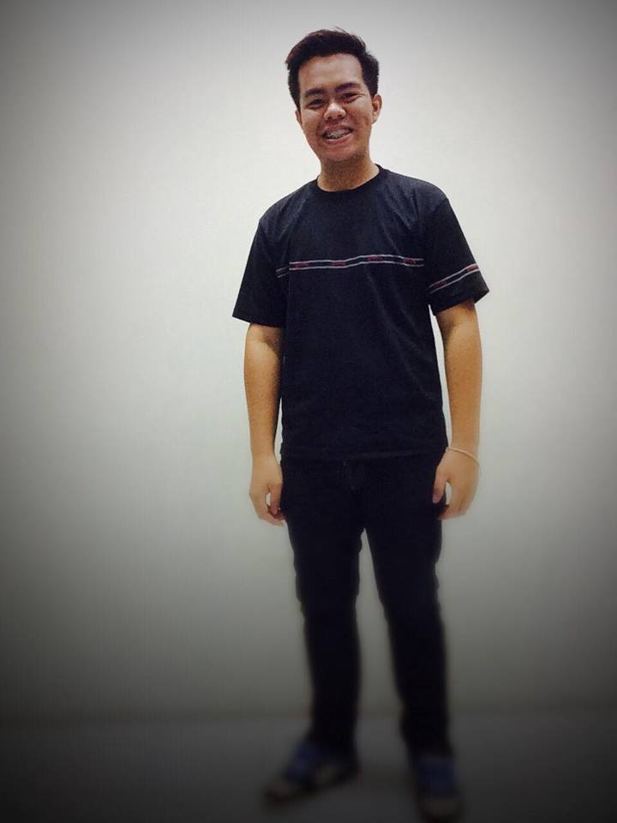**Supakiat Charoenklin**

30/13 M.7 Bang Chalong,

Bang Phli, SAMUT PRAKAN

The impress suvarnabhumi 616A

E-mail : [Champ-cp9@windowslive.com](mailto:Champ-cp9@windowslive.com)

**Tel : 0816548038**

**Date of birth**: 12 November 1994

**Age**  : 20

**Certification** : Thailand, Chonburi

Birth – 2012

Thailand, Samut prakan

2012 – present

**Education**  : Sriracha school

Huachiew chalermprakiet university

**Personal skill** : Excellent team worker,Enjoy working about fashion,Good physical, honest,

Language : English , Japanese

**Employment** : **Club21 Thailand** (Siam centre,Bangkok)**­**

January 2014 – May 2014

**Major Cineplex**  (Mega bangna, Samut prakan)

May 2014 – August 2014­