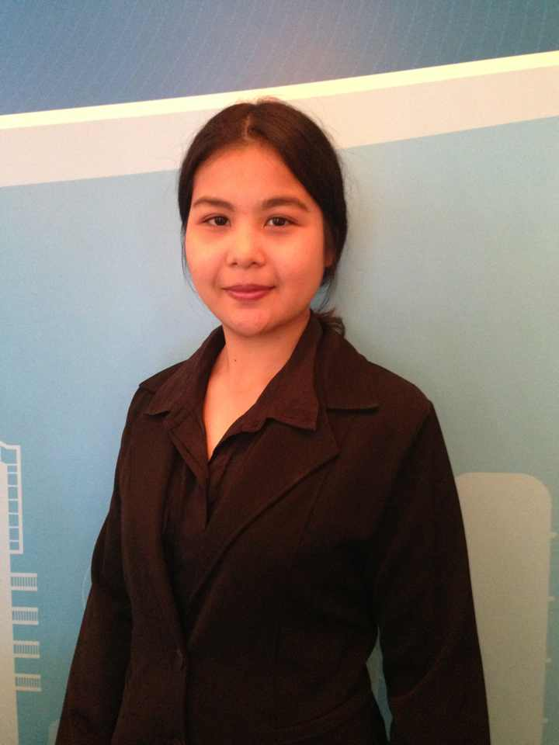**Suparat Treesaksri**

**Address:** 54 Jaransanidwong Raod Bang-or,

Bangphat District, Bangkok 10700

**Contact:** +6684-342-1066

Coadzer@gmail.com

**EXPERIENCE :**  ***Adecco New Petchburi Recruitment Limited***

**Client: ExxonMobil Limited**

**Position:** HR Recruiting Administrator

**Period:** August 2013 – Present

**Responsibilities:**

- Contacting employment agencies, recruiters, media, and internet sites; providing organization information.

- Evaluates applicants by discussing job requirements and applicant qualifications with managers; screening applicants on consistent set of qualifications.

- Arranges management interviews by coordinating schedules and escorting applicant to interviews.

- Manages internship program by contact University; screening potential students; Arranges management interviews by coordinating schedules and escorting applicant to interviews and assistance new interns during the internship program.

- Using SAP program to purchase requests to meet the requirements of the recruiting team.

- Supporting Singapore recruitment team for screening the resume

***Work and Travel program - McDonald’s Restaurants Ltd.***

**Position:** Crew Member – Back and front area

**Period:** May 2013 – July 2013

**Responsibilities:**

* Cooking, preparing and serving the menu for customer.

***CS LOXINFO PUBLIC COMPANY LIMITED***

**Position:** Trainee

**Period:** March 2012 – May 2012

**Responsibilities:**

* Schedules, contacting and escorting applicant to interviews.
* Coordinate for pre-testing of psychology test and basic office skill test.
* Preparing the documents for training program.
* Manages internship program by assistance new interns during internship period, checking time attendance and calculating the intern’s allowance.
* Supports the Human Resource department staff as needed and/or assigned for the purpose of assisting in the performance of their work activities.

**EDUCATION :** **Burapha University (2009 – 2012)**

Bachelor of Science, Industrial and Organizational Psychology Major

GPA: 3.57 (Second class of Honor)

**SKILL : TOEIC 680/990**: Listening 420/495, Reading 260/495

**Microsoft Office**: Word, Excel, Power point and Outlook

**Other:** SPSS, SAP and Adobe Illustrator