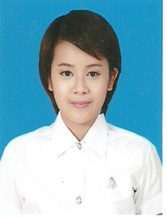**Ornnicha Kridsadatikarn**

**Permanent Address**

99/91, Surawong city resort, Naret road

Bangrak, Bangkok

Thailand, 10500

**E-mail:** Jirawat_dj@hotmail.com **Tel** : 0830655693

**Objective** To apply a position as a tutor that will enable me to use my skills,

knowledges, interests as a engineering student.

**Education** Junior year(3rd year)**,** engineering student, 2013-present

King Mongkut's University of Technology Thonburi,

Bachelor of Engineer in Production and Mechatronic Enginnering

Minor in Mechatronic Engineer.

GPA : 2.87 / 4.00

Mahaprutharam Girls' School , 2007-2012

Science-Math program, Math-Gifted program

GPA : 3.80 / 4.00

**Working** Tutor, 2013 - present

**Experience** Helped students to understand to lecture and practicing the students by

provide the exercises for Secondary Maths, Calculus I, Calculus II,

Differential Equation, Linear Algebra, Physics, Secondary chemistry, PAT1,

And PAT 2

**Activities** Gold medal, Mathematics project

**And** Gold medal, Region mathematics competition

**Honours** Bronze medal, 9 schools gifted mathematics competition

Member, Institute of field robotics