RESUME

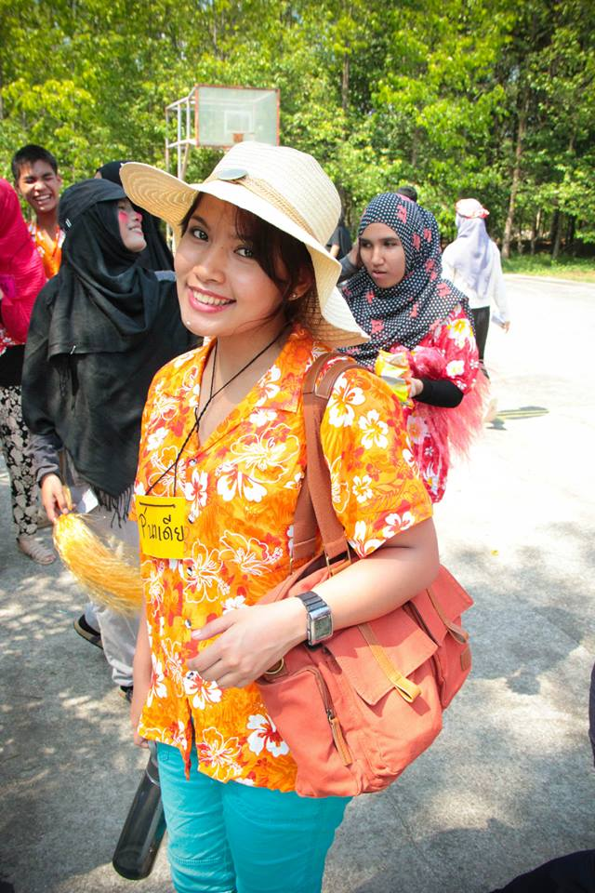

**NAME : NADEEYA SATTHAMANU**

**Date of Birth** : *06-14-1995*

**Address** : 5-721 moo 3. soi 12. Chaofah road. tambol wichit.

Aumper Muang. Phuket,Thailand 83000

**Mobile Phone Number** : *(+66) 805267284*

**Email address** : *nadia_theroofthatcher@outlook.com*

**Personal Profile**

* Who am I?
* a dreamer and a fighter is what I would describe myself, because, I like to picture myself ahead; how I want myself to be in the future and what I have to do to achieve them. As a result, I work hard today for the day would come true as I pictured it. There were many things in the past that I have accomplished from what I wanted myself to be and I got it because I would just fight for it and never give up.
* **Why am I qualified for the job**

I believe that i have much experience enough to assist student with his or her communication or speaking skill or even the other basic english skills, reading, writing or even grammar, that is why i am qualified for the job.

**Education**

* University Name: *Thammasat University*
* University Address: *99 Moo 18. Pahonyotin Road. Tambon Klong Nueng. Aumper Klong Luang. Patumtani,Thailand 12120*

Degree Expected: *Liberal Arts*

**About My Class:** I’m taking English as my major and Spanish as my minor. I have always enjoy learning languages because it really interests me and i am very good at it , moreover, it is supportive for my future carreer .

**Activities** : I like to join the camp concerned with knowledge for children and some faculty activities such as helping with the show on Liberal Arts day and wooden board painting for insidious competition of faculty.

* Languages and Level : I used to be an exchange student in Hawaii for about a year so my English skills are very good because of real life using.
* Sports & Clubs : I do running recently because my dormitory is close to the treadmill.
* Hobbies : I like watching movies the most out of all things; it just takes me away from my real life to a movie world for a moment and it is totally entertaining. My favorite movie type is romantic comedy because it gives me a good feeling also I think that the laughter and love is what this world cannot live without.

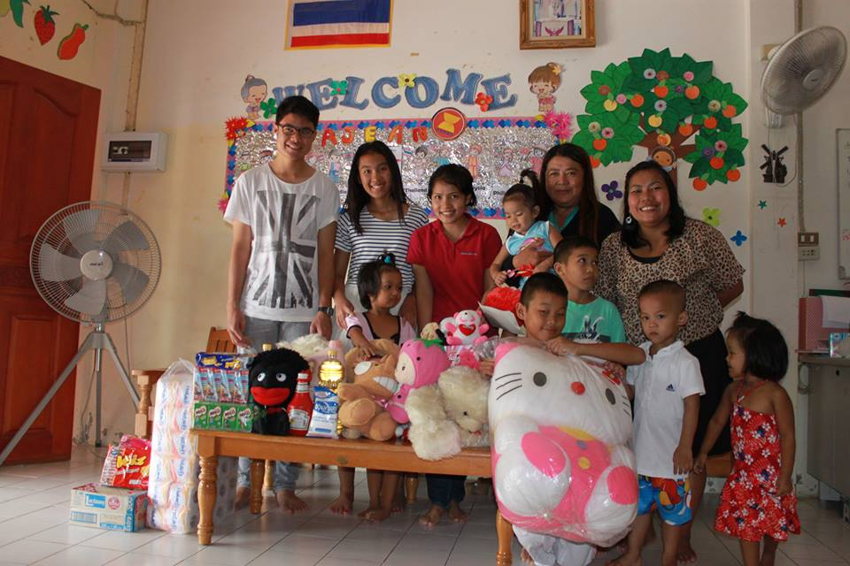

I did the donation for an orphanage in Phuket.

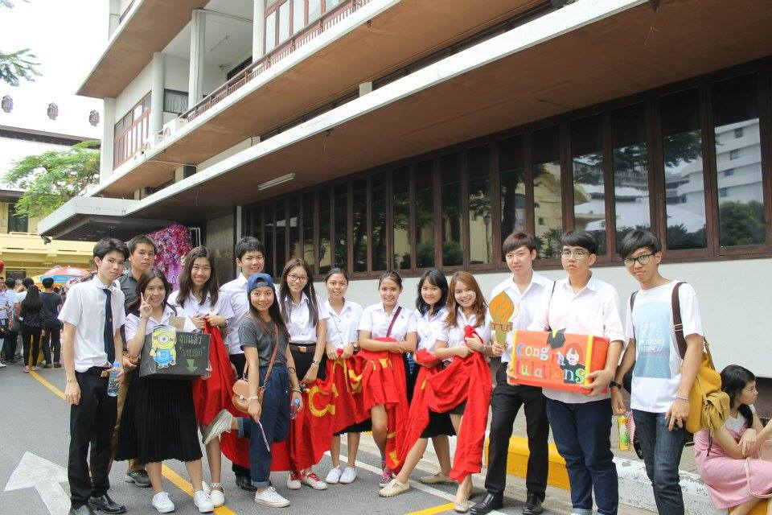

On my university’s senior graduation day, my friends and I went to congrat-ulate them.

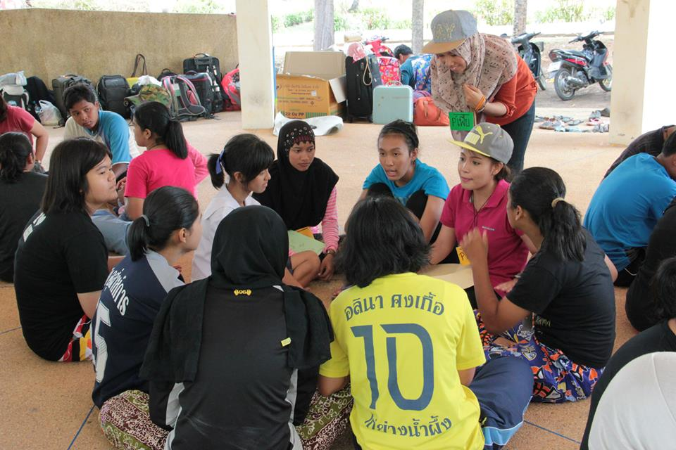

This is an English camp I did with my friends in Phang-Nga, a southern province in Thailand.