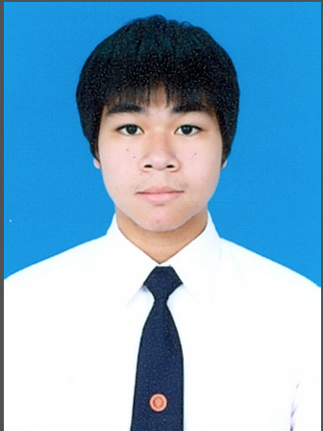**Jirawat Santiwarodom**

**Permanent Address**

403/6-7 Silom road,

Bangrak, Bangkok

Thailand, 10500

**Contacts** : [jirawat_santi@hotmail.com](mailto:jirawat_santi@hotmail.com) **Tel** : 086-700-3006

**Objective** To apply a position as a tutor that will enable me to use my

skills, knowledges, interests as a engineering student.

**Education** Junior year (3rd year), engineering student, 2013-present

Sirindhorn International Institute of Technology (SIIT), Thammasat University

Bachelor of Engineer in Chemical Engineering

Minor in Chemical Process and material engineer

GPA : 2.90 / 4.00

Sarasas Ektra School (Bilingual program), 2007-2012

Science-Math program

GPA : 3.20 / 4.00

**Work** Tutor, 2012 - present

**Experiences** Helped students with concepts and coursework.

The subjects that I’ve been teaching are on the following lists

• Organic chemistry

• Physical chemistry

• Fundamental chemistry

• English II,III (Thammasat University curriclum)

• English for secondary student, and entrance program

• Biology

• High school science 🡪 Student in responsible earn full score in exam

**Activities** Sarasas Ektra School student council

**and** Sarasas Ektra School, Honour student, 2007

**Honours** Member, SIIT, faculty basketball player

Gold medal, NBA 3 on 3 Thailand 2011

Sirindhorn game, staff and organizer, 2015