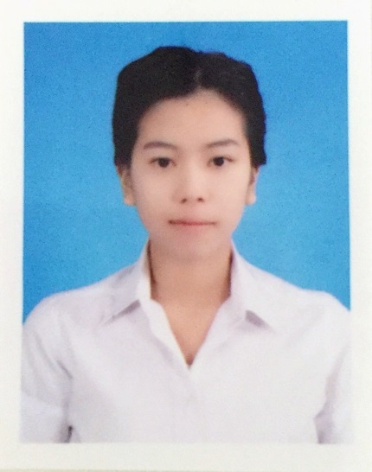**Resume**

**Name :** Miss Suntharee Numpoo.

**Personal Information.**

**Date of birth :** March 7, 1994 **Age** : 22 years old.

**Nationality** : Thai **Religion**  : Buddhist

**Height**  : 162 **Weight**  : 54 kg.

**Marital status** : Single **Military Service** : Exempted

**E-mail** : [baby_lovelymilk@hotmail.com](mailto:baby_lovelymilk@hotmail.com) **Phone** : 087-133-3689

**Address** : 14 serithai 61 kannayao district , serithai road, Bangkok 10230.

**Education**

**High vocational** : Graduated in grade 12 , science – math major. Grade 3.86

**Bachelor** : I am studying in Accounting major at the International College of Rajamangala University of Technology Krungthep. ( Year-3 ) . Grade 3.25

**Temporary jobs :**

* Mathematics and English tutor for grade-2 at home (2 years.)
* Mathematics tutor for grade 1
* Mathematics tutor for grade 4
* Mathematics tutor for grade 5
* Mathematics and Science tutor for grade 3
* Mathematics and tutor for grade 6
* English tutor for grade 2, 4 and 12
* Science tutor for grade 3 and 5
* General homeworks for primary 3
* General homeworks for grade 2 and 6