SAOWAPAK BUPHOO 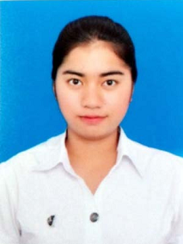

# ABOUT ME

* **Name** **:** Saowapak Buphoo
* **DOB :** 21/01/1993
* **Location :** 5/690 Airvilla Village Lumlookka Road Kukot Lumlookka Patumtanee 12130
* **Phone :** (+66) 809094731
* **E-mail** **:** [saowapak.baynja@gmail.com](mailto:saowapak.baynja@gmail.com)

# Education

Kasetsart University Bangkok, Thailand

Bachelor of Science *2011 – 2015*

*Department of Earth Sciences* *(GPAX : 3.13)*

**Rittiyawannalai School** Bangkok, Thailand

*Mathematics-Science program (GPAX : 3.88)* *2008 – 2010*

# ExperiEnce

* Mathematics (Elementary School and Junior High School) 2012
* Science (Junior High School) 2012 - 2013

# objective

I am interested in Mathematics and Science and I would like to teach in your tutorial school which relevant to my field study and get more experiences.