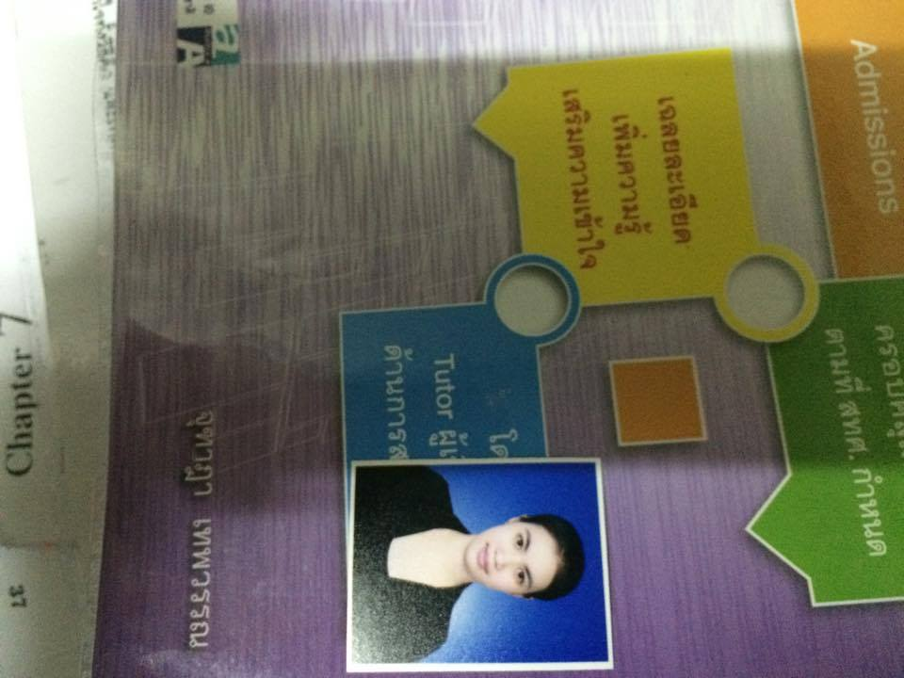**NATCHA KHUNTHONG**

6644 M.7, Sampran, Nakorn Pathom, 73210

Tel: 08-8228-8355 E-Mail: khunthong67@gmail.com

**Objective** Production Engineer, Research and development, Chemistry

**Education**

2011-present Bachelor of Industrial Engineering, Silpakorn University. (GPA 3.15)

Relevant course -Thermodynamics for Chemical Engineering - Transports - Kinetics

-Unit operation

2005-2010 Wat Raikhing Wittaya shcool

**Intern**  Production Engineering Department, AGC Chemicals (Thailand) Co.,Ltd

Duties : •Learned about P&ID of Brine Process

•Learned about Electrolyzer operation and Electrochemical reaction

**Activity**

Staff Cheer Entaneer, faculty of Engineering, Silpakorn University

Visited AGC Chemicals (Thailand) Co.,Ltd

Participants Rouses Camp of Chemical Engineering, Silpakorn University

Participants Visited factory, Chemical Engineering Silpakorn University

**Special Skill**

Computer Microsoft Office (Advanced)

Aspen Plus (Intermediate)

VASP (Basic Knowledge)

Instrument Gas Chromatography (Advance)

N2 adsorption desorption (Advanced)

Language English (Intermediate)

**Special Qualities** Quick learner – creative – enjoy working under pressure

**References** Assistant Professor, Suwimol Wongsakulphasatch (Project Consultant)

Contact : suwimol1331@yahoo.com