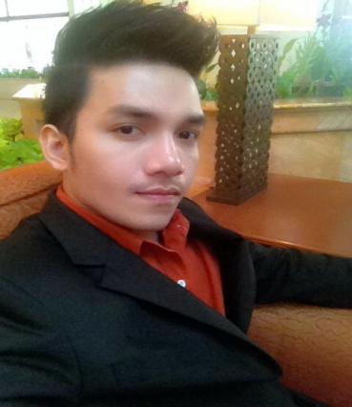

**PRAPHAN (PEA) KHUNPROM MR.**

FAMILY PARK CONDOMINIUM LADPRAO 48, SAMSEN-NOK, HUAYKWANG, BANGKOK

Cell number: 0926124224 Email: [P_scholar_@hotmail.com](mailto:P_scholar_@hotmail.com)

**EDUCATION**

Bachelor of Art

Suan Dusit Rajabhat University, majoring English with Second Class Honor.

**SAMMARY**

High-energy Consultant focused on promoting customer satisfaction through exceptional service and maintaining outstanding hotel accommodations. And dedicated Consultant offering more than 3 years in the hospitality industry, as well as in-depth knowledge of managing and the greatest way to encounter with customers.

**HIGHLIGHT**

- Exceptional customer service - Travel agency experience

- Exceptional communication - Sales experience

- Fluent in both English and Thai - Relationship-building

- Conflict resolution - Staff motivation and training

**EXPERIENCE**

Freelance Translator, 2013-Present

* Read through original material and rewrote it in the target language

The Hilton Premium club freelance Telemarketer, 2013-2014

* Searched new members by calling to explain membership benefits
* Looked for target leads
* Persuaded members to join hotel promotions/events
* Interacted with marketing team to achieve target sales
* Built healthy relation with members and make reservations as members required
* Solved problems as hotel fully booked (some related problems), find solution and follow problem-solving procedure

The White Card membership freelance Telemarketer, 2013-2014

* Indentified opportunities and produced leads
* Searched new members by calling to explain membership benefits
* Promoted updated hotel promotions and events to members
* Persuade members to join hotel events
* Interacted with marketing team to achieve target sales
* Reported feedbacks to manager of lost sales

Siam Dhurakit Technological College-Rajchatevee, Bangkok, Special Instructor, 2011-2013

* Taught English language and literature.
* Planned lessons and created and implemented curriculum conducive to teaching English.
* Established clear objectives for all lessons and projects.
* Communicated with parents about student progress.
* Provided appraisal and reviewed of individual student performances.

The St. Regis Bangkok Hotel- Pathumwan, Bangkok, Membership Administration Manager, 2011-2013

* Processed guest payments for room, food and beverage and phone charges.
* Greeted and registered guests and issued room keys.
* Processed credit card transactions during the membership fee process.
* Greeted all guests in a courteous and professional manner.
* Attend to any requires from hotel guests regarding the membership concerns.
* Trained new hotel staffs regarding membership updated benefits and promotions.

SDI Media (Thailand) Co.,Ltd-Ladprao, Bangkok, English Subtitle Editor, 2009-2011

* Ensured story fits a particular word count by cutting or expanding
* Ensured facts and stories, copyright laws
* Cropped photos and decided to use for best effectiveness.
* Added last minute news stories.
* Keep up-to-date issues.
* Rewrote material for flowing and reading.