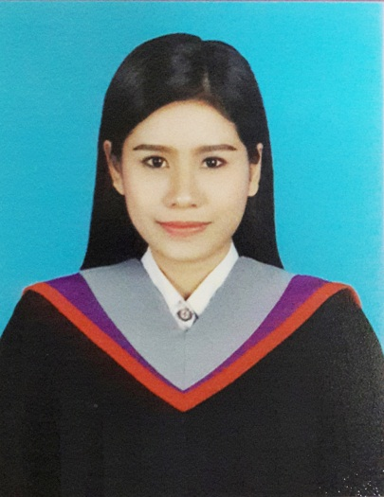

**Work Experience**

**Dec 2015 – Present**

Trainee at Holiday Inn Express Bangkok Siam

* Preparing about document in Human resource Department
* Welcoming customer, Answering telephone call and customer inquiries
* Updating customer database

**Jan 2015 - Present**

Tutor at Smart English School Ekkachai 69 Branch

* Teaching one by one or group about English language, Thai Language and another subject for children in Primary school

**2012-Present:**

B.B.A.(Tourism and hotel),The faculty of Social Science, Srinakharinwirotuniversity,Bangkok,Thailand

**2009-2011:**

High school certificate from Phra Mae Mary School ,

Bangkok,Thailand

**Computer skill**

Microsoft office , Photoshop

**Language skill**

English: good reading, writing and speaking

Chinese: fair

**Driving License:** Have Driving License

Yananan Limplertlaksana

**References**

Atchareeya Saknarong, Ph.D.Lecture, Tourism and hotel Program The Faculty of Social Science,Srinakrinwirotuniversity.

TanapoomAtivatin, Ph.D.Lecture, Tourism and hotel Program The Faculty of Social Science,Srinakrinwirotuniversity Tel 020649-5000 ext 11716

E-mail: tanapoom@swu.ac.th

To apply for a Receptionist in Zenniq Hotel

**Objective**

**Education**

Name: Yananan Limplertlaksana

Date of Birth: 19 November 1993

Age: 22

Nationality: Thai

Marital Status: Single

Mobile No.

6683 700 9516

E-mail

Yananan.limp@hotmail.com

**Personal data**