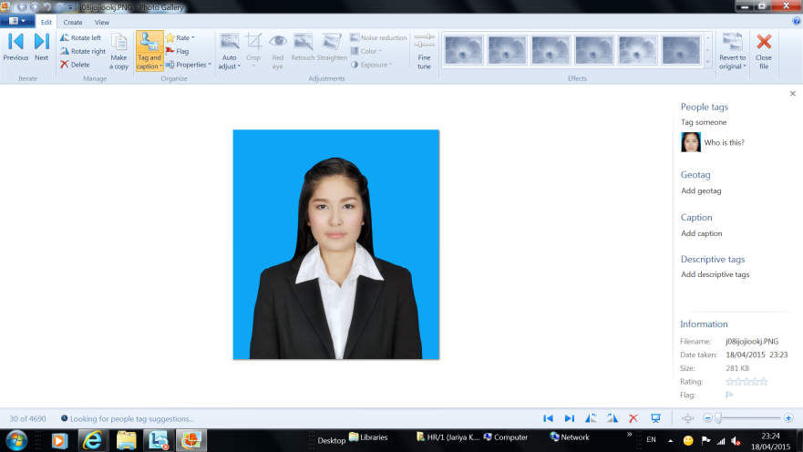

**Miss. Aisirinttar Chunton**

Date of Birth: Nov 7, 1991, Age: 23 Marital status: Single

Address: 214 M.7, Sawangdaendin District, Sakhonnakhon, 47240, Tel: 081-8748334 E-mail: [demo_bear@hotmail.com](mailto:demo_bear@hotmail.com)

**OBJECTIVE**

To obtain a challenging responsibility, utilize knowledge to explore/expand my capability and grow in the field of Statistic, Financial, Accounting or Administration related.

**EDUCATION**

May 2010 - March 2014 Bachelor's Degree in Science, Major Statistic

Khon Kaen University, Thailand, GPA.2.94

**EXPERIENCE**

Summer 2013 Accounting Internship

**Select Service Partner Group Plc**

* Controlling and checking daily document for Bangkok Brach
* Daily credit card document checking from banks and recording in accounting software/database.
* Controlling and checking daily meal voucher to invoices airline customers.

ACTIVITIES

* Participate Seminar “The preparation Thailand Society to AEC in 2010, organized by Faculty of Science , Khon Kean University.
* Organize and participate the 25th Science Camp for Faculty of Science , Khon Kean University.
* Completed as an athlete for Faculty of Science and Faculty of Arts relationship game.
* Participated as Social Responsibility Project member for Khon Kean University.

**QUALIFICATIONS**

* Fast learner and having ability to use ability to use Microsoft Word, Excel and Power Point well.
* Microsoft Office Programs
* Good personality, attitude and be a team player.
* Typing skills: Thai, 40 words per minute English, 35 words per minute
* English Language Ability: Read: Good, Writing and Communication: Moderate.