|  |
| --- |
|  |

**MAHATAKOOL ROONG-RAJATAVEJ**

4184 Soi Our Lady of Fatima Church, Din-Daeng, Bangkok 10400 | **Mobile:** (+66)81-6980149 | **E-mail:** roong.mahata@gmail.com

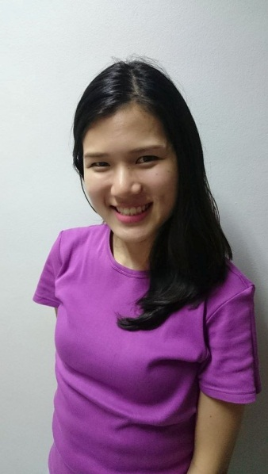

**Y. 1990**

|  |  |
| --- | --- |
|  | **Born in Songkhla, Thailand.** |

**\**

|  |  |
| --- | --- |
| **Y. 2009** | **Graduated high school from Mahidol Wittayanusorn School, Nakorn Prathom.** |

|  |  |
| --- | --- |
| **Y. 2012** | **Joined Bangchak Petroleum Plc.** (*internship program*)  Supply chain management trainee   * Learnt about proportional and trends of ethanol market share for both domestic and international and also pricing for export. * Studied and proposed varieties of catalysis and method involving improvement in “Biodiesel from cooking oil process”. |

|  |  |
| --- | --- |
| **Y. 2013 to Present** | **Graduated bachelor's degree from Chulalongkorn University**  Faculty of Engineering (Major Chemical Engineering – GPAX 3.13) |
|  | **Join Johnson & Johnson**  Support of marketed product (SMP) Scientist (2 years experience)   * Responsible for material qualification in order to support business to be continuously; and new innovation of product as well. * Be effective participant in across functional meeting by providing technical input. Besides, raise concern/option from various perspectives during meeting in order to make project go smoothly. * Join ‘Flawless Project Execution (FPX) training’ in Indonesia. |

|  |  |
| --- | --- |
| **Additional skills** | |
|  | **Communication skill**  Thai & English (TOEIC 700). |
|  | **Computer skill**  Microsoft Office, Minitab, Matlab. |
|  | **License of Professional Practice (Professional Chemical Engineer)** |