**Pimwipa Kanasup**

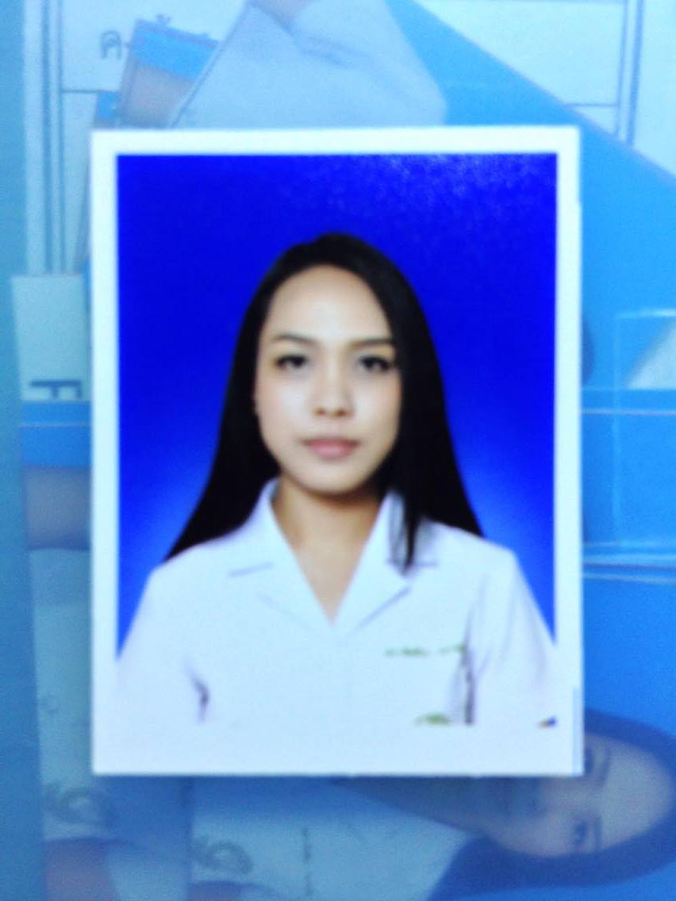

141/67 Trat-Laem Ngob Road, Nongsamed, Muang, Trat, 23000

Tel. 080-0959349

E-mail: [pimwipa.kp@gmail.com](mailto:pimwipa.kp@gmail.com)

**Education**

|  |  |
| --- | --- |
| 2011 – 2016 | Doctor of Pharmacy (Industrial Pharmacy) (GPA 3.73)  Pharmaceutical Sciences, Chiang Mai University - Thailand |
| 2006 – 2011 | Streeprasertsin School (GPA 4.00)  Muang, Trat 23000 |

**Internship**

|  |  |
| --- | --- |
| May – June 2015 | Pharmaceutical Sciences, Chiang Mai University  Introduction to industrial pharmacy internship, Manufacturing production, QA/QC process and Drug regulation |
| June – July 2015 | The Government Pharmaceutical Organization (GPO), Bangkok  R&D (Method Development and Validation) |
| Aug. – Sept. 2015 | The Government Pharmaceutical Organization (GPO), Bangkok  R&D (Method Development and Validation) |
| Sept. – Oct. 2015 | T.O. Chemicals (1979) Co., Ltd., Bangkok  Manufacturing production, QA/QC process |
| Nov. – Dec. 2015 | T.O. Chemicals (1979) Co., Ltd., Bangkok  Manufacturing production, QA/QC process |
| Dec. 2015 – Jan. 2016 | T.O. Chemicals (1979) Co., Ltd., Bangkok  Manufacturing production, QA/QC process |
| Feb. – Mar. 2016 | T.O. Chemicals (1979) Co., Ltd., Bangkok  Manufacturing production, QA/QC process |

**Research Project in Pharmaceutical Science**

“Behaviors and attitudes toward electronic devices usage during class sessions of pharmacy students at Chiang Mai University”

**Presentation**

|  |  |
| --- | --- |
| 2015 | Kanasup P, Kawinkul M, Eakanunkul S, Suwannaprom P. Behaviors and attitudes toward electronic devices usage during class sessions of pharmacy students at Chiang Mai University. The First International Conference on Pharmacy Education and Research Network of ASEAN. Bangkok, Thailand. December 2-3, 2015. |

**Skill**

|  |  |
| --- | --- |
| **Pharmacy Skill**  Pharmacy Technician Skills  *Basic medication counselling and dispensing skills*  Analytical Technique  *HPLC*  Drug Registration  *ACTD*  Research and Development  *Method validation* | **Computer Skill**  Microsoft Office  IBM SPSS  Adobe Photoshop |

**Reference**

Dr. Suntara Eakanunkul, Ph.D.

*Department of Pharmaceutical Sciences, Faculty of Pharmacy, Chiang Mai University*

*Suthep Road, Chiang Mai, Thailand, 50200*

*Tel: 0 53 94 4395 Email: eakanunkul@gmail.com*