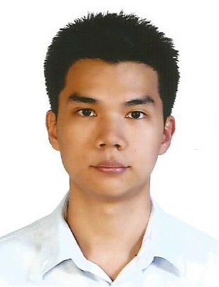

**MR. PAAK PHANTUMABAMRUNG**

**Personal Information**

**Date of birth:** 18 July 1991

**Marital status:** Single

**Military Service:** Fulfilled

**Nationality:** Thai

**Address:** 83, Soi Krungthep-Nonthaburi 23, Krungthep-Nonthaburi Road, Bangsue district, Bangkok, Thailand 10800

**Telephone:**  (+66) 85-553-6918

**Email:**  P.paak18@gmail.com

**OBJECTIVE**

In Bachelor Degree, I studied not only science that will be used to improve athletes’ efficiency, but also operating and managing sport events and recreation. Furthermore, I studied knowledge of management including economic, marketing, human resource, financial management, strategic management and service quality in Master Degree. I am seeking to apply my abilities to manage in any sectors. I am a dedicated individual who can be relied upon to help the organization achieve the goals.

**EDUCATION**

2014 – 2015 Master of Science Loughborough University, UK

Major: Sport Management, 57.5%

2009 - 2013 Bachelor of Science GPA: 3.11

Faculty of sport science, Chulalongkorn University

Major: Recreation and Sport management

**WORK EXPERIENCE**

2012 Trainee***,*** Bangkok Broadcasting Television Channel 7 (Sport Media Organization)

**ACTIVITIES**

2010 Chamchuri Game , 38th University game, Chulalongkorn University

2009 – 2011 Chulalongkorn Futsal Championship

2011 – 2013 Operated events at Chulalongkorn University

2015 Volunteered in Rugby University Game at Loughborough University

2016 Young Ambassador at Honda LPGA Thailand 2016

**QUALIFICATIONS**

- Excellent communication in English (TOEIC: 805)