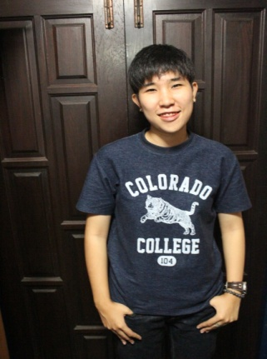**PERSONAL DETAILS**

NAME : Nutnaree Chatchalermpan [MAII]

D.O.B. : 03/07/1994 (23)

LOCATION : 119/36 Ruansuk1 Rangsit-Nakhonnayok Road

Rumpakkud Thanyaburi Pathumthani 12110

CONTACT : 0824468621

id line : ncmaii

[mammos.m@hotmail.com](mailto:mammos.m@hotmail.com)

**EDUCATION**

HIGH SCHOOL : Suankularb Vittayalai Rangsit (Math-Eng) (2550-2555)

UNIVERSITY : Kingmongkut University Of Technology North Bangkok (Stat) (2551-2560)

**SKILL**

MATH

ENGLISH

GUITAR

SOCIALIZE