**Work experiences**

* **Dec 2013-Dec 2016 : Phukhieo Technological College**

***As an English teacher***

-taught students both in vocational and high vocational certificate about basic English conversation and how to answer questions about their personal information

- created class materials and lesson plans, including activities for these classes

-encouraged students to be brave to speak English

- lecturer assistant in English training course for teachers

***As a teacher working for student activities department***

- created projects or activities to promote student’s ethical behavior

- summarized student's activity attendance records in each semester and declared to the students

- coordinated activities both within the organization and outside

- responsible for and acted as a lead in coordinating 4 activities or projects related to students; Student Council election, Kathin ceremony,V-Star’s day and PTC Got Talent

- performed daily routine and responsible for related documents

- worked as a part of the team to execute marketing strategies for student recruitment

-Visited middle schools, high schools, and colleges, spoke to groups and individual student, and met with school counselors and administrators to promote recruitment.

-arranged visits for prospective students and parents, including providing all needed information about recruitment to parents

* **October 2012 – March 2013 : The Thai silk company (Jim Thompson at Donmuang International airport)**

***Sale representative***

-Presented, promoted and sold products to customer based on customer needs to improve revenue

-answered questions about the products and maintained current knowledge

- handled and resolved customer complaints

- greeted every customer with a smile and made customers feel valued, welcomed and accepted.

-processed customer payments by cash, credit card

-put our new merchandise on the shelve, including cleaning the area frequently

-mainly communicated with customers in English and Chinese

**Career objective**

To obtain a job position in a high quality environment workplace where I can utilize my skills and knowledge to help the company and my coworkers be successful

**Qualification**

-a committed ,loyal and hard worker

-ability to organize and prioritize and work under pressure

- experienced in customer service field mostly spoke in English

-Awarded “ Best practice teacher” 2 times in 2015

- Awarded “Best teaching award” in 2016 from the Chaiyaphum Vocational education office

-completed the upgrade training course in 9 behaviors 9 successful

**Education**

2008-2012: Bachelor of Science, Faculty of Science

and Technology in the minor of

Agricultural Technology.

Thammasat University (GPA 2.98)

2004-2007: High school at Phukhieo School,

Chaiyaphum

**Skills**

**Computer :** MS Word, Excel, PowerPoint, Internet,

e-mail, photoshop

**Language** : Thai (Native) , English (Intermediet)

**Toeic Score :** 785 (listening =410, reading =375)

**Availability**

Immedietly

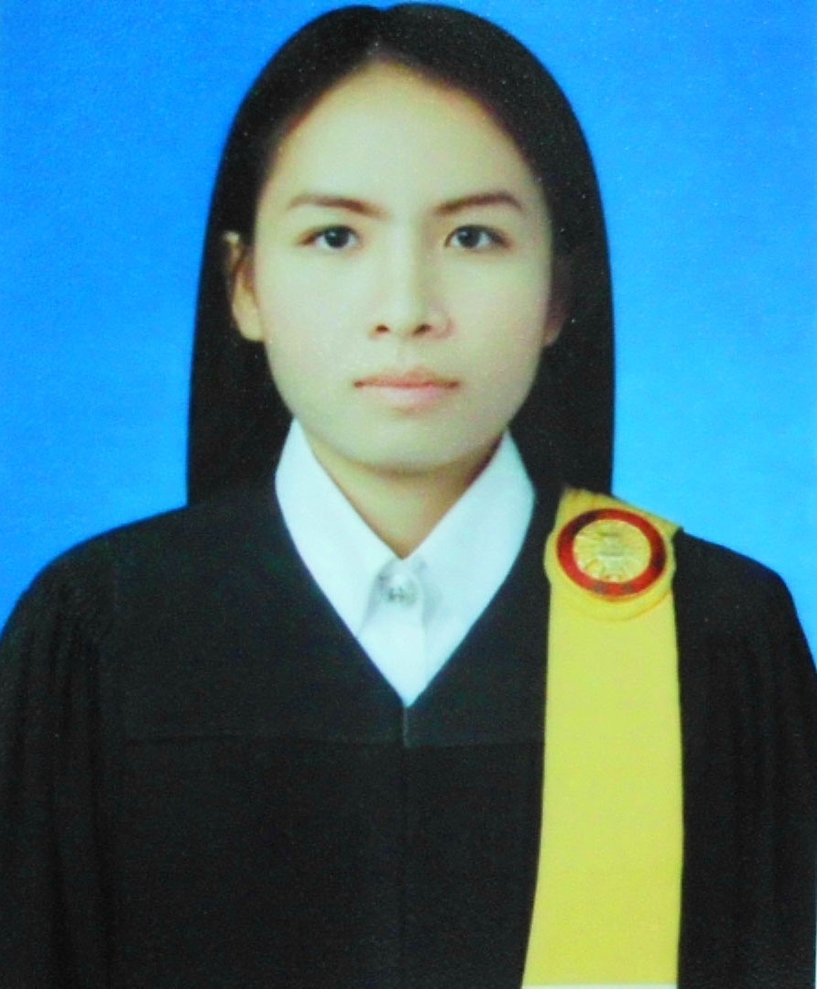

**Miss Suntreeporn Sukhong**

240 M.1 Olo subdistrict, Phukhieo District

Chaiyaphum Province, 36110

Tel. 088-1227299

E- mail :[s](mailto:hahanut1@hotmail.com)untreenut@hotmail.com